
EMADLANGENI LOCAL MUNICIPALITY
Amended INTERGRATED DEVELOPMENT PLAN
2024/25
TEL: 034 331 3041 Email:Info@emadlangeni.gov.za
Address: 34 Voor
PO BOX 11
UTREGHT
2980

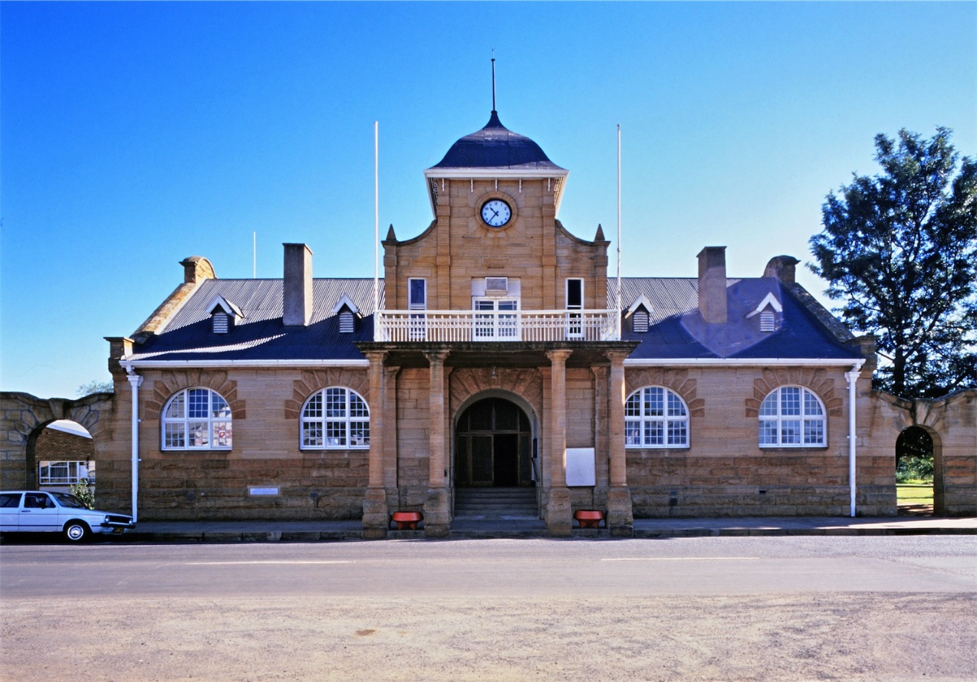
Contents
SECTION A: EXECUTIVE SUMMARY 12
A.1 BACKGROUND 13
A.1.1. MUNICIPAL DEVELOPMENT STRATEGY AND LONG TERM VISION 14
A1.2 KEY CHALLENGES 15
A.1.3 KEY CHALLENGES AND INTERVENTIONS 18
A.1.4 PURPOSE 21
A.1.5 OBJECTIVES OF THE INTERGRATED DEVELOPMENT PLAN 21
A.1.6 SCOPE OF THE EMADLANGENI IDP 22
A.1.7 APPROACH 23
A.1.8 MECHANISMS FOR PUBLIC PARTICIPATION 23
A.1.9 BUDGET PROCESS PLAN FOR 2023/2024 MULTI-TERM BUDGET 23
A.10 SECTOR DEPARTMENT INVOLVEMENT 29
A.11 ALIGNMENT WITH THE DISTRICT FAMILY OF MUNICIPALITIES 29
A.12 SPATIAL DEVELOPMENT FRAMEWORK (SDF) 29
SECTION B: GOVERNMENT POLICIES AND PLANNING & DEVELOPMENT PRINCIPLES 31
B.1 PLANNING AND DEVELOPMENT PRINCIPLES 31
B.1.2. POLICY CONTEXT 32
B.1.2.1 GLOBAL POLICY CONTEXT 32
B.1.2.1.1 Sustainable Development Goals 32
B.1.2.1.2 Agenda 2063 32
B.1.3. NATIONAL POLICIES AND PRIORITIES 32
B.1.3.1.1 Constitution of the Republic of South Africa Act, No.108 of 1996 33
B.1.3.1.2 National Development Plan 33
B.1.3.1.3 The 14 National Outcomes 33
B.1.3.1.4 Local Government Back to Basics 34
B.1.3.1.5 Operation Clean Audit 35
B.1.3.1.6 Local Government Management Improvement Model 35
B.1.3.1.7 District Development Model (DDM) 35
B.1.3.1.8 National Government adopted a National Infrastructure Plan in 2012. 35
B.1.3.1.9 Medium Term Strategic Framework 36
B.1.3.1.10 NATIONAL INFRASTRUCTURE PLAN 37
B.1.3.1.11 State of The Nation Address 38
B.1.4 PROVINCIAL POLICY CONTEXT AND PRIORITIES 39
B.4.1.1 Provincial Growth and Development Strategy 39
B.1.4.1.2 KZN PROVINCIAL GROWTH AND DEVELOPMENT PLAN (PGDP) 40
B.1.4.1.3 PROVINCIAL SPATIAL ECONOMIC DEVELOPMENT STRATEGY (PSEDS) (2016) 40
B.1.4.1.4 State of the Province Address 41
B.1.5. LOCAL POLICY CONTEXT AND PROGRAMMES 42
B.1.5.1.1 Amajuba District Growth and Development Plan 42
SECTION C: SITUATIONAL ANALYSIS 43
C. Situational Analysis 43
C.1. Demographic Characteristics 44
Population Size and Growth 44
Population Distribution 45
HOUSEHOLD SIZE 46
Population Groups 47
Age Distribution 47
GENDER PROFILE 48
Key Findings 49
C.1.3.1 SPACIAL ANALYSIS 51
C.1.3.1. Regional Context 52
C.1.3.2 ADMINISTRATIVE ENTITIES 52
C.1.3.3 STRUCTURAL ELEMENTS 52
C.1.4 EXISTING NODES AND CORRIDORS 53
C.1.4.1 DEVELOPMENT CORRIDORS 53
C.5.1.2 PRIMARY DEVELOPMENT NODE: UTRECHT 54
C.2 CROSS CUTTING 55
C.2.1 ENVIRONMENTAL ANALYSIS 55
C.2.1.1 BIODIVERSITY AND PROTECTED AREAS 55
C.2.1.1.1KEY HYDROLOGICAL FEATURES 55
C.2.1.1.2 CATCHMENTS 55
C.2.1.2 Biodiversity Areas 57
C.2.1.3 PROTECTED AREAS AND STEWARDSHIP SITES 57
C.2.1.4 Vegetation 58
C.2.1.5 Environmental Management 61
C.2.1.6 IMPACT OF CLIMATE CHANGE 62
C.2.1.7 STRATEGIC ENVIRONMENTAL ASSESSMENT 62
C.2.1.8 TOPOGRAPHY 62
C.2.2 SPATIAL AND ENVIRONMENTAL: SWOT ANALYSIS 63
C.2.3 DISASTER MANAGEMENT 68
C.2.3.1 MUNICIPAL LEGISLATIVE MANDATE 68
C.2.3.2 MUNICIPAL INSTITUTIONAL CAPACITY 68
C.2.3.3 RISK ASSESSMENT 68
C.2.3.4 DISASTER RISK REDUCTION 76
C.2.3.5 RESPONSE AND RECOVERY 77
C.2.3.6 EDUCATION, TRAINING AND AWARENESS 78
C.2.3.7 FUNDING ARRANGEMENTS 78
C.2.3.8 FUNDING MOBILISATION MEASURES 79
C.2.3.9 DISASTER MANAGEMENT: SWOT ANALYSIS 80
C.2.4 KEY CHALLENGES DERIVED FROM SWOT ANALYSIS 81
C.3 MUNICIPAL TRANSFORMATION & ORGANISATIONAL DEVELOPMENT ANALYSIS 81
C.3.1 MUNICIPAL TRANSFORMATION 81
C.3.2 ORGANISATIONAL STRUCTURE / ORGANOGRAM 83
C.3.3 MUNICIPAL INSTITUTIONAL CAPACITY & STATUS OF CRITICAL POSTS 85
C.3.4 EMPLOYMENT EQUITY AND RETENTION POLICY 85
C.3.7 ICT FRAMEWORK 86
C.3.8 MUNICIPAL TRANSFORMATION & INSTITUTIONAL DEVELOPMENT: SWOT ANALYSIS 87
C.4 GOOD GOVERNANCE & PUBLIC PARTICIPATION ANALYSIS 87
C.4.1 Batho Pele Policy 87
NATIONAL AND PROVINCIAL PROGRAMMES AT MUNICIPAL LEVEL 89
C.4.2. Operation Sukuma Sakhe (OSS) 89
C.4.2.1 Approved Documents Under Public Participation 89
C.4.3. Inter-governmental Relations (IGR) 89
C.4.4. WARD COMMITTEE 90
C.4.4.1 WARD COMMITTEE FUNCTIONALITY 90
C.4.5.1 BROAD BASED COMMUNITY NEEDS 92
C.4.5.2 BROAD BASED COMMUNITY NEEDS 92
C.4.6 PARTICIPATION OF TRADITIONAL LEADERS IN MUNICIPAL COUNCIL 92
C.4.7 IDP STEERING COMMITTEE 92
C.4.8 MANAGEMENT STRUCTURES 93
C.4.9 Communications Plan/Strategy 93
C.4.10 MUNICIPAL STRUCTURES 94
MUNICIPAL COUNCIL 94
C.4.10.1 INTERNAL AUDIT 94
C.4.10.2 AUDIT COMMITTEE 95
C.4.11.1 Enterprise Risk Management 95
C.4.11.2 Risk Register including Fraud Risk 95
C.4.11.3 Anti-fraud Strategy 95
C.4.11.4 RISK MANAGEMENT COMMITTEE 96
C.4.12 MUNICIPAL BYLAWS 96
C.4.13 BID COMMITTEES 99
C.4.14 MPAC 99
C.4.16 LAND USE MANAGEMENT 100
C.4.16 BROAD LAND USES 101
C.4.16.1. COMMERCIAL AGRICULTURE 101
C.4.16.2 SETTLEMENTS 101
C.4.16.3 ENVIRONMENTAL AREAS 101
C.4.16.4 LAND OWNERSHIP 101
C.4.16.5 LAND REFORM 101
C.4.16.6 LAND RE-DISTRIBUTION 105
C.4.16.7 LAND CAPABILITY 105
C.4. 17 Good Governance & Public Participation Swot Analysis 105
C.5.1 WATER & SANITATION 106
C.5.1.2 SANITATION 108
C.5.2 SOLID WASTE MANAGEMENT 110
Waste recycling, treatment and disposal 115
National Domestic Waste Collection Standards 116
Financing of Waste Management 117
Revenue sources 119
Waste Management Implementation Plan 120
C.5.3.1 ROAD NETWORK 125
C.5.3.1 PUBLIC TRANSPORT 125
C.5.5 Access to Community Facilities 127
C.5.5.1 Community Development 127
C.5.5.3 ANIMAL POUND 133
NON-GOVERNMENTAL ORGANISATIONS (NGOs) 134
C.5.5.4 SOCIAL DEVELOPMENT 134
YOUTH DEVELOPMENT 135
ELDERLY (SENIOR CITIZENS) AND PEOPLE WITH DISABILITIES 135
DEVELOPMENT OF WOMEN 136
MEN’S DEVELOPMENT 137
PEOPLE AFFECTED BY CRIME, HIV/AIDS, DRUGS 137
DEVELOPMENT OF PEOPLE WITH DISABILITIES 138
C.5.5.4 DEVELOPMENT OF PEOPLE WITH DISABILITIES 139
C.5.5.5 EARLY CHILDHOOD DEVELOPMENT 139
C.5.6 HUMAN SETTLEMENTS 147
C.5.7 TELECOMMUNICATIONS Error! Bookmark not defined.
C.5.8 BASIC SERVICE DELIVERY AND INFRASTRUCTURE SWOT ANALYSIS 153
C.6 KPA: LOCAL ECONOMIC DEVELOPMENT (LED) AND SOCIAL DEVELOPMENT ANAYLSIS 154
C.6.1 LOCAL ECONOMIC DEVELOPMENT 154
Main Economic Sectors 154
Employment 156
Income 156
Agriculture 157
EMadlangeni Agri-Village Development 158
Manufacturing 159
Tourism 159
Mining 159
C.6.2 LED Strategy 160
C.6.2.1 EPWP/CWP 161
C.6.2.2 Local Economic Development: SWOT Analysis 161
C.6.3 STRATEGIC MAPPING 162
C.6.3.1 ENVIRONMENTAL SENSITIVE AREAS 162
C.6.3.2 STRATEGIC INTERVENTION AREAS 162
C.6.3.3 DESIRED SPATIAL FORM 163
C.6.3.4 STRATEGIC GUIDANCE IN RESPECT OF DEVELOPMENT 166
C.6.3.5 SPATIAL ALIGNMENT WITH NEIGHBOURING MUNICIPALITIES 171
C.7 KPA: FINANCIAL VIABILITY & MANAGEMENT 166
C.7.1.1 Capital funding and expenditure to address service delivery 166
C.7.1.2 MIG and ENEP FUNDING 168
C.7.1.3 Municipal Standard Chart of Accounts 170
C.7.1.4 Budget Assumptions 170
C.7.2 REPAIRS AND MAINTENANCE 171
C.7.5 REVENUE MANAGEMENT 176
C.7.5.1 Revenue Enhancement and Protection Strategies 176
C.7.5.2 Municipal Consumer Debt Position 177
C.7.5.3 Grants & Subsidies 177
C.7.5.4 Employee Related Costs 178
C.7.6.1 Government Grants 180
C.7.6.2 Capital Funding by Source 181
C.7.6 DEBT CATEGORY 181
C.7.7 FINANCIAL RATIO’S 182
C.7.7.1 loans/borrowings and grand dependency 183
C.7.8 AUDITOR-GENERAL OPINION 183
C.7.9 FINANCIAL VIABILITY SWOT ANALYSIS 184
C.7.10 PROJECTS PRIORITIZED AS PER BUDGET 184
C.8 AG ACTION PLAN 187
D. MUNICIPAL DEVELOPMENT STRATEGY 188
D.1.1 MUNICIPAL VISION, GOALS AND OBJECTIVES 188
D.1.2 STRATEGY MAP AND STRATEGIC FIT 189
189
D.1.3 PRIORITY ISSUES AND STRATEGIC DEVELOPMENT GOALS 190
190
D.1.4 STRATEGIC FRAMEWORK 191
D.1.4.1 BASIC SERVICE DELIVERY AND INFRASTRUCTURE DEVELOPMENT 191
D.1.4.2 MUNICIPAL INSTITUTIONAL DEVELOPMENT AND TRANSFORMATION 193
D.1.4.3 MUNICIPAL FINANCIAL VIABILITY AND MANAGEMENT (SOUND FINANCIAL MANAGEMENT) 194
C.1.4.4 GOOD GOVERNANCE AND PUBLIC PARTICIPATION (PUTTING PEOPLE FIRST) 196
D.1.4.5 LOCAL ECONOMIC AND SOCIAL DEVELOPMENT (SERVICE DELIVERY) 198
E. IMPLEMENTATION PLAN 200
F. FINANCIAL PLAN Error! Bookmark not defined.
G. ANNUAL OPERATIONAL PLAN (SDBIP) 204
H. ORGANISATIONAL & INDIVIDUAL PERFOMANCE MANAGEMENT SYSTEMS 241
H.1 PERFORMANCE MANAGEMENT POLICY STATEMENT 241
ORGANISATIONAL PERFORMANCE AND MANAGEMENT SYSTEM 245
OPERATIONAL AND CAPITAL BUDGET OF PROGRAMMES AND PROJECTS – PER DEPARTMENTS 245
ROLES AND RESPONSIBILITIES IN OPMS 246
MEASUREMENT AND ANALYSIS 246
PERFORMANCE REPORTING AND REVIEWS 247
ANNUAL PERFORMANCE REPORT 247
ORGANISATION KEY PERFORMANCE INDICATORS LINKED TO DEPARTMENTAL INDICATORS 247
H.2 2022/23 Auditor General Report on Performance Management 248
H.3 BACK TO BASICS 248
I. SECTOR INVOLMENTS 248
Department of Transport Projects 2023/24 projects 257
Betterment & Regravelling Projects 2023-2024 257
H.10.4 Municipal Projects (MIG & INEP) 263
INEP Projects 278

LIST OF TABLES

TABLE 1: KEY CHALLENGES
TABLE 2: KEY CHALLENGES AND INTERVENTIONS
TABLE 3: Framework Plan for IDP, Budget and OPMS Action Plan
TABLE 4: Planning and Development Principles
TABLE 5: IDP Alignment with national Policy and Priorities
TABLE 6: PGDS Goals
TABLE 7: Table 7: Key Demographic Statistics
TABLE 8: District population growth trends
TABLE 9: District municipalities
TABLE 10: Protected Areas
TABLE 11: Conversation Status of Vegetation Types
TABLE 12: Funding Mobilisation
TABLE 13: Departments within the Municipality
TABLE 14: Municipal Policies and By-Laws
TABLE 15: Source of Water
TABLE 16: Sanitation Facilities
TABLE 17: Energy for Cooking
TABLE 18: Energy for Heating
TABLE 19: Community Halls
TABLE 20: Sports Fields/Grounds
TABLE 21: Schools Per Ward
TABLE 22: Early Childhood Development Centres
TABLE 23: Current Housing Project
TABLE 24: Amajuba District Department of Human Settlements
TABLE 25: EMadlangeni GDP Contribution
TABLE 26: Tourist Visits to eMadlangeni
TABLE 27: Employment BY Sector (Formal and Informal Sector)
TABLE 28: Broad land Use Typologies
TABLE 29: Annual Growth
TABLE 30: Collection Rates Assumptions

LIST OF FIGURES
Figure 1 – Average Household size………………………………………………… PAGE 47
Figure 2 – Population Groups ………………………………………………………. PAGE 48
Figure 3 – Age Distribution …………………………………………………………. PAGE 49
Figure 4 – Gender Distribution …………………………………………………….. PAGE 50
Figure 5 – Energy for lighting ……………………………………………………… PAGE 124
Figure 6 – Level of Education ………………………………………………………. PAGE 130
Figure 7 – Type of main Dwelling …………………………………………………… PAGE 145
Figure 8 – Unemployment status …………………………………………………… PAGE 153
Figure 9 – Individual Monthly Income ……………………………………………. PAGE 154
Figure 10 – Newcastle SDF 2016/17 ………………………………………………… PAGE 168

LIST OF MAPS
Map 1: Locality
Map 2: Locality within KZN
Map 3: Municipal Context
Map 4: Water Systems
Map 5: Critical Systems
Map 6: Critical Biodiversity Areas
Map 7: Land Degradation
Map 8: Agricultural Potential
Map 9: Topography
Map 10: Land Ownership
Map 11: Land Reform within Emadlangeni
Map 12: Road Network
Map 13: Hospital Catchment
Map 14: Clinic Catchment
Map 15: Primary Schools Catchment
Map 16: Housing Projects
Map 17: Secondary School Catchment
Map 18: Police Station Catchment
Map 20: Environmental Framework
Map 21: Agricultural Framework
Map 22: Spatial Development Framework
Map 23: Cross-Border Alignment
Map 24: Cross-Border Alignment

LIST OF ANNEXURES

ANNEXURES | POLICY/FRAMEWORK
ANNEXURE A | FINAL SPATIAL DEVELOPMENT FRAMEWORK (SDF)
ANNEXURE A1 | HOUSING SECTOR PLAN
ANNEXURE B | AUDITOR GENERAL REPORT FOR YEAR ENDED JUNE 2023
ANNEXURE B1 | AG ACTION PLAN-MARCH 2023/24 PROGRESS
ANNEXURE C | ADOPTED DISASTER MANAGEMENT PLAN
ANNEXURE C1 | DISASTER MANAGEMENT SECTOR PLAN
ANNEXURE C2 | DRAFT INTERGRATED WASTE MANAGEMENT PLAN
ANNEXURE C3 | WASTE MANAGEMENT BY-LAWS
ANNEXURE D | FINAL LOCAL ECONOMIC DEVELOPMENT STRATEGY (LED)
ANNEXURE D1 | FINAL EPWP PROCESS PLAN
ANNEXURE F | FINAL PERFORMANCE MANAGEMENT SYSTEM POLICY
ANNEXURE F1 | 2024/25 ORGANISATIONAL SCORECARD
ANNEXURE F2 | C88 OUTPUT INDICATORS FOR QUARTELY REPORTING
ANNEXURE G | COMMUNICATION STRATEGY
ANNEXURE G1 | COMMUNICATIONS POLICY
ANNEXURE G2 | SOCIAL MEDIA POLICY
ANNEXURE H | HUMAN RESOURCE STRATEGY
ANNEXURE H1 | FINAL ORGANOGRAM
ANNEXURE H2 | EMPLOYMENT EQUITY PLAN
ANNEXURE H3 | RECRUITMENT & SELECTION POLICY
ANNEXURE H4 | SKILLS DEVELOPMENT POLICY
ANNEXURED H5 | LEAVE POLICY
ANNEXURE H6 | OVERTIME POLICY
ANNEXURE H7 | TELEPHONE POLICY
ANNEXURE H8 | SUBSISTENCE & TRAVELLING POLICY
ANNEXURE H9 | PAYROLL POLICY
ANNEXURE H10 | CAR ALLOWANCE POLICY
ANNEXURE H11 | ICT GOVERNANCE FRAMEWORK
ANNEXURE H12 | ICT SECURITY POLICY
ANNEXURE I | ROAD MAINTANANCE PLAN
ANNEXURE J | REVENUE ENHANCEMENT STRATEGY
ANNEXURE J1 | SUPPLY CHAIN MANAGEMENT POLICY
ANNEXURE J2 | INDIGENT POLICY
ANNEXURE J3 | INDIGENT REGISTER
ANNEXURE K | PUBLIC PARTICIPATION STRATEGY
ANNEXURE K1 | WARD BASED PLAN
ANNEXURE K2 | WARD COMMITTEE OPERATIONAL PLANS
ANNEXURE L | ZENZELE AMAJUBA HORSE CARNIVAL BUSINESS PROPOSAL

SECTION A: EXECUTIVE SUMMARY
Map 1: Locality
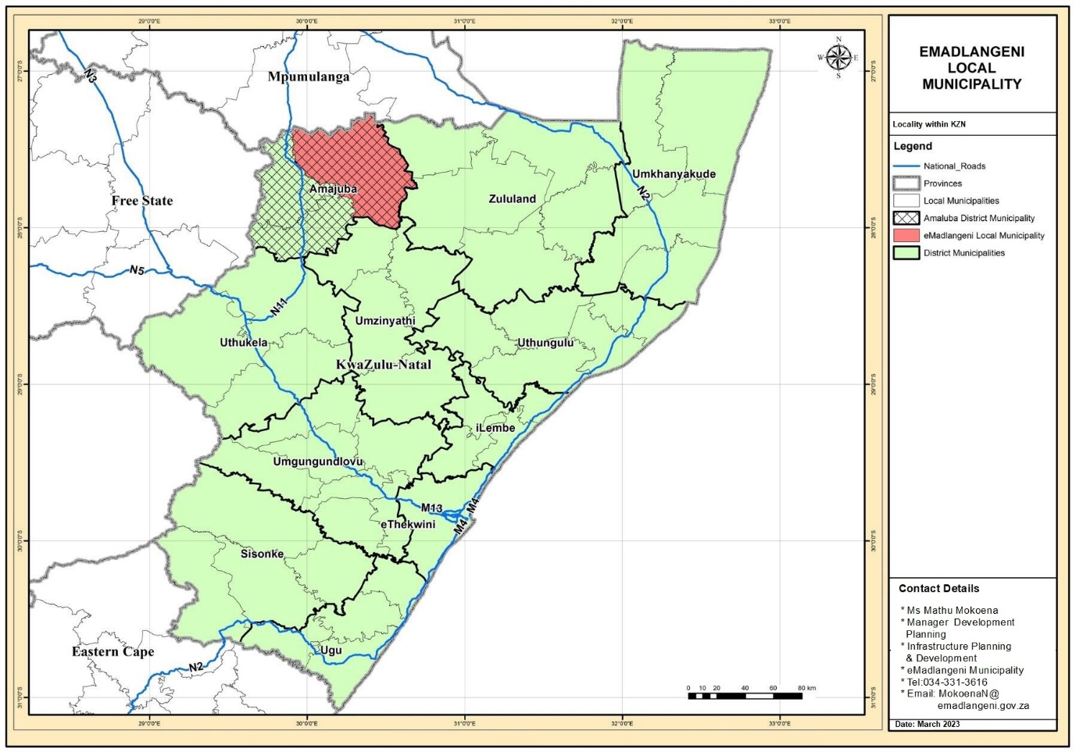

A.1 BACKGROUND
Located on the R34 regional highway, the eMadlangeni Local Municipality(ELM) is situated roughly 52 kilometers east of Newcastle and 68 kilometers west of Vryheid. It is one of three local municipalities that make up the Amajuba District. on. Dannhauser Local Municipality and Newcastle Local Municipality complete up the group of municipalities. About 3 539 km2 make up this Municipality. The ELM shares boundaries with the Newcastle Local Municipality to the west, Dannhauser Local Municipality to the east, Endumeni Municipality to the south, Edumbe Municipality the northeast, Abaqulusi to the southeast boundary and Pixely Ka Seme Municipality to the north. The latter forms part of the Mpumalanga Province.
The ELM has the smallest population size within the district as it accounts for only 6% of the district population. The ELM population is spread unevenly among the six electoral wards with 10% residing in in urban areas. The majority of the population resides in rural settlements and in commercial farmlands. According to Statistics South Africa (Stats SA), the eMadlangeni Local Municipality (ELM) had a population of approximately 34 442 people in 2011. Currently there are approximately 36,948 people residing in ELM, according to the 2022 Stats SA community survey. Compared to 2011, this is a 7.3% increase. The number of households rose from 6 667 to 7 998 in the same time frame.
The town of Utrecht lies within the confines of the Balele Game Park and the Utrecht Community Game Farm, with a total Game Park area of 2500 ha. All the mountains that surround the town are part of the Game Park stocked with animals such as Grey Duiker, Genet and the odd Impala. This is joint initiative between the Municipality and the Balele Conservancy. It has brought about a greater awareness of the magnificent natural surroundings of the town and has shifted the focus of the town from mining to tourism. The Utrecht Community Game Farm is the core of tourism development in the area. Tourism opportunities in the ELM also include trout fishing, hiking, birding tours, birding tours and adventure tourism.
The developed area of town is 100% serviced but large backlogs exist in the rural and land reform areas. The larger, more important services, such as provision of water, sanitation are the responsibility of the Amajuba District while electricity is the responsibility of ESKOM. The ELM is predominantly rural and is characterised by vast commercial farmlands with rural settlements concentrated in selected areas. It has six electoral wards and five Traditional Councils, namely: Ndlamlenze Traditional Council, Thekwani Traditional Council, Amantungwa Traditional Council, Mbatha Traditional Council and Mgundeni Traditional Council.
The municipality's greatest need is economic growth. Diversification of the local economy requires immediate attention. Limited mining occurs while sectors making a notable contribution to the economy of the area include trade, finance and government services. Agriculture is the most important economic sector with excellent potential. Amajuba District is one of the agricultural, particularly commercial stock farming region, in KwaZulu-Natal. Dry land crop production occurs on a small scale, and just 1 000ha is under irrigation. Various small-scale (emerging) farmers, of whom very few have land of their own, are scattered throughout the district. About 300 households have claimed land through the Labour Tenant Act. The economic development opportunities identified for the eMadlangeni Local Municipality are; Organic farming, Timber and forestry, Game farming and Livestock and dairy farming.

A.1.1. MUNICIPAL DEVELOPMENT STRATEGY AND LONG TERM VISION

The Vision
By 2036 eMadlangeni Municipality will be a self-sustaining exemplary local municipality with a diverse thriving economy where all citizens enjoy a high quality of life within a sustainable and resilient environment.

The Mission
In pursuit of its development, eMadlangeni municipality pleadges to its communities and stakeholders to:
- Be the embodiment of good governance;
- Deliver services in an efficient and effective manner;
- Promote and facilitate sustainable socio-economic development;
- To create mutual trust and understanding between the municipality and the community.
- Promote tourism, agriculture and mining, and facilitate the development of urban hubs in support of these economic sectors and delivery of services.
- To apply good and transparent corporate governance in order to promote community prosperity.

A1.2 KEY CHALLENGES

TABLE 1: KEY CHALLENGES
KPA | KEY CHALLENGES
Basic Service Delivery and Infrastructure Development | - Road infrastructure is poorly maintained  - Backlogs in water infrastructure  - Backlogs in sanitation infrastructure  - The area still has huge backlogs in electricity, especially in the rural areas.  - Housing (RDP & rural housing)  - Land Issues  - Disaster Management  - Waste Removal  - Educational Facilities  - Telecommunications  - Health Services  - Access to community services (Thusong Centres)
Local Economic and Social Development (Service Delivery) | - Inadequate use of Arts & Culture Centre (Mangosuthu)  - Poor management of Council facilities/loss of income  - Staff complement  - High unemployment  - Aging infrastructure (Roads, Game Park facilities)  - Inefficient procedures for EPWP grant application  - Marketing and promotion of tourism  - Pound management  - Implementation of SLPs  - Protection of Heritage sites: Isihlahla sikaShaka
Good Governance and Public Participation (Putting People First) | - Overtime and Stand-by costs (institution-wide)  - Operational hiccups resulting from financial constraints and thus staff shortage.  - Power Supply back-up  - Overstretched span of control  - High vacancy rate  - Unsatisfactory Leave Management  - Lack of Time-keeping  - Security for buildings, contents and occupants  - Insufficient Maintenance budget, resulting in deterioration of Municipal Buildings.  - Wasted resources in issuing Traffic Fines  - No law enforcement being carried out  - Outdated electronic Infrastructure (Computers and Telephones)  - Inadequate background check/screening and qualifications verification  - Inadequate Funding for Skills Development Programmes  - Lack of records infrastructure in all facilities (Strong rooms, Steel cabinets and burglar guards)  - Review of Employment Equity Plan  - Shortage of space for hardcopies of applications (Internship and Learnerships)  - Shortage of Office Space
Municipal Transformation and Institutional Development | - Overtime and Stand-by costs (institution-wide)  - Operational hiccups resulting from financial constraints and thus staff shortage.  - Power Supply back-up  - Overstretched span of control  - High vacancy rate  - Unsatisfactory Leave Management  - Lack of Time-keeping  - Security for buildings, contents and occupants  - Insufficient Maintenance budget, resulting in deterioration of Municipal Buildings.  - Wasted resources in issuing Traffic Fines  - No law enforcement being carried out  - Outdated electronic Infrastructure (Computers and Telephones)  - Inadequate background check/screening and qualifications verification  - Inadequate Funding for Skills Development Programmes  - Lack of records infrastructure in all facilities (Strong rooms, Steel cabinets and burglar guards)  - Employment Equity Plan  - Shortage of space for hardcopies of applications (Internship and Learnerships)  - Shortage of Office Space
Municipal Financial Viability and Management (Sound Financial Management) | - Low revenue  - High dependency on government grants  - Loss of revenue resulting from unpaid tariffs  - Grading vs remuneration not proportional  - Electricity loss due to theft  - Revenue enhancement
Cross cutting measures | - Dissemination of early warnings to relevant communities  - Limited resources:  - No PPE;  - No uniform;  - Limited fire equipment;  - No relief material  - Enforcement of municipal by-laws  - Integrated information management & communication systems (Call-Centre number)  - Fire hydrants not serviced  - Lack of employment opportunities  - Low population  - Failure to attract investors  - Closure landfill site

A.1.3 KEY CHALLENGES AND INTERVENTIONS

TABLE 2: KEY CHALLENGES AND INTERVENTIONS
KPA | KEY CHALLENGES | INTERVENTIONS
Basic Service Delivery | - Road infrastructure is poorly maintained;  - Backlogs in water infrastructure  - Backlogs in sanitation infrastructure  - The area still has huge backlogs in electricity, especially in the rural areas. | - Bulk water pipeline  - Development of a Waste Management Plan  - Infrastructure upgrading  - Solar energy to meet electrification target
Local Economic Development and Social Development Analysis | - Declining agricultural sector  - Weak mining sector  - Growing tourism sector  - Lower percentage of the population with higher education qualification against a higher percentage with a grade 12 qualification  - Low employment levels  - High percentage of economically inactive population  - Low incomes  - Considerable percentage of income earners fall within the income bracket that includes government grant recipients.  - Educational facilities require upgrading  - Tourism strategy: i.e. game park & birding  - Mining Industry- revival and Regulation  - High percentage of economically inactive population  - Low incomes  - Considerable percentage of income earners fall within the income bracket that includes government grant recipients.  - Educational facilities require upgrading  - Implementation of a Youth programme  - Existing co-operatives are not captured on municipality’s database  - Challenges in monitoring co-operatives.  - Electricity loss due to theft | - Agri-village development to enhance agricultural output  - Infrastructure provision to support and drive agriculture in rural areas.  - Development of the tourism sector  - Revitalisation of the mining sector  - Skills development to allow the absorption of economically active segment of the population  - Development of early childhood educational facilities to support the large young population;  - there is an opportunity to create employment with the revival of the agricultural sector;  - Youth impact on participating in the municipal  - Development of the tourism sector to facilitate the advancement of the second economy into the first economy  - Employing alternative energy source to meet electricity targets.  - Pilot project for Agri-village in Groenvlei
Good Governance and Public Participation | - Lack of a Community Participation Strategy  - Difficulty in reaching all community members due to the scattered nature of settlements | - Fast-tracking recruitment processes for the filling vacant positions, including critical posts, with suitably qualified candidates  - Development of a marketing Strategy  - Development of a Communication Plan
Municipal Institutional Development and Transformation | - Review of Housing Plan  - Adoption and implementation of sector plans and by-laws  - Capacity issues resulting from vacant position  - Skills Development and Training  - IT systems  - Employment Equity (2% disability composition)  - Contingency Liabilities (legal)  - Adoption of By-laws | - Constant development of staff through training and workshop in order to increase capacity and efficiency.  - Meeting the 2% Employment Equity for disability  - Adoption of Communication Plan  - Training programmes for different municipal structure to equip them with the right skills to undertake respective tasks and responsibility in an efficient manner.  - Review Housing Plan
Financial Viability and Management | - Low revenue  - High dependency on government grants  - Loss of revenue resulting from unpaid tariffs  - Grading vs remuneration not proportional  - Revenue enhancement | - Enforcement of revenue enhancement strategies.  - Development of a comprehensive Financial Plan to incorporate Enhancement Strategy and ensure that revenue supports others municipal need  - Stringent Enforcement of Property Rates policy
Cross cutting measures | - Disaster management; veld fires and lightning  - Relationship between municipality, Traditional Councils and Community Property Associations.  - Protection of Sensitive Areas, i.e. Springs and Animal species  - Enhancement of Birding  - Protection of Heritage sites | - Development of a 24-hour Disaster Management Centre.  - Incorporate Disaster Management in to ward committees.  - Mainstreaming DM in community structures including traditional leaders.  - Development and upgrading of tourism attractions and facilities.  - Revamping of Balele Game Park and Caravan Park  - Development of tourism supply database

A.1.4 PURPOSE

Integrated Development Planning in South Africa is an integral planning process with the aim of steering development at local government level and guiding service delivery. The Integrated Development Plan is a planning tool used to implement a co-operative and integrated development project in South Africa’s spatial economy. This IDP process is a covenant between the community structures and the municipality on issues pertaining to the delivery of government services, integrated development and building cohesive communities.
This document presents an Integrated Development Plan (IDP) for the eMadlangeni Local Municipality (KZ253) hereafter referred to as the ELM. The IDP is prepared in compliance with the requirements of Chapter 5, particularly Section 25 of Local Government Municipal Systems Act (32 of 2000), which obliges a municipal council to adopt a single, all-inclusive and strategic plan for the development of the municipality, within a prescribed period after the start of its elected term. It outlines a development agenda for the municipality for the period of 2023 to 2027.
The eMadlangeni Local Municipality IDP informs the budget and responds to community aspirations and needs. It sets the level of economic growth for the municipality’s area of jurisdiction thereby identifying economic opportunities and areas of investments. The IDP is a five-year development plan. Its review happens annually to take into account changes in the development trends and patterns within the municipality.

A.1.5 OBJECTIVES OF THE INTERGRATED DEVELOPMENT PLAN

The eMadlangeni Local Municipality IDP adopted a long term planning horizon, but also presents a short to medium term strategic agenda and a detailed five year programme commencing in 2022/2023 financial year and ending in 2026/2027 financial year. This period coincides with the term of office of the incumbent council and aligns with the budget cycle. The IDP is prepared in accordance with the requirements of the Municipal Systems Act and the associated regulations (refer to Box 1), and is intended to serve as a strategic guide for public sector investment and development generally. It is based on the issues articulated by all stakeholders and is informed by the national and provincial development imperatives. Its objectives are as follows:
Box 1: Section 25 (1) of the Municipal Systems Act (2000)
Each municipal council must, within a prescribed period after the start of its elected term, adopt a single, all-inclusive and strategic plan for the development of the municipality which-
- Links integrates and coordinates plans and takes into account proposals for the development of the municipality;
- Aligns the resources and capacity of the municipality with the implementation of the plan;
- Complies with the provisions of this Chapter; and
- Is compatible with national and provincial development plans and planning requirements binding on the municipality in terms of legislation.
- To guide decision making in respect of service delivery and public sector investment.
- To inform budgets and service delivery programs of various government departments and service agencies.
- To coordinate the activities of various service delivery agencies within the eMadlangeni Local Municipality’s area of jurisdiction.
- To engage communities and other key interested and affected parties in municipal affairs, particularly continuous integrated development process.
- To position the municipality to make a meaningful contribution towards meeting the district and provincial development targets and priorities.

A.1.6 SCOPE OF THE EMADLANGENI IDP

In line with Section 26 of the Municipal Systems Act, which prescribes the key components of an IDP, and the focus on development outcomes, the eMadlangeni Local Municipality IDP has five main sections as follows:
1. An introductory section provides background to the municipality and its area of jurisdiction (Executive Summary).
2. An outline of the key development issues and trends based on an analysis of the current level of development (Situational Analysis).
3. A strategic framework, which outlines a Council long-term vision with specific emphasis on the municipality’s most critical development objectives, actions plan and strategies.
4. A capital program including a one-year program, three-year program aligned to the Medium Term Expenditure Framework and the Five (5) Year Plan.
5. Implementation framework, which includes sector plans particularly the financial plan, spatial development framework, organizational performance management system and an organizational transformation and institutional development plan.
The IDP will inform the Medium Term Expenditure Framework (MTEF), and guide the annual budget process. Chapter 4 Section 21 (1) of the Municipal Finance Management Act (MFMA) requires a municipality to align and sustain a close functional link between its IDP and the budget.

A.1.7 APPROACH

The preparation of this IDP is in accordance with the guidelines (Revised KZN IDP Framework Guide dated 23 December 2016) for the preparation of IDPs that the Department of Co-Operative Governance and Traditional Affairs (COGTA) introduced in 2013. The guidelines advocate for a process that is integrative, sustainable, issue driven, people centered, practical and action oriented.

A.1.8 MECHANISMS FOR PUBLIC PARTICIPATION

The IDP preparation process involved extensive stakeholder and public participation as required in terms of Chapter 4 of Local Government: Municipal System Act No. 32 of 2000. This Act stipulates that the IDPs should work as a developmental tool within the district, local municipalities and all other stakeholders. Therefore, all municipalities have a constitutional mandate to encourage the involvement of community participation organizations in the matters of local government. Communication at municipal level will happen through a highly structured and strategic process.
The needs assessment at local level participation will feed into the process through local municipality participation. Other role-players in community participation include Steering Committee, MANCO, IDP Representative Forum etc. Individual and community input will also be requested through the local media, municipal website [print/electronic]. Other communication structures are;
• Mayoral outreach programme / Izimbizo
• Ward Committees
• CDW’s / NGO’s
• Media

A.1.9 BUDGET PROCESS PLAN FOR 2023/2024 MULTI-TERM BUDGET

The Revised KZN IDP Framework Guide dated 23 December 2016, that the Department of Co-Operative Governance and Traditional Affairs (COGTA) introduced in 2016, guided the development of the IDP for the 2024/25 financial year.
The Municipal Systems Act as promulgated in 2000 describes the various core processes that are essential to realizing the system of developmental local government. These aspects include participative governance, IDP, performance management and reporting, resource allocation and organizational change. These processes link into a single cycle at the local level that will align various sectoral initiatives from national and provincial government departments
The table below provides the detailed framework plan for IDP, Budget and OPMS Action Plan for eMadlangeni Local Municipality 2024/25 IDP Annual review. The action plan is broken up into the 4 quarters of the municipal financial year with activities reflecting IDP, PMS and Budget.
TABLE 3: Framework Plan for IDP, Budget and OPMS Action Plan
Date | IDP | PMS | BTO
JULY 2023 | 1. Lodge advert to register on IDP Forum Database  2. Publication and advertisement of the availability for comments of the Draft 2024/25 Process Plan for at least 14days.  3. Ensuring alignment of the Section 54 & 56 Managers individual Scorecards with the IDP strategies | 1. Signing of new performance contracts for Section 54&56 Managers and submission to EXCO (Section 69 of the MFMA and Section 54&56 of the MSA).  2. Prepare Departmental Business Plans SDBIP (Component 3) for the next financial year. 3. Previous year S54&56 Managers’ Performance Assessments | 1. IDP and Finance to discuss the 2024/2025 Budget planning issues  2. Prepare budget process plan and timetable for the 2024/2025.  3. Compile Section 71 Reports and present to the Mayor.  4. Compile section 52 Report.
AUGUST 2023 | 1. Adoption of the Final Process Plan by end of August 2023  2. Publication/notification to the public of the adoption of the Final 2024/25 Process Plan  2. Manager IDP/PMS to submit the Final IDP, PMS and Budget Process Plan to COGTA.  3. Receive MEC comments on previous year’s IDP COGTA submission.  4. End of August 2021 IDP Project Steering Meeting (Extended MANCO) | 1. Quarterly Project Implementation Report  2. Quarterly Audit Committee meeting  3. Performance evaluation panel  4. Start the process of the Drafting Annual Report 2022/2023 | 1. Obtain Council’s approval for 2024/2025 Multi-year budget process and timetable (IDP Process Plan)  2. Review external mechanisms affecting the medium term budget forecasts.  3.Compile Section 71 Reports and present to the Mayor
SEPTEMBER 2023 | 1. Formalise Council’s Vision, Mission, Objectives and Strategies  2. Consultation with and alignment with Sector Departments. 3. Create template in relation to the scorecard (*Situational Analysis*)  4. Feedback to Steering Committee regarding MEC’s assessment  5. Review and updating of Departmental Sector Plans  6. Ward Councillors and Ward committees to submit community needs for budget consideration |  | 1. Assess Council’s 2022/2023 Financial Statements and current year’s revised results and capacity, to determine the impact on future strategies and budgets  2. Assess the funding policies including the tariff structures.  3. Compile Section 71 Reports and present to the Mayor.
OCTOBER 2023 | 1. Integration of information from adopted Sector Plans into the IDP Review  2. Review mission, vision and objectives 3. Cross border municipal alignment and Formulate Strategies  4. Feedback from Senior Managers on Priorities - Projects – as well as Budget inclusions  5. Regional alignment (District Municipality) |  | 1. Complete first Quarter Section 52 Financial Performance Evaluation Report.  2. Discuss Findings and obtain input from management, BSC and Council.  3. Compile Section 71 Reports and present to the Mayor.
NOVEMBER 2023 | 1. 22 November 2023 - IDP Steering Committee - Reviewing of strategies/IDP RF  2. November 2023 - Sector Alignment Workshop – COGTA | 1. Quarterly Project Implementation Report (for first quarter)  2. Quarterly Audit Committee meeting (for the first quarter) | 1. Compile Section 71 Reports and present to the Mayor.
DECEMBER 2023 | 1. Review KPI’s and targets  2. IDP Best Practise Conference with COGTA  3. Amajuba District Municipality Planner’s Forum  4. Review of Strategies  5. Alignment of Capital estimates to the IDP | 1. Compile annual report (MFMA Sect 121) | 1. Compile Section 71 Reports and present to Mayor.  2. Commence processes for Section 72 and adjustment budge
JANUARY 2024 | 1. Steering Committee in the month of January 2024  2. Send reminders 22-24 January 2024 requesting projects (with proposed budgets)  3. IDP Review integration phase  4. Projects/Send template by the end of January 2024 | 1. Mayor tables annual report MFM Sect 127 (2)  2. Make public annual report and invite community inputs into report (MFMA Sect 127 & MSA Sect 12a)  3. Sect 54&56 Managers’ quarterly assessments (for second quarter) 4. Tabling of Midterm Report to Council by the 25th of January. | 1. Submit the mid-year budget and performance assessment report to Council. Submit to National Treasury and Provincial Treasury both printed and electronic form the mid-year budget and performance assessment (Section 35).  2. Compile Section 71 Reports and present to Mayor.
FEBRUARY 2024 | 1. Consolidation of information and finalization of MEC Assessment issues  2. Meeting with COGTA IDP submission and assessment  3. Draft IDP & Budget – Prioritization and Budget Allocation  4. Conclusion of Sector Plans initiated and integration into the IDP Review report  5. Finalise outstanding MEC assessment issues | 1. Quarterly Project Implementation Report (for second quarter implementation)  2 Quarterly performance audit committee meeting 3. Oversight process for the annual report and public participation.  4. Submit annual report to AG, Provincial & DTLGA (MFMA Sect 127).  5. Adjustment of the Organizational Scorecard targets tabled to Council with Adjustment budget. | 1. Compile Section 71 Reports and present to Mayor.  2. Adjustment budget to be considered if necessary  3. Make public the adjustment budget and supporting documentation within 10 working days after being approved by Council (Section 126).  4. Draft IDP & Budget – Prioritization and Budget Allocation  5. Review of the Mid-year visit Report by National Treasury and implementation of any recommendations. 6. Compile Section 71 Reports and present to Mayor.
MARCH 2024 | 1. 21 IDP Representative Forum on/by mid-March 2024  2. 18-29 March 2024 Adoption of Draft IDP 2024/25 financial year.  3. Submit 2024/25 Draft Multi-year budget, IDP and Service Delivery and Budget implementation plan in both printed and electronic format forwarded to Provincial COGTA, within 10 working days after being approved by Council. | 1. Council to consider and adopt an oversight report [Due by 29 March 2024 MFMA Sec 129 (1)]  2. Set performance objectives for revenue for each budget vote (MFMA Sect 17) 3. Annual Customer Satisfaction survey (to be considered to annual report) MSA Sect 40.  4. Submit 2024/2025 Service Delivery and Budget Implementation Plans submitted to Executive Committee and Council for approval  5. Submit 2024/2025 Draft Multi-year and Service Delivery and Budget implementation plan in both printed and electronic format forwarded to National and Provincial Governments, including National Treasury within 10 working days after being approved by Council.  6. Final approval and adoption of the 2022/23 APR by Council by end of March. | 1. Submit 2024/2025 Draft Multi-year budget and IDP submitted to BSC and Council for consideration.  2. Submit 2024/2025 Draft Multi-year budget in both printed and electronic format forwarded to National and Provincial Governments, including National Treasury within 10 working days after being approved by Council.  3. All Income inputs by no later than 25th February. All Expenditure and Capital inputs by no later than 3rd March inputs to the Budget Office.  4. Make public the tabled draft budget and supporting documentation within 10 working days after being approved by Council.  5. Compile Section 71 Reports and present to Mayor.
APRIL 2024 | 1. Notice to publicize the draft IDP (21 days)  2. Incorporate comments –adjust the IDP & Budget where necessary  3. IDP Budget Roadshows.  4. Report back on the results of Assessment Feedback  5. Ward committee meeting highlighting involvement of members in the IDP and Budget Public Participation process  6. Possibly undertake a 2- week community consultation process of the budget.  7. Adjustment of Draft IDP from 15th of April 2024. | 1. Strategies, objectives, KPA’s, KPI’s and targets and inclusion into IDP Review Report.  2. Section 54&56 Managers’ Quarterly Performance Assessments  3. Publicise Annual Report [Due by 7 April MFMA Sec 129 (3)]  4. Submit Annual Report to Provincial Legislature/MEC Local Government (Due by 7 April MFMA Sec 132 (2) | 1. Revision of the budget and IDP from inputs received from the community, Government departments and National Treasury, if required  2. Compile Section 71 Reports and present to Mayor.  3. All consultation processes to be completed during April 2024.  4. All departmental feedback by no later than the end of April 2024.
MAY 2024 | 1. Adjustment of Draft IDP from the 1st – 15th May 2024  2. On/By 31st of May 2024 Final 2024/25 IDP Adoption | 1. Implementation Report (for third quarter)  2. Quarterly Audit Committee meeting  3. Annual review of organizational KPIs 4. Review annual organizational performance targets (MPPR Reg | 1. Compile Section 71 Reports and present to Mayor.  2. Final Alignment sessions between IDP, PMS and Budget.  3. All final inputs and balancing of the budget and presentation to BSC by 6th May 2024.  4. Between the 6th and 20th May 2024 loading of budget and generating of mSCOA report and other Council required documentation.  5. Presentation of final Budget for adoption to Council.
JUNE 2024 | . Submit to MEC on or before 10 days after adoption.  2. Prepare Draft IDP Process Plan for the 2025/26 Financial Year.  3. Publish Council’s adopted FINAL IDP 2024/25 on the Municipal website and local Newspapers. | 1. Submission of draft SDBIP to the mayor within 14 days of approval of the budget  2. Establish and complete performance evaluations for functional outcomes based on operational plans and the IDP  3. Approval of the SDBIP within 28 days after approval of the budget and completion of the annual performance contracts in accordance with S54/56 of MSA  4. Make public the SDBIP within 10 working days after being approved by Council  5. The Service Delivery and budget implementation plan in both printed and electronic format to be forwarded to national Treasury within 10 working days after being approved by Mayor. | 1. Compile Section 71 Reports and present to Mayor.  2. Approved 2024/2025 Multi-year budget in both printed and electronic format forwarded to National Treasury within 10 working days after being approved by council  3. Make public the approved budget and supporting documentation within 10 working days after being approved by Council.  4. Publish Council’s budget on the website and local Newspapers.

A.10 SECTOR DEPARTMENT INVOLVEMENT

In general, sector planning is very weak within the South African Local Government system. Participation of government departments in the IDP process is very poor. Departments continue to identify and implement projects outside of the IDP framework. This makes it difficult to align their budgets and integrate development initiatives. Current legislation does not compel sector departments to align their budgets and allocate resources (project funds and human resources) through the IDP process.
As such, the eMadlangeni Local Municipality has engaged sector departments on a one-on-one basis in order to deal with specific issues affecting the municipality and to collect information pertaining to projects that departments implement with the ELM.

A.11 ALIGNMENT WITH THE DISTRICT FAMILY OF MUNICIPALITIES

The municipality participated in various meetings with the district family of municipalities to align the IDPs and also convene Strategic Planning Session which serves as a vehicle for the development of 2023.2024 to 2026.2027 IDP. The following is an indication of some of the key alignment issues addressed to date. The IDPs of the Amajuba family are focusing on the outcome based IDP approach thereby incorporating the Key Performance Areas developed by national government.

A.12 SPATIAL DEVELOPMENT FRAMEWORK (SDF)

The municipal agenda for a spatial vision is outlined in the Spatial Development Framework (SDF). The SDF is a spatial expression of the municipal development vision and advocates for the creation of a spatial structure that enables integrated and sustainable development. A hierarchy of development nodes were identified within the municipality, eMadlangeni Local Municipality compiled and tabled before Council its final SDF in May 2023, SDF document and Council Resolution are attached as ANNEXURE A.
• Regional centre: The Newcastle-Madadeni-Osizweni Complex provides for higher order services. The centre comprises of a large population, further to that, the areas economic significance and accessibility makes it a District centre. In addition to the above, the area accommodates a large number of government departments and parastatals, which serves to strengthen the administrative role it plays within the District.
• Primary Development Node: Utrecht- is the main economic and administrative hub within the municipality. The area accommodates a greater variety and more permanent higher order of a multitude of services.
• Secondary Development Nodes: Groenvlei, Vaalbank/Berouw and Kingsley- these nodes provide supporting services to surrounding settlements. They are equipped with essential service infrastructure but not at the same intensity as the primary node.
• Tertiary/sub-satellite Nodes: Reserve, Zaaihoek and Nzima- these are lower order nodes that support secondary development nodes. Although they may not have strong influence and minor development, their location in close proximity to development corridors give them the potential to develop into service nodes.
The N11 national corridor plays a significant role within the Amajuba District. It facilitates external linkages for the eMadlangeni Local municipality with the industrial areas of Newcastle as well north (Johannesburg) and south linkages (Durban). The routes facilitate a mobility function with access at key intersections and/or off-ramps along the route. The identification and classification of movement routes in eMadlangeni reflects function or role, and intensity of use or development along the route/corridor and include;
• National/Provincial Corridor: N11 traverses a small portion of the municipality on the extreme western boundary.
• Primary Corridors: R34 (P37 & P 41) runs in an east-west direction connecting the municipality to Newcastle via the N11 and Vryheid and the coast to the east.
• Secondary Corridors: R33- links the municipality to Dundee and Vryheid and provides access to Kingsely; P43- connects Utrecht to Groenvlei; P42- connects northern settlements to Utrecht via the R34.
• Secondary Mixed Activity Corridor: P483-links Utrecht and broadly the municipality to Osizweni, Madadeni and Newcastle west.
• Tertiary Corridors: P279, P269, P332- provide east-west linkages in the municipality and also links the secondary of Groenvlei with sub-satellite node of Blue Mountain and Ingogo rural node in Newcastle.

SECTION B: GOVERNMENT POLICIES AND PLANNING & DEVELOPMENT PRINCIPLES

B.1 PLANNING AND DEVELOPMENT PRINCIPLES

The following table provides a summary of planning and development principles that underpin the IDP.
Table 4: Planning and Development Principles
PLANNING AND DEVELOPMENT PRINCIPLES | DESCRIPTION | APPLICATION OF PRINCIPLES
Spatial Justice (SPLUMA) | Seeks to redress the spatial imbalances of the past through improving access to land and ensuring efficient use of land. | The IDP advocates for development to be focused on identified development nodes and corridors.  The capital investment plan directs where public and private investment should occur.
Spatial Justice (SPLUMA) |  | The IDP identifies various nodes- urban/rural with development potential.
Spatial Sustainability (SPLUMA) | Requires the sustainable use and management of natural resources to ensure the protection of prime land and natural resources. | The IDP identifies environmentally sensitive areas and significant areas for agricultural development that should be protected and preserved for agricultural practices.
Spatial Efficiency (SPLUMA) | Advocates for the effective use of resources such as land and the optimal use of infrastructure | The IDP identifies prime land for preservation and development and where infrastructure should be directed.
Good Governance (SPLUMA) | Suggests the adoption of a transparent and collaborative approach to development and accountability of local government to decisions within their jurisdiction. Furthermore, it requires a public participatory element to development planning within local government. | The IDP identifies cross-boundary alignment with neighbouring municipalities. It also identifies structures at ward level that facilitate participatory planning within the municipality.
Good Governance (SPLUMA) |  | LED Strategy: integrative approach that includes all local role-players as well as all internal structure.
Spatial Resilience (SPLUMA) | Flexibility in spatial plans and land use management systems to ensure that settlements can recover from environmental and economic shocks. | The IDP discusses Disaster management within the municipality including, risk reduction and prevention.

B.1.2. POLICY CONTEXT
National policies and imperatives provide a framework within which development should take place. This section analyses the global, national, provincial and local policy and legislative framework that guide development. EMadlangeni Local Municipality acknowledges these and strives towards their effective implementation.

B.1.2.1 GLOBAL POLICY CONTEXT

B.1.2.1.1 Sustainable Development Goals
The Sustainable Development Goals (SDGs) were adopted in 2015 and focus on 17 goals. They build on the successes of the Millennium Development Goals (MDGs). Critically, they recognise that poverty eradication must be accompanied by strategies aimed at economic growth, addressing social needs and the tackling of climate change and environmental protection in the process. South Africa, as a country and member of the United Nations, is committed to the 2030 Agenda for Sustainable Development. The seventeen SDG’s are embraced in all spheres of government and are in line with the NDP.
EMadlangeni Local Municipality strives for the development of the municipal area in a way that will address the advancement of these goals.

B.1.2.1.2 Agenda 2063
The African Union adopted its 50-year strategic framework for socio-economic transformation within the African continent in 2015, Agenda 2063. Agenda 2063 is both a Vision and an Action Plan towards holistic development on the African continent. Furthermore, it builds on past and present growth initiatives and seeks to accelerate the implementation of these. The framework identifies seven aspirations for growth and development within the African continent across all sectors: social, economic, political and environmental. South Africa is also dedicated to the realisation of these aspirations and has aligned these with national priorities. Some of the key priorities of Agenda 2063 are echoed in the Key Performance Areas within the IDP and overall they are echoed in the strategies and priorities of the NDP.

B.1.3. NATIONAL POLICIES AND PRIORITIES

B.1.3.1.1 Constitution of the Republic of South Africa Act, No.108 of 1996
The Constitution is the supreme law of the Republic. The Constitution recognises three spheres of government, which are interdependent and must ensure vertical and horizontal alignment. Section 152 of the Constitution lists the 5 objects of local government as follows:
- To provide democratic and accountable government for local communities;
- To ensure the provision of services to communities in a sustainable manner;
- To promote social and economic development;
- To promote a safe and healthy environment;
- To encourage the involvement of communities and community organisations in the matters of local government.
Furthermore, Section 156 of the Constitution assigns powers and functions to municipalities as stipulated in Schedule 4, Part B of the Constitution. The development of an IDP is in fulfilment of the municipality’s constitutional mandate to spatial planning.

B.1.3.1.2 National Development Plan
The National Development Plan (NDP) introduces the long-term vision for the future development of South Africa. As such, the National Planning Commission (NPC) has formulated a National Development Plan (NDP), ‘vision 2030’ as a strategic plan to guide development at a national level over the short to medium term. The plan is based on a detailed diagnosis of issues facing the country and strategic engagement with all key sectors. It identifies unemployment, poverty and inequality as some of the key challenges facing South Africa, and outlines a number of strategic interventions to address these issues. These strategic interventions cover the social, economic, environmental and political spectrum of development. The 5 national priorities include Job creation (Decent work and economic growth); Education; Health; Rural development, food security and land reform; Fighting crime and corruption; Nation-Building and Good Governance. EMadlangeni strives to attain these priorities within a local context and further execute the critical role played by local government in the effective implementation of the NDP.

B.1.3.1.3 The 14 National Outcomes
Government introduced the outcomes based approached and adopted fourteen outcome areas. The objective is to improve service delivery across all spheres of government and to introduce a systematic planning, monitoring and evaluation process.
Outcome 9 specifically relates to local government and calls for ‘Responsive, accountable, effective and efficient local government system’. EMadlangeni has to respond to the outputs set out in Outcome 9 and deal with issues facing the municipal area. The municipality also has to ensure the provision of efficient and effective services to its communities. The municipality is committed to implementing the respective outputs by focusing on improved service delivery, economic, environmental and social development.
The seven outputs of outcome 9, are indicated below:
- Output 1: Implement a differentiated approach to municipal financing, planning and support.
- Output 2: Improving access to basic services.
- Output 3: Implementation of the Community Work Programme.
- Output 4: Actions supportive of the human settlement outcome.
- Output 5: Deepen democracy through a refined Ward Committee Model.
- Output 6: Administrative and financial capability.
- Output 7: Single window of coordination.
BOX 2: 14 NATIONAL OUTCOMES

- An improved quality of basic education.
- A long and healthy life for all South Africans.
- All South Africans should be safe and feel safe.
- Decent employment through inclusive growth.
- A skilled and capable workforce to support an inclusive growth path.
- An efficient, competitive and responsive economic infrastructure network.
- Vibrant, equitable, sustainable rural communities with food security for all.
- Sustainable human settlements and an improved quality of household life.
- A responsive, accountable, effective and efficient local government system.
- Environmental assets and natural resources that are well protected and enhanced.
- A better Africa and a better world because of South Africa’s contributions to global relations.
- An efficient and development-oriented public service and an empowered, fair and inclusive citizenship.
- An inclusive and responsive social protection system.
- Transforming society and uniting the country.

OUTCOME 9:
‘a responsive, accountable, effective and efficient local government system’

B.1.3.1.4 Local Government Back to Basics
The Local Government Back to Basics programme was initiated by the National Department of Cooperative Governance and Traditional Affairs (COGTA) and is founded on the following pillars:
- Put people and their concerns first and ensure constant contact with communities through effective public participation platforms. This is the essence of our ‘back to basics’ approach.
- Create conditions for decent living by consistently delivering municipal services to the right quality and standard. This includes planning for and delivery of infrastructure and amenities, maintenance and upkeep, including the budgeting to do this. Ensure no failures in services and where there are, restore services with urgency.
- Be well governed and demonstrate good governance and administration - cut wastage, spend public funds prudently, hire competent staff, ensure transparency and accountability.
- Ensure sound financial management and accounting, and prudently manage resources to sustainably deliver services and bring development to communities.
- Build and maintain sound institutional and administrative capabilities, administered and managed by dedicated and skilled personnel at all levels.

B.1.3.1.5 Operation Clean Audit
Operation clean audit is a government initiative aiming at giving support to local municipalities to ensure clean audits, transparency and improved service delivery. The municipality identifies the need to have a clean audit as one of their strategic objectives. It is envisaged that this will be achieved through the creation of awareness in order to improve cooperation from all departments, as well as to ensure that the municipality achieves all the interventions in respect of Municipal Financial Viability & Management, as they will have a huge impact in the audit findings.

B.1.3.1.6 Local Government Management Improvement Model
The Local Government Management Improvement Model (LGMIM) is a management information tool for the management of municipalities to reflect upon their operational and management practices and focus on gaps that might exists in order to improve service delivery. The LGMIM focuses on the following:
- Integrated Planning and Implementation;
- Service delivery;
- Human Resource Management;
- Financial Management;
- Community Engagement; and
- Governance.

B.1.3.1.7 District Development Model (DDM)
It is a game changer model that aims to improve the coherence and impact of service delivery with focus on 44 Districts and 8 Metros around the country as development spaces that can be used as centres of service delivery and economic development including job creation. Under the DDM all three spheres of government coordinate and integrate development plans and budgets and mobilise the capacity and resources of government and civil society including business, labour and community in pursuit of inclusive growth and job creation (Cogta.gov.za).

B.1.3.1.8 National Government adopted a National Infrastructure Plan in 2012.
The intention of the plan is to transform the economic landscape of South Africa, while simultaneously creating significant numbers of new jobs, as well as to strengthen the delivery of basic services. The plan identified 18 Strategic Integrated Projects (SIP), which were adopted by Cabinet.
SIPs of specific importance for eMadlangeni include the following:
SIP 11 is crucial for predominantly rural municipalities and emphasise investment in agricultural and rural infrastructure. This allows for growth in production and employment from both small-scale farming and rural development.
SIP 18: Water and Sanitation Infrastructure. SIP 18 is a ten-year plan that seeks to address backlogs in water supply and basic sanitation to households. This will help serve social needs through efficient basic service delivery.

B.1.3.1.9 Medium Term Strategic Framework
The Medium-Term Strategic Framework is a strategic five-year implementation plan for the 2014-2019 electoral term. It sets out actions and targets for government within the five-year period. Furthermore, it aims to ensure policy coherence, alignment and coordination across government plans and alignment with budgeting processes. It forms part of the key implementation framework for the NDP and is structured around the 14 key outcomes of the NDP. Noteworthy, the framework has two overarching strategic themes; radical economic transformation and improving service delivery, which encapsulates its priorities and their translation into the fourteen key outcomes of the NDP. The framework calls for local government that is responsive, accountable, effective and efficient.

Table 5: IDP Alignment with national Policy and Priorities
NATIONAL POLICY AND PRIORITIES | IDP ALIGNMENT
Sustainable Development Goals | The municipality agri-village project and food are aimed at eliminating poverty  The ELM is also looking at alternative energy source to endure the provision of service infrastructure to areas in need.
Constitution of the Republic of South Africa Act, Act No. 108 of 1996 | The IDP addresses challenges within the municipality to ensure the fulfilment of rights enshrined in the constitution, i.e. housing, services, education, health etc.  eMadlangeni Local municipality holds itself to the fulfilment of the five objects of local government as ascribed by the constitution  The development of the municipality’s IDP is also in fulfilment of the powers and functions of municipalities as ascribed in section 156 and schedule B of the Constitution.
National Development Plan 2030 | eMadlangeni LM has developed an LED Strategy that identifies areas and programmes that will promote economic growth and development.
The 14 National Outcomes(Outcome 9) | The municipality has implemented a number of community programmes addresses the Outcome 9  The SDBIP indicates the projects to be undertaken by the municipality and all stakeholders to be involved in these as well as budget indication for these projects.
Local Government Back to Basics | The municipality has put in place interventional measures that address the basic services backlogs,  The ELM will develop a communication strategy that guides on how to engage and promote good governance & public participation.  The municipality has also identified certain areas to assist with improving its financial management and institutional capacity
National Infrastructure Plan | The municipality has identified priority areas in need of water and sanitation infrastructure.  The municipality has also identified alternative energy sources to meet service delivery targets in electricity supply

B.1.3.1.10 NATIONAL INFRASTRUCTURE PLAN
National Government adopted a National Infrastructure Plan in 2012. The intention of the plan is to transform the economic landscape of South Africa, while simultaneously creating significant numbers of new jobs, as well as to strengthen the delivery of basic services. The plan identified 18 Strategic Integrated Projects (SIP), which were adopted by Cabinet.
SIPs of specific importance for eMadlangeni include the following:
• SIP 11 is crucial for predominantly rural municipalities and emphasise investment in agricultural and rural infrastructure. This allows for growth in production and employment from both small-scale farming and rural development.
• SIP 18: Water and Sanitation Infrastructure. SIP 18 is a ten-year plan that seeks to address backlogs in water supply and basic sanitation to households. This will help serve social needs through efficient basic service delivery.

B.1.3.1.11 State of The Nation Address
On February 8, 2024, President Cyril Ramaphosa delivered his eighth State of the Nation Address (SoNA) to a joint sitting of Parliament.
The Story of Tintswalo
“Over the last three decades, we have been on a journey, striving together to achieve a new society - a national democratic society,” said President Ramaphosa, placing the speech in the context of South African history. He spoke of the last 30 years with an eye on the positive developments but did not waver from acknowledging what still needs to be done, and the stumbling blocks, both locally and internationally. “Just as we cannot deny the progress South Africans have made over the last 30 years, nor should we diminish the severe challenges that we continue to face.”
“Much of the task of this administration was to get our country through these great challenges and to work to regain our way,” said the President, after outlining the turbulent events of the past 5 years. “While each of these events has left its mark, our country has weathered every storm. Yes, we have the scars to show. But in every case South Africans have been resolute. We have not only persevered, but we have come back stronger and more determined.”
To describe the successes of the last 30 years, His Excellency used the analogy of “democracy’s child”, Tintswalo – which is a Xitsonga name that refers to the gratitude offered to one who has given you a gift. In this instance, the gift is the fruits of our democracy and the social impact it has had through the various services and opportunities provided to people in post-Apartheid South Africa.
Tintswalo’s life begins with the birth of our democracy, with a constitution recognised around the world for the wide nature of its inclusive and transformative philosophical foundations. Here the rule of law and the conception of human rights has opened up a society in which dignity and compassion are at the heart of the state’s mission. In the early years of the country’s democracy, free healthcare, housing, basic water and electricity, free education, social grants, employment equity and economic empowerment became the cornerstones of the government’s approach to fulfilling their mandate.
“This is the story of millions of people who have been born since the dawn of democracy. But it is only part of the story. For despite the remarkable achievements of the last 30 years, many of democracy’s children still face great challenges.”

Youth Unemployment:
- The youth vote poses a significant challenge for the ruling African National Congress (ANC) in the upcoming election.
- Over 3 million young South Africans (aged 15–24) are neither in education nor employment.
- President Ramaphosa announced the launch of the Presidential Employment Stimulus and other initiatives to create over 1.7 million work opportunities.
- Platforms like SAYouth.mobi were introduced to help young people access learning and earning opportunities.

National Health Insurance (NHI):
- While no specific timeline was provided, President Ramaphosa acknowledged the controversial NHI bill.
- The government plans to incrementally implement the NHI, focusing on health system financing, the health workforce, medical products, vaccines, and health information systems.

Infrastructure and Challenges:
- The SoNA was light on big announcements, reflecting a retrospective view of the ANC’s three decades in power.
- South Africa faces serious challenges, including crisis in ports, rail networks, and electricity supply, as well as high youth unemployment.
- President Ramaphosa’s speech emphasized achievements to date and existing plans to address these issues.

Combating Crime:
- President Ramaphosa unveiled bold strategies to combat crime and ensure citizens’ safety.
- Details of these strategies were not explicitly outlined in the speech, but they signal the government’s commitment to addressing security concerns.

In summary, President Ramaphosa’s SoNA 2024 highlighted both achievements and challenges, emphasizing the need for continued efforts to build a stronger, more inclusive South Africa.

B.1.4 PROVINCIAL POLICY CONTEXT AND PRIORITIES

B.4.1.1 Provincial Growth and Development Strategy
The Provincial Growth and Development Strategy (PGDS) presents a long-term vision and outlines a strategic growth and development agenda for the province. It provides the province with a strategic framework for accelerated and shared economic growth through catalytic and developmental interventions, within a coherent equitable spatial development architecture, putting people first, particularly the poor and vulnerable, and building sustainable communities, livelihoods and living environments (PGDS, 2016). The municipality’s role within the provincial development agenda of the PGDS is noted in the economic, environmental and social position it is located within the strategy.
Concomitant attention is also given to the provision of infrastructure and services, restoring the natural resources, public sector leadership, delivery and accountability, ensuring that these changes are responded to with resilience, innovation and adaptability.
Table 6: PGDS Goals
PGDS STRATEGIC GOALS | APPLICATION
Human Resource Development | The municipality is facilitating the development of an Amajuba FET College satellite branch and the development of crèches to promote early childhood development.
Inclusive Economic Growth | The municipality focuses on the implementation of the Extended Public Works Programme. There is also a focus on the implementation of the Community Work Programme, promotion of SMME’s and Cooperatives Infrastructure, investment and development and the promotion of mining activities.
Human and Community Development | The municipality aims to focus on the constructing and maintaining access roads, to encourage and facilitate participation in Operation Sukuma Sakhe and the implementation of EPWP and CWP.
Strategic Infrastructure | Capital budget to fund the development of tourism and agriculture as well as transport and service infrastructure.
Environmental Sustainability | Promoting solar powered energy and green building.
Governance and Policy | At a district level there is an IGR structure formed wherein the MM’s meet to discuss matters relating to the municipalities. Fraud & corruption strategy is in place. Transparency is being promoted through the public participation strategy/policy that is in place, and the community is engaged in processes undertaken by the municipality and the municipality plays the accountability role to the local community.
Spatial Equity | The municipality’s SDF and LUMS are in place to guide the allocation and utilisation of human and environmental resources towards sustainable growth and development, and they are being reviewed annually.

B.1.4.1.2 KZN PROVINCIAL GROWTH AND DEVELOPMENT PLAN (PGDP)
The PGDP is an implementation Framework for the province. The main purpose of this PGDP document is to enabling the province to measure its progress in achieving the accepted growth and development goals.

B.1.4.1.3 PROVINCIAL SPATIAL ECONOMIC DEVELOPMENT STRATEGY (PSEDS) (2016)
The KZN PSEDS is a framework for prioritization of spatial economic development initiatives in the province. The 2007 version of the strategy is currently under review to be updated to align with the changing policy environment in the country and with the trends and patterns that have characterized the province since then. This review has resulted in the identification of new nodes and corridors for prioritization. These include the identification of the R34 as part of the economies of scale corridor as a result of its diverse services to international, national and provincial clients (link to Richards Bay Port).

B.1.4.1.4 State of the Province Address
The Premier of KwaZulu-Natal, Nomusa Dube-Ncube, delivered the State of the Province Address at the Oval Cricket Stadium in Pietermaritzburg today, February 28, 2024.

Five key takeaways from KwaZulu-Natal’s SOPA
1. Support for amakhosi
Dube-Ncube said traditional leaders played a critical role in the province, particularly in partnering with the government to bring peace and stability and to promote development.
“The government of KZN respects and values the institution of traditional leadership. In order to give effect to the proper recognition that ubukhosi (royalty) deserves, we have transformed the legislative framework from the old KwaZulu Amakhosi and Iziphakanyiswa Act of 1990, which was based in draconian and colonial Bantu Administration of 1927, to the passing of the National Traditional Leadership Governance Framework Act in 2003 followed [by] our provisional act on Traditional Leadership and Governance of 2005.
“The aim of the legislative transformation was to rectify a lot of wrongs, including giving back to royal families the right to choose the heirs and to introduce gender into the composition of the traditional councils,” she said.
2. Digital economy
Dube-Ncube said her government was alive to the challenges and opportunities offered by digital transformation and information and communication technologies.
“Among these milestones, we are implementing the provincial Digital Transformation Strategy. We are increasingly adopting a paperless government with services set to use less physical documentation to a total elimination altogether. Schools (in KZN) are converted into skills development centres by setting up digital skills labs in each district.”

3. Black industrialists
The KZN premier said her government was embarking on several programmes to grow and transform the economy, including support for black industrialists.
“The purpose of [the] black industrialist policy is to support black-owned manufacturers through state resources to develop and grow the manufacturing base. In KZN, 35 black industrialists have been supported by the Department of Trade Industry and Competition (DTIC) for grant funding and they will create approximately 4,000 jobs. The target is to support 10 new black industrialists in the coming financial year.”
4. Fighting crime and GBV
KwaZulu-Natal has one of the highest crime rates in the country. Dube-Ncube said the scourge required all social partners to work together to bring crime statistics down, particularly violent crimes such as murder and gender-based violence. She said the province was turning the corner in its war against criminals and gangs.
“According to the latest SAPS statistics, great improvements have been recorded for crimes which are dependent on policy action for detection, with an increase of 9.6% or 2,419 cases. This is a ray of hope as our province has stabilised violence in areas such as uMsinga, hostels such as KwaMashu and Glebelands hostels. Add to this, taxi-related violence in Folweni, Chesterville, Pinetown, Mpumalanga Township and KwaDabeka has stabilised.”
5. Cross-border crime
In the past few years, KZN has been affected by escalating incidents of cross-border crime, particularly in the north bordering Mozambique and, to a lesser extent, Eswatini.
“We are pursuing diplomatic channels to ensure that properties (especially vehicles) of South Africans stuck in sister countries illegally are returned to their rightful owners. In this regard, we met with the Mozambican High Commissioner to South Africa to discuss this matter. We have installed Jersey barriers at exit points to make it difficult for stolen vehicles to cross into Mozambique.
“We are working closely with SAPS’s KZN Stabilising Team to address issues of criminality in and around Manguzi area. As a result of these interventions, several highly sought criminals have been arrested and [are] now facing justice,” Dube-Ncube said.

B.1.5. LOCAL POLICY CONTEXT AND PROGRAMMES

B.1.5.1.1 Amajuba District Growth and Development Plan
The Amajuba District Growth and Development Plan is intended to translate the Provincial Growth and Development Strategy into a more localized and implementable plan at a district level. It identifies a number of strategic objectives and then details the strategic programmes and key intervention areas required to ensure the realization of those objectives. Furthermore, it also maps out the spatial vision for the district and details the various key elements forming part of the spatial vision. These spatial development elements identified at a district level will inform the eMadlangeni IDP.

SECTION C: SITUATIONAL ANALYSIS

C. Situational Analysis

Map 2: Locality Within KZN

C.1. Demographic Characteristics
Statistics South Africa has released the 2022 Community Survey results. This information was used to analyze the trends in demographic and social economic profiles. The 2011 Census and the Census 2022 Community survey data was then used to compare trends and patterns within the municipality.

Table 7: Key Demographic Statistics
 | 2011 |  |  |  | 2022
Population size | 34442 |  |  |  | 36 948
Population Growth | 0.65% |  |  |  | 7.3%
Households | 6252 |  |  |  | 7 998
Males per 100 females | 103 |  |  |  | 103.1
Dependency Ratio per 100 (15-64) | 74 |  |  |  | 69.3
Age | >14 | 15-34 | 35-64 | 65< | >14 | 15-34 | 35-64 | 65<
Age | 35.85% | 35.06% | 24.02% | 5.07% | 29% | 35% | 29% | 6%

Population Size and Growth

Table 8: District population growth trends
Municipality | Population |  |  | Population Growth (% p.a.) | Share of District population |  | Extent (km²)
 | 2001 | 2011 | 2022 | 2011-2022 | 2011 | 2022
Newcastle LM | 332981 | 363236 | 507 710 | 39,7% | 75.67% | 74% | 1 855
EMadlangeni LM | 32277 | 34442 | 36 948 | 7,2% | 6.89% | 5% | 3 539
Dannhauser LM | 102779 | 102161 | 142 750 | 39,7% | 20.44% | 21% | 1 516
Amajuba DM | 468036 | 499839 | 687408 | 37,5% |  |  | 6 911
Source: Statistics South Africa, Census 2022

Population Distribution

In August 2016, the Municipal Demarcation Board delimited eMadlangeni Local Municipality into 6 wards. In 2011, eMadlangeni’s population was approximated at a total of about 34 442 people. According to the 2016 community survey, the total population in the municipality was recorded at approximately 36 869 people. According to Statistics South Africa 2024 Midyear population estimates the eMadlangeni Local population is approximately 48 559 in 2023.
Statistics South Africa 2021 Midyear estimates recorded approximately 48 559 people.

2023 MID YEAR POPULATION ESTIMATES
Males | 25 153
Females | 23 406
Total Population | 48 559

Source: Census 2022

HOUSEHOLD SIZE
According to the Census 2011 data, the number of households in eMadlangeni was 6 252, which increased by 415 households to 6667 households in 2016. This indicates that as the number of households increase so does the average number of households. This is could be a result of in-migration into the area due to job transfers or a new dwelling for the household. The average household size is illustrated in the figure 1 below.
Figure 1: Average Household Size

Population Groups

Figure 2: Population Groups

Statistics South Africa, Census 2011 & Community Survey 2022
The population groups in eMadlangeni comprises of four categories; Black African, Coloureds, Indians/Asians, White and Other groups that do not fall within any of the other four categories. Majority of the population is made up of Black Africans, most of whom reside in the rural settlements of the municipality. In 2022, the municipality’s population comprised of 91.26% of Black Africans while the number of White people in the area increase by 24.33% from 1 986 in 2011 to 2 447 in 2022.

Age Distribution
According to the Statistics South Africa 2022 Community Survey data, the age structure of the population reveals a generally young population (see figure 2) with a large portion falling below the age of 35 being 74.38%. The needs of this generally young population thus become important and it has implications on the provision of educational facilities, social welfare and the stimulation of the economy to provide job opportunities and economic development for the economically active portion of the population.

Figure 3: Age distribution

Source: Statistics South Africa, Census 2011 & Census 2022

GENDER PROFILE
EMadlangeni’s population is also characterised by a predominant female population, representing 53% of the total population. In 2011, the gender distribution within the municipality comprised slightly of more males than females where males accounted for 50.77% of the population. Between 2001 and 2011 majority of the households in eMadlangeni were male-headed at 67.45% and 61.24%, respectively. Although there are more male-headed households, efforts should be aimed at assisting and empowering women as the number of female-headed household increases.

Figure 4: Gender Distribution

Census 2011 & Census 2022

Key Findings
The municipality’s demographic trends reveal the following key findings:
- EMadlangeni has been experiencing a steady increase in population size since 2001. The implications for this includes, service delivery in terms of housing and service infrastructure especially.
- The municipality has a generally young population with approximately 73.48% of the population falling under the age of 35. This has implications for education, youth facilities and the creation of job opportunities.
- A majority of the households in the municipality are male-headed. There are slightly more females than males according to the 2016 community survey data by Statistics South Africa
- The population is made up of 91.94% of Black Africans while the percentage of White people was recorded at 5.07% in 2016. Other population groups are less represented within the municipality.
- Between 2001 and 2011, ward 2 has recorded the lowest population number, it coincidently includes Utrecht town which is the Primary node of eMadlangeni.
- Changes in household size can be attributed to circular migration.

C.1.3.1 SPACIAL ANALYSIS
Map 3: Municipal Context
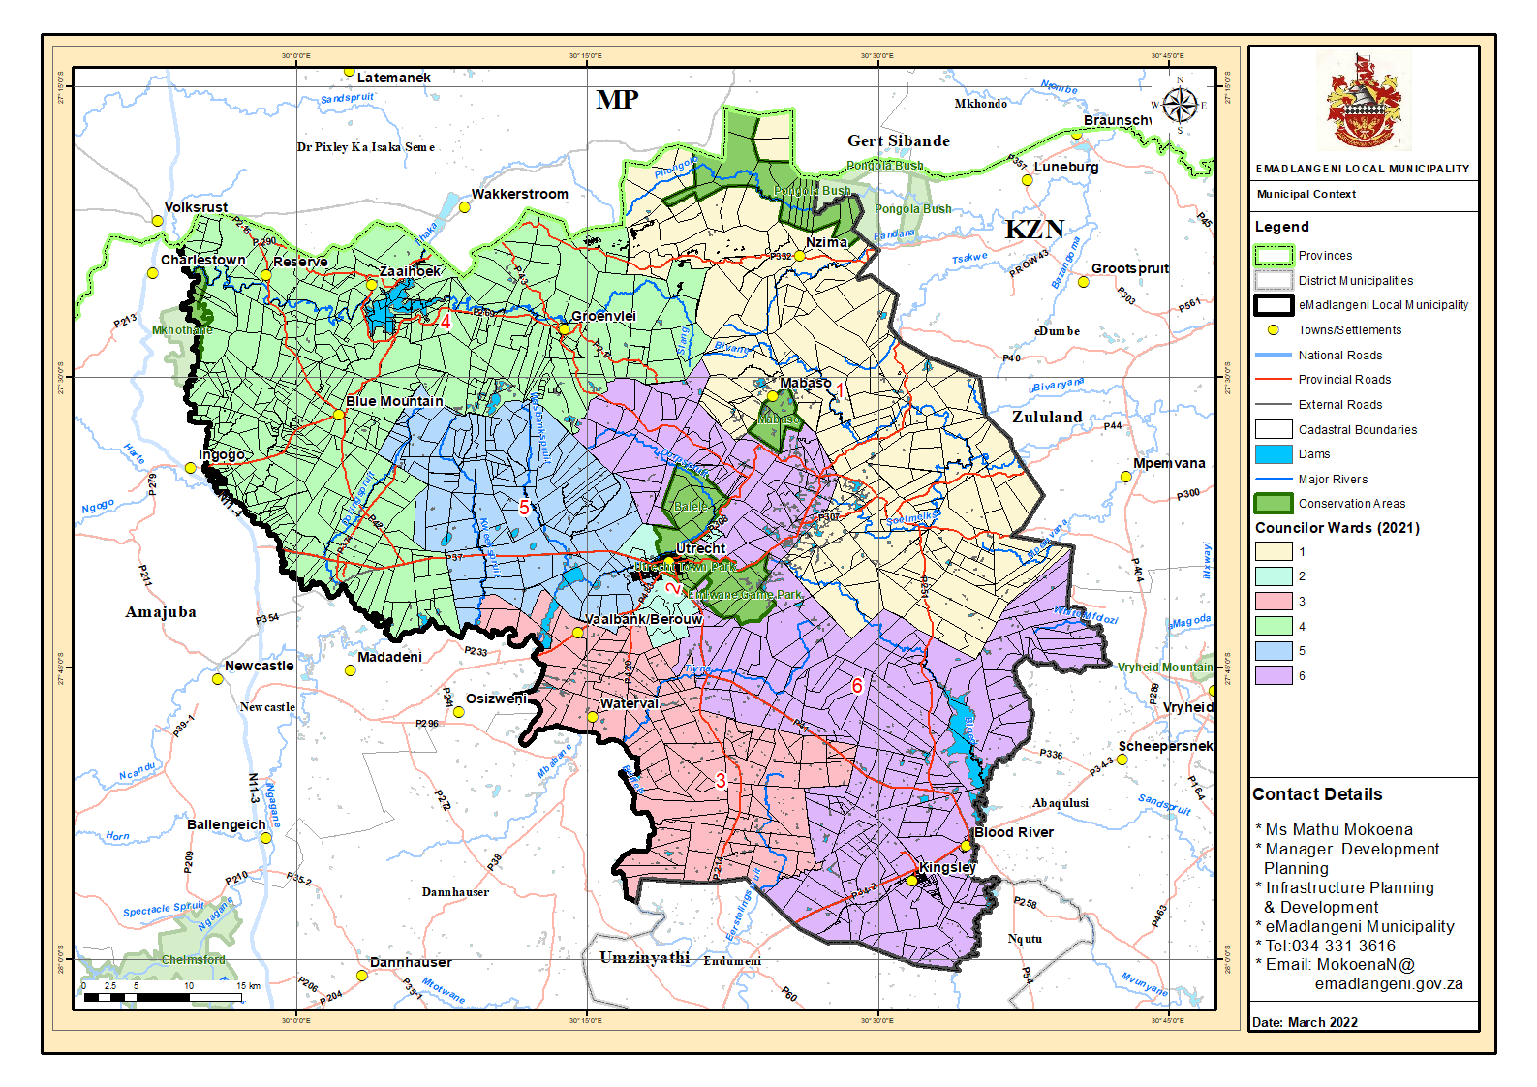

C.1.3.1. Regional Context
EMadlangeni Local Municipality (KZN 253) is one of three local municipalities within Amajuba District Municipality. It is the largest local municipality in the District in terms of geographical size measuring at 3 539 Km². The municipality covers the central regions of Amajuba District on the north-western parts of KwaZulu-Natal.
The major transportation route within the municipality is the R34. The N11, which borders a small section of the municipality on the western portion, connects the municipality to outer areas of Newcastle and Volksrust. The R34 runs through the district and divides the municipality into north and south regions. The northern region includes Utrecht, Groenvlei and Blue Mountain while the southern region includes Kingsley. The R34 further connects to the R33 on the south linking the municipality with Dundee.

Municipality | Extent (km²)
Newcastle Local Municipality | 1 855
EMadlangeni Local Municipality | 3 539
Dannhauser Local Municipality | 1 516
Amajuba District Municipality | 6 911
Table 9: District municipalities

C.1.3.2 ADMINISTRATIVE ENTITIES
EMadlangeni Local Municipality comprises of 6 wards as indicated on Map 3. The municipality has 5 traditional councils namely; Ndlamlenze Traditional council, Amantungwa Traditional Council, Thekwani Traditional Council, Mgundeni Traditional Council and Mbatha Traditional Council.

C.1.3.3 STRUCTURAL ELEMENTS
The municipality’s main structuring elements should be acknowledged as follows:
- R34 runs through the municipality linking it to Newcastle and Vryheid. The R34 also provides linkages between Free State and the port in Richards Bay.
- Rivers and Wetlands: There are three wetlands found in eMadlangeni, namely; Groenvlei, Boschoffvlei and Blood River Vlei.
- Topography: The municipality is characterised by vast land accommodating a range of scattered settlements. The majority of the municipal area is made up of moderate to gentle slopes while the northern region contains the steepest terrains in the municipality where altitudes increase to 1,900m above sea level (SDF 2023). Coincidently, the northern region is where the Balele Mountains are located.
- Dams: The Zaaihoek Dam on the north that forms part of the Groenvlei wetland system.

C.1.4 EXISTING NODES AND CORRIDORS

Nodes and corridors are significant structuring elements that allow for the concentration of activities and land uses. The development of nodes enforces easy access to opportunities, services and social facilities. Corridors are linking networks between nodes and are areas where a high intensity of development would occur and be encouraged. The level of intensity of nodes depends on their size and their relation to corridors. In turn, corridors also influence nodes in terms of mobility and access and they include access to public transport.

C.1.4.1 DEVELOPMENT CORRIDORS
The R34 is a Primary/major movement corridor within the municipality. It links to the N11 on the western portion, connecting eMadlangeni with Newcastle and Volksrust. The R34 also connects eMadlangeni with Vryheid in a south-eastern direction via the R33.
• Secondary movement corridors within the municipality include the following: The R33 (P43-2) links eMadlangeni to Dundee and Vryheid. It also intersects with the R34 Primary corridor at Blood River. The P483 road links eMadlangeni with Osizweni and Emadadeni. The P483 is also a Mixed Activity Corridor links eMadlangeni to Osizweni, Madadeni and western parts of Newcastle.P43: this road connects the town of Utrecht with Groenvlei on the north and links to the R543 connecting eMadlangeni with Wakkestroom in the Mpumalanga province.
• The P308 connects to the P43 linking Groenvlei and the Town of Utrecht. The P42 provides access to the north western settlements within the municipality. It also links to the P215 which connects the north western settlements to Wakkestroom and Volksrust via the R543 in the Mpumalanga province.
• The P269 links Groenvlei and Nzima settlement on the northern portion of eMadlangeni. It also links Groenvlei to the Zaaihoek Dam and Zaaihoek settlement. Tertiary corridors within eMadlangeni include; The P279 which links Blue Mountain to Ingogo rural settlement in Newcastle. The P332 provides access to the biodiversity region on the northern quadrant of the municipality and access to eDumbe municipality. There is also a tertiary corridor that runs in a north-south direction where it intersects with the P269 and links Groenvlei to Zaaihoek.

C.5.1.2 DEVELOPMENT NODES

C.5.1.2 PRIMARY DEVELOPMENT NODE: UTRECHT
Utrecht serves as the municipality’s primary development node and plays an administrative and economic role within the municipality. The node offers a great variety of services and accommodates a diversity of land uses.

C.15.2.1 SECONDARY DEVELOPMENT NODES
Three secondary nodes are identified in eMadlangeni and include; Groenvlei, Vaalbank/Berouw and Kingsley. Secondary nodes provide supporting services to surrounding settlements and have higher order services compared to tertiary nodes. These are developed with supporting services which are smaller in scale but critical for surrounding communities including; clinics, schools, police stations, regional offices and commercial activities.
Groenvlei is located on the north of Utrecht and is linked to Wakkerstroom in Mpumalanga and Paulpietersburg in Edumbe municipality. The node is supported by basic services including a Police Station and a clinic.
Vaalbank/Berouw is located on the west of eMadlangeni along the P483. The area is a land reform settlement and lies in close proximity to the Dicks cluster in Newcastle. The settlements is equipped with a filling station and is also the home to the Amantungwa Tribal Court.
Kingsley is located on the south of the municipality and is linked to Utrecht via the R34. It lies along the R33 which links it to Dundee and Blood River. The node also has basic services such as a police station

C.5.1.2.2 TERTIARY DEVELOPMENT NODES
Tertiary development nodes are sub-service satellites that deliver supplementary service to surrounding communities. These nodes provide services to the local rural community and surrounding settlements. They include Reserve, Zaaihoek and Nzima.
Reserve: is a land reform settlement located on a farm in ward 4. The node has the potential to serve surrounding settlements especially to the north. The area is currently experiencing growth pressures resulting in the northward growth towards Volksrust. Reserve has a primary school while other social facilities are limited in the area. As a result, the community makes use of facilities in the neighbouring settlement areas of Volksrust.
Zaaihoek: is located in ward 4 on portion 7 of the farm 377. It is under the traditional leadership of iNkosi uShabalala. The settlement has a tribal court, a primary school, a community hall and sports grounds.
Nzima: is a settlement located on the upper eastern portion of the municipality within ward 1. The settlement is under the of iNkosi Nzima. A tribal court and a school are found in the area while other social facilities are lacking.

C.2 CROSS CUTTING

C.2.1 ENVIRONMENTAL ANALYSIS

C.2.1.1 BIODIVERSITY AND PROTECTED AREAS

C.2.1.1.1KEY HYDROLOGICAL FEATURES
The main rivers within the eMadlageni Local Municipal area include the Phongolo River, Slang River, Bivane River and Pandana River which flow through the northern portions around Gronvlei and Mabaso (see map 8). The western and central portions are traversed by the Doringspruit, Kweekspruit, Washbankspruit and Dorspruit Rivers which share a common root on the south eastern segment of Utrecht. The eastern and southern segments are home to the Tiyna River, Buffels Rivers and its tributary Eerstelingspruit which connects near Endumeni on the south in the neighbouring Umzinyathi District Municipality. The Blood River flows through the south eastern side, into the Blood Dam, and then out through the southern boundary. Most of these rivers fall within the free flowing rivers category, as they mostly follow their natural flow path created within the undulating terrains.
EMadlangeni has three significant wetlands; the Boschoffvlei, Groenvlei and the Blood River vlei. The Zaaihoek Dam located on the north eastern region of the municipality forms part of the Groenvlei wetland system. There are also wetlands systems to the west of the municipality within the Kweekspruit and Doringspruit river systems in Ward 5. Wetland areas as well as areas within 100m of the river banks should be excluded from active development. To preserve the significant functionality of these hydrological bodies within the catchments, it is advisable to conserve these areas as open spaces in all spatial plans that may be developed (see map 8).

C.2.1.1.2 CATCHMENTS
The Amajuba district has an extensive system of rivers and tributaries, which fall within the uThukela and Phongola catchments. The main Thukela catchment covers the majority of the District and is drained in a southerly direction by the Buffalo River and several tributaries including the Ngogo Ncandu, and Ngagane Rivers to the south and the Slangspruit, Dorpspruit, Doringspruit and Wasbank Rivers to the north. The Phongola catchment predominantly falls within the Zululand District, but also includes the high lying area along the north-western border of Amajuba. The Amajuba section of this catchment is drained by the Bivane River, and forms the headwaters of the uPhongolo River (Agriculture master plan 2016/17).

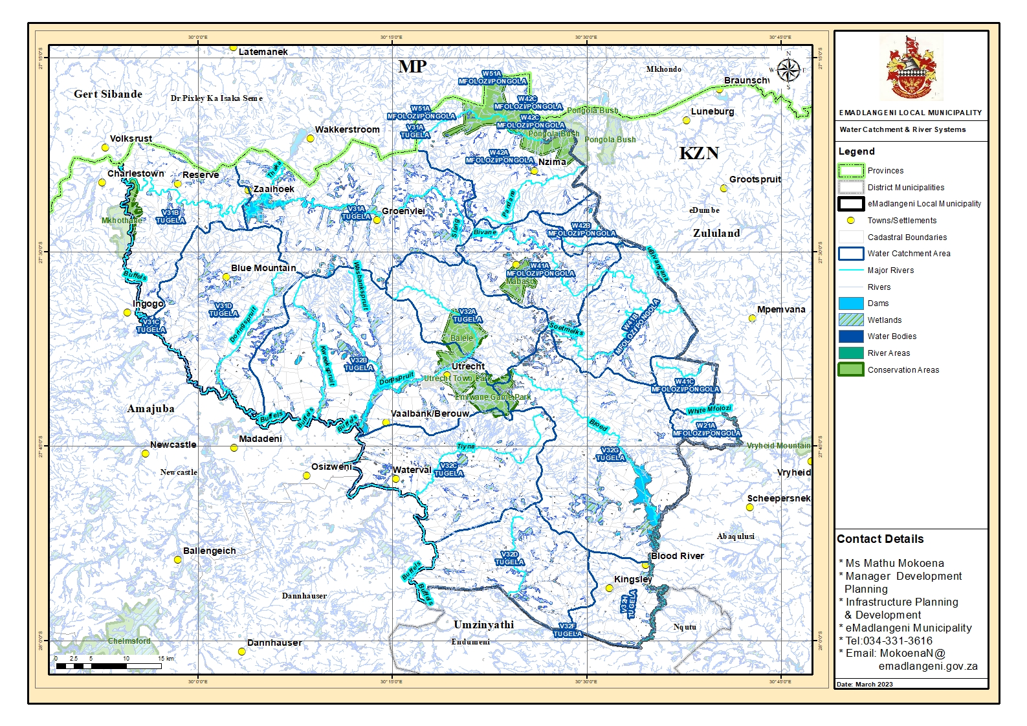
Map 4: Water system

C.2.1.2 Biodiversity Areas

Biodiversity refers to the diversity of plants and animals (living things) that occur in a given area. These plants and animals interact with the physical elements (the soils, water, and atmospheric conditions) of the given area in such a manner that the various living and non-living components of that area maintain a suitable living environment for all the components of that environment. The resulting suitable environment provides various benefits for people and communities that live in the area.
The Ezemvelo KZN Wildlife uses Critical Biodiversity Areas (CBA) maps to analyse the terrestrial biodiversity priorities regions within the province. The CBA identifies areas with irreplaceable status and optimal status. Irreplaceable areas are areas containing specific biodiversity resources or species, and area therefore necessary to be kept intact to maintain their functionality. Within eMadlangeni areas with irreplaceable CBA status are located on the north eastern region covering the settlement areas of Traditional Leader Inkosi Mabaso, Nzima and Groenvlei. There are also portion on the extreme north western region of the municipality that are identified as Irreplaceable CBA areas, and cover the settlement areas of Reserve and those surrounding the Zaaihoek Dam (see map 9).
Area that are identified as Optimal CBA areas area where biodiversity needs can be met the most without taking more land space from other uses. Optimal CBAs are located across the municipal landscapes mainly on the western and south eastern regions of the municipality (see map 9).

C.2.1.3 PROTECTED AREAS AND STEWARDSHIP SITES

EMadlangeni Local Municipality has three nature reserves which are formally protected. These are all located in the central region of the municipality and include Utrecht Town Park, Emlwane Game Park and Balele/Enlanzeni Game Park (see map 10). Private nature Reserves account for 37.79% of protected areas, while 4.18% is community conservation areas. The municipality has one stewardship site, the Mabaso stewardship site (see table 8). Stewardship areas are areas that have been negotiated for stewardship programmes but have no final landowner agreement or gazetting through NEMPA. Stewardship areas accounts for 58.03% of the total protected areas within the municipality.

Table 10: Protected Areas
Type of Protected Area | Area (ha) | Percentage (%)
Private Nature Reserves | 6950.9 | 37.79&
KZN Community Conservation Are | 768.5 | 4.18%
Stewardship areas | 18391.3 | 5.20%

C.2.1.4 Vegetation
The KZN version of the vegetation classification, (Jewitt, 2011) indicates that the municipal area is covered by seven main vegetation types. These include the Wakkerstroom Montane Grassland, found mostly on the mid to northern sections of the municipal area, the Paulpietersbug Moist Grassland found mostly along the eastern boundary. The south western segment is mainly covered by the Income Sandy Grassland with an intrusion of the KwaZulu-Natal Highland Thornveld around Rodekop and its surroundings
Of the major vegetation types occurring within the municipal area, only the Eastern Mistbelt Forest is listed as endangered. Three are listed ad vulnerable while the other four are listed a least threatened. The conservation status of the vegetation types within the municipal. Table 9 lists the type of vegetation within the municipality and their vegetation status.

Name | KZN Biome | Conservation target (%) | Remaining natural (2008) | Conservation status | Protection status in KZN
Amersfoort Highveld clay Grassland | Grassland | 27% | 65% | Least Threatened | 0%
Eastern Mistbelt forest | Forest | 66.5% | 67.4% | Endangered | 14.0
Income Sandy Grassland | Grassland | 23% | 46.2% | Vulnerable | 0%
KwaZulu-Natal Highland Thornveld | Grassland | 23% | 62.7% | Least Threatened | 1.8%
Low Escarpment Moist Grassland | Grassland | 23% | 88% | Least Threatened | 1.7%
Northern Kwazulu-Natal Moist Grassland | Grassland | 24% | 56.5% | Vulnerable | 1%
Paul Pietersburg Moist Grassland | Grassland | 30.31 | 42.7% | Vulnerable | 0.8%
Wakkerstroom Montane Grassland | Grassland | 27% | 86.4 | Least Threatened | 0.1%
Fresh water Wetlands (Eastern Temperate Wetlands) | Azonal Wetlands | 24% | 58.8% | Vulnerable | 0.6%
Table 11: Conversation Status of Vegetation Types
Source: KZN Vegetation Description, 2011

Map 5: Critical Biodiversity Areas
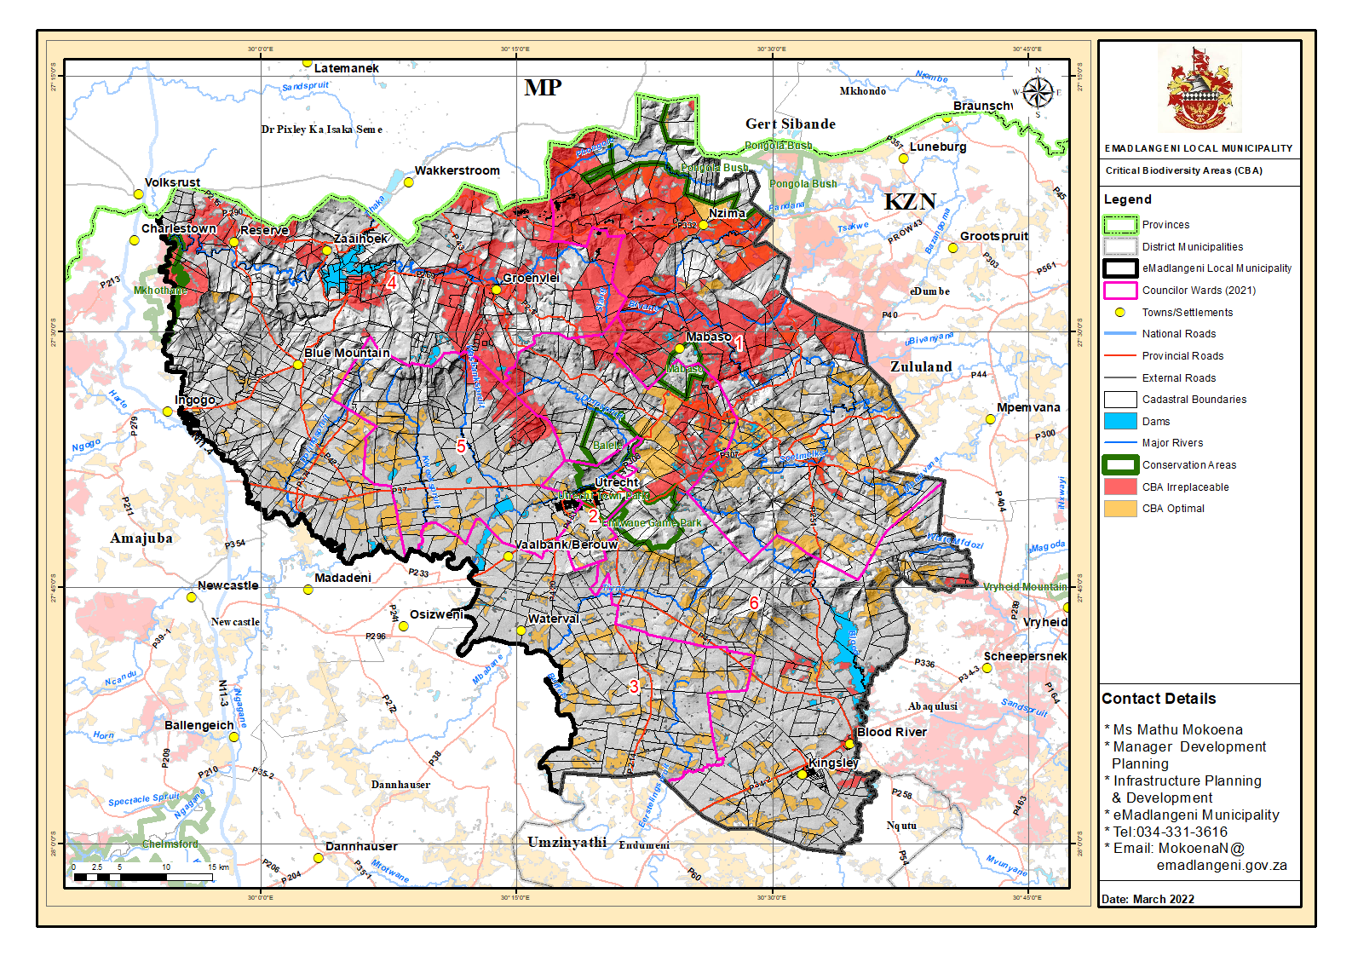
Map 6: Protected Areas
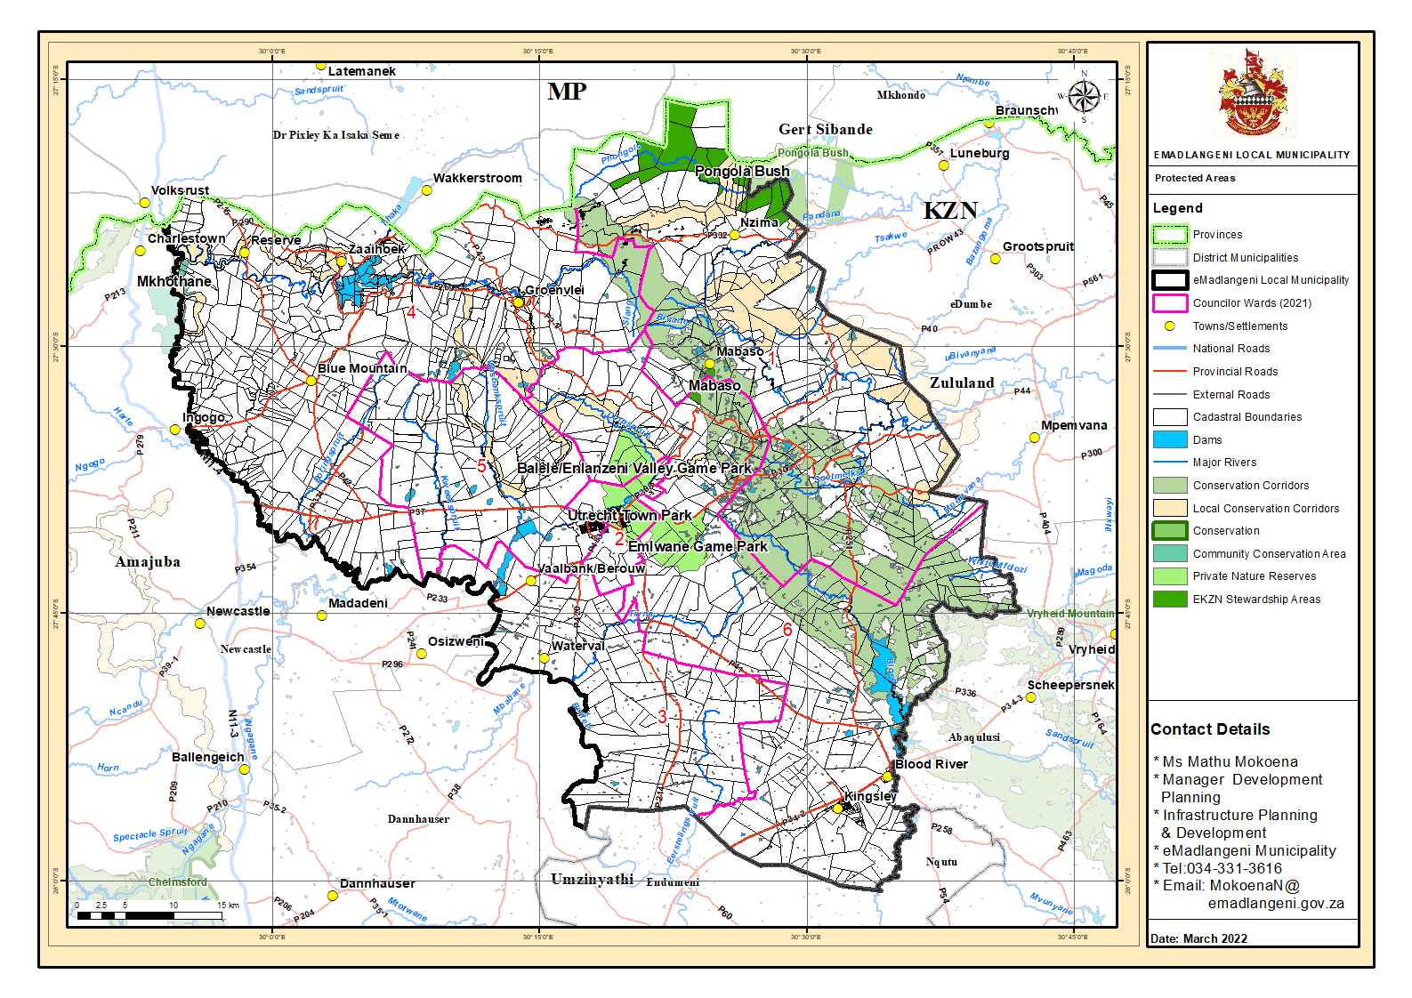

C.2.1.5 Environmental Management

C.2.1.5.1 Environmental governance
The environmental management systems in eMadlangeni has the potential to drive change and create desirable outcomes for people and the environment, specifically those that will uphold the principles of sustainable development.
Environmental governance is defined as “the exercising of authority over the use and management of natural resources, and the environment. It is essentially about making decisions and about who makes decisions. It includes rules, processes and behaviours that affect the manner in which decisions are made. These decisions ultimately determine whether the environment is harmed or improved” (DAERD, 2010). Environmental management is provided for in the municipality’s sector plans where developments with the potential to negatively affect the environment and environmentally sensitive areas are discouraged. The delineation of an urban edge is also a spatial tool the municipality can utilise to curb the encroachment of development into environmentally sensitive areas.

C.2.1.5.2 CLIMATE AND CLIMATE CHANGE
Climate change impacts affect disaster management, infrastructure and human settlements in several ways in eMadlangeni Municipality. The increase in the severity of thunderstorm events and increase in flooding damage infrastructure which may result in service delivery disruptions. The impacts of thunderstorm events particularly affect communities located in informal settlements, on flood plains and where there is poor drainage infrastructure. In addition, communities in rural areas that depend on subsistence farming may be unable to grow crops that they have grown in the past due to the changing climate. It is predicted that there will therefore be an increase in rates of rural-urban migration.
Rural communities may also become more physically isolated due to extreme events impacting on key infrastructure (Amajuba district climate change vulnerability assessment and response plan, 2018, version 2). As climatic changes increase average temperatures and rainfall variability (such as extended periods of drought), human settlements may express a higher demand for cooling appliances and access to water (EDTEA, 2015). Additionally, contrasting extreme weather (such as severe thunderstorms and flash floods) may induce the displacement of people and settlements, increase public health risks, and escalate pressures on rural and urban infrastructure and transport systems (Department of Environmental Affairs 2015). Major climatic risks in the municipal area include: drought, floods, severe thunderstorms (strong wind, heavy rain, lightning) and veld fire hazards. Regarding veld fires specifically, the entire municipal area has an extreme veld fire risk (Department of Agriculture, Forestry and Fisheries 2010).

C.2.1.6 IMPACT OF CLIMATE CHANGE
Climate change is a global phenomenon that brings about varying impacts on a region’s ecosystems. Climate change can potentially affect the biodiversity integrity of a region and heighten the risk of extinction of some species. The municipality has been affected with climatic changes which is evident in the drying up of rivers in some parts of the area. The municipality has implemented the following programmes to contribute towards climate change mitigation and adaptation:

Climate Change Mitigation
- Identification of flood lines and environmentally sensitive areas e.g. wetlands;
- Encouraging communities not to settle on floodplains;
- In process of resuscitating the ‘Buy-Back’ centre in Ward 2, Bensdorp for recycling; and
- The Integrated Waste management plan was adopted by council 31st of August 2023
Climate Change Adaptation
- Creation of fire breaks to the most vulnerable communities;
- Installation of lightning conductors; and
- Continuous climate change education& awareness campaigns to communities and schools

C.2.1.7 STRATEGIC ENVIRONMENTAL ASSESSMENT
There is currently no Strategic Environmental Assessment in place within eMadlangeni Local Municipality. Environmental characteristics and measures towards environmental management are however, elaborated on in the SDF. Amajuba district has an Environmental Management Plan to address environmental issues within the district. The primary aim of the Amajuba Integrated Environmental Programme should be to provide the high-level environmental analysis for the district including the local municipalities (Amajuba District SDF).

C.2.1.8 TOPOGRAPHY
The municipality is characterized by undulating hills on the north and north eastern portions associated with the Balele Mountains (see map 11). Rivers and valleys span the entire municipal areas and these are critical water catchments within the municipal area. The settlement pattern in the municipality tends to follow resources and infrastructure such as roads. Due to the spatial nature of the municipality the provision of service infrastructure to these areas becomes a challenge with regards to costs. The settlements on the north tend to grow in a northern direction towards Wakkerstroom while settlements on the west tend to growth in a western direction towards Osizweni.

C.2.1.8.1 ENVIRONMENTAL (BIOPHYSICAL) ISSUES
• Land degradation: Changes in the fertility of arable soils and an increase in soil erosion and vegetation degradation are all contributing factors to environmental degradation. Data on land degradation within the municipality indicates that a very large portion of the area remain untransformed. The eastern portions (area covered by plantations), and western areas (areas covered by commercial agriculture) of the municipality have been transformed (see map 10).
• Climate Change: the municipality is not immune to climate change. The effect of global warming is being felt globally and the recent floods has compromised the municipality’s water resources. This is evident in the drying of some of the rivers within the municipality. the implications for this is that households relying rivers as water sources are left in a state of despair and it also endangers animal species in these river systems. The effects of climate change can potentially compromise the agricultural output and ultimately reducing productivity in a region.
• Topography and Settlement: eMadlangeni is characterised by mountainous, undulating terrain to the north (see map 9). The terrain influences the drainage trends and patterns in the landscape, which in turn influence settlement patterns.
• Protected Areas: As an effort towards ensuring the availability of terrestrial biodiversity resources, Ezemvelo KZN Wildlife has identified critical biodiversity areas within eMadlangeni (see map 11 &12). EMadlangeni has a number of formally protected areas (formally protected by law) and conservation areas. Biodiversity conservation is often perceived to conflict with economic and social needs, it is thus necessary to ensure that biodiversity conservation is managed in a manner that will not arbitrarily affect people or environmental resources.
• Protection of agricultural land: the protection of agricultural land and resources cannot be overstated. Taking into account that the municipality has good agricultural potential and that agriculture is one the municipality’s biggest sectors, the protection of agricultural land should be one of the municipality’s primary priority.

C.2.2 SPATIAL AND ENVIRONMENTAL: SWOT ANALYSIS
STRENGTHS | WEAKNESSES
The municipality is rich in biodiversity resources  Environmental management is provided for in the SDF  Good agricultural potential  Land reform projects | Inadequacy of basic services  Lack of accessibility  Poor protection of grasslands  Poor preservation of agricultural land  Lack of agricultural infrastructure to support small-scale farmers in rural areas  Mountainous/steep terrain  Land degradation
OPPORTUNITIES | THREATS
Good climate  Tourism potential  Availability of the Zaaihoek Dam  At local level the municipality has good air quality  Intensive agricultural development  Development of a Strategic Environmental Assessment.  Development at key points along development corridors | Lack of food security  Climate change  Settlement encroachment into sensitive areas  Land degradation  Alien invasive species  Mining impact on biodiversity  Poor water quality

Map 7: Land Degradation
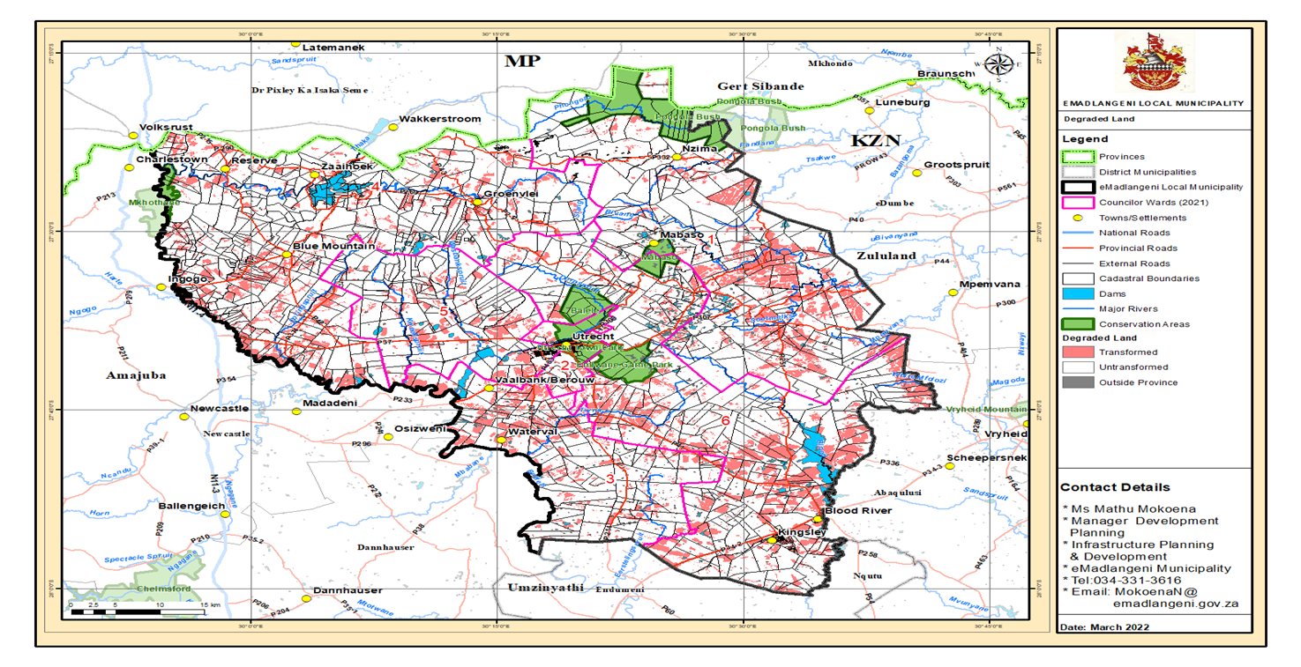

Map 8: Agricultural Potential

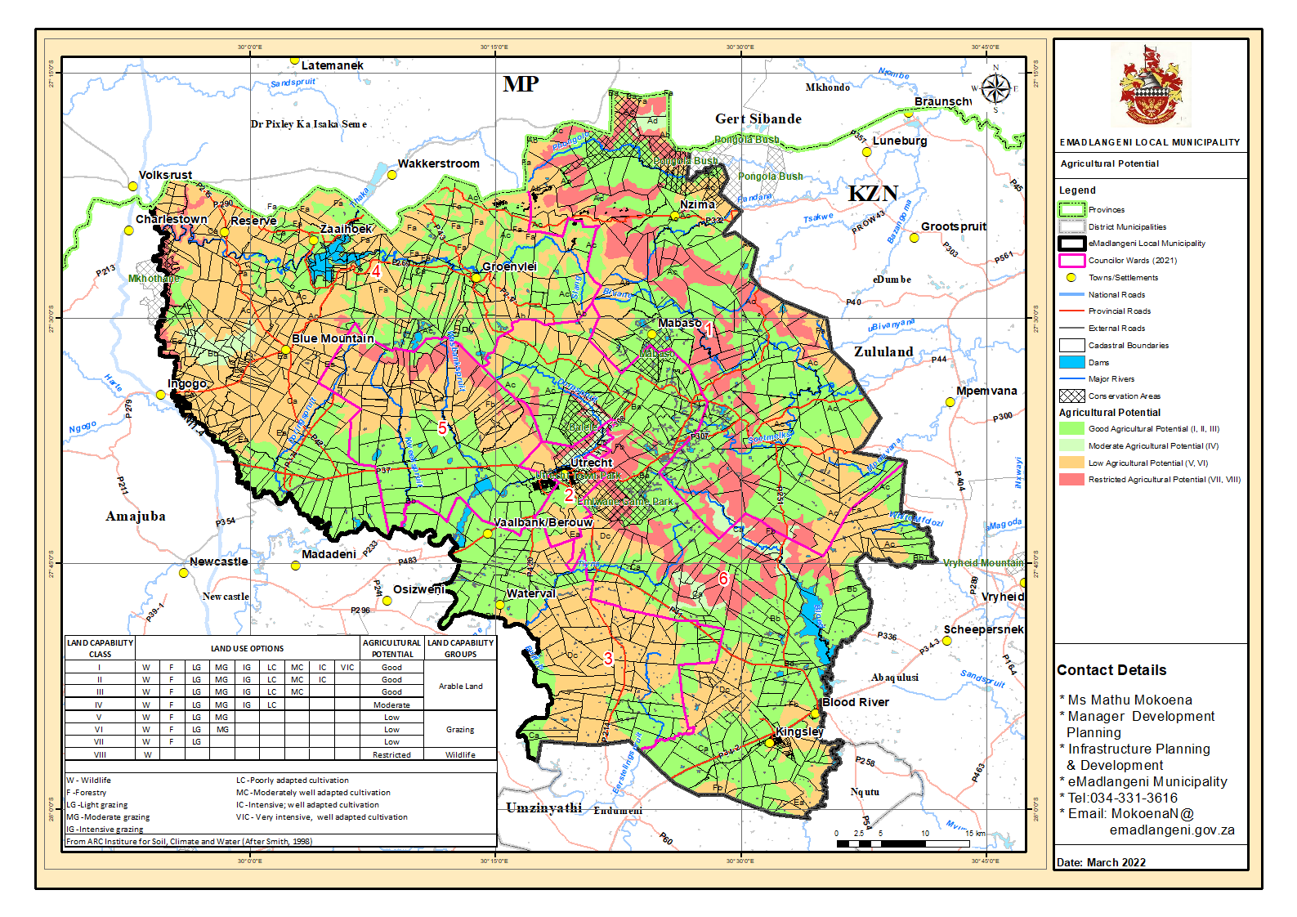
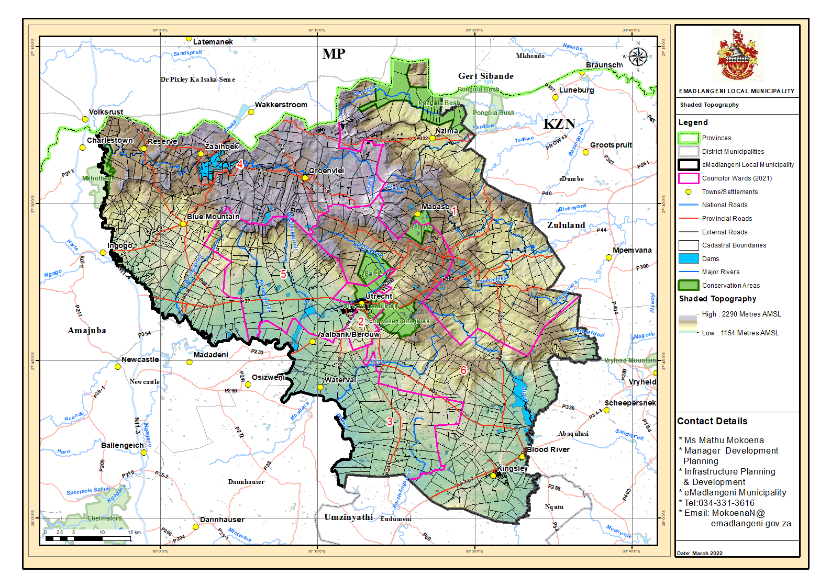
Map 9: Topograph

C.2.3 DISASTER MANAGEMENT

C.2.3.1 MUNICIPAL LEGISLATIVE MANDATE
Chapter 5, Section 26 (g) of Municipal Systems Act No. 32 of 2000 requires the municipal IDP to reflect an applicable disaster management plan. Section 53 (2) (a) of Disaster Management Act No. 57 of 2002 stipulates that a disaster management plan for a municipal area must form an integral part of the municipality’s IDP. The Fire Brigade Services Act No. 99 of 1987 is the primary piece of legislation regulating fire services and seeks to provide for the establishment, maintenance, employment, co-ordination, and standardization of fire brigade services. The National Disaster Management Framework (Notice 57 of 2005) classifies disaster management into four Key Performance Areas (KPAs) and three Enablers. KPA three (3) on “Disaster Risk Reduction” stipulates that disaster risk reduction efforts must be included into strategic integrated structures and processes. The risk related information must also be incorporated into spatial development frameworks (SDFs).

C.2.3.2 MUNICIPAL INSTITUTIONAL CAPACITY
The Municipality has established the disaster management unit in January 2015 which is operating in one of the municipal buildings at 44 Scheepers Street, Utrecht. The Disaster Manager was appointed in November 2016. There is only one (1) Disaster Management Officer. The unit is operational, which is 24 hours 7 days a week (24/7) with a very limited staff. The municipality was registered with the fire protection association in April 2016 as required by the National Veld and Forest Fire Act, 1998. The Municipal bylaws to regulate internal fire were developed and approved in July 2015-Provincial Governmental Gazzette no 1461 and need enforcement. The Municipal Disaster Management Advisory Forum (MDMAF) was established in July 2015 and comprises of all relevant stakeholders of disaster management within the municipal area. The MDMAF sits quarterly and when there is a need to coordinate strategic issues related to disaster management. The Municipality is in the process of constructing the Emergency Services Centre in partnership with Uitkomst Colliery as the main funder.

C.2.3.3 RISK ASSESSMENT
The municipality is mostly threatened by veld-fires; structural fires; strong winds; lightning; thunderstorms; heavy rains; and flash floods. The municipality has also experienced tornado; drowning; snow; airborne; waterborne and hazmat in a small scale. The municipality has a largest area for grazing and agricultural purposes; veld fires are the most devastating hazards within municipal area and cause loss of lives and extensive damages to agriculture and infrastructure. The strong winds and lightning strikes have increased from 2017 to date in the municipality. Lightning poses a hazard to people and livestock, and can also cause loss of life extensive damages to agriculture and infrastructure. The thunderstorms have increased from 2019 to date; and they leave the communities devasted and helpless. There is also an increase in heavy rains from 2021 to date; heavy rains also cause extensive damages to infrastructure such as human settlements, roads, bridges, electricity and essential community amenities Due to climate change the municipality is most likely to be threatened by both agricultural and hydrological droughts. The dam failure is also a threat due to an increasing intensity in weather patterns.

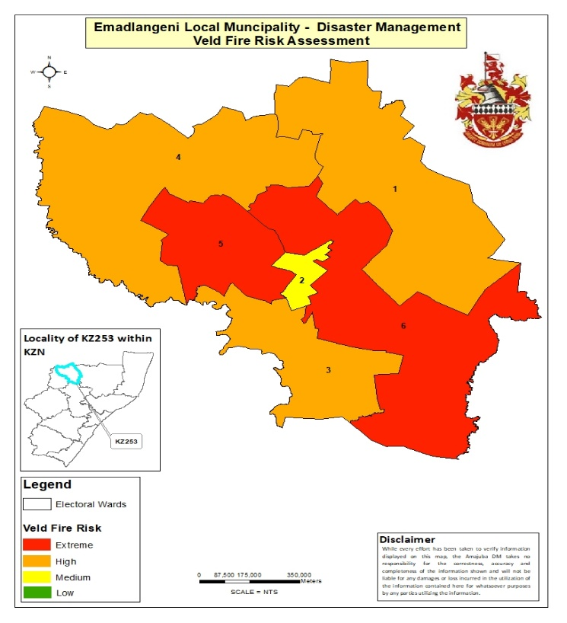 Map 1: Veld Fires Hazard Map | 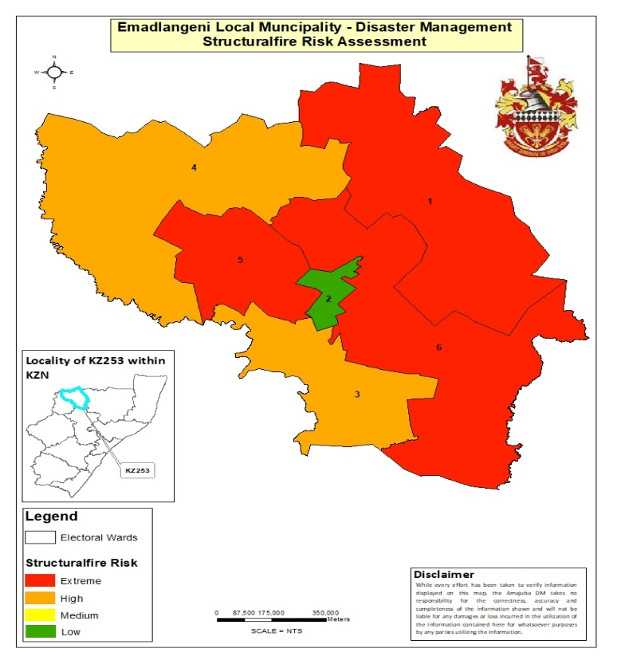 Map 2: Structural Fires Hazard Map
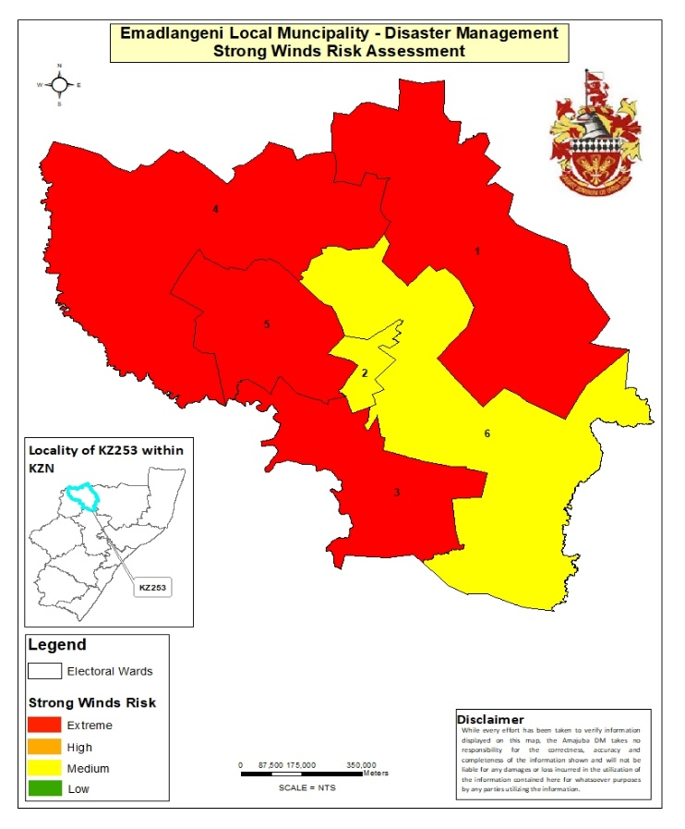Map 3: Strong winds Hazard Map | 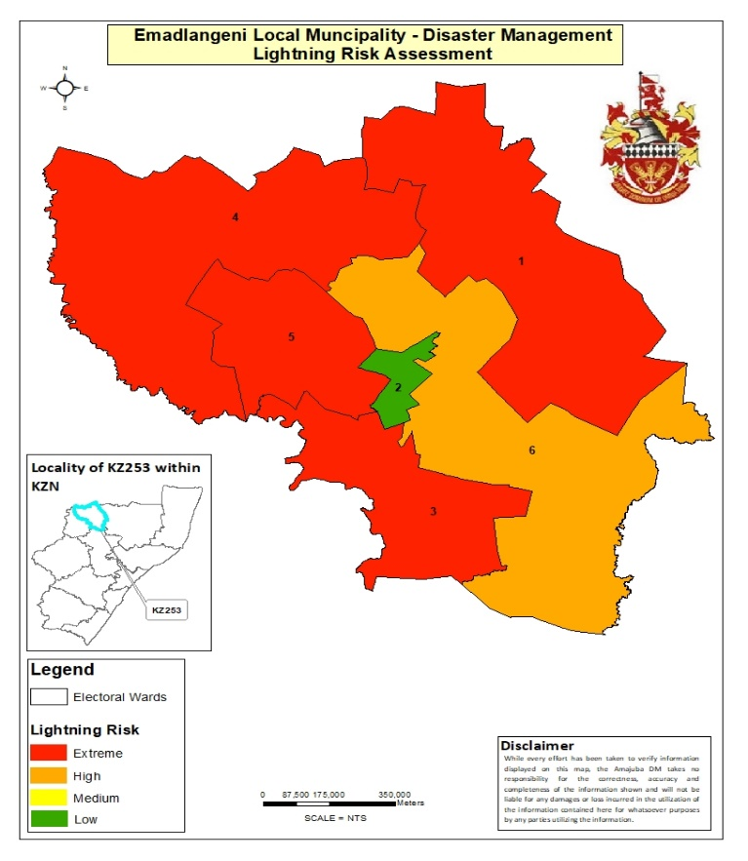Map 4: Lightning Hazard Map
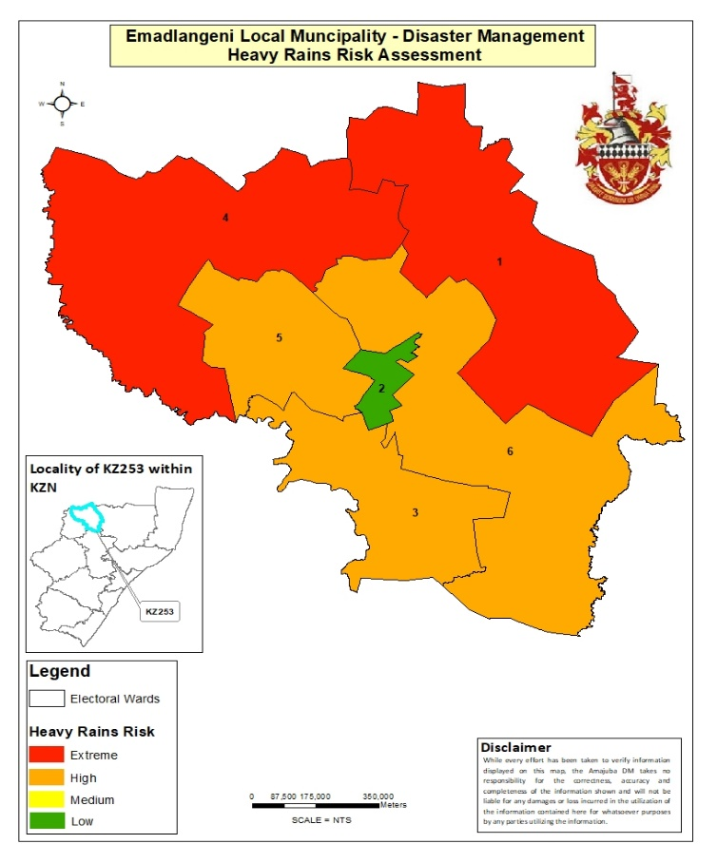Map 5: Heavy rains Hazard Map  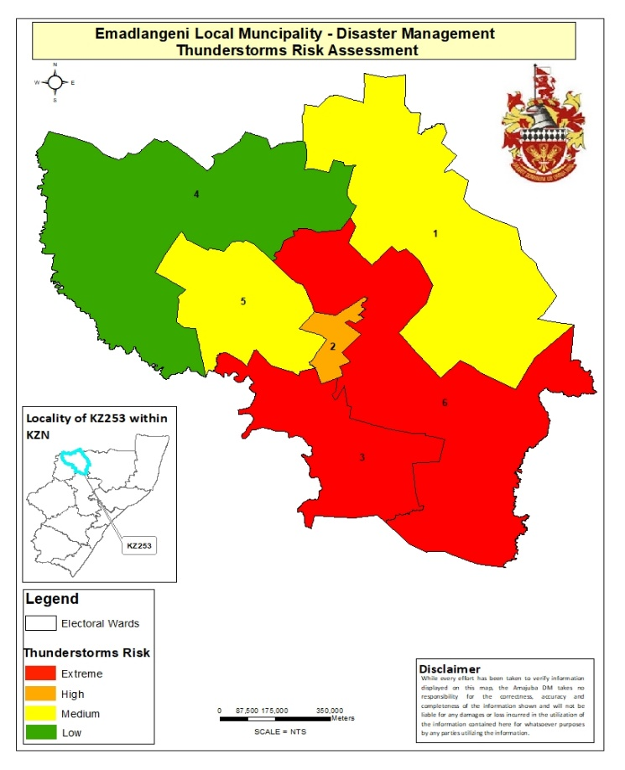Map 7: Thunderstorms Hazard Map | 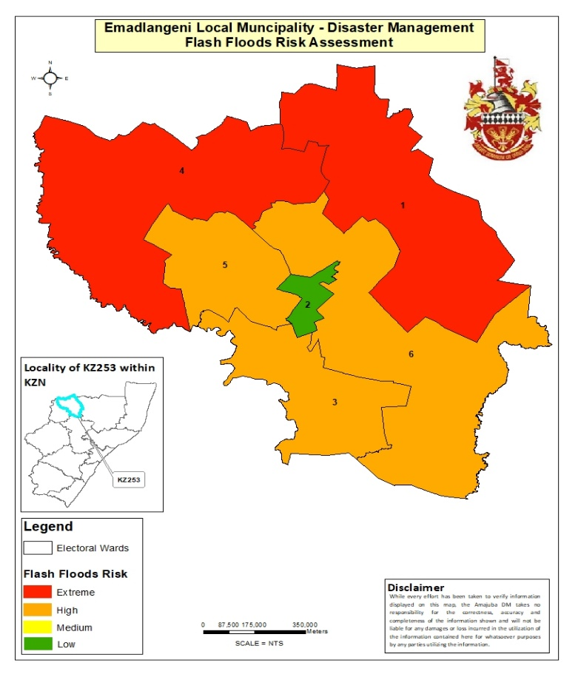Map 6: Flash floods Hazard Map  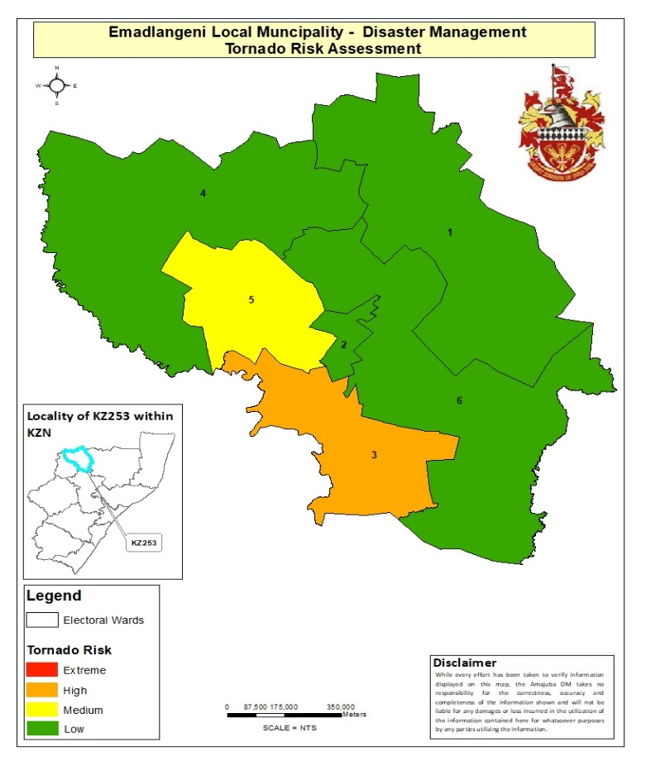Map 8: Tornado Hazard Map
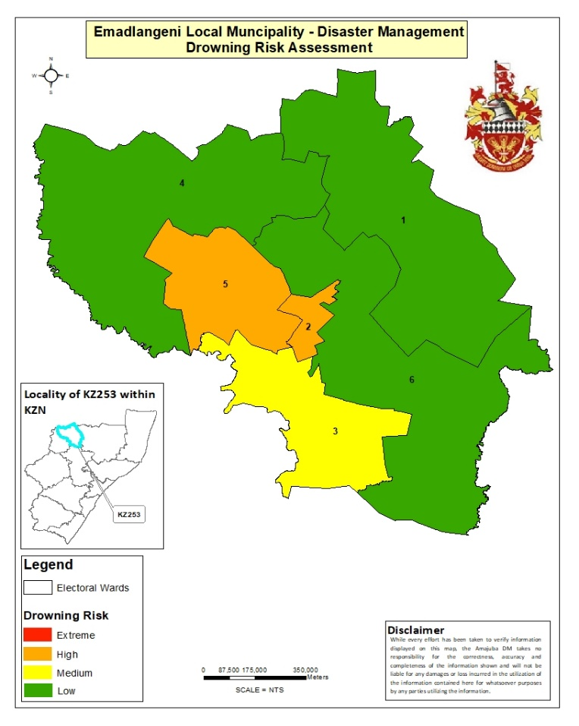Map 9: Drowning Hazard Map | 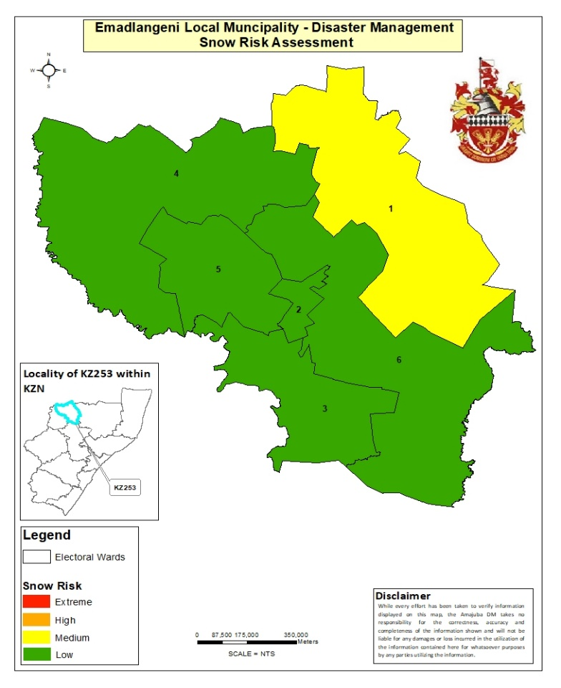Map 10: Snow Hazard Map
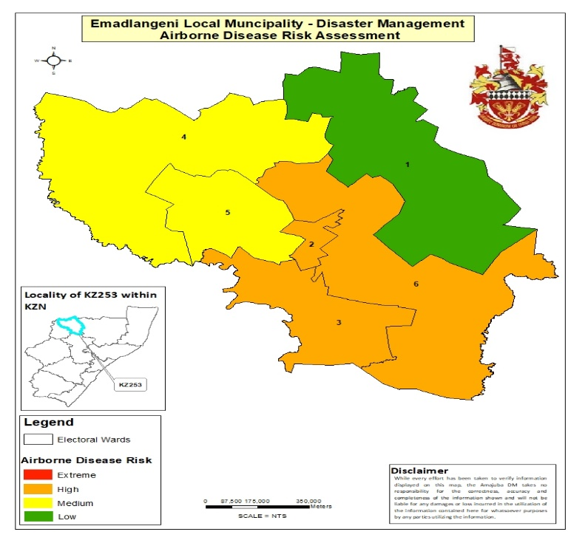  Map 11: Airborne disease Hazard Map | 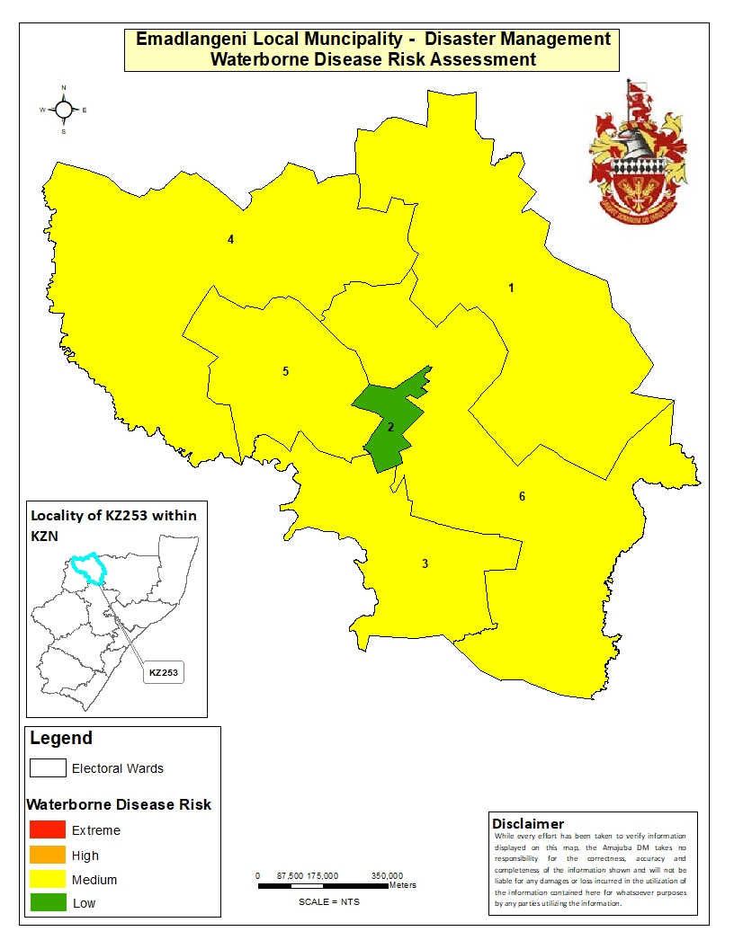  Map 12: Waterborne disease Hazard Map
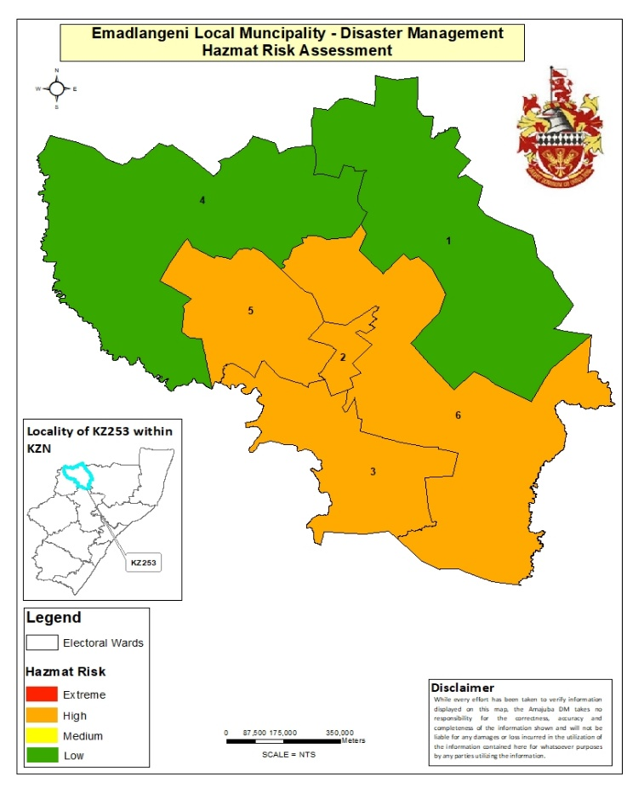  Map 13: Hazmat Hazard Map | 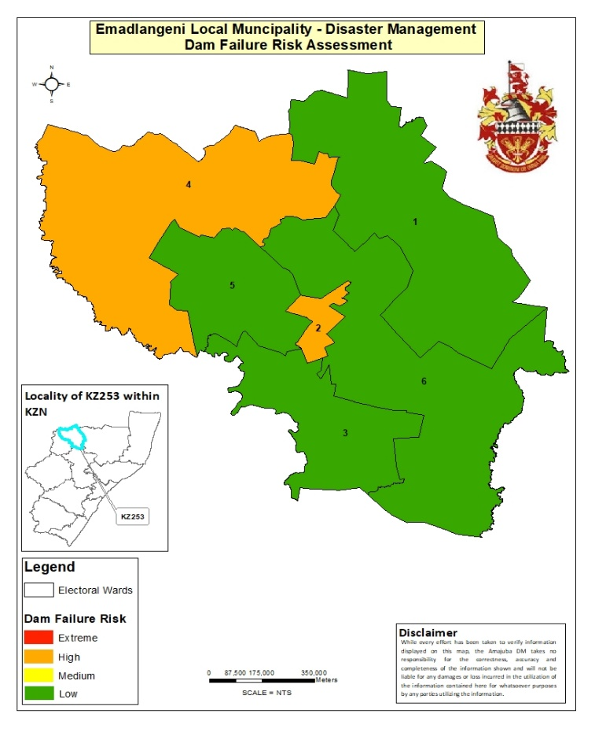  Map 14: Dam Failure Hazard Map
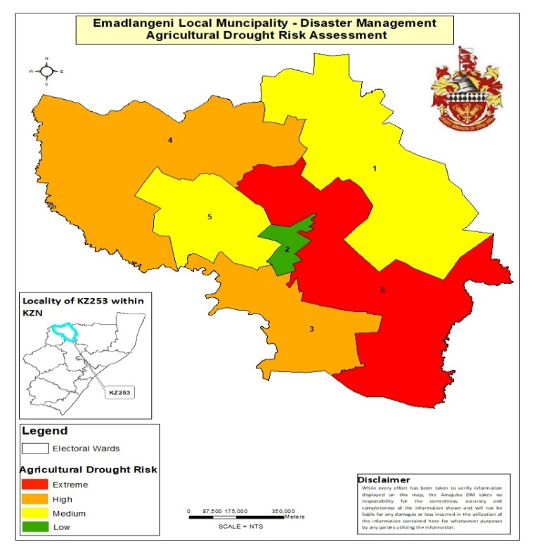Map 15: Agricultural Drought Hazard Map | 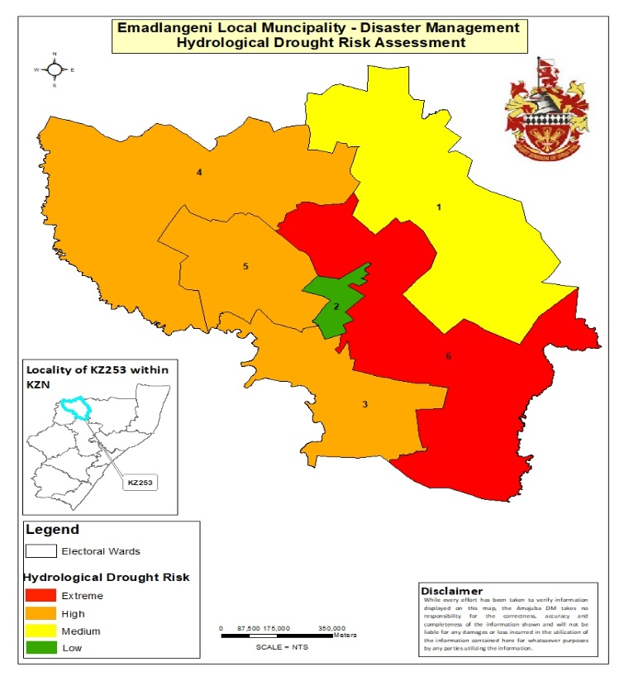Map 16: Hydrological Drought Hazard Map
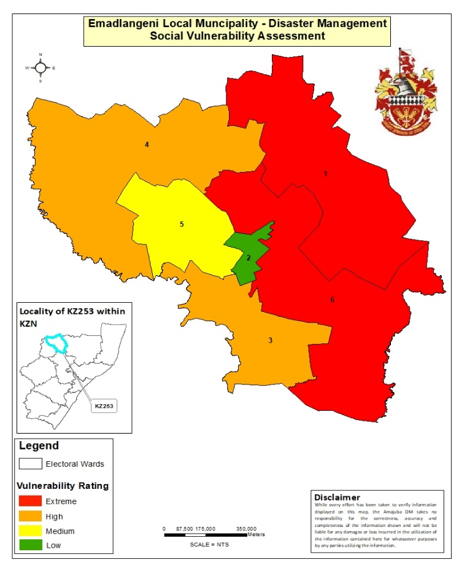  Map 17: Social Vulnerability Map | 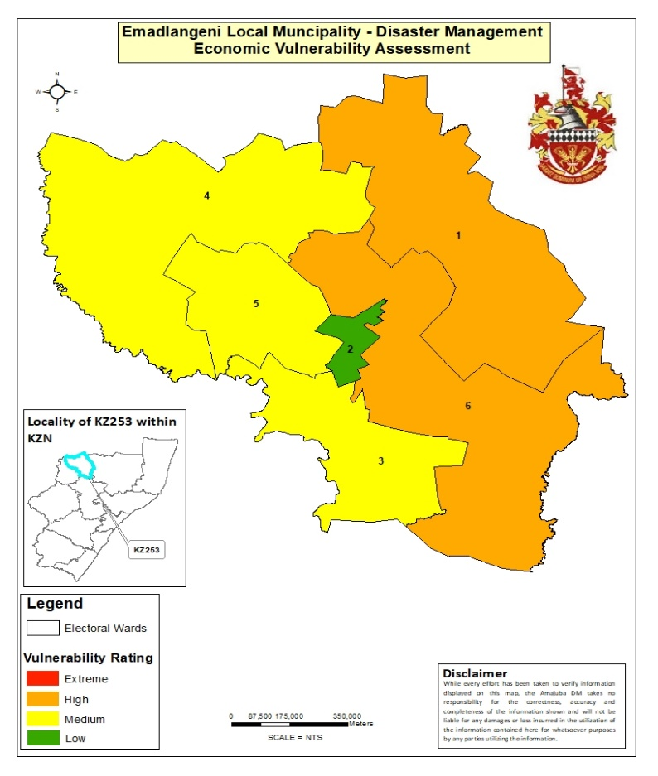Map 18: Economic Vulnerability Map
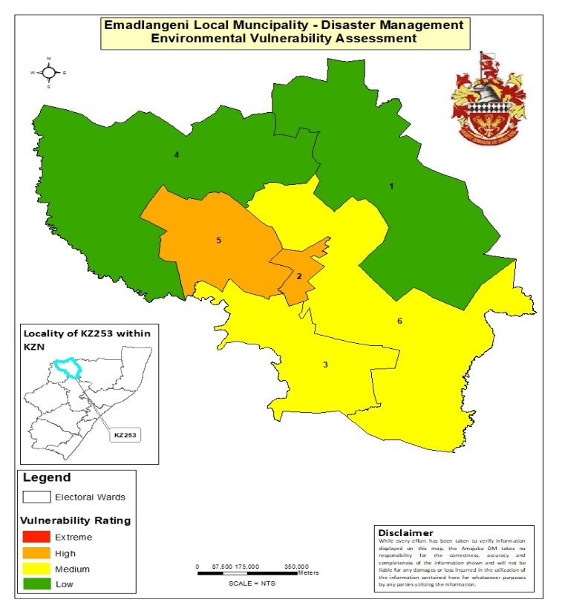Map 19: Environmental Vulnerability Map | 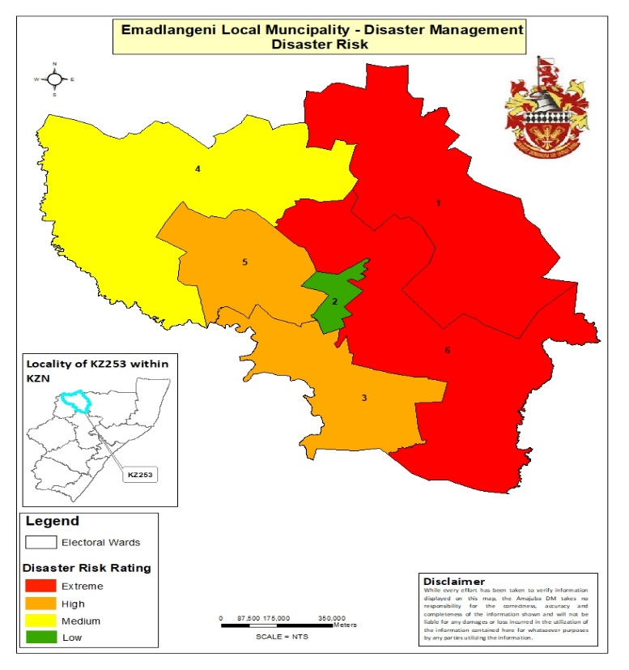Map 20: Disaster Risk Rating Map

C.2.3.4 DISASTER RISK REDUCTION

The Municipal Disaster Management Plan has been developed and adopted by the Municipal Council in May 2018; it was reviewed and adopted by council on 30 June 2023 and is attached as ANNEXURE C. The reflecting the disaster risks, disaster risk reduction, climate change issues, and funding arrangements was adopted by council on the 26th of April 2023 and referred to as ANNEXURE C. The Municipality has identified projects towards ensuring risk reduction, which includes; the creation of fire breaks, installation of lightning conductors, capacity building/workshops and relief interventions. The municipality will be responsible for all these projects. The sector departments have also identified projects towards risk reduction, which includes planting of trees as windbreakers, human vaccination, emergency fire drills and school-based disaster management.
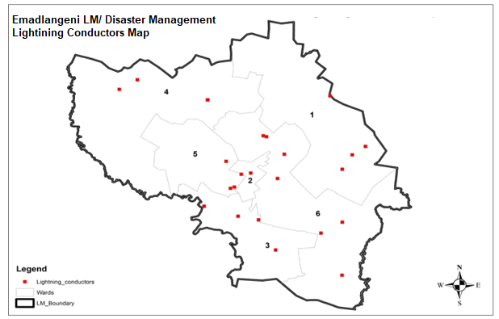
Map: Installation of lightning conductors
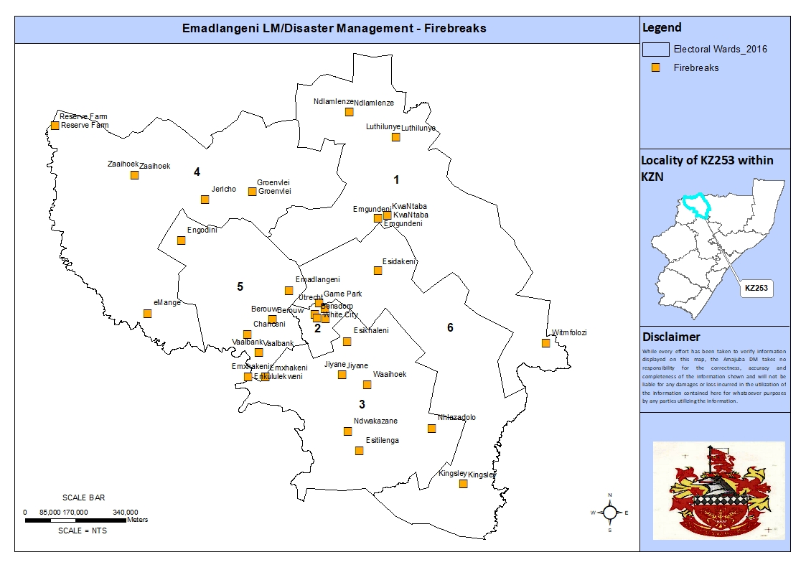
Map: Creation of fire breaks

C.2.3.5 RESPONSE AND RECOVERY
The municipal disaster management unit facilitate, guide, coordinate and monitor the integrated response to disasters. The relevant stakeholders relating to the occurrence will form part of the Joint Operations Centre (JOC). The JOC shall be responsible for the coordination of all operations. Decisions shall be taken through joint consultation. JOC will assume responsibility for all allocation and distribution of resources. The Disaster Manager will act as a chairperson.
When relief measures are implemented due to a disaster that strike a community, the following principles will be taken into account:
- ensure that physical materials fulfil the actual needs;
- ensure coordination between the relief agencies to prevent conflict between agencies or among various segments of the population; and
- ensure that it doesn’t increase congestion in and near the disaster area.

C.2.3.6 EDUCATION, TRAINING AND AWARENESS
The municipality promotes formal and informal initiatives that encourage risk-avoidance behavior by organs of state, the private sector, non-governmental organizations, communities, households and individuals in the municipal area. The Municipality in partnership with all relevant stakeholders are set to conduct workshops to enhance mainstreaming of disaster risk management at local level where incidents occur. This is also a means to ensure that all wards are developing necessary precautionary measures and capacities for coordination and responding to incidents when they occur. The workshops include traditional leaders; schools and subsistence farmers. The public awareness includes communities within the municipal area.

C.2.3.7 FUNDING ARRANGEMENTS
The Uitkomst Colliery (Pty) Ltd and the Municipality agreed that Uitkomst will fund the construction of the Municipal Emergency Services Centre (ESC) with the amount of R3.7 million in terms of its social and labour plan. The Uitkomst has appointed ECA Consulting to develop the project concept and construction plan of the ESC. The contractor was appointed on 08 March 2024; the site-handover was done on 12 March 2024; and sod turning was done on the 09 April 2024. The completion date of the Centre is 15 July 2024. The ECA Consulting will also oversee the construction of the ESC in consultation with the Municipality. The breakdown of estimated budget for disaster management and fire services is depicted on the below:

ACTIVITY | ESTIMATED BUDGET
Municipal Disaster Management Advisory Forum Meetings | R 5 500.00
Installation of lightning conductors | R120 000.00
Fire equipment & material | R 300 000.00
PPE | R250 000.00
Training of communities | R20 000.00
Awareness campaigns | R20 000.00
Relief material | R50 000.00
TOTAL | R 765 500.00
Source: eMadlangeni Disaster Management Sector Plan (2024/25)

C.2.3.8 FUNDING MOBILISATION MEASURES
The municipality is continuously engaging interested stakeholders in funding the fire and disaster management functions. To ensure the fully functional Disaster Management Unit additional funding for projects/activities is needed. Therefore, the interested stakeholders may fund the following projects/activities:
PROJECT/ACTIVITY | ESTIMATED BUDGET
Integrated information management and communication system | R500 000.00
Rescue vehicle (4x4 double cap fire fighting vehicle with jaws of life) | R2 600 000.00
Personal Protective Equipment (PPE) for structural fires | R150 000.00
Lightning conductors | R250 000.00
Extension of the Emergency Services Centre to meet the minimum infrastructural requirements of a Disaster Management Centre as stipulated by the NDMC Guideline, (2017). | R5 000 000.00
Table 12: Funding Mobilisation
Source: eMadlangeni Disaster Management Sector Plan (2024/25)

C.2.3.9 DISASTER MANAGEMENT: SWOT ANALYSIS

STRENGTHS | WEAKNESSES
- MDMAF established.  - Mainstreaming Disaster Management in community structures.  - Implementation of prevention programmes/projects such as firebreaks, installation of lightning conductors, training of communities and awareness.  - Integrated response and recovery.  - Participation in Operation Sukuma Sakhe (OSS) structures.  - Municipal by-laws developed and approved.  - Dissemination of early warnings to relevant stakeholders.  - Establishment of Ward Based Disaster Management Structures/ Committees.  - Construction of Emergency Services Centre in partnership with private sector | - Insufficient capacity to deal with disaster management.  - Mutual assistance and agreements in cross border (Mpumalanga Province, Umzinyathi and Zululand District Municipalities).  - Integrated information management and communication system not established  - Insufficient budget for preparedness to deal with disaster management (inventory, resources etc.).  - Enforcement of municipal by-laws.  - No dedicated official to perform environmental duties including climate change.  - Unsustainable use of some of the indigenous plant resources
OPPORTUNITIES | THREATS
- Inclusion of disaster risk reduction efforts in other structures and processes. | - Accessibility to incident/disaster scene eg roads.  - Vastness of settlements limits the ability of fire & rescue services to respond in other areas.  - Land degradation  - Invasion by alien species  - Network problem in Wards 1, 4, 5 & 6 for the community to report.  - Climate change (weather patterns)  - High water tables that are easily contaminated  - Potential for flooding occurs in low lying areas.

C.2.4 KEY CHALLENGES DERIVED FROM SWOT ANALYSIS
- Insufficient budget for disaster management function.
- Shortage of relief material in case of major incidents.
- Vastness of wards to respond to emergencies.
- No dedicated official to perform environmental duties including climate change.

C.3 MUNICIPAL TRANSFORMATION & ORGANISATIONAL DEVELOPMENT ANALYSIS

C.3.1 MUNICIPAL TRANSFORMATION

The Municipality adopted the reviewed Human Resource Policies in May 2023. The following Policies were also reviewed:
• Human Resource Strategy (Attached as ANNEXURE H)
• Organogram (Attached as ANNEXURE H1)
• Employment Equity Plan (Attached as ANNEXURE H2)
• Recruitment and Selection Policy (Attached as ANNEXURE H3)
• Workplace Skills Plan (Attached as ANNEXURE H4)
• Skills Development Policy (Attached as ANNEXURE H4a)
• Leave Policy (Attached as ANNEXURE H5)
• Overtime Policy (Attached as ANNEXURE H6)
• Telephone Policy (Attached as ANNEXURE H7)
• S&T Policy (Attached as ANNEXURE H8)
• Payroll Policy (Attached as ANNEXURE H9)
• Car Allowance Policy (Attached as ANNEXURE H10)
• ICT Governance Framework (Attached as ANNEXURE H11)
• ICT Security Policy (Attached as ANNEXURE H12)

The municipality will need to align all components that will retain employees to the budget before developing the Retention Policy in the next financial year (2024/25). The retention policy will assist to curb the staff turnover rate and retain the employees. The policy will attract employees with critical and scarce skills to stay long with the municipality.
The municipality adopted the ICT Governance Framework in May 2023, it is attached as Annexure H11 and ICT Security Policy which is attached as ANNEXURE H12. The ICT steering committee is functional. Due to change in management, then municipality will coopt new members.
The Employment Equity Plan was adopted in 2022 and it will be reviewed on the next financial year. See the attached as Annexure H2. The Annual Employment Equity Report was submitted online to the Department of Labour portal on the 14 January 2024. The municipality still need to recruit more people with disability and the current rate is 0.70%. The municipality had new created posts on the organogram and the vacancy rate had increased to 30,1%.
The municipality will continue to be the learning organization, in order to fulfil the National Development Plan 2030, to be a capable state. The Workplace Skills Plan (WSP) which is attached as ANNEXURE H4, was developed to address the gaps skills from employees, Councillors and unemployed youth. The following skills programme are part of Workplace Skills Plan to benefit employees, councilors and the community.
- Short courses, Workshops
- In-services Bursaries and bursaries
- Recognize to Prior Learning (RPL)
- Learnership
- Formal qualification
- Internship
- Work Integrated Learning (In-service training)
The COGTA, Provincial Treasury and National School of Government do provide the capacity building programme for officials and Councillors that addresses the UIFW (unauthorized, irregular, fruitless and wasteful expenditure). These capacity building programme aim to eradicate audit findings.
In terms of the Local Government: Municipal Staff Regulations, government gazette number 45181, dated 20 September 2021. The municipality is implementing the Performance Management System to all employees. The job description, work plan and performance agreement are developed to assess the performance of the employees.

C.3.2 ORGANISATIONAL STRUCTURE / ORGANOGRAM

The organogram as a attached ANNEXURE H1 was aligned to the prototype assessment initiative supported by COGTA. The prototype assessment had recommended the re-established the Department of Community Services and some of the movement of functions across the departments. The organogram reflects the few new created positions that will assist the municipality change the conditions of the services to shift systems across the essential services. However, the additional positions had increased the vacancy rate to 30,1%. The highlights of the organogram are as follows:

Office of the Municipal Manager
- Change the Manager in the Office of the Municipal Manager to Manager: Municipal Manager Support
- Changed the Manager Internal Audit to Manager Internal Audit and Forensic
- Relocation of Manager Legal and supervise the Risk Management Officer

Budget and Treasury Office
- Combined Fleet Officer and Asset Clerk.
- Fleet services be moved from Corporate to Budget and Treasury Office
- Creation of new Meter Reader post
- SCM Practitioner be moved from SCM Practitioner Logistics to SCM Practitioner Demand and Acquisition post
- Change the SCM Practitioner Logistics to SCM Practitioner Contract Management

Corporate Services
- Creation of the Office of the Speaker Unit and supervise the Public Participation Officer
- Relocation of the Office of the Mayor and Social Services Officer
- Creation of the Stakeholder and Marketing Unit and Supervise the Communication Officer
- Creation of new PMS Clerk position
- Change the Occupational Health & Safety Clerk to OHS Officer

Infrastructure and Planning Development
- The Department renamed to Municipal Planning and Technical Services
- The Planning and Development unit to renamed to Spatial Planning and Land Use Management unit
- The Tourism and LED unit to renamed to Economic Development unit
- Moving one (1) General Worker from Waste to Roads
- Creation of new Cashier post at Game Park

Community Services
- Re-establishment of Community Services Department
- Relocation of the following units – Parks, Libraries, Protection Services, Waste Management and Fire & Disaster.
- Establishment of the Recreation and Parks unit with the following sub-components – Parks, Utrecht Library, KwaNkosi Khumalo Modular Library and Youth & Sport Development.
- Creation of new posts – Control Room Operators x4 and two (2) Fire fighters
- Moving one (1) General Worker from Parks to Waste
- Moving one (1) General Worker from Roads to Parks

The Human Resource Strategy was developed and adopted by Council in 2022 Financial year (attached as ANNEXURE H) in order to address the movement of the organization structure for the next three years and to project the attrition rate and staff turnover.
The municipality introduced the concept on tapping into Internship Programme, as an interim measure, until the budget allows filling of additional posts on the incremental basis. The Municipality appointed 5 interns from Municipal Finance Management Internship Programme and KwaZulu Natal COGTA approved the provision of 14 interns to the Municipality. COGTA interns are specialising in the following fields: Human Resources, Finance, Internal Audit, Public Admin, Integrated Development Plan, Town Planning, Public Relations and Local Economic Development
The Departments include; Office of the Municipal Manager, Corporate Services, Community Services, Budget and Treasury and Municipal Planning & Technical Services. Functions of each Department are indicated in table 11.

Table 13: Departments within the Municipality
DEPARTMENT | FUNCTIONS
Office of the Municipal Manager | Municipal Management;  Municipal Planning (IDP and PMS); and  Municipal Finance Management.  Internal Audit & Forensic  Legal Services  Risk Management
Corporate and Community Services | Administration: it is responsible for advertisements in public places; skills development, labour relations, council secretariat, registry; communication and IT.  Council support programmes, Implementation of By-laws and Municipal Pound  Contract Management and Litigations  Special programmes and Public Participation
Community Services | Protection Services: Public transport, public safety and roadworthy and Law enforcement.  Library Services  Maintenance of Parks and Gardens  Provide Disaster Management Services  Waste Management
Budget and Treasury Office | Income: is responsible for Revenue Management; Debt Management and internal control.  Expenditure: is responsible for expenditure management; procurement; materials; insurance; internal control and properties  Supply Chain Management, assets and facilities.
Municipal Planning & Technical Services | Electrical: is responsible for electricity and gas reticulation and street lighting.  Civil Services: is responsible for air pollution; municipal airports; municipal public works; storm water management; fence and fences; municipal roads; responsible for Building Regulations, infrastructure planning, housing, maintenance of assets and facilities  Municipal planning: SDF, LUMS, environmental management, facilitation of human settlements (housing).  Local economic development  Local tourism management

C.3.3 MUNICIPAL INSTITUTIONAL CAPACITY & STATUS OF CRITICAL POSTS

The municipality had filled Chief Financial Officer and Director Infrastructure positions in November 2023. The Director Corporate Services position is vacant and there is process to fill the position soon. The municipality managed to achieve 50% of women in Senior Management positions where 2 females and one male in the Senior Managers positions.

C.3.4 EMPLOYMENT EQUITY AND RETENTION POLICY

The municipality approved the Employment Equity Plan, in line with Section 20 of the Employment Equity Act 55 of 1998. Council adopted it in May 2022, see attached ANNEXURE H2.
The Annual Employment Equity Report was submitted online to Department of Labour portal system, in order to comply with Employment Equity Act.
Currently, there is one person with a disability, thus make 0,7% and the Municipality still striving to reach a minimum of 2% of People with disability.
The municipality adopted the Car Allowance Policy and Cellphone Policy in May 2023 to add on the fringe benefits, in order to retain and attract more scarce and critical skills. The Municipality is yet to develop the Retention Policy, in order to tackle the poaching of employees (turnover rate). The major challenges are that the Municipality is placed under category one with less 35 000 populations and less than R100 million revenue. These challenges determine the equitable share and the Municipality unable to pay attractive incentives. However, the Municipality will development the retention policy to add Car Allowances, Cellphone Allowances, Career pathing programme and counter-offers on the normal salary.

C.3.5 Refer to C.3.1 for the adopted Employment Equity Plan, Workplace Skills Plan and Recruitment Policy.

C.3.7 ICT FRAMEWORK

The ICT policy was reviewed and adopted by council on the 31ST OF AUGUST 2023 document is attached as ANNEXURE H12, no further amended were done on the ICT Policy since it was reviewed and adopted.
The objectives of ICT Security policy are;
• to inform municipal IT system users of their responsibilities when utilizing the system.
• to ensure a better service delivery by enabling a reliable and robust IT system environment;
• to outline controls and standards that promote acceptable IT system usage; and
• to identify and mitigate ICT related risks

The purpose of Telephone policy is;
- Regulate the allocation and usage of municipal communication facilities
- Promote effective, efficient and responsible utilisation of communication tools.
- Promote honesty and accountability in dealing with Public resources for authorized official purposes;
- Instil the culture of cost-saving and diligence when bestowed with municipal facilities.

Implementation.
Most implementation takes place on the system itself. User awareness is taking place next week, Monday, 20 May to Thursday, 23 May 2024.

C.3.8 MUNICIPAL TRANSFORMATION & INSTITUTIONAL DEVELOPMENT: SWOT ANALYSIS

MUNICIPAL TRANSFORMATION & ORGANISATIONAL DEVELOPMENT: SWOT ANALYSIS
STRENGTHS | WEAKNESSES
Staff Complement across the departments  Council Committees in operation  Human Resource policies and plans in place | Skills deficiency  Weak ICT infrastructure
OPPORTUNITIES | THREATS
Institutional growth through employment  Skills Development Programmes (Internship, Work Integrated Learning, Bursaries and Learnerships)  Mobile library to service outlying areas  Online NSG course | loss of critical skills  Tools of trade are limited

C.4 GOOD GOVERNANCE & PUBLIC PARTICIPATION ANALYSIS

C.4.1 Batho Pele Policy

Complaints Management System
The municipality has established a complaints management system in order to address service delivery related complaints. The municipality procured and installed a complains/suggestion/complement boxes in all its respective municipal offices. Through this system the municipality is able to attend and address complaints raised by community members. The municipality also liaises with both the Office of the Municipal Manager, the Mayor and CoGTA to address issues concerning the municipality directed to all municipal offices. The municipality has developed risk policies which will outlines how the municipality will deal with risks
The municipality has a visitors register in the office of the mayor where all visitors sign in and list their complains/grievances. This register is monitored and attended to by the office of Mayor monthly.
The table below illustrate a list of community concerns that were raised on the IDP Road Show (Imbizo) held on the 16 April 2024.

Name and Surname | Ward/Isigodi | Issuie/Compliment
Thobile Nhlengethwa  Busisiwe Mdlalose | Nzimane  Ward 1 | - Issues with electricity  - Issues with flooded bridge and houses  - Request reliable school transport
Ntombifuthi Khoza  Busisiwe Madonsela | Ikhayalethu – Ward 2  Balgray – Ward 2 | - Never Hand electricity  - Had Issues with water for the past 3 weeks  - Argued the municipality to maintain the cemetery better  - Requested street lights to halt crime at night  - Maintenance of roads  - Requested RDP’s  - Requested a visit from the mayor in Balgray
Veli Khanyile | Emxhakeni – Ward 3 | - Flood bridge and roads  - Still waiting for lightning conductors
Ms Madonsela | Vaalspruit Farm – Ward 4 | - Never had electricity  - Unmaintained roads
Mfanafuthi Zwane | Ward 5 | - Issues of safety around town  - Request of agricultural funding  - Requested more supervision for EPWP workers as they slack
Zodwa Zwane  Mr Nkabinde | Jiyane - Ward 6 | - Unemployment  - Unmaintained roads  - Loose and unsafe electricity poles  - Water trucks not delivery water fairly  - Request for RDP houses in rural areas.

NATIONAL AND PROVINCIAL PROGRAMMES AT MUNICIPAL LEVEL

C.4.2. Operation Sukuma Sakhe (OSS)
The warroom meetings are convened in all 6 wards within the eMadlangeni Local Municipality. All warrooms are functional. The Local Task Team (LTT) visits the warrooms quarterly for support and further interventions. The Warroom Chairpersons report to the LTT on Tuesdays twice a month. The warroom meetings are attended by: sector Departments, CCGs, CDWs, Ward Committee Members, CWP, Forum members i.e. Disability Forum, Senior Citizens Forum, Women’s Forum, Men’s Forum, Child Care Forum as well as Traditional Leaders and Faith Based Organizations. The warroom meetings are championed by Ward Councillors. The warroom have been revitalised and capacitated to seat as per the below schedule:

Ward No. | Venue | Date | Time
Ward 1 | Ndlamlnze Tribal Court | Wednesday (Once a month) | 10h00
Ward 2 | Utrecht Town Hall | Mondays (once a month) | 10h00
Ward 3 | Mxhakeni Hall | Thursday (once a month) | 10h00
Ward 4 | Groenvlei Community Hall | Wednesday (once a month) | 10h00
Ward 5 | Amantungwa Tribal Court | Wednesday (twice a month) | 10h00
Ward 6 | Ebuhleni School | Mondays (once a month) | 10h00

C.4.2.1 Approved Documents Under Public Participation
- Ward Based Plans (ANNEXURE K1)
- Ward Committee Operational Plans (ANNEXURE K)
- Public Participation Strategy (ANNEXURE K2)

C.4.3. Inter-governmental Relations (IGR)
The municipality participates in IGR forums at a District level to ensure co-operative governance and wall-to-wall development. Cross boundary issue address in these forums and sector departments are also afforded the opportunity to give input on technical matters. IGR forums at District level include;
- Mayors Forum
- LED Forum
- Planning Forum
- Municipal Managers Forum
- Infrastructure Development Forum
- Financial Management Forum
- Co-operative Services Forum
In addition to the above, the municipality participates in other structures as the Forum of Municipalities and Members of the Executive Councils, the Speaker’s Forum in Legislature and the Premier’s Monitoring & Evaluation Committee. Participation in these committees is key in ensuring effective planning that is aligned with National, Provincial and District imperatives and key strategic documents. The Accounting Officer and the Mayor attends all Provincial Munimecs.

C.4.4. WARD COMMITTEE

EMadlangeni Local Municipality has 60 ward committee members, 10 in each ward. The ward committees have been inducted and are functional. Each Ward Committee received the out pocket of R1200.00 per Month. The main role of ward committees is to be a link between the Municipality and the community in all 6 wards. Ward committees seat in the Municipal IDPRF to add their inputs from community meetings and war rooms. They provide support to the Ward Councillors, facilitate feedback on matters raised by the community with the Ward Councillors, conduct door to door campaigns for household profiling and indigent applications serve notices to communities for meetings and mobilize the community. The ward committees have been aligned to different sectors i.e. Infrastructure and Planning, IDPRF, Water and Sanitation, Transport, Education, and LED. Ward committee meetings are chaired by the Ward Councillor, and are conducted on a monthly basis, sectoral reports are submitted to the Public Participation Practitioner on a monthly basis as per the Ward Committee Verification Process.

C.4.4.1 WARD COMMITTEE FUNCTIONALITY
The municipality is guided by its Public Participation Strategy which was adopted by council on the 23rd of May 2023, it is referred to as ANNEXURE K. The ward committee functionality verification results were a 100% for the year 2022/2023. The ward verification result is calculated as follows:
- -Number of Ward Committee Meetings chaired by Ward Councillor (annual target 72- actual 72)
- -Number of Public Meetings chaired by Ward Councillor (annual target 4 meetings- reached)
- -Number of Sectoral reports submitted (annual target 720, report submitted 700)
- -Ward Councillor’s report (annual target 4 –target reached)

FUNCTIONALITY RESULTS OF EACH WARD PER QUARTER IN 2022/2023
Ward | 1st Quarter | 2nd Quarter | 3rd Quarter | 4th Quarter | Challenges
1 | Functional | Functional | Functional | Functional | None
2 | Functional | Functional | Functional | Functional | None
3 | Functional | Functional | Functional | Functional | None
4 | Functional | Functional | Functional | Functional | None
5 | Functional | Functional | Functional | Functional | None
6 | Functional | Functional | Functional | Functional | None

Interventions by the Municipality to sustain the functionality
- The Public Participation Practitioner is dedicated and ensures that all the ward committee functionality assessment elements are met
- The Public Participation Practitioner ensures that ward committee members attend the quarterly ward committee meetings for debriefing, so that they will be able to serve their communities better.
- Ward committee schedules for meetings, warroom meetings and public meetings are made available to all ward committee members and ward councillors.
- Ward Based Plans and Ward Committee Operational Plans were compiled and adopted by Council
- Ward Committees were inducted on Code of Conduct, Roles and Responsibilities and ward committee functionality assessment process
- Ward Committee Members attend workshops, trainings and sector meetings conducted by various stakeholders in order to deepen their knowledge on public participation programs and to also improve their report writing skills.

C.4.5.1 BROAD BASED COMMUNITY NEEDS

The Municipality had a joint IDP and Budget Roadhow with the District Amajuba. The roadshow was held at Bensdorp Sport field on the 16th of April 2024. Ward Based Plans were conducted in all wards, referred to as ANNEXURE K1.

C.4.5.2 BROAD BASED COMMUNITY NEEDS
The IDP roadshows (Izimbizo) will be convened in April 2024 and Ward Based Plans to be conducted in May 2024.

C.4.6 PARTICIPATION OF TRADITIONAL LEADERS IN MUNICIPAL COUNCIL

Emadlangeni Local Municipality has six electoral wards and five Traditional Councils, namely: Ndlamlenze Traditional Council, Thekwani Traditional Council, Amantungwa Traditional Council, Mbatha Traditional Council and Mgundeni Traditional Council. Section 81 of the Municipal Structures Act (Act No. 117 of 1998) states that According to Section 81 of Municipal Structures Act Amakhosi should form part of the Municipal Council. At eMadlangeni, Amakhosi are parts of the Council they seat to all council meetings as per their oath as well as their proportion. Inkosi uMabaso and Inkosi uNzima are recognized as a traditional leaders attending council meetings. Below are meetings attended by Amakhosi.

DATE | MEETING / ENGAGEMENT ATTENDED | VENUE
06 February 2024 | Infrastructure & Planning Development Portfolio | Emadlangeni Municipal Council Chamber
28 February /2024 | Emadlangeni LM Municipal Council Meeting | Emadlangeni Municipal Council Chamber
05 March 2024 | Infrastructure & Planning Development Portfolio | Emadlangeni Municipal Council Chamber
19 March 2024 | Corporate Services and Budget & Treasury Portfolio | Emadlangeni Municipal Council Chamber
06 March 2024 | Engagement with Amajuba Traditional Leaders prior 2024/25 IDP adoption | Amajuba Council Chamber

C.4.7 IDP STEERING COMMITTEE
Management structures such as MANCO and Extended MANCO are in place. The structures are all functional and meet on a monthly basis. The IDP/Budget/PMS Steering Committee is essentially existing
MANCO is assigned the following responsibilities:
- Ensuring the gathering and collating of information while the IDP implementation is proceeding.
- Support the IDP department in the management and co-ordination of the IDP.
- Discussion of input and information for the IDP review.
- Ensuring the monitoring and evaluation of the gathered information; and
- Attending to MEC’s comments.

C.4.8 MANAGEMENT STRUCTURES

The Municipality filled the critical positions within the 2022/23 financial year. The municipality managed to achieve 75% of women in Senior Management positions where 3 females and one male in the Senior Managers positions. The following critical positions were filled on the following dates.:
Municipal Manager - 01 October 2022
Acting Director Corporate Services – 01 March 2024
Chief Financial Officer - 02 May 2023
Director Infrastructure and Planning Development – 02 May 2023

C.4.9 Communications Plan/Strategy

A communication strategy, policy, and social media policy were adopted during the current administration to cater for communication in eMadlangeni Local Municipality, referred to as ANNEXURE G. The municipality has a clear program for communicating with its citizens, which includes the following:
- Monthly Radio Slots, where the mayor attends media interviews with commercial and community radio stations.
- The municipality has a formal social media page that is updated on a daily basis. - The website is managed internally.
- The municipality has an external newsletter published quarterly. - The municipality has a WhatsApp line called "Si'Ringa NoMayor."
- Notice boards are utilized for public notices.

The Communications Directorate seeks to achieve the following:
- Enhance understanding of municipal services and communicate opportunities for participation programs.
- Share the municipality's position on emerging issues and community needs.
- Communicate how the actions of the municipal administration are driven by and connected to Office Bearers, municipal priorities, and community needs.
- Link municipal priorities with the community's vision. - Ensure the delivery of accurate and understandable messages to the community, stakeholders, and staff.
- Make the best possible use of municipal communications resources and align them with the activities and expertise of the organization.
- Create a climate to promote broader and more effective civic engagement.
There is also the existence of a communications and marketing strategy designed to provide immediate and longer-term strategies to address the following objectives:
- Enhance understanding of municipal services and communicate opportunities for participation programs.
- Share the municipality's position on emerging issues and community needs. - Communicate how the actions of the municipal administration are driven by and connected to Council's directions, municipal priorities, and community needs.
- Link municipal priorities with the community's vision. - Ensure the delivery of accurate and understandable messages to the community, stakeholders, and staff.
- Make the best possible use of municipal communications resources and align them with the activities and expertise of the organization.
- Create a climate to promote broader and more effective civic engagements. The municipality also allocates resources to support enhanced communications.

C.4.10 MUNICIPAL STRUCTURES

MUNICIPAL COUNCIL
The municipal council is accountable for the achievement of the goals and objectives of the municipality and its municipal entities. Taking into account the necessity of risk management is an important tool to support the achievement of this goal, it is critical that Councilor’s provide leadership to governance and risk management.

C.4.10.1 INTERNAL AUDIT
The eMadlangeni Local Municipality has an established internal audit unit as required by the section 165 of the Municipal Finance Management Act, the Unit is established internally and not outsourced. The Internal Audit unit ‘’ is an independent, objective assurance and consulting activity designed to add value and improve the eMadlangeni operations, it evaluates and contribute to the improvement of risk management, control and governance systems of the eMadlangeni Municipality. Audit committee and Performance Audit Committee is a combined Committee and is required to report to Council on a quarterly basis.
The Head of Internal Audit unit reports administratively to the accounting officer and functionally to the Audit Committee. The Internal Audit unit has an approved charter and annual plan and program for each financial year.

C.4.10.2 AUDIT COMMITTEE
EMadlangeni Local Municipality has an established Audit Committee as required by Section (166) of the Municipal Finance Management Act 56 of 2003.The Municipality has appointed a new Audit Committee with effect from 01 August 2022 – 31 July 2025. The Audit Committee has the responsibility of being an independent advisory body to the Council, the Political Office Bearers and the Accounting Officer, thus assisting Council in its oversight role. The Internal Audit unit report functionally to the Audit Committee, this ensures that the oversight is exercised. The Audit Committee table its reports to Council on a monthly basis. The current Audit Committee has met its minimum requirement of 4 meetings per each financial year for 2022- 2023 financial year. The Audit Committee of the eMadlangeni Local Municipality is made up of the following members:
Names and Surname | Position
- Buhle Dhlamini | Chairperson
- Thandeka Ndlovu | Member
- Advocate Jabulani Mhlongo | Member
- Velaphi Kubeka | Member

C.4.11.1 Enterprise Risk Management
Enterprise Risk Management (ERM) forms a critical part of any institution’s strategic management. It is the process whereby an institution both methodically and intuitively addresses the risk attached to their activities with the goal of achieving sustained benefit within each activity and across the portfolio of activities. In terms of sections 62(1)(c)(i) and 95(c)(i) of the MFMA, Accounting Officers should ensure that their municipalities and municipal entities have and maintain effective, efficient and transparent systems of risk management. At the eMadlangeni Local Municipality, Risk Management currently falls under the Internal Audit Unit which is headed by the Senior Internal Auditor and the Risk and Compliance Officer, who ensures that the operational and strategic risk registers are updated and reported to the Risk Management Committee (RMC) on a quarterly basis.

C.4.11.2 Risk Register including Fraud Risk
The risk register covers the fraud risk. The action to verify service providers that have been identified to be in the employment of the state that have traded or attempted to trade with the municipality through CSD and DPSA is an example of fraud risk. Emadlangeni Local Municipality has a zero tolerance attitude to fraud and will do everything financially prudent to ensure that fraud, corruption or misconduct, cannot affect its assets and financial well-being.

C.4.11.3 Anti-fraud Strategy
The municipality has an Anti-Fraud and Anti-Corruption Strategy in place which aims on preventing and reporting fraud. The strategy is intended to set down the stance of EMadlangeni Local Municipality towards fraud and corruption as well as to reinforce existing systems, policies, procedures, rules and regulations of the Municipality aimed at preventing, deterring, detecting, reacting to, and reducing the impact of fraud and corruption, where such dishonest activities exist. In keeping with the zero tolerance approach, acts of fraud, corruption and misconduct will not be tolerated at any level. All fraud will be investigated and followed up by the application of all remedies available within the full extent of the law as well as the application of appropriate prevention and detection controls. These prevention controls include the existing financial and other controls, and checking mechanisms as prescribed in the systems, policies, procedures, rules and regulations of government. The Anti-Fraud Strategy is yet to be reviewed.

C.4.11.4 RISK MANAGEMENT COMMITTEE

The Risk Management Committee is an oversight committee responsible for the monitoring of risk management. It is responsible for assisting the Accounting Officer in addressing oversight requirements of risk management and evaluating the Municipality’s performance with regard to risk management. The municipality has a Risk Management Committee in place which endeavors to meet on a quarterly basis to ensure that all risks are identified and documented in the risk registers are monitored and addressed. The Municipality has appointed an external risk management chairperson with effect from 01 January 2023 to 31 July 2025.

C.4.12 MUNICIPAL BYLAWS

EMadlangeni has adopted and implemented a number of by-laws to govern planning and to ensure the effective management and operation of the municipality.
Table 14 presents a list of all municipal policies and their status.
Table 14: Municipal Policies and By-Laws
 | POLICY | STATUS | COUNCIL RESOLUTION NUMBER
ITEM NUMBER | HUMAN RESOURCES AND OTHER POLICIES
 | HUMAN RESOURCES POLICIES
 | Recruitment, Selection and Appointment Policy | Adopted and implemented | A180/2023  29.06.2023
 | Fleet Management Policy | Adopted and implemented | A180/2023  29.06.2023
 | Delegation Framework | Adopted and implemented
 | Supply Chain Management Framework | Adopted and implemented | A162/2023  30.05.2023
 | Indigent Policy | Adopted and implemented | A114/2016  27.06.2016
 | Records Management | Adopted and implemented | A159/2023  26.04.2023
 | Human Resource Strategy | Adopted and implemented | A92/2022  26.05.2022
 | Code of Conduct | Adopted and implemented | B108/2016  23.08.2016
 | Acting Policy | Adopted and implemented | A56/2022  27.10.2022
 | Municipal Facilities Policy | Adopted and implemented | A146/2022  29.06.2022
 | Delegation Policy | Adopted and implemented
 | Workplace Skills Plan | Adopted and implemented
 | Employment Equity Plan | Adopted and implemented | A97/2022  26.05.2022
 | FINANCIAL POLICIES
 | Budget Policy | Adopted and implemented | A162/2023  30.05.2023
 | Virement Policy | Adopted and implemented | A162/2023  30.05.2023
 | Social Media Policy | Adopted and implemented | A143/2023  26.04.2023
 | Re-imbursement Policy | Adopted and implemented | A162/2023  30.05.2023
 | Travel and Subsistence | Adopted and implemented | A162/2023  30.05.2023
 | Other
 | Communication Policy | Adopted | A148/2023  26.04.2023
 | Property Rates Policy | Adopted and implemented | A162/2023  30.05.2023
 | Municipal By-laws | Adopted and implemented | A140/2015  29.06.2015
 | Building works, Building Plans, completion: Policies and Procedures | Adopted and implemented
 | Ward Committee Establishment Policy | Adopted and implemented
 | HIV/AIDS and Chronic Illness Policy | Adopted
 | Language Policy | Adopted | A98/2016  27.06.2016
 | Contract Management Policy Framework  Procedural Manual  Contract Management Policy | Draft in place

C.4.13 BID COMMITTEES

The municipality established the following BID committees;
- Bid specification committee
- Bid Evaluation committee
- Bid Adjudication Committee

C.4.14 MPAC

EMadlangeni Local Municipal Council has appointed the MPAC in accordance with section (79) of the Municipal Structures Act. The terms of reference have been approved by the MPAC Committee and adopted by Council. The primary purpose of the MPAC is to assist Council to hold the Executive and the Municipal administration accountable for the efficient and effective use of the municipal resources. To fulfil its role of oversight, the MPAC has to be provided with the necessary information and documentation to interrogate the actions of the executive and the administration. The function of the MPAC is to;
- Detect and prevent abuse, arbitrary behaviour and illegal or unconstitutional conduct from the municipality’s part;
- Hold the municipality accountable with regards to how taxpayer’s money is used and thereby to improve efficiency and the economy;
- Ensure that policies/projects approved are delivered;
- Improve transparency in municipal operations and enhance public trust.
After 2016 local government elections; eMadlangeni Local Municipality was proclaimed as a collective municipality from plenary council which means the municipality has an Executive Committee. The Municipality have a functional Executive Committee.
The Executive Committee holds its ordinary meetings in terms of the Council approved meeting schedule and convenes special meetings as per need. As the principal Committee of Council, it receives and processes reports from Portfolio Committees and makes recommendations to Council for adoption or approval.

PORTFOLIO COMMITTEE/S BTO | MEMBERS
 | Cllr M.L Buthelezi
 | Cllr P.F Chongo
 | Cllr V.C Ndlovu
 | Cllr N Madida
 | Cllr M.R Khumalo
 | Cllr N.M Dekker

PORTFOLIO COMMITTEE/S INFRASTURE PLANNING AND DEVELOPMENT | MEMBERS
 | Cllr Chongo
 | Cllr NM Dekker
 | Cllr M.R Khumalo
 | Cllr S.M Khoza
 | Cllr M.J Mthethwa
 | Cllr K.V Sibisi
 | Cllr N Nkosi

C.4.16 LAND USE MANAGEMENT

The Emadlangeni Local Municipality is now fully SPLUMA complaint with appointed Authorising Officers, planning Registrar, planning appeal Registrar, functional Municipal Planning Tribunal and a Municipal Appeal Authority. The municipality now has a Single Land Use Scheme for it area of jurisdiction. Since the inception of the Single land use scheme there has been an increase number of rezoning applications. This due to the contravention notices been served.
There is a shortcoming of a written and spatial representation of the five year SDP for the spatial form of the municipality as required by section 21(b) of SPLUMA.

C.4.16 BROAD LAND USES

C.4.16.1. COMMERCIAL AGRICULTURE
Commercial agriculture accounts for the largest land use in the municipality, covering approximately 9.36% of the total municipal area. A concentration of commercial agriculture rests in pockets on the western portion of the municipality. There is also a concentration of commercial plantations on the eastern region of the municipality.

C.4.16.2 SETTLEMENTS
Settlements in the municipality are largely rural in nature. Urban settlements include the nodal areas of Utrecht, Groenvlei and Kingsley and accounts for a small share of 0.12% of the total municipal area.

C.4.16.3 ENVIRONMENTAL AREAS
A large portion of the municipality is covered by grassland. Environmental areas also include conservation areas which have ecological and economic importance as a result of their function. These include water courses, wetlands, grasslands, open spaces and other natural habitats. Furthermore, this use zone provides for the protection and conservation of ecologically significant areas, culturally significant areas and natural habitats. Environmental uses/area are scattered across the municipal area and account for the largest percentage of the total municipal area.

C.4.16.4 LAND OWNERSHIP

Land ownership in eMadlangeni falls within the state, Ingonyama Trust, Communal Trust, state land and privately owned land. Majority of the land in the municipality is privately owned, where private ownership includes individuals, families and trusts. The municipality owns a very small percentage of land within the eMadlangeni area. Ingonyama Trust owns a small percentage of land of land within the municipality.

C.4.16.5 LAND REFORM
There are a number of land reform projects within the municipality, these include; land redistribution, labour tenants’ projects and land redistribution projects. Map 6 indicates the land reform projects within the municipality.

Map 10: Land Ownership
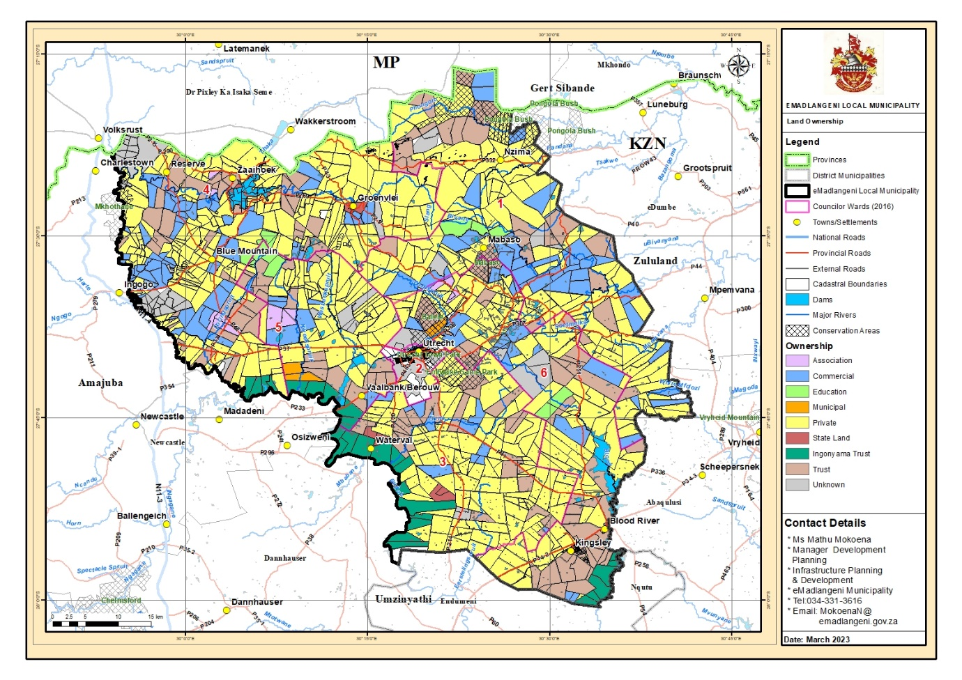

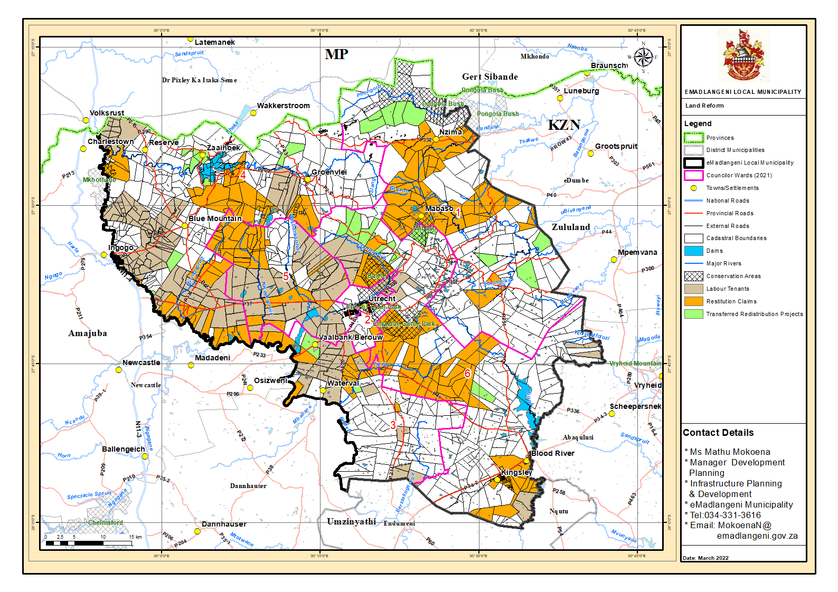
Map 11: Land Reform Within Emadlange

C.4.16.6 LAND RE-DISTRIBUTION
Many of the land redistribution projects in eMadlangeni are located in service satellites and service sub-satellites centres. The locality of satellites and sub-satellites have been determined by the land-reform processes and not by spatial or environmental planning and may thus not be located in the most “environmentally suitable” areas. The following three settlements area have been identified as land reform projects:
• The Groenvlei settlement is located in close proximity to a major wetland; The Amantungwa settlement is located in close proximity to the Boschoffsvlei; and The Mabaso community is located in a mist belt grassland area, an area of high erodibility, along the Bivane River.
The future growth of these settlements will have to be within the regulations of Environmental Management policies and procedures including Environmental Impact Assessments and Environmental scoping to prevent encroachment onto priority areas.
C.8.2 LABOUR TENANT PROJECTS
Most of the land reform projects include those registered by people living on individual farms. These are primarily located on the western region of the municipality, largely in wards 5 and 4.

C.4.16.7 LAND CAPABILITY
EMadlangeni comprises of good to moderate agricultural land potential. There is a small segment on the eastern and south central portions of the municipality which runs in a band that have very restricted agricultural potential. The western, south central and north central portions have good agricultural potential (see map 7).

C.4. 17 Good Governance & Public Participation Swot Analysis
STRENGTHS | WEAKNESSES
Numerous By-laws have been adopted and implemented  Municipal Structures in place  Public participation structures established and operational  EPWP projects | Some key Sector Plans not adopted  Acceleration of projects focused on community development
OPPORTUNITIES | THREATS
Communication Plan  Development and Review of municipal policies and plans | Crime  Political instability

C.5.1 WATER & SANITATION

C.5.1.1 WATER
The Amajuba district has prepared 5-year long-term Water Services Development Plan for the municipality and subsequently appointed uThukela Water as the Water Services Provider (WSP) (IDP 2017/18:96). The 2022 Census data reveals the following in terms water services in eMadlangeni:
• 2.63% of household use water from boreholes inside the yard.
• 18.69% of the municipality’s households use water from rivers/streams.
• 41.47% of households have access to pipe/tap water.
• 4.11% of households use water from a communal stand.
• 18.12% households accessed water from communal taps.

Table 15: Source of Water
Water Source | No. Households | % Households
Regional/local water scheme (operated by municipality or other water services provider) | 4291 | 54%
Borehole | 1326 | 17%
Spring | 294 | 4%
Rain water tank | 68 | 1%
Dam/pool/stagnant water | 138 | 2%
River/stream | 1080 | 14%
Water vendor | 56 | 1%
Water tanker | 545 | 7%
Other | 211 | 3%
Not applicable | 0 | 0
Total | 7998
Source: Statistics South Africa, Census 2022

There are still a number of backlogs faced by the municipality where water service provision is concerned. About 18.69% of households within the municipality still use water from rivers and streams, which is a slight increase from 17.97% in 2011. Although there has been an increase in the number of households with access to tap water since 2011, it is clear that the municipality still has a long way to go in ensuring adequate provision of services to households within the area.

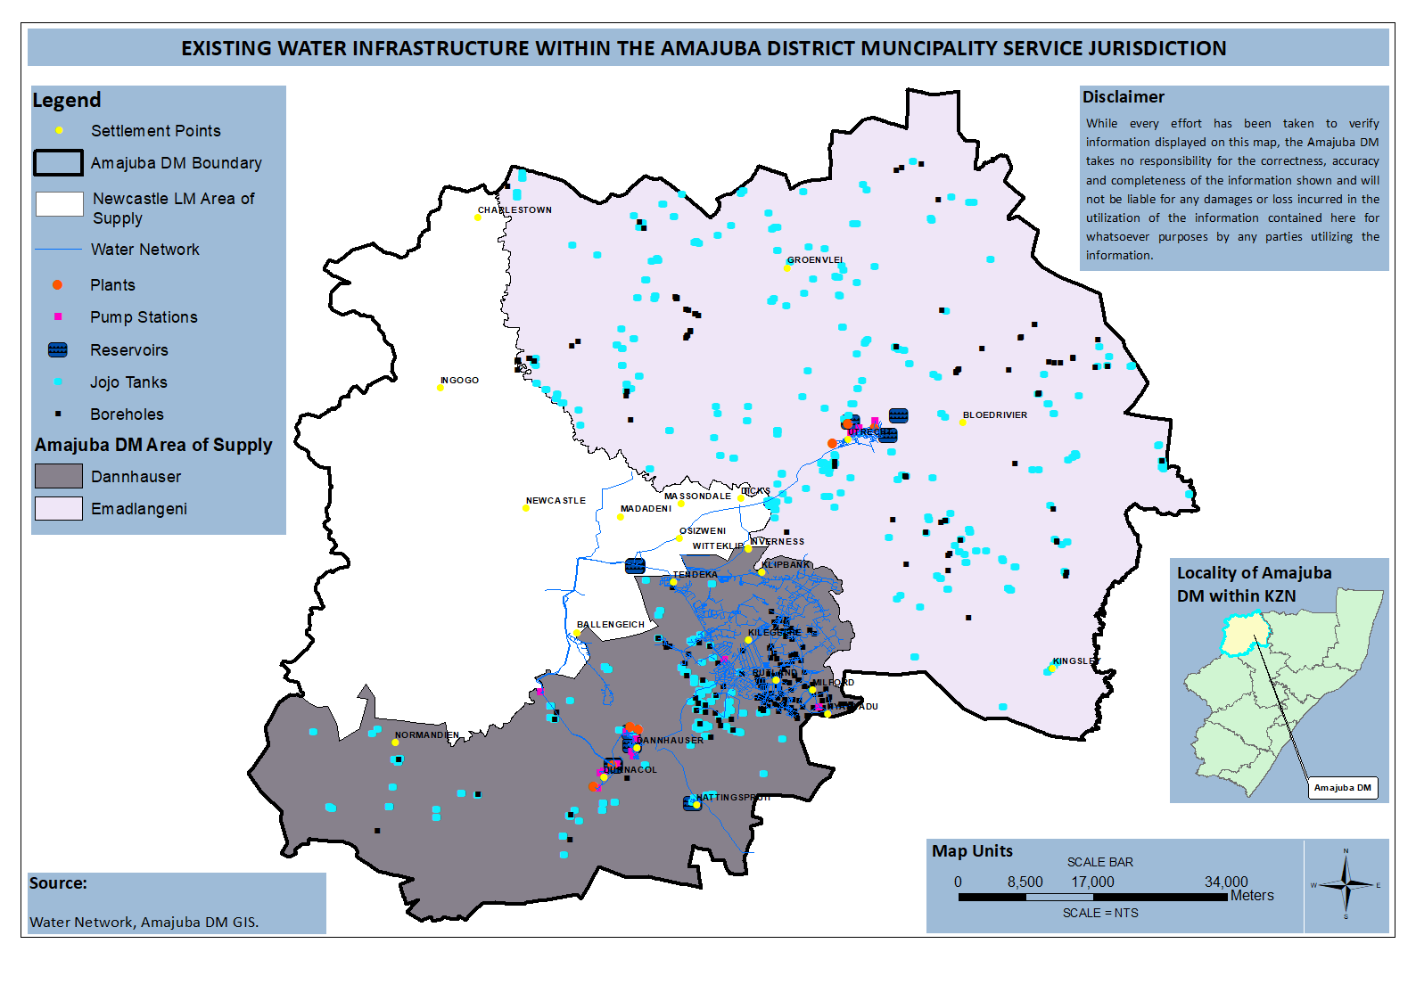
Map: Water Infrastructure

C.5.1.2 SANITATION
According to the IDP (2017/18:99), Amajuba District municipality has provided eMadlangeni with sanitation as the basic infrastructure. The municipality continues to experience sanitation backlogs in some areas, especially in traditional authority areas. The scattered nature of communities in these settlements yields challenges in access and high costs per households (IDP 2017/18:98).

Table 16: Sanitation Facilities
YEAR | TOILET FACILITY | NO. HOUSEHOLDS | % HOUSEHOLDS
2011 | None | 956 | 15,30%
2011 | Flush toilet (connected to sewerage system) | 1783 | 28,53%
2011 | Flush toilet (with septic tank) | 289 | 4,63%
2011 | Chemical toilet | 759 | 12,14%
2011 | Pit toilet with ventilation (VIP) | 136 | 2,17%
2011 | Pit toilet without ventilation | 2015 | 32,23%
2011 | Bucket toilet | 36 | 0,57%
2011 | Other | 277 | 4,43%
2011 | Unspecified | 0
2011 | Not applicable | 0
2011 | Total | 6252
2022 | Flush toilet (connected to sewerage system) | 3138 | 40%
2022 | Flush toilet (with septic tank) | 304 | 4%
2022 | Chemical toilet | 472 | 6%
2022 | Pit toilet with ventilation (VIP) | 1968 | 25%
2022 | Pit toilet without ventilation | 1731 | 22%
2022 | Bucket toilet | 120 | 2%
2022 | None | 164 | 2%
2022 | Total | 7896
Source: Statistics South Africa, Census 2011 & Census 2022

The predominantly used type of sanitation facility in the municipality are Pit toilet without ventilation (see table 14). Approximately, 48.68% (2015 households) of households had access to pit toilet with or without ventilation in 2016, which is a 14.27% increase from 34.41% (887 households) in 2011. The number of households without access to sanitation facilities was recorded at 15.30% of households in 2011, approximately 956 households. The number of households with flush toilets accounted for 37.43% (2365 households) in 2016 indicating an increase of 4.28% from 33.15% (2072 households) in 2011.

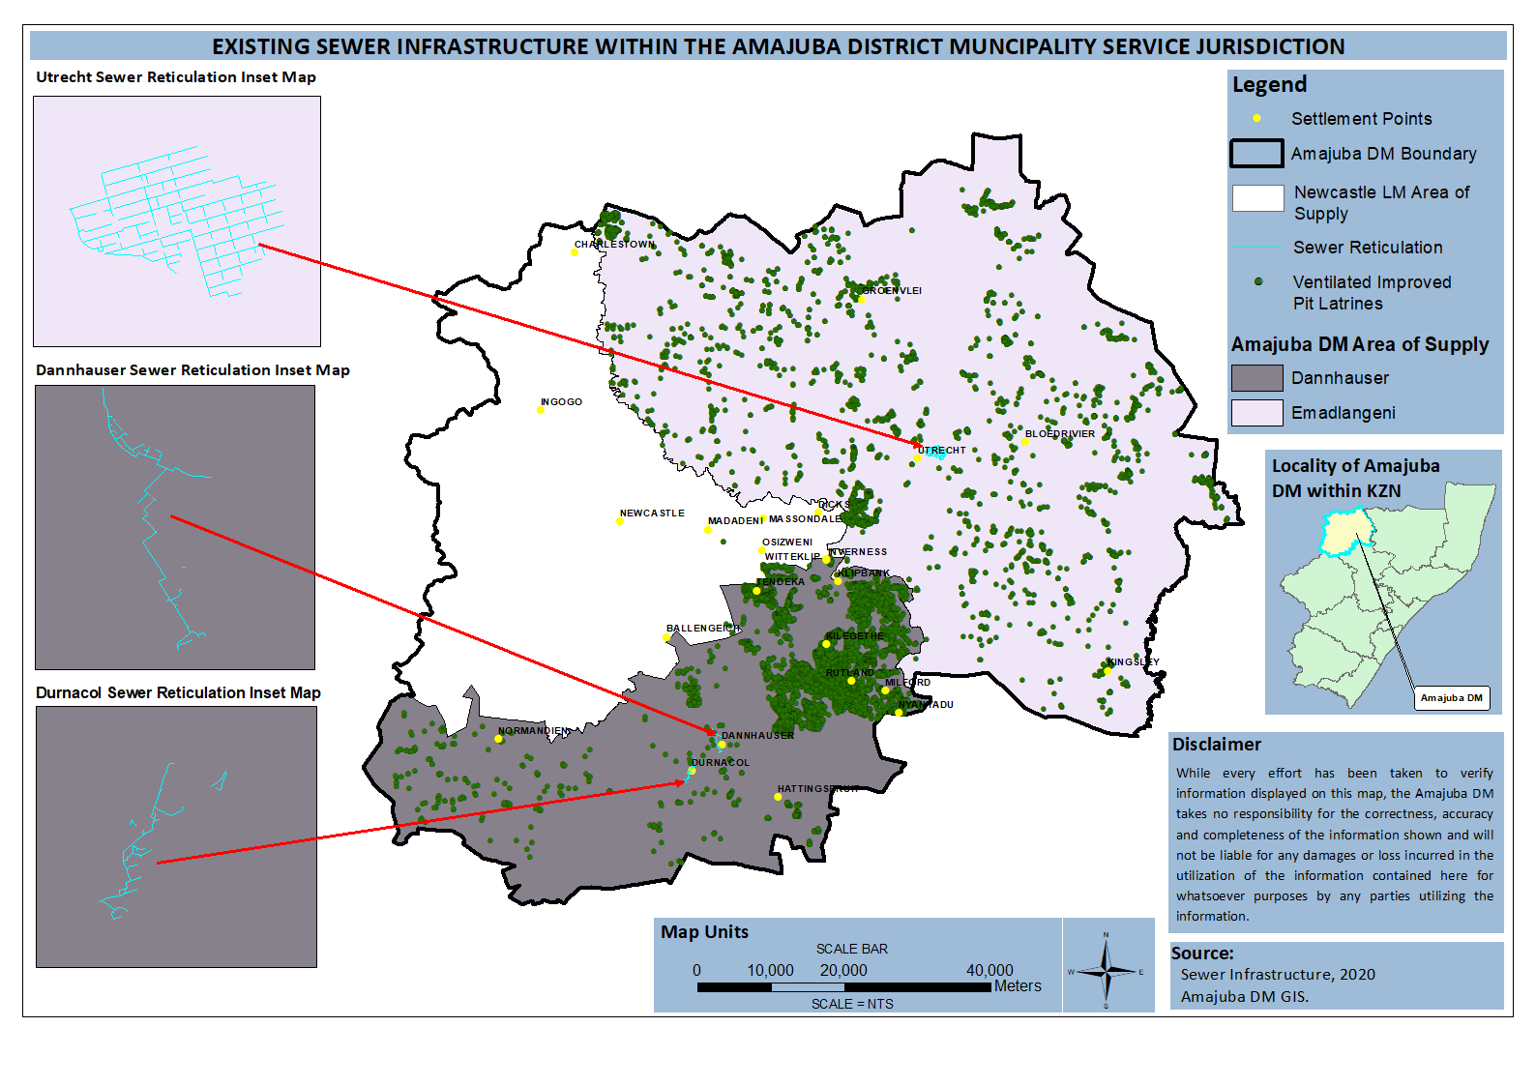
Map: Sewer Infrastructur

C.5.2 SOLID WASTE MANAGEMENT

The eMadlangeni Local Municipality Final Integrated Waste Management Plan and Waste Management Bylaws were tabled before council on the 31st of August 2023 for the final adoption. Both documents have been adopted and the IWMP has since been sent to EDTEA for the MEC’s endorsement. Waste Management Bylaws are yet to be gazetted before they can be implemented.

EMadlangeni Local Municipality has a final Integrated Waste Management Plan (IWMP) compiled and adopted by Council on the 31st of August 2023, it is attached as (Annexure C1). In terms of waste collection services, eMadlangeni Local Municipality is responsible for the general and domestic waste. Residents are responsible for the collection/transporting of their garden waste to the landfill site, private institution are also responsible for the management and collection of medical or hazardous waste using approved companies for collecting such waste. The municipality currently provide services in formal areas such as Utrecht CBD, White city township, Khayalethu, Bensdorp, Caravan Park, Country club and Balgray. However, informal settlements like Thekhani Traditional Council, Amantungwa Traditional Council, Mbatha Traditional Council; and Mgundeni Traditional Council area, are some of the areas where the municipality does not provide waste collection services but caters for KwaNkosi Khumalo Library. Other waste collection services are done through illegal dumps clearing, clean up campaigns and community awareness’s.
WASTE QUANTITIES AND TYPES
WEIGHBRIDGE
The municipality has a landfill site licensed for closure, Namely the eMadlangeni Landfill Site. The site has since been re-fenced and appointed a security guards as the part of starting decommissioning of the site. The site has a weighing pad donated by khabokad but it was never installed since the landfill site is licensed for closure. The site has improved operation in terms of compliance with the license conditions. We are now covering and pushing waste three times a week to avoid windblown litter and unpleasant smell.

VOLUME DENSITY ESTIMATION SYSTEM
EMadlangeni Dump site
Waste type/streams | Waste generated per annum (tons) | Total percentages
Organic waste | 20 | 25.641 %
Cans | 4 | 5.12821 %
Paper | 13 | 16.6667 %
Glass | 20 | 25.641 %
Plastic | 17 | 21.7949 %
Construction and demolition waste | 4 | 5.12821 %
Tyres | 0 | 0 %
Other | 0 | 0 %
Total | 78 tons p/a | 100 %

Service Area and Refuse Collection
The waste service delivery areas of ELM are co-coordinated from Utrecht town, caravan park, Bensdorp, Khayalethu, white city Township and Peri-Urban Areas. The municipality is rendering the following services:
- Kerbsides refuse collection (domestic) once a week in residential areas.
- Removal of waste in Central Business areas is done on daily basis.
- Street sweeping and litter picking are also indicated when Cleaning or emptying street litter bins.
- Landfill operation and management.
Collection services from residential areas are rendered from 08H00 am according to the schedule each day. The municipality has 15 bins with the capacity of 30ℓ bins in town only and the municipal clients are required to have a cage where they place their waste.
Weekly refuse removal services are rendered to 1324 ratepayers (Business and residential) who are counted according to the billing system. Collection in rural areas is uncounted for as it’s not done per household and is partially carried out due to the breakdowns that are encountered.
The municipality has only one refuse truck which is used for waste collection and this refuse truck is very small to accommodate volumes of waste and a daily waste collection service.
The municipal EPWP workers and municipal general workers are responsible for waste collection, street sweeping of the CBD and clean-ups. The street sweeping and waste collection are done on daily basis in the CBD. The municipality in July appointed 26 EPWP participants that they will responsible for waste picking within the jurisdiction of the municipality. Other participants come from CWP and government projects. The municipality benefitted in the Good Green Deeds project from the department of forestry, fisheries and the environment for a period of two years (2019-2021).

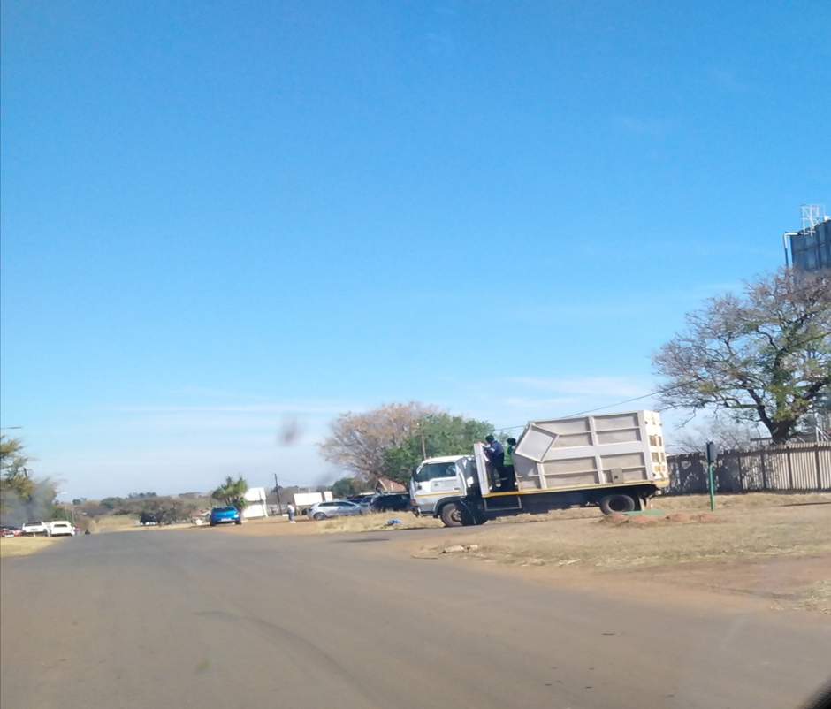
EMadlangeni Local Municipal refuse collection truck NUT3585

Indigent residences
The municipality is currently collecting for the residents that are rates payers. The low income area frequently receive collection through clean-up campaigns. The municipality does not have an approved indigent policy or register.
Mines
Mines that are within Emadlangeni jurisdiction do not receive municipal collection services from the municipality as their waste is piles and their domestic is reused or recycled.
Prisons
The correctional services centres within ELM receives waste collection services for general waste. The medical waste produced by the prisons is collected by the contractor, Compass Medical Waste Services. The prisons indicated that medical collected per month is less than 500kg. However, they are not registered with SAWIS.
Hospital
The municipality has a contract with Niemeyer Memorial Hospital to receive waste collection services for food and other general waste. However, the medical waste is collected by the contractor, Buhle Waste (Pty) Ltd. The hospital could not able to produce the correct answer of how many quantities of medical waste is collected by Compass medical waste services. The hospital has been encouraged to register with SAWIS and register their tonnages.

Challenges/backlog
The municipality is various challenges that prohibits smooth provision of waste management services. The following listed challenges are persisting in the municipality;
- Insufficient funds to fund waste management tools, equipment and infrastructure.
- Refuse truck is old and breaks often and there is no alternative vehicle to assist with waste collection.
- No structure or unit that further or deals with environmental management agenda/issues
- Small portion MIG funds to extract 5% of waste management.
- Landfill site is not properly managed and budged for.
- Lack/insufficient budget for waste management
- Increasing trucks on R34 has increased waste litter along R34 especially in Utrecht.
- Municipality does not have waste bylaws especially the one to address the issue of illegal dumping of building rubble and garden waste.

1.2.1.2 WASTE STREAM ANALYSIS
Waste is classified into two categories, namely: General and Hazardous waste in terms of the National Environmental Management Waste Amendment Act,2014 (Act No 26 of 2014). eMadlangeni Local Municipality has one general landfill site licensed for decommissioning which only caters for the disposal of general domestic waste and garden waste. General and garden waste can be subdivided into the following categories:
- Paper
- Metals
- Glass
- Plastics
- Organic
- Inert material (e.g. building rubble)
- Garden waste (tree branches and grass etc.)

This report will mainly deal with general waste of domestic and garden origin. General waste as described above is divided into the following waste types for the eMadlangeni Local Municipality Area, namely.;
Waste Types
Domestic
Garden
Building rubbles
Non-hazardous

Determining Current Waste Generation and Estimating Future Waste Generation Rates And Quantities

- Domestic Waste Generation Current waste

Generation and estimated future waste generation
Current domestic waste generation rates | 105.63
Future domestic waste generation rates (in 10 years) | 1056.3

Domestic Waste Generation graph:

Waste recycling, treatment and disposal

Status Quo of Waste Disposal Facilities
The EML has one landfill site which in 2018 was licensed for decommissioning and closure. The landfill site lacked engineering planning equipment for it to meet the standards of a landfill site. The landfill site will shortly start its preparations for closure. The landfill site is currently not properly managed because of municipal financial constraints. The EML received a donation from the national department of forestry, fisheries and the environment to construct a buyback centre. However, there has been no communication to start building the said buyback centre.
The municipality is currently faced with financial difficulties to help those who wish to expand in waste recycling initiatives. However, the municipality is currently helping recyclers to register as cooperatives, seek funding and assistance for them. The difficult part about seeking funding for recycling is that the landfill is already licenced for closure, so funders decides not to donate anything as the licence is already indicating closure.

EMadlangeni landfill site
Status | Licensed for closure
Total capacity | I
Existing capacity | ±1,5 years
Available airspace | 100 m3

Status Quo of Waste Treatment Facilities
The municipality is currently starting with the rehabilitation. The current state of the landfill site is merely meeting the conditions of the landfill site license.

Status Quo of Waste Recyclers
The EML does not have a reliable recycler. However, there are recyclers on-site collecting recyclables for transportation to Newcastle. The challenging issue at the landfill site is that the site does not have the electricity to support recycling with the baling machine to accelerate recycling. The municipality is currently considered by the DFFE for the donation of a buyback centre. However, the matter of a buyback centre is still pending. There are current plans to engage pig farmers to source them under waste collection. The aim will be that they will collect all food waste from the municipal clients. Municipal clients will receive containers/ plastics to put food waste separately from recyclables. Then, the willing pig farmers will collect all the food waste.

Collection services
A total number of 6252 households, residential and business facilities inclusive of the game park and old age homes receive waste collection services. This includes domestic, commercial, and urban areas. There is a dire need to extend waste collection services within the municipality due to the concern about waste management raised by residents in most of the un-serviced areas (Refer to IDP on the Total households and subtract the serviced) within the municipality.

National Domestic Waste Collection Standards

Item | Total number
Households | 6252
Serviced households | 1324
Un-serviced households | 4928
Indigent households | Unverified/adopted by council
Un-serviced indigent households | Unverified
Service Level A: On-site appropriate and regularly supervised disposal | 1324
Service Level B: Community transfer to central collection point: | 0
Service Level C: Organised transfer to central collection points and/or kerbside collection: | 0
Service Level D: Mixture of Service Level B and Service Level C: | 0
Total Serviced households as per the National Domestic Waste Collection Standards: | 1324

Financing of Waste Management

Budget/Expenditure: Income and expenditure
Item | Amount
Collection
Transportation | R 0
Capex-purchase (vehicles) | R 0
Maintenance | R 28 501,22
Fuel | R 100 000
Receptacles | R 200 000
General | R 300 000
 | R 0
Subtotal | R 628 501,22
Governance
Staff (remuneration) | R 1 791 196,26
Education and awareness | R 0
IWMPS | R 0
By-laws | R 0
 | R 0
Subtotal | R 1 791 196,26
Disposal
Transfer station | R 0
Disposal sites | R 0
Acquisition of land, equipment | R 0
Regulatory compliance, EIA’s and licence | R 0
 | R 0
Subtotal | R 0
Total | R 0

Revenue sources
Source | Amount
Funding sources | R 2 431 510,90
MIG Funding | R 0
Equitable share funding | R 0
Revenue from waste disposal fees | R 0
 | R 0
Total | R 2 431 510, 90

Waste Management Implementation Plan
This section presents an implementation plan by which the ELM aims to meet the objectives defined in the IWMP. The plan consists of a number of projects and initiatives which, if appropriately executed, should move the ELM towards realizing these objectives. An implementation programme is presented in the table below. It is however being acknowledged that the ELM will face numerous challenges in the implementation of these projects including financial and human resource limitations. It is therefore expected that the implementation plan will be modified during the next 5-year period as resource allocation changes.

Condition | Action | Priority ranking | Estimated Budget | Funding Options | 5 Year implementation plan
 |  |  |  |  | 23/24 | 24/25 | 25/26 | 26/27 | 27
Waste Administration
Waste management bylaws | Develop, adopt and gazette new waste bylaws and should be updated every after years | High | Unfunded | Internal | X | X
Law enforcement | Develop enforcement plan:  Hire peace officers/fining penalties etc. | Medium | Unfunded | Internal |  |  | X | x
IWMP implementation and Monitoring | Monitor the implementation of the IWMP | High | Internal | Operational | X | X | X | X | x
Waste collection tariffs | Review waste collection tariffs to meet standard needs for waste provisions | High | Internal  Current Revenue: 1 935 774, 43 | Internal |  | X | X | X | x
Recycling and waste minimisation
Recycling initiatives | Assist to register recycling companies in the LM and assist them to apply for funding | High | R50 000 | Internal | X | X | X | X | x
Buyback centre | Follow up on the donation of the buyback centre by the DFFE | High | External/unfunded | External | X | X | X | X | x
Establish composting recycling | Conduct a training for composting recycling to the current existing recyclers | Medium | Unfunded | Internal |  | X | X
Landfill site decommission | Start the implementing rehabilitation plan (control access, movable toilets, fencing, capping & shaping, boreholes etc | High | Unfunded | Internal | X | X | X | X | x
Illegal dumping | Clear all illegal dump sites and install a “do not dump board” | Medium | R40 000 | Operational | X | X | X | X | x
New landfill site | Identify land for the establishment of a new landfill site | Medium | Unfunded | Internal |  | X
Construction of the new landfill site | Once land is identified and a landfill budgeted for, establish the site. | Low | Unfunded | Internal |  |  |  | X | X
Waste collection services
Waste collection | Expand waste collection services to areas of indigent provision of free waste collection | High | R 200 000 | Operational |  | X | X | x
Separation at source | Create programmes such as separation at source to diverge going to the landfill site | Medium | Unfunded | Operational |  |  | X | X | x
Waste Fleet | Upgrade the current waste management fleet, procure big compactor truck and 4X4 van | High | Unfunded | Internal | x | X
Street bins | Provide street bins in the town of Utrecht and skips in informal areas | Medium | R25 000 | Operational | X | X | x
Environment education
Awareness | Develop awareness plan for implementation and conduct those awareness’s | High | R40 000 | Operational | X | X | X | X | X
Education | Use municipality website to undertake waste education and awareness and inform all stakeholders on waste projects the municipality is undertaking | Medium | Internal exercise | Internal | X | X | X | X | x
Conduct landfill site audits | Conduct landfill sites audit to check compliance status and improvements | High | Unfunded | Internal | X | X | X | X | x
Human resources and financing
Waste management staffing | Determine additional waste management staffing needed to implement IWMP and recruit accordingly.  Ensure continuous educational development of the staff by identifying suitable waste training needs | High | Unfunded | Operational | X | X | X | X | x
Appropriate finance for waste management programmes | Provide timeously adequate budget to continue with waste management service delivery to achieve the goals of the IWMP. The budget must be approved by council | High | Internal | Operational |  | X | X | X | x
Grants | Apply for Financial grants from external sources to fully implement this IWMP | High | External | Capital |  | X | X | X | x
IWMP
Review IWM[P | Review the IWMP every after five years | Medium | Unfunded | Operational |  |  |  |  | X

C.5.3 TRANSPORTATION INFRASTRUCTURE
Map 12: Road Network
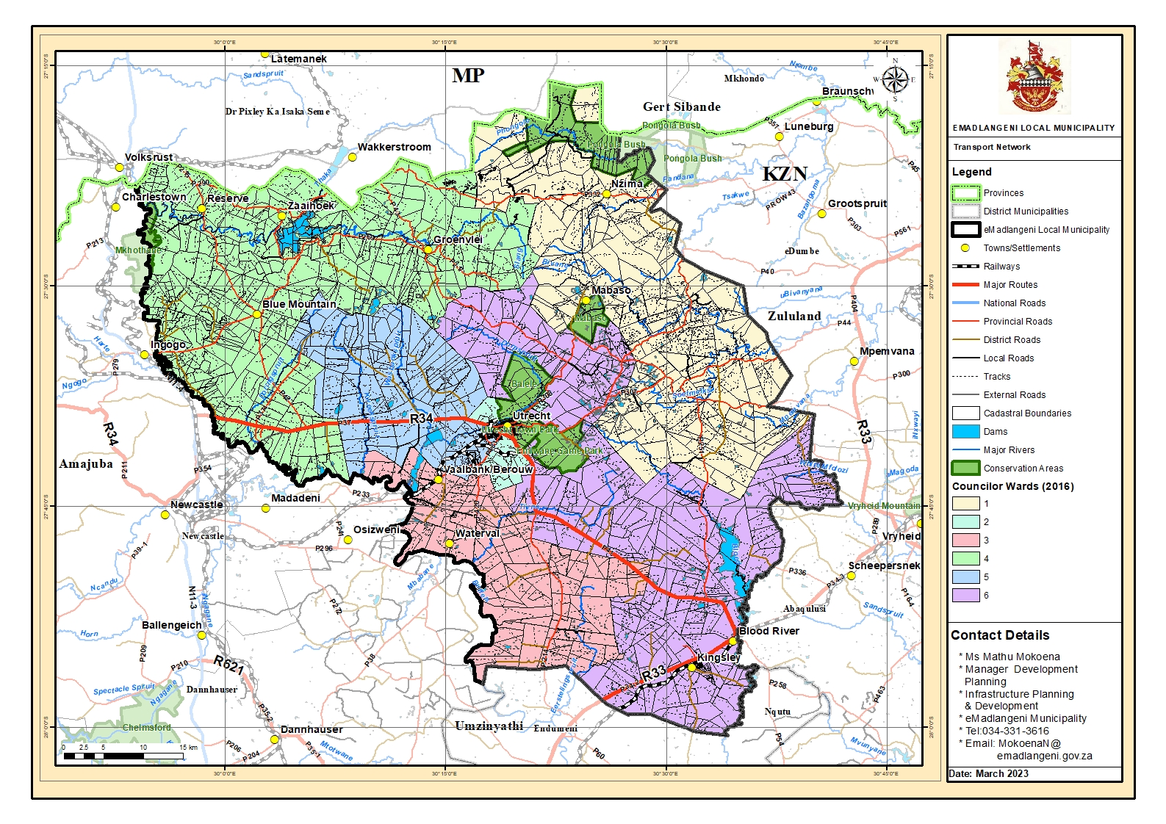

C.5.3.1 ROAD NETWORK
EMadlangeni is linked to the surrounding towns of Dundee, Newcastle and Vryheid. Newcastle is linked to eMadlangeni via the R34 tarred road and via P483, and provides most of the administrative and institutional needs within the district. Newcastle serves as a commercial core for eMadlangeni residents particularly those in the central and southern portion of the Municipality. The municipality is also linked with Dundee and Vryheid via R33 tarred road and with Volksrust via National Road N11; this makes an easy access from the KwaZulu–Natal Province to other Provinces (SDF 2023).

C.5.3.1 PUBLIC TRANSPORT
Public transport is essential in providing access and mobility. The N11 is the main transport route linking the municipality to outside areas (Durban-Johannesburg). However, only a small section of this road borders on the western side of eMadlangeni). The R34 that runs through the municipality from west to east divides eMadlangeni into northern (Utrecht, Groenvlei, Blue Mountain) and southern areas (Kingsley, Waterval).

C..5.4 Energy

The National Electricity Regulator of South Africa in exercise of the powers conferred by section 6 of the Electricity Act, 1987 (Act No.41 of 1987) licenses Emadlangeni Local Municipality to distribute and supply electricity to 1 483 consumers of electricity within ward 2 and ward 5. The municipality is in the process of developing the electricity plan for the 2025/26 financial year.
The spatial distribution of electricity within the municipality exhibits a trend where urban nodes and areas around road transport infrastructure tend to be better serviced compared to outlying areas. Scattered and isolated communities in outlying areas tend to contribute the biggest backlog in the municipality due to the high cost associated with connection to low-density areas.
Figure 5: Energy for Lighting

Source: Statistics South Africa, Census 2011 & Census2022

In 2011, 48.49% of the households within the municipality used electricity for lighting which is approximately 3032 households (see figure 5). This number increased to 3816 households in 2016, accounting for approximately 57.24% of the households within the municipality. The 2016 Community Survey reveals that approximately 2770 (34.04%) households in the municipality use candles for lighting which is a 14.30% decrease from 2011.
Energy for Cooking | 2011 |  | 2022
Energy for Cooking | No. Households | % of Households | No. households | % households
Electricity from mains | 2515 | 40,22% | 2940 | 36.7%
Gas | 237 | 3,80% | 2188 | 27.3%
Paraffin | 234 | 3,75% | 112 | 1.4%
Wood | 2820 | 45,10% | 2581 | 32.2%
Coal | 216 | 3,46% | 100 | 1.2%
Animal dung | 211 | 3,38% | 28 | 0.3%
Solar | 3 | 0,05% | 11 | 0.1%
Other source of electricity (e.g. generator etc) | 4 | 0,07% | 28 | 0.3%
None | 11 | 0,17% | 10 | 0.1%
Total | 6252 |  | 7998
Table 17: Energy for Cooking
Source: Statistics South Africa, Census 2011 & Census 2022
Table 15 and 16 show the different energy sources used for cooking and heating throughout the municipality between 2011 and 2016. The number of households using wood for cooking has decreased from 45.10% (2810 households) in 2011 to approximately 41.06% (2724) of households within the municipality in 2016. This is worrisome since wood is an environmentally unfriendly energy source and the use of wood ultimately leads to de-forestation and contributes to the degradation of land within the area. The use of electricity within the municipality for cooking and heating has increased between 2011 and 2016 to approximately 52.185 and 47.62% (see table 15 & 16), respectively. However, not at a rate that can significantly curb the consequences of using wood as an energy source. This is concerning because the backbone of the municipality is agriculture.
Table 18: Energy for Heating
Energy for Heating | 2011 |  | 2022
Energy for Heating | No. Households | % Households | No. Households | % Households
Electricity from mains | 2003 | 32,04% | 2940 | 36.7%
Gas | 125 | 2,00% | 2188 | 27.3%
Paraffin | 114 | 1,83% | 112 | 1.4%
Wood | 3031 | 48,48% | 2581 | 32.2%
Coal | 358 | 5,72% | 100 | 1.2%
Animal dung | 270 | 4,32% | 28 | 0.3%
Solar | 6 | 0,10% | 11 | 0.1%
Other source of electricity (e.g. generator etc) | 4 | 0,06% | 28 | 0.3%
None | 341 | 5,45% | 10 | 0.1%
Total | 6252 |  | 7998
Source: Statistics South Africa, Census 2011 & Census 2022

C.5.5 Access to Community Facilities

C.5.5.1 Community Development
In terms of The Municipal Systems Act No. 32 of 2000; Section 51 (a) states that: “A municipality must within its administrative and financial capacity establish and organise its administration in a manner that would enable the municipality to be responsive to the needs of the local community.”
eMadlangeni Local Municipality co-ordinates, develops and promotes a range of community development programmes aimed at ensuring that social upliftment and development objectives are accomplished. These programmes are executed through interacting with community based structures to facilitate alignment of needs and priorities of vulnerable groups in the community. The Municipality utilises structures (forums) for different vulnerable groups in the community to identify and prioritise needs in order to ensure the execution of a needs based service in the community. These structures (forums) are established both at ward level, and at local level. The establishment of these structures also assist to strengthen the relationship between the government and the community.
The following are the community development programmes that are executed by the Municipality, which are aimed at addressing the needs of vulnerable groups in the community as mandated by the Municipal Systems Act No. 32 of 2000.

Libraries
EMadlangeni Local Municipality has a public library located in the town of Utrecht. It contains textbooks for both children and adults while at the same time accommodating Council Agendas to keep the public informed about council matters. In an effort to improve internet access within the town, the library has been provided with computers and internet services.
The municipality is assessing the provision of mobile library services to distant areas which cannot access library services. Mobile library services will potentially visit areas outside the town of Utrecht and outlying peri-urban settlements within the municipality. There is a new completed and operational library constructed by Department of Art and Culture at KwaNkosi Khumalo (Moduler Library) in 2022.

Community Halls
There are two community halls located within Utrecht. The low densities within settlements makes it a challenge to construct community halls within single settlements. There are five community halls within eMadlangeni and are illustrated in the table below:

Table 19: Community Halls
WARDS | LOCATION
Ward 2 | Utrecht town  White City
Ward 3 | Emaxhakeni
Ward 4 | Groenvlei

Sports Facilities
The municipality faces challenges with regards to the maintenance of sports facilities. The provision and maintenance of sports facilities throughout the municipality differs between the rural and urban areas. There are currently 13 sports field/grounds within eMadlangeni Municipality; these are unevenly spread out through the municipal wards. The table below illustrates the distribution of sport fields/ground within the municipality.
Table 20: Sports Fields/Grounds
WARD | LOCATION | NUMBER
Ward 1 | Gelykwater  Dorothea – Phesheyakobivane  -Nkonjane  Lembe – Mondi  -Lembe  Luthulunye  Enzimane – Makhomba  -Maphekuleni  -Wema  -Mbanjwana  -Nzimane School | 1
Ward 2 | White City  Bersig  Khayalethu | 1  1  1
Ward 3 | Vaalbank  Enkululukweni  Emxhakeni  Giyane  Ndwakazane | 2  1  1  1  1
Ward 4 | Groenvlei sport ground  Kaalport Sports Ground  Slang Sports Ground  Zaaihoek Enkosini Sports Ground  Phokweni Sports Ground  Reserve sports ground  Rooiwal sports Ground  Mange Sports Ground  Thobothi Sports Ground  Jericho Sports Ground | 10
Ward 5 | Ezimbuthu  Bensdrop  Ngodini  Ingulane  Chanceni  Emadlangeni  Midway | 1  1  1  1  1  2  1
Ward 6 | Esidakeni  Engodini  Umlwane  eSlagveld  Kingsleyd | 1  1  1

Cemeteries
eMadlangeni has three registered cemeteries located in the town of Utrecht. Only two are operational; the Khayalethu Cemetery and the New Town Cemetery. The old Utrecht cemetery is full with the exception of reserved graves. There is an unregistered cemetery (Kingsley Cemetery) located in Kingsley town (ADM Cemetery Plan Report: 2004)). Groenvlei and Vaalbank/Berouw has a number of informal cemeteries. There are households within rural settlements which also engage in traditional burials within the homestead.

Correctional services
Emadlangeni Local Municipality comprises of two Correctional Services, namely: Utrecht Correctional Centre in Ward 2 and Waterval Correctional Centre in Ward 3.

Health
The eMadlangeni sub-district consists of 1 district hospital, 1 prison hospital, 2 provincial fixed clinics (gate clinic), 3 mobile provincial clinics, 1 EMRS base and 1 forensic mortuary (IDP RF March 2022). The district hospital, Niemeyer Memorial Hospital, is located in Utrecht and offers district level services. Patients requiring regional level, advanced and specialized healthcare are referred to Newcastle and Madadeni hospitals. Many people have to travel more than 10km to access hospital services. There is an EMRS base at no 14 Hoog street, Utrecht which is dispatched from Newcastle, thus improving response time.
The Groenvlei clinic is operational while there are three mobile clinics operating throughout the eMadlangeni area. These mobile clinics operate as follows:
Mobile 1 = 26 visiting points
Mobile 2 = 26 visiting points
Mobile 3 = 34 visiting points

The department of health at eMadlangeni sub-district has the following Ward Based Outreach Teams:
Niemeyer Gateway clinic
• 1 School health team
• 1 Family health team

Groenvlei clinic
• 1 School health team
• 1 Family health team
Further to the above, there are seven philamntwana centres throughout the municipality, 3 pick-up points for chronic medication (old age home, Dr. Docrat and Niemeyer Gateway Clinic).

Education
EMadlangeni is generally well-provided with educational facilities, except tertiary facilities. There are approximately 31 schools within eMadlangeni as indicated in Table 21 as per new demarcation. The municipality also has a total of 12 Early Childhood Development Centres. However, the schools within the areas are in need of upgrading of facilities as well as additional classrooms. Other issues include long distances learners and educators have to travel to access educational facilities.

Figure 10: Level of Education

Source: Statistics South Africa, Census 2011 & Stats SA Census 2022

Table 21: Schools Per Ward
WARD | SCHOOL
Ward 1 | Gelykwater Primary School  Ingcaka High School  Dorothea Primary School  Lembe Primary School  Luthulunye Primary School  Enzimane Combined School  Myayiza Primary School
Ward 2 | Utrecht High School  Bersig Special School  Emalahleni Combined School  Umlandomusha High School
Ward 3 | Ndwakaza Combined School  Isibonelesihle Primary School  Mxhakeni Primary School  Mzilikazi High School  Thamsanqa Primary School  Odoland Primary School
Ward 4 | Blue Mountain Primary School  Groenvlei Combined School  Kroomellenboog Primary School  Sinqobile Primary School
Ward 5 | Emadlangeni Primary School  Zimbuthu Primary School  Utrecht Primary School  Intuku Primary School
Ward 6 | Esidakeni Primary School  Umlwane Primary School  Slagveld Primary School  Kingsley Combined School  Wit –Mfolozi Combined school  Mbathani Primary School  Waaihoek Primary School  Nhlazadolo Combined School

SAFETY AND SECURITY
EMadlangeni has 3 police stations located in Kingsley, Groenvlei and Utrecht (see map 18). Response times to outer lying settlements tends to be longer because of the scattered nature and pattern of rural settlements in the municipality.

C.5.5.3 ANIMAL POUND

In terms of section 3(1) of the Emadlangeni Municipality Pound By Laws the Municipality must establish a pound at any convenient place within its area of jurisdiction: Provided that the Municipality may, on application, enter into a service delivery agreement with an institution or person mentioned in section 76(b) of the Municipal Systems Act, to provide for the establishment and operation of a pound to service its area of jurisdiction.
On the 1st November 2023 the Municipality appointed Loma Business Enterprise as the service provider for animal pound services in the jurisdiction of eMadlangeni Municipality. In terms of the agreement between the parties, the service provider is to provide monthly reports on the operation of the pound. The monthly report as of the 1st November 2023 to 29 February 2024 can be summarized as follows:

MONTH | COMPALINTS RECEIVED | NO. OF ANIMALS RECEIVED | NO. OF ANMALS RELEASED | NO. OF ANIMALS SOLD | BODY RECEIVED FROM | NO. OF STAKEHOLDER MEETINGS | NO. OF MUNICIPAL OFFICIAL VISITS
NOVEMBER | Several | 0 | 0 | 0 | 0 | 0 | 0
DECEMBER | Stock theft operations | 08 | 08 | 0 | SAPS/ stock-theft | 01 | 0
JANUARY | Stock theft | 02 | 02 | 0 | SAPS/ stock-theft | 0 | 01
FEBRUARY | 01 | 04 | 06 | 0 | Land owner | 0 | 0

NON-GOVERNMENTAL ORGANISATIONS (NGOs)
Name of NGO | Registration Number | Registration Date | Funding Status
Sibonikusasa Drugs and Treatment Rehabilitation Centre | 260-885 NPO | 01 July 2021 | Unfunded

C.5.5.4 SOCIAL DEVELOPMENT

The Municipality is mandated by the Municipal Systems Act No. 32 of 2000; Section 51 (a) to ensure the establishment and organisation of its administration in a manner that would enable the municipality to be responsive to the needs of the local community within its administrative and financial capacity. Emadlangeni Municipality established and launched forums for the vulnerable groups in 2022, to serve for the period of five (5) years. The establishment of these forums assist in identifying the needs of vulnerable, and to ensure that the Municipality gives priority to needs of the vulnerable groups in the community. The Municipality develops and executes Social Development Programmes based on the identified needs for each sector. Forums also assist in strengthening the relationship between the Municipality and the community.

The forums for the vulnerable groups are as follows:
- The Local Drug Action Committee
- The Local Aids Council
- The Local Youth Council
- The Local Women’s Forum
- The Local Men’s Forum
- The Local Senior Citizens Forum
- The Local Disability Forum
- The Local Arts & Culture Forum
Forum meetings are held, and programmes for the empowerment and development of vulnerable groups are executed in collaboration with the stakeholders of Operation Sukuma Sakhe, for a collaborative effort and shared resources.

YOUTH DEVELOPMENT
With a very youthful population making a large portion of eMadlangeni, the municipality dedicates itself to the contribution and empowerment of the youth through:
The establishment and maintenance of community structures that help to ensure youth development;
Ensuring the existence and functionality of the Local Youth Council. The Municipality officially launched the current Local Youth Council on the 20th of May 2022, to serve for the period of five (5) years in line with the current Administration. Local Youth Council Meetings sit on a quarterly basis.
Ensuring that community outreach activities aimed at youth development are executed, and these include:
- Youth Dialogues;
- The Matric Empowerment Programme;
- Career guidance/ expo;
- Matric Excellence Awards;
- The Back to School Campaign;
- Emadlangeni Sports & Arts Festival
- Awareness Campaigns addressing different social ills affecting the youth;

ELDERLY (SENIOR CITIZENS) AND PEOPLE WITH DISABILITIES
EMadlangeni Local Municipality ensures that older persons are given the opportunity to remain independent, active and contributing citizens in the community while receiving quality services. Additionally, the municipality ensure that older person receive integrated and coordinated services and elucidate the roles and responsibilities of stakeholders with regards to service provision to the elderly.
Programmes towards the development of Senior Citizens at local level include the following:
- Facilitate the establishment and ensure the functionality of Ward and Local Senior Citizens Forums.
- Capacity Building Workshops for Senior Citizens Forum.
- Participation of Senior Citizens in Luncheon Clubs.
- Facilitate interaction with stakeholders in addressing the needs of senior citizens.
- Assist in the mobilization of senior citizens to participate in active healthy lifestyle programmes (Golden Games).
- Participate in all structures that seek to promote the interest of senior citizens.
- Ensure participation of Senior Citizens in Senior Citizen’s Parliaments.
- Old Age Home Support Programme.

Number | Name | Number of Beneficiaries
1 | SAVF Huis Joanna Old Age Home | 50

DEVELOPMENT OF WOMEN
EMadlangeni Local Municipality is committed to playing a more proactive and supportive role in promoting the inclusion and development of women in the municipality. Efforts towards the development of women in the municipality include the following programmes and activities:
- Ensuring the existence and functionality of the Local Women’s Forum;
- Women’s Dialogues;
- Execute programmes and interventions to deal with the scourge of Gender Based Violence and Femicide at local level in line with the six (6) key Pillars of the Provincial Gender Based Violence and Femicide Strategic Plan 2021 – 2025.
- Economic empowerment through Expanded Public Works Programme;
- Skills development programme to support women entrepreneurs as a means to address economic inequality by enabling women previously denied of opportunities because of skills gaps to participate in the economy and/ or start and grow their businesses;
- Support programme for vulnerable households;
- Execute women programmes in the jurisdiction of eMadlangeni;
- Awareness promotion campaigns on health and wellness programmes, HIV/AIDS prevention and care, and other diseases;
- Ongoing activity on promoting access to and uptake of social grants for women;
- Contribution to the development of housing over the next 10 years to ensure that women have access to affordable, safe and decent accommodation.

MEN’S DEVELOPMENT

EMadlangeni Local Municipality ensures development and empowerment of men; and that men play a vital role in the fight against women and children abuse. Men’s Development Programmes include the following:
Ensuring the existence and functionality of the Local Men’s Forum; Men’s Dialogues;
Isibaya Samadoda;
Men Championing Change Programmes with the focus on social and behavioural change to ensure that men are mobilised within eMadlangeni Local Municipal area, and that men play a role in ending social ills including violence and substance abuse;
Mentorship programmes – men playing a role in raising responsive responsible young men;
Programmes aimed at addressing issues of social and economic development in order to attack the triple challenges of poverty, unemployment, and inequality.

PEOPLE AFFECTED BY CRIME, HIV/AIDS, DRUGS
EMadlangeni Local Municipality has a Strategic Plan for HIV/AIDS in place. The plan was adopted by the council in September 2015 and was reviewed in 2023. There are support groups through Ward Aids Committee / Ward War Rooms, the LAC established – Chaired by the local Mayor.

Interventions at local level include the following:
- Develop and Execute HIV/AIDS Programmes and interventions at local level in line with outcome goals of the Provincial Multi-Sectoral Response Plan for HIV, TB and STIs.
- On-going provision of a treatment, care and support, which includes counselling, voluntary testing, mother to child transmission prevention, wellness programmes, home-based care, and bereavement support and the targeting of vulnerable groups such as children and orphans,
- The establishment of a local database on HIV infections and AIDS deaths, disaggregated on the basis of age, gender, race and geographic area;
- Anti-discrimination and de-stigmatisation campaigns;
- On-going monitoring and evaluation of programmes.

Furthermore, community awareness’s are conducted within the municipality in order to:
- Reduce HIV/AIDS and mitigate its impact by expanding the on-going programme of information dissemination, provision of condoms and community mobilisation, with a special focus on peer education campaigns and the youth;
- Expand other community outreach programmes that identify people/ households in need and provide HBC, referral services etc;
- Support on providing services to home-based terminally ill patients;
- Market support groups and programmes for people infected and affected by HIV/ AIDS.

DEVELOPMENT OF PEOPLE WITH DISABILITIES
EMadlangeni Local Municipality facilitates and ensures the empowerment of People Living with Disabilities (PLD) through;
- The establishment and functionality of local structures for People Living with Disabilities;
- Engaging in systems change and efforts towards capacity building that promote self-determination, integration, and inclusion of people living with disabilities;
- Raise awareness and promote disability issues and rights.
- Ensure that people living with disabilities participate in healthy life style programmes.
- Ensure participation of People with Disabilities in Disability Parliaments
- Employment Services- where persons living with disabilities will be assisted in finding careers matching their strengths, abilities, conditions and preferences for employment (1 general worker employed during 2014);
- Health, Prevention and Wellness Programs to ensure that PLD remain as healthy as possible.

STRENGTHS | WEAKNESSES
Skilled and Experienced Staff  Dedication, willingness, and commitment to perform duties attached to the Social Services unit.  Forums exist to deal with issues of vulnerable groups.  Well-developed Program mandates and goals for the development and empowerment of vulnerable groups.  Effective Coordination of Community Development Initiatives.  Numerous Activities executed for the development & empowerment of vulnerable groups (e.g. Back to School Campaign, Matric Empowerment Programme, Matric Excellence Awards, Child Protection Week Programmes, Men & Women Dialogues, Golden Games for Senior Citizens, Disability Games, Workshops for Vulnerable Groups, etc.) | Lack of capacity finances to execute community development programs.  Only one employee responsible for the functioning of the Social Services Unit.
OPPORTUNITIES | THREATS
Tapping into the internship programme to increase and strengthen capacity and continuity of service.  Strong and healthy working relations with other stakeholders.  Integrated Planning and Implementation of Programmes at OSS Level. | Social ills (e.g. High levels of unemployment & lack of employment opportunities among the youth, Substance Abuse, Crime, Teenage Pregnancies, Gender Based Violence & Femicide, etc.)

C.5.5.4 DEVELOPMENT OF PEOPLE WITH DISABILITIES

EMadlangeni Local Municipality facilitates and ensures the empowerment of People Living with Disabilities (PLD) through;
- The establishment and functionality of local structures for People Living with Disabilities;
- Engaging in systems change and efforts towards capacity building that promote self-determination, integration, and inclusion of people living with disabilities;
- Raise awareness and promote disability issues and rights.
- Ensure that people living with disabilities participate in healthy life style programmes.
- Ensure participation of People with Disabilities in Disability Parliaments
- Employment Services- where persons living with disabilities will be assisted in finding careers matching their strengths, abilities, conditions and preferences for employment (1 general worker employed during 2014);
- Health, Prevention and Wellness Programs to ensure that PLD remain as healthy as possible.

C.5.5.5 EARLY CHILDHOOD DEVELOPMENT

The Municipality does not take early childhood development lightly. It is important that efforts be made towards ensuring that every child is afforded access to the services that are inherently necessary for his/her development. To this end, the municipality provides a range of services to children in line with the implementation of the Children Act 38 of 2005. The Act is guided by rulings in favour of the best interests of the child.
To this effect, the municipality ensures that programmes aimed at Child Development and Support are executed, and these include:
- Children’s Dialogues;
- Conducting awareness programs on the protection of children’s rights;
- Conducting the Back to School Campaign to contribute towards the support of disadvantaged children in the community;
- Engages in the building of ECD centres (as per requirement);
- Provides resources and support in the field of early childhood development;
- Strives to ensure the effectiveness and efficiency of ECD provision to all children;
- Ensures the provision of Childcare and protection services;

Early Childhood Development Centres
WARD | CENTRE NAME
Ward 1 | Sigodiphola Creche
Ward 2 | Utrecht Pre-Primary  Little Journey Creche  Siphintuthuko Creche  Emalahleni Creche
Ward 3 | Khanyekahle Creche
Ward 4 | Imizamoyethu Creche
Ward 5 | Lindokuhle Creche  Mbalenhle Creche  Thandulwazi Creche  Isisekelo Creche  St Fransis Creche and Pre-School

Table 22: Early Childhood Development Centres

A need for new ECD Centre was reported in Ward 4 – Groenvlei.

Map 13: Hospital Catchment

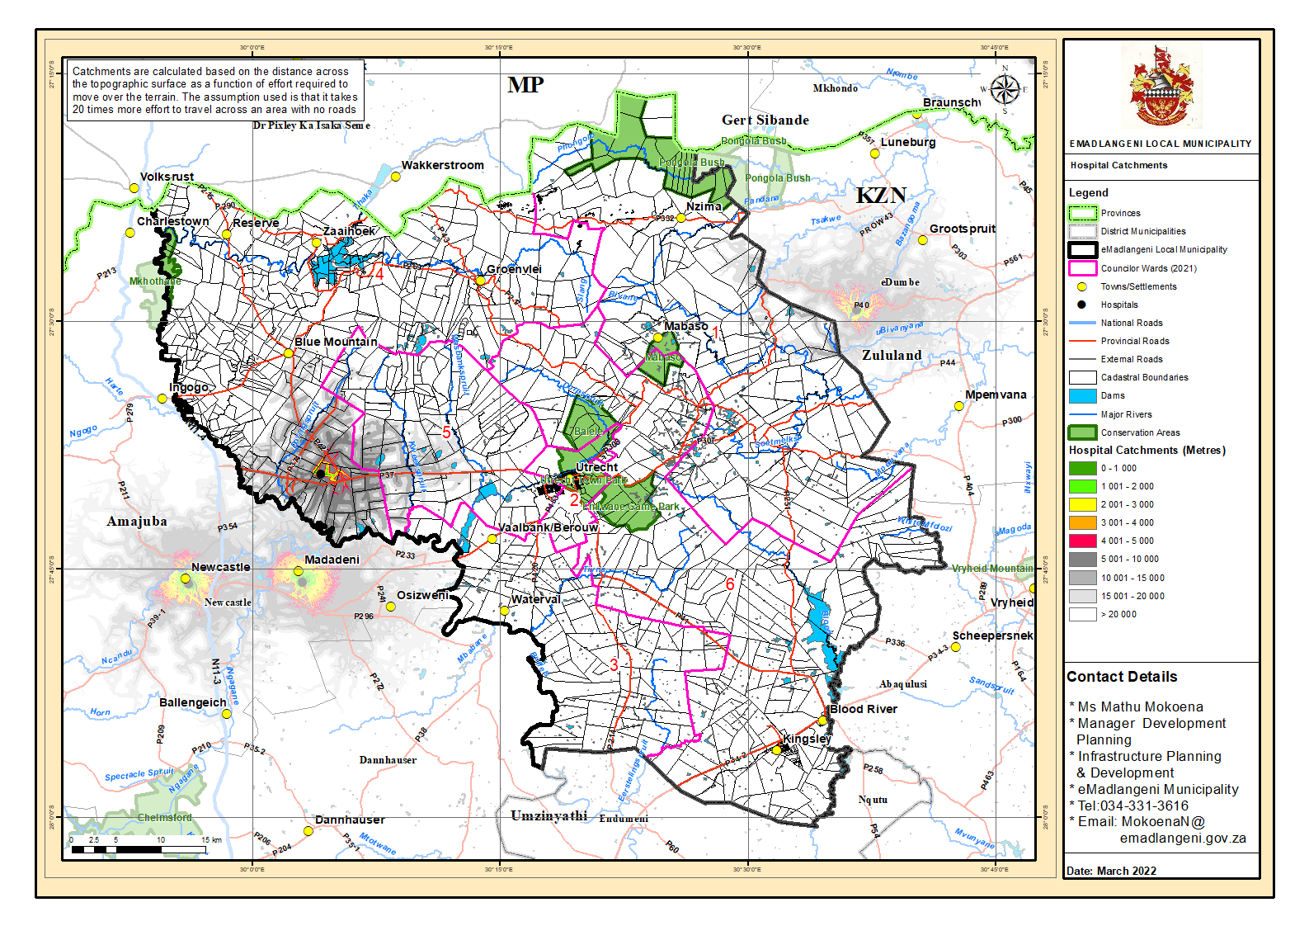
Map 14: Clinic Catchment

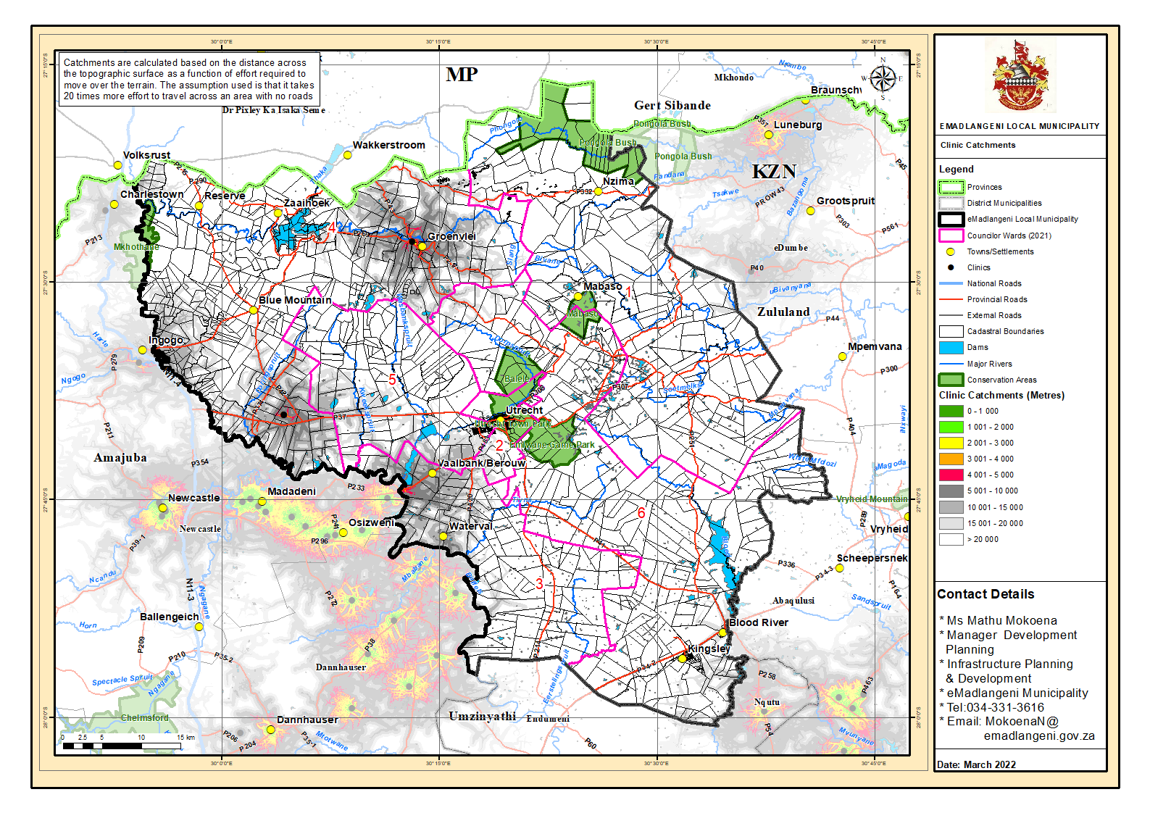
Map 15: Primary School Catchment

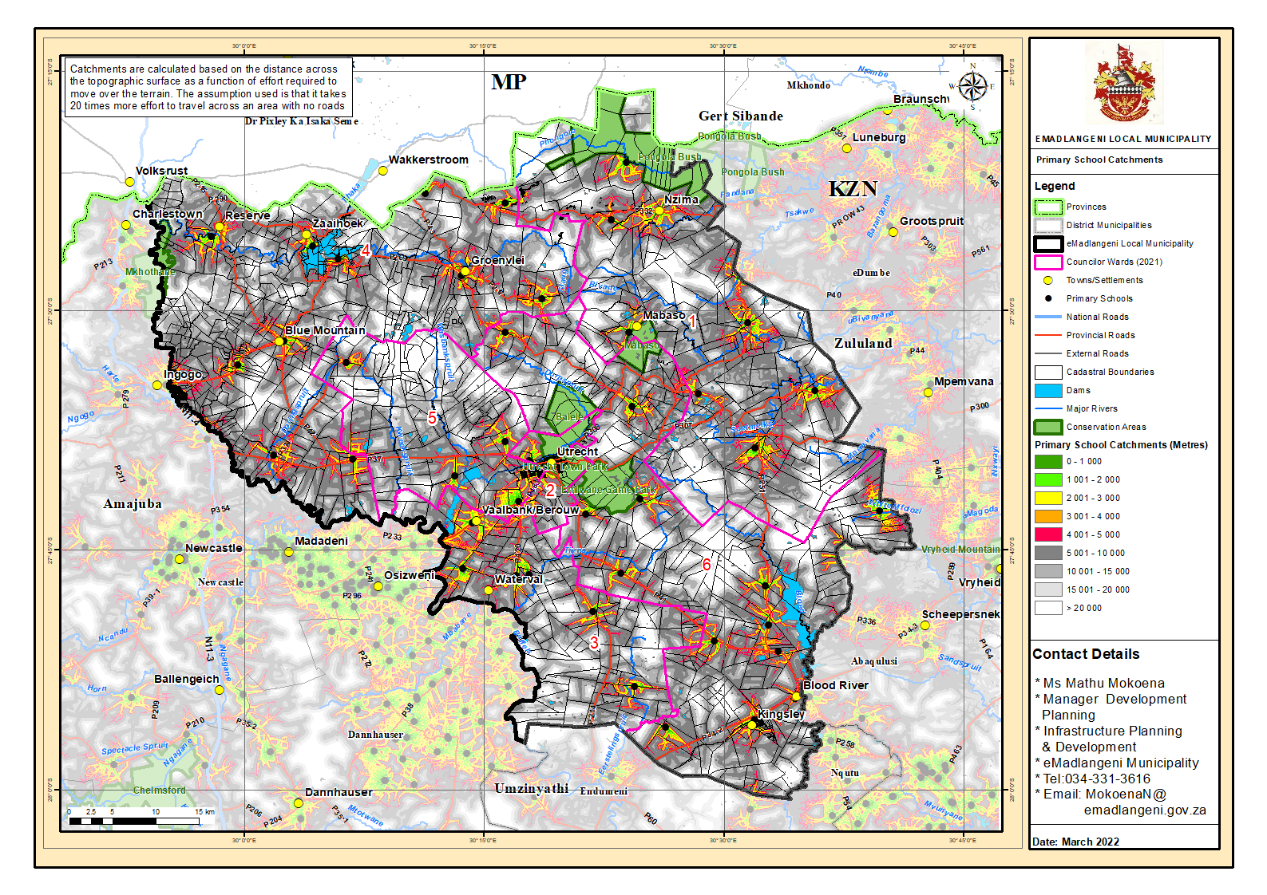
Map 17: Secondary School Catchment

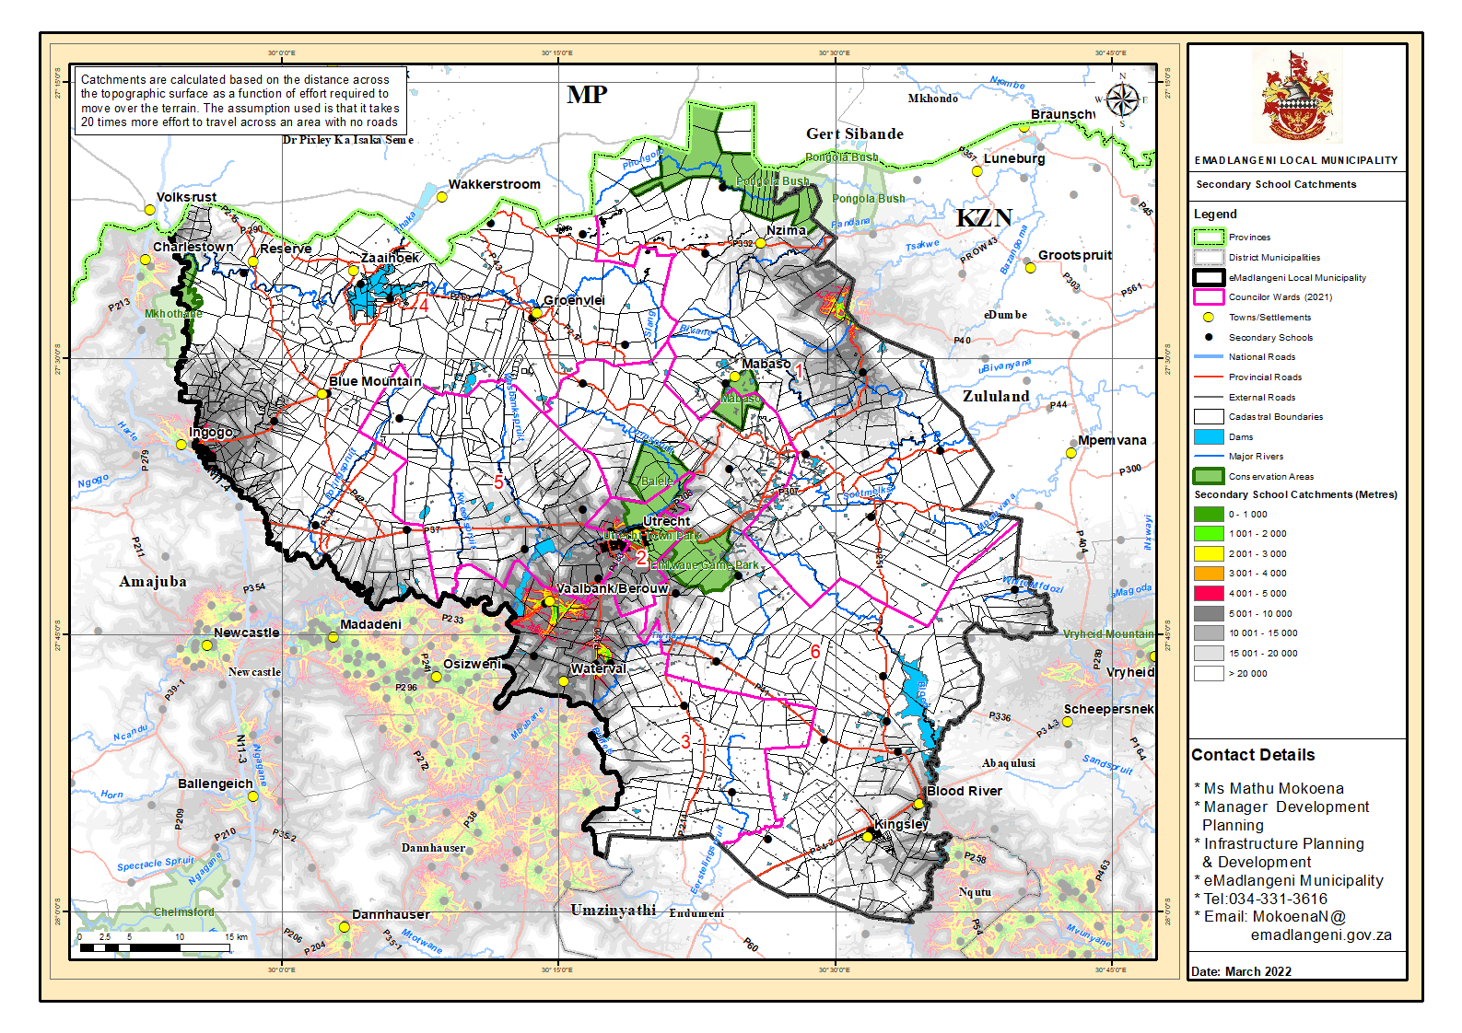
Map 18: Police Station Catchment

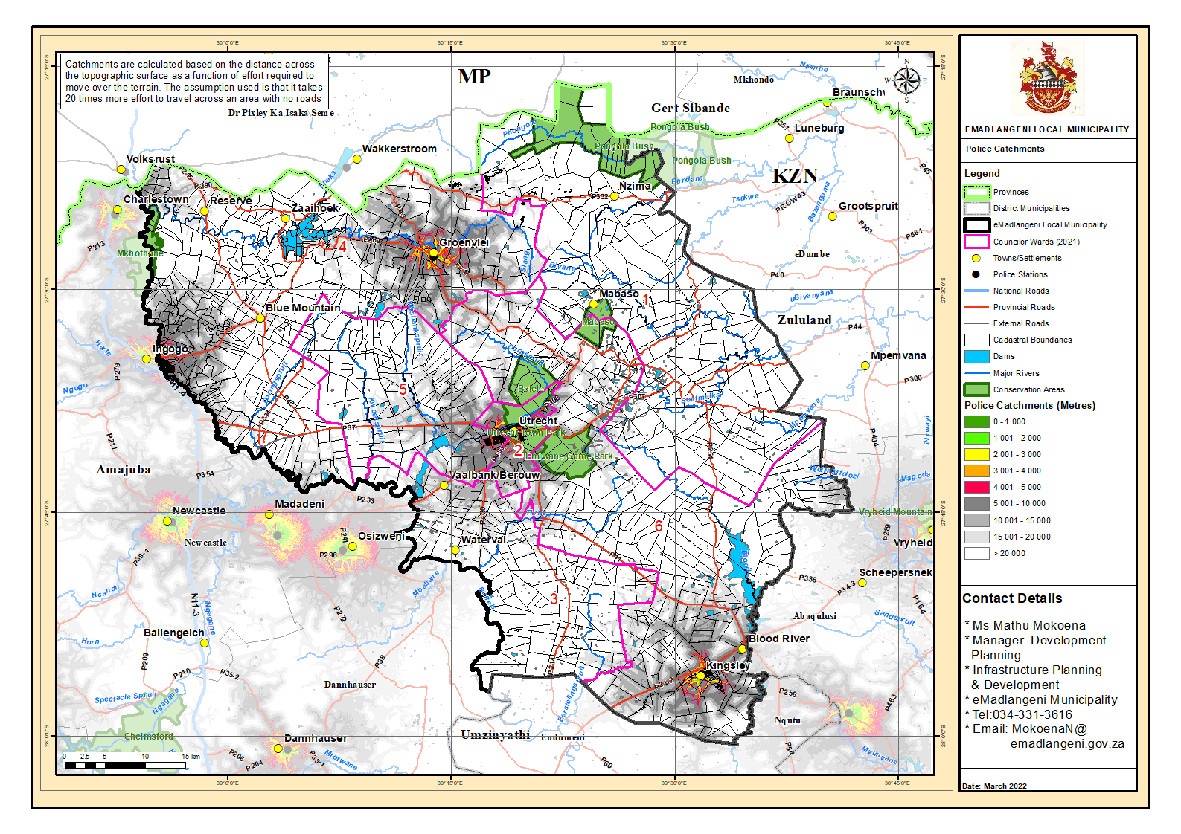

C.5.6 HUMAN SETTLEMENTS

The municipality has an adopted Housing Sector Plan in May 2023 attached as ANNEXURE A1, that is aimed at providing a framework within which the eMadlangeni Local Municipality can start with the task of addressing the housing need of their communities and thereby meeting their obligation of providing shelter for those in need. This is a working document that will guide the eMadlangeni Local Municipality and other role-players to set in motion the process of housing delivery. It is a requirement that the plan should set strategies and timeframes for the development of housing in the area and should be linked to the Municipal Integrated Development Plan (IDP) as well as the Provincial Housing Plan in order to ensure the alignment of programmes and objectives at all spheres of governance. More specifically, the project aims to identify the current housing demand, recently conducted by the Municipality with the following outcomes.
(Housing Sector Plan 2023-2024)
EMadlangeni Local Municipality has identified future projects to be packages as agri-village projects. The table below illustrated the projects identified, some of these projects are illustrated on Map 13.

Type of Dwellings
The majority of the settlements within eMadlangeni include formal dwellings or brick structure and traditional dwellings in the form of huts or structures made of traditional matter. Approximately 1079 (see figure 6) people reside in traditional dwellings, accounting for 13% of the population.
Figure 6: Type of Main Dwelling

Source: Statistics South Africa, Community Survey 2022
The majority of the eMadlangeni area suffers from bad communication network. The usage of cell phones, telephones as well as internet is not efficient within the entire municipal area. Only the Utrecht area has full access to network. However, the municipality uses other means of communication as a counter off to the network situation. This includes word of mouth, active social media platforms (Facebook & X/twitter), radio and television, municipal notice boards as well as local newspapers.
STRENGTHS | WEAKNESSES
Availability of Capital budget and Capital programme  Improvement  N11 provides provincial linkages for the municipality  R34 important road network facilities intra-municipal and inter-municipal linkages.  Development of Waste Management Plan | Lack of water and sanitation services in rural areas  Lack of maintenance of existing infrastructure  Backlogs in refuse removal  Non availability of Capital budget for capital programmes  Backlogs in electricity infrastructure
OPPORTUNITIES | THREATS
Bulk water pipeline  Development of a Waste Management Plan  Infrastructure upgrading  Alternative energy sources i.e. solar power  Registration of landfill site | Use of environmentally unfriendly energy sources  Ageing infrastructure  Scattered settlement patterns  Lack of water and sanitation in rural areas  Infrastructure backlog  Farm owners denying access to service delivery; denies way-leave for INEP Projects

KEY CHALLENGES
- Farm owners denying access to service delivery; denies way-leave for INEP Projects
- Scattered settlement patterns
- Use of environmentally unfriendly energy sources

Map 16: Housing Projects

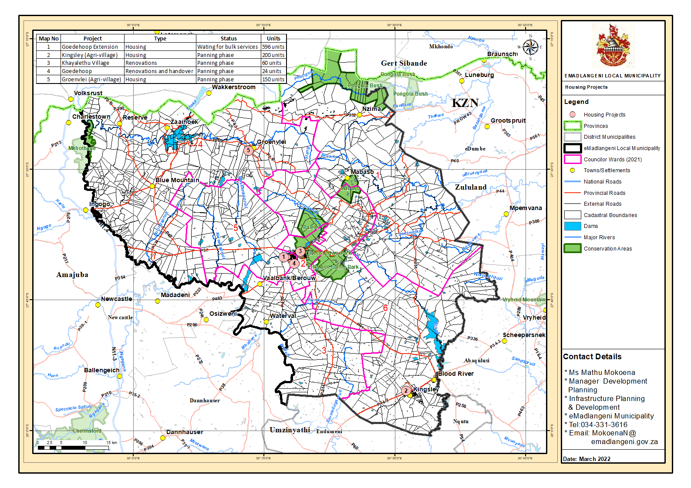
Table 23: Current Housing Project
PROJECT | TYPE | STATUS | UNITS | BUDGET
Goedehoop Extension | Housing | Phase 1 (completed) | 596 units
Goedehoop Extension | Housing | Phase 2  Internal reticulation Complete  Sewer treatment plant upgrade  Registration of sites | 596 units
Khayalethu Formalisation | Township Establishment | Completed | 60 units | R150 000
Khayalethu Extension | Housing | Service provider appointed | 150 units | R150 000
Khayalethu | Title deed | Conveyancer appointed | 60  Units | R103 620
Groenvlei (Agri-village) | Housing | EIA | 150 units | R 410 100
Erf 739 | Social housing | Service provider appointed | 300 units | R1 900 000
Portion 2 of 7 of the farm Weltervreden 53  (Balgrey) | HDA Land acquisition | Completed |  | R5 500 000
Portion 2 of 7 of the farm Weltervreden 53  (Balgrey) | Housing | Service provider appointed | 300 units | R1.737 720.00
Portion 2 of 7 of the farm Weltervreden 53  (Balgrey) | Renovations |  | 18 units | TBC

Preferred Location | Totals
Utrecht Town | 1007 Households
Kingsley | 269 Households
Groenvlei | 202 Households
Vaalbank/Berouw | 1295 Households
Reserve | 175 Households
Zaaihoek | 95 Households
Nzima | 661 Households
Preferred Location Grand Total | 3705 Households

The Department of Human Settlements has identified future projects to be packages as Agri-village projects. The table below illustrated the projects identified, some of these projects are illustrated on map 16.
Table 24: Amajuba District Department of Human Settlements
eMadlangeni Pipeline List of Projects
 | Project | Type | Units | Date | Budget | Status
 | Groenvlei Housing Project | Rural (Agri-village) | 150 | 2014 |  | Await EIA appointment by DHS
 | Kingsley Housing Project | Rural (Agri-village) | TBC | TBC | TBC | - Project identified as potential site for development
 | Waaihoek Housing Project | Rural (Agri-village) | TBC | TBC | TBC | - Project Identification in the IDP not yet finalized
 | Amantungwa Housing Project | Rural (Agri-village) | TBC | TBC | TBC | - Project Identification in the IDP not yet finalized
 | KwaNdlamlenze Housing Project | Rural (Agri-village) | TBC | TBC | TBC | - Project Identified in the IDP & SDF
 | Kingsley | Housing | 200 units | TBC | TBC | - Project Identified in the IDP & SDF
 | Remainder of erf 740 | Land Acquisition | 100 units | TBC | TBC | Project Identification in the IDP& SDF not yet finalized
 | Bensdorp extension | Vacant sites | 50 units | TBC | TBC | Project Identification in the IDP& SDF not yet finalized
 | Erf 10 000 | Balele estate | 30 units | TBC | TBC | Project Identification in the IDP& SDF not yet finalized
 | Erf 10000 | Middle income housing | 200 units | TBC | TBC | Project Identification in the IDP& SDF not yet finalized
 | Erf 1001  Remainder of erf 1000 | Land acquisition | 300 units | TBC | TBC | Project Identification in the IDP& SDF not yet finalized

C.5.8 BASIC SERVICE DELIVERY AND INFRASTRUCTURE SWOT ANALYSIS

STRENGTHS | WEAKNESSES
- Skilled competent work force,  - Age profile (young work force)  - Good relationship with other government  departments’ both national and provincial level (DMRE, Eskom, Disaster and Cogta).  - Adequate provision of essential services at urban residential areas and villages of ward 2 and part of ward 5 (electricity) | - Staff shortage  - Limited sources of funding  - Dependency on government grant funding  - Insufficient fleet and heavy duty plant  - Ageing of infrastructure  - Inadequate funding for infrastructure development  - Backlog in road rehabilitation & construction  - Backlog in electrification of rural households  - Poor maintenance of infrastructure (road and electricity) due to lack of funds.
OPPORTUNITIES | THREATS
- Training of staff  - Improved infrastructure will create investor confidence.  - Upgrading of infrastructure | - Economic slowdown  - Changes in technology  - Changes in legislations  - Insufficient funds  - Scattered settlements patterns

C.6 KPA: LOCAL ECONOMIC DEVELOPMENT (LED) AND SOCIAL DEVELOPMENT ANAYLSIS

C.6.1 LOCAL ECONOMIC DEVELOPMENT

Comparative advantage
The table below shows eMadlangeni’s comparative advantage in terms of GDP contribution. The municipality’s most competitive sector is government services. Personal services, Manufacturing and Wholesale, Retail & Motor Trade/Tourism show marginal contribution.

Table 25: EMadlangeni GDP Contribution
DESCRIPTION OF SECTOR | NATIONAL – GDP | PROVINCIAL – GDP CONTRIBUTION TO NATIONAL GDP | EMADLANGENI LOCAL MUNICIPALITY CONTRIBUTION TO GDP
Agriculture | 2.3% | 3.4% | 0.001%
Mining | 7.7% | 1.7% | 0.012%
Manufacturing | 13% | 15.9% | 0.01%
Electricity & Water / Utilities | 2.4% | 3.6% | 0
Construction | 3.4% | 4.1% | 0
Wholesale, Retail & Motor Trade / Tourism | 13.7% | 13.9% | 0.01%
Transport, Storage & Communications | 8.4% | 12.3% | 0
Finance, Real Estate & Business Services | 19.4% | 15.6% | 0.001%
Government Services | 15.1% | 14% | 99,98%
Personal Services | 5.4% | 5.6% | 0.01%

Main Economic Sectors
The main economic sectors in eMadlangeni include: Tourism: eMadlangeni is part of the battlefields heritage tourist sites. The Utrecht Community Game Farm and Wildlife Products (Balele Game Reserve) forms part of the tourism attraction in the municipality and is located on the edge of the town of Utrecht in Northern Kwazulu-Natal, the game farm lies on the east of Utrecht, in an area known as Knights Hill, and covers approximately 2 500 ha. The town of Utrecht is located centrally in the municipality at the foot of the Ehlanzeni Valley in the Balele Mountains (part of the Drakensburg escarpment).
Table 26: Tourist Visits to eMadlangeni
DESCRIPTION | 2022/23
DESCRIPTION | FOREIGN | DOMESTIC
Estimated tourists (overnight visitors) to eMadlangeni per annum | 269 | 18 610
Tourists to Battlefields per annum (2013) | 16 096 | 127 000
Tourists to EMadlangeni as a % of Battlefields tourists | 1.7% | 14.7%
Tourists to KZN per annum (2013) | 847 146 | 7.1 million
Tourists to EMadlangeni as a % of KZN tourists | 0.03 % | 0.26 %
Source: EMadlangeni Local Economic Development Strategy 2022/2023
Agriculture: The municipality has vast tracts of land, which is either underutilised or have been occupied by rural informal settlements who undertake subsistence farming or no farming at all. The municipality’s agricultural contribution to GDP is at a low. In additionally the sector’s employment numbers have experienced a slow increase between 2011 and 2015, from approximately 236 people to approximately 288, respectively (see table 22). This indicates that the sector employed a total of about 52 labourers between 2012 and 2014. The further indicates the slow growth and decline of the agricultural sector.
Mining: Mining activities in eMadlangeni primarily include coal mining. Coal is mined in the area and exported internationally via the Richards Bay Coal Terminal. Due to its size the sector is one of the lowest labour absorbing sectors in the municipality.
Manufacturing: Manufacturing has experienced a fluctuating trend in the amount of labour absorbed within the sector. Between 2014 and 2015 the manufacturing had a decrease of approximately 10 labourers which follows the increase of about 42 labourers between 2013 and 2014.
Services sector: The finance sector and the community services has been the biggest labour absorbing sectors between 2011 and 2015.
Table 27: Employment BY Sector (Formal and Informal Sector)
SECTOR | 2011 | 2012 | 2013 | 2014 | 2015
Agriculture | 236 | 222 | 230 | 247 | 288
Mining | 48 | 57 | 65 | 70 | 69
Manufacturing | 1 012 | 970 | 998 | 1 040 | 1 030
Electricity | 16 | 18 | 22 | 26 | 29
Construction | 500 | 476 | 482 | 530 | 594
Trade | 2 435 | 2 399 | 2 396 | 2 485 | 2 536
Transport | 592 | 616 | 641 | 646 | 655
Finance | 1 009 | 995 | 996 | 1 030 | 1 061
Community services | 1 228 | 1 265 | 1 369 | 1 498 | 1 603
Households | 591 | 585 | 591 | 625 | 636
Total Industries | 7 668 | 7 604 | 7 790 | 8 197 | 8 502
Source: Global Insight 2017

Employment
EMadlangeni’s economically inactive population contributes approximately 25.68% of the total population within the municipality. The Census 2011 data further reveals that only 16.89% of the municipality’s population is employed (see figure 7). Unemployment within the municipality was recorded at 10.18%. This indicates that municipality is facing challenges in the generation of employment opportunities and a possible lack of necessary skills and education to participate in the economy may be lacking within the municipality.
Figure 7: Employment Status

Source: Statistic South Africa, Census 2011

Income
In addition to low employment levels, 11857 people within the municipality earn no income, accounting for 34.43% of the population (see figure 8). Notable, 10447 people in eMadlangeni earn between R 1-R 400 which contributes 30.33% of the total population. This income bracket includes government grant recipients and thus indicative of a state-dependent section of the population. More worrisome is that 49.69% (17114) of income earners earn below R1600 per month. Consequently, suggesting a large portion of the population living in poverty with low levels of disposable income.
Figure 8: Individual Monthly Income

Source: Statistic South Africa, Census 2011

Agriculture
The municipality has large tracts of agricultural land spanning the municipal landscape. Most of these portions of land are held in private Trust of which the municipality cannot impose or legal require them to undertake any agricultural activity. These segment of land within the municipality are occupied by rural settlements where some households engage in subsistence farming. Households with livestock have followed the norm of letting their livestock roam the expansive landscape for grazing. Livestock farming in the municipality include; cattle and dairy farming, goat and sheep farming, poultry farming. This affects the land being capability in these areas and ultimately the agricultural output of these areas. Development of commercial agriculture is hampered by a lack of funding for raw materials, machinery, skills and transport markets for produce within traditional authority areas. Land claims also pose as a hindrance to agricultural development (EMadlangeni LED Strategy: 2022/23).
The agricultural sector experienced positive annual growth between 2012 and 2014. However, in 2015 the sector experienced a negative annual growth of -5.2%. This indicates that the growth of the agricultural sector within eMadlangeni declined in 2015.
Table 29: Annual Growth
SECTOR | 2012 | 2013 | 2014 | 2015
Agriculture | -0,1% | 4,9% | 8,3% | -5,2%
Source: Global Insight 2017

EMadlangeni Agri-Village Development
The Provincial Spatial Economic Development Strategy 2016 (PSEDS) identified for agricultural development within KZN. The municipality has good agricultural potential and has vast commercial farmlands across the landscape. The agri-village is project is co-ordinated by the Department of Agriculture and Rural Development.
The Groenvlei area within the municipality has been identified as a pilot project for the agri-village development. The agri-village development concept focuses on the development of new settlements or the reinventing of existing settlements within commercial farm areas into sustainable communities. The concept centres the agricultural economy as the basis of the community. The agri-village development will bring together various stakeholders which will include commercial farmers, farm dweller residents with agricultural livelihoods, land reform beneficiary residents with agricultural farms and possible livelihoods, traditional authority with some governance responsibility and some agricultural interest. It will also include government departments/stakeholders with interest in the provision of public services, economic development of citizens and natural resource management. The development will create an opportunity for farmers that are currently excluded to be part of the agricultural value chains. This will ultimately improve the sustainability and profitability of these farmers while increasing job opportunities in the agricultural sector.
UNEP in partnership with KZNEDTEA they identify Emngundeni area to do community economic empowerment pilot project. The project was launched on the 27th of March 2023 and it was visited on the same day after the launched on the 27th March 2023. On August KZNEDTEA submitted quotation for solar lantern and Paraffin lamps. UNEP has not yet responded, the is no progress from them.

SMMEs
The municipality recognizes the role played Small Micro and Medium Enterprises in the areas economic growth and contribution towards reducing unemployment. The support and development of SMMEs is an imperative across all three spheres of government and thus eMadlangeni aligns itself with the legislative directive aimed at supporting and developing SMME. The municipality has a database for all active SMMEs and Cooperatives. As far the support and development of SMMEs goes in the municipality and the municipality’s awareness of the challenges faced by SMMEs, focus is placed on the following;
- Infrastructure needs for SMMEs development in the municipality
- Market Management training
- Skills availability and mentorship
- Financial management Training

Manufacturing
The manufacturing sector in eMadlangeni is fairly small and is dominated by textile and clothing. A satellite hub aimed at developing the SMMEs and Co-operative within the municipality is currently in planning stage initiated by the Department of Economic Development. The development of the textile and clothing industry has the potentially to grow into a fully operational mini- industrial hub taking into consideration the municipality’s location to Newcastle municipality which is and industrial giant in Amajuba district. Furthermore, the R34 provides the municipality with linkages to the Richards Bay and dude trade port Special economic zones (eMadlangeni LED Strategy: 2024/25).

Tourism
EMadlangeni Local municipality is rich in tourism. The municipality forms part of the Battlefields heritage tourism sites. The tourism sector holds a lot of potential for the economy of the municipality, with potential to contribute to the creation of more employment opportunities, contribute to formalization of the second economy, contribute to poverty alleviation in the areas of the municipality. The Blood River is of historical significance and runs on the southern portion of the municipality. The municipality has a Game farm, the Utrecht community Game Farm on the eastern portion of the municipality covering approximately 2500ha of land. The Balele Mountain form part of the Drakensberg escarpment and are located to the north of the municipality. Approximately 14.7% of the domestic tourists within the municipality is accounted for by the Battlefields in 2013/14 period while foreign tourist in the area accounted for 1.7% in the same period (EMadlangeni LED Strategy: 2024/25). Emadlangeni Local Municipality has already begun with applications of sourcing funding to resuscitate Information Tourism Center.

Mining
Mining within eMadlangeni mainly comprises of coal. Most of the mines within Amajuba district closed in the late 90s due to the international fall in coal prices however, some of these mines have reopened. The municipality is strategically linked to the Richards Bay Coal terminal via the R34 where high grading coal from the municipal area is shipped to international markets (eMadlangeni LED strategy: 2022/23). EMadlangeni Local Municipality is currently working with Uitkomst Colliery Mine to Develop New Social and Labour Plans for year 2022-2027.

C.6.2 LED Strategy

EMadlangeni Local Municipal Council adopted its Local Economic Development Strategy on the 30th of April 2024, the municipality is in a process to source a funding to review LED strategy, see ANNEXURE D. The aim of building the economic capacity of the municipality; improve the economic sectors and the overall quality of life by developing the local economic potential of the municipality. Private enterprise drives the creation of employment opportunities and wealth within local communities and thus eMadlangeni Local municipality ensures collaboration with the private sector towards developing the economy and its people. EMadlangeni Local Municipality has a Functional Informal Traders Chamber, currently the Municipality is in a process of reviving Tourism Association, establishing formal economic Chamber and improve working relationship with farmer’s association and all SMME’s.
EMadlangeni Local Municipality LED strategy is aligned to Amajuba District one Plan. Emadlangeni Local Municipality has drafted informal economic policy and it was tabled and adopted by council on the ….of March 2024. EMadlangeni Local Municipality has revived Mangosuthu Arts and Craft Centre, the centre is currently leased to Local Art and Craft Markers and a restaurant owner specializing PIZZA. Emadlangeni Local Municipality is working with Department of Economic Development, Tourism, Environmental Affairs (EDTEA) regarding red tapes reduction program they will be assisting the municipality in improvement on the following unit SCM, LED and Communications Units where people identify red tapes. EMadlangeni Local Municipality is currently using KZN Automated Business Licensing and Information Management System to produce Business Licenses and Informal Trading Permit. EMadlangeni Local Municipality LED strategy does consider Spatial Planning through the prioritization of Tourism Projects in Nodal areas of the Municipality. Additionally, eMadlangeni also works hand in hand with Amajuba District in executing the municipality’s LED mandate. Focus areas for the eMadlangeni LED Strategy includes:
- Poverty Alleviation: providing support and minimum skills and support
- Increasing Employment: Creation of employment opportunities and exploring ways to achieve upward mobility in employment
- Growing the First Economy: encouraging economic growth through investment and enhancing the competitiveness of the local industries. Focus directed at targeting previously disadvantaged individuals and supporting SMMEs.
- Developing the Second Economy: facilitating advancement of locals and businesses from the second economy to the first economy.
All stakeholders involved formed part of the strategy development and the MEC comments are incorporated in the review of the strategy.

Projects and Programs to be implemented in 2024/25 Financial Year
Project Name | Project Status | Budget
Balele Game Park Phase 2 Refurbishment | Implementation stage (20 % complete) | R4, 5 Million (from KZNEDTEA)
Balele Game Park Phase 3 Refurbushment | Design Planning Stage | R3 Million (from KZNEDTEA)
Expanded Public Works Program | Program will resume on 1 July 2024 | R1 331 000 (from Public Works)
Municipal Employment Initiative Grant for SMMEs | Implementation Stage (20 % Complete) | R500 000
TOTAL: |  | R 9 331 000

C.6.2.1 EPWP/CWP
EMadlangeni Local Municipality has adopted EPWP Process Plan on the 30th April 2024, attached as ANNEXURE D1. the EPWP Process Plan is in line with EPWP Phase Five. EPWP program for 2024/2025 financial year will create 120 job opportunities. CWP also have a target of 1100 job opportunities to be created in the new financial year EMadlangeni Local Municipality will prioritize previously disadvantaged groups in all business and employment opportunities. The program assists in the contribution to the livelihoods of participants through the income earned and it absorbs labour from community to ensure and facility community development and upliftment. EPWP projects within the municipality include:
- Road maintenance & maintenance of buildings
- Tourism and cultural
- Waste management
- Parks and beautification
- Sustainable land-based livelihoods
- Social services programmes
- Health service programmes
- Community safety programmes

C.6.2.2 Local Economic Development: SWOT Analysis
STRENGTHS | WEAKNESSES
Development of a satellite hub for clothing and textile in planning stages  Potential for agricultural development  Agri-village development projects | Lack of informal economy policy  Staff capacity
OPPORTUNITIES | THREATS
Revival of the agricultural sector  Growing Tourism Sector  Development of the tourism sector  Revitalisation of the mining sector  Large percentage of the population within working age | Climate change can adversely affect the agricultural sector  Declining Agricultural sector  Weak mining sector  Low employment levels  Low GDP contribution

C.6.3 STRATEGIC MAPPING

C.6.3.1 ENVIRONMENTAL SENSITIVE AREAS
EMadlangeni is characterized by a range of environmentally sensitive areas. The municipality is rich in biodiversity, and is well-endowed with unique environmental features, including a mountain range, river systems and wetlands. One of the prominent features in the municipality is the Balele Mountains on the north and the historically significant Blood River on the south. The municipality also has a great diversity in vegetation types, bird species, richest and these require appropriate management. River valley are some of the most important hydrological feature due to their significant environmental role as catchments areas. The municipality’s birding route runs in an east –south route and offers a variety of bird species. Incidentally, this route also falls within the north-south conservation corridor on the eastern segment of the municipality further accentuating the environmental character of the region. The Balele route provides the most scenic regions within the municipality associated with the Balele Mountains, wetlands and rivers within the municipality.
EMadlangeni holds significant cultural value and has been identified as part of the Battlefields tourist sites. Furthermore, the area attracts both domestic and foreign tourists for its environmental features and cultural heritage. These environmental resources within the municipality also call for effective management to ensure preservation and linkage with the economic development of the municipality. Buffer zones should be established around environmentally significant areas where development beyond the buffer will be limited to developments that will be aligned with preserving the state of these environmental areas and with NEMA regulations.

C.6.3.2 STRATEGIC INTERVENTION AREAS
Agriculture is the backbone of the economy of eMadlangeni. A majority of the households, 51.9%, within the municipality are involved in agricultural activities. Most agricultural activities include livestock production and poultry production. Grain and food crops are undertaken by approximately 12.26% of the municipality’s population and these include commercial farmers. EMadlangeni Local municipality generally has good agricultural potential and this needs to be aligned with agricultural production in order to increase the municipality’s agricultural output and thereby absorb more labour and strengthen food security.
The agri-village development seeks to create or re-develop settlements with agriculture as the basis of the settlements economy. This will help small and emerging farmers in gaining access to markets, and result in the creation of self-sustaining rural settlements.
The revamping of the Balele Game Reserve will help establish the town of Utrecht as a tourist destination. In order to maintain the tourism in the area, focus will be directed into the development of tourism products and activities within the Game Park and development at key tourism attraction locations.
Areas in critical need of electricity, water and sanitation infrastructure have been identified as ward 1, 3, 4 and parts of ward 6. The proposed sanitation infrastructure in these areas includes Ventilated Pit Latrine toilets (VIP), this is primarily due to limited funding towards the provision of infrastructure. The provision of windmills, specifically within farm areas will assist in reducing water backlogs within the municipality. The provision of non-grid electricity to farm areas and settlements located in these will also assist in reducing the electricity backlog within eMadlangeni.

C.6.3.3 DESIRED SPATIAL FORM
The eMadlangeni SDF sets out the spatial vision of the municipality and identifies focus areas for development and investment. The SDF identifies the primary, secondary, tertiary nodes, as well as development corridors.
The primary aim of the SDF is to facilitate the transformation of eMadlangeni into an integrated and sustainable spatial system. The SDF will influence directly the substantive outcomes of planning decisions towards the attainment of the following strategic objectives:
- To give a spatial expression to the development vision, strategy and multi-sectoral projects outlined in the IDP.
- To create a spatial environment that promotes and facilitates economic development and growth.
- To facilitate the development of sustainable human settlements in line with national policy directives.
- To promote sustainable development and enhance the quality of the natural environment.
- To facilitate sustainable and efficient utilisation of land.
- To guide private and public investment to the most appropriate areas in support of the municipal spatial development vision;
- To provide a visual representation of the desired spatial form of the municipality.
SDF seeks to influence the substantive outcomes of planning decisions at different levels and to achieve planning outcomes that: facilitates correction of spatial distortions of the apartheid past; channel resources to areas of greatest need and development potential; take into account the fiscal, institutional and administrative capacities of role players, the needs of communities and the environment; stimulate economic development opportunities in rural areas; protects and enhances the quality of both the physical and natural environments; and promote an inherent value of the natural and built environment.

Map 22: Emadlangeni SDF

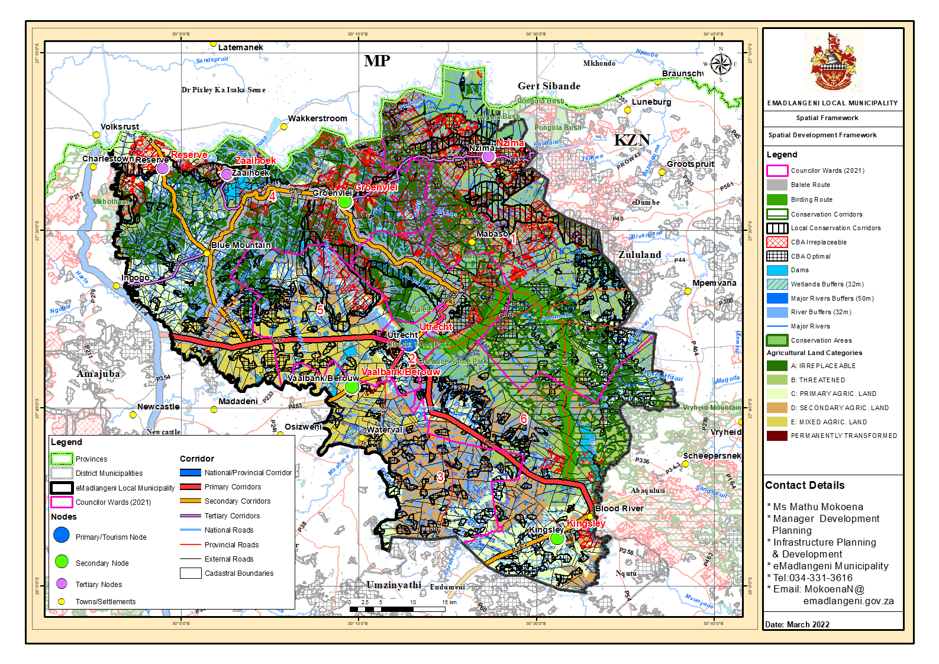

C.6.3.4 STRATEGIC GUIDANCE IN RESPECT OF DEVELOPMENT
EMadlangeni Local municipality is made up a system of diverse land use typologies including urban settlements, scattered rural settlements, commercial farmlands, plantations etc. In order to ensure an efficient, effective and consistent land management practices, it is necessary that the municipality enforces wall-to-wall development through the development of a wall-to-wall scheme with a range of use zone some of which will not apply in the less developed areas. From interviews conducted with stakeholders, the municipality is currently facing challenges with regards to land allocation by Traditional Leaders. Traditional councils within the municipality have been formally allocated land, essentially there are no clear demarcations or boundaries on which segments of the land is under which Traditional Council. This ultimately leads to conflict and infringing on privately owned properties during these land allocation process by Traditional Leaders. The following broad categories will be used in the development of the municipality’s wall-to-wall scheme.
Urban: which includes all areas that fall within the urban edge as delineated in this SDF.
Agricultural: areas that are subject to the Sub-division of Agricultural Land Act, Act No. 70 of 1970.
Rural settlements: located on communal land, state land and/or privately owned land.
Protected areas, conservation areas and tourism areas.
Land use policies will be used to guide land use management to guide land use management on agricultural land, privately owned land, environmentally sensitive areas.
Broad land use typologies for the Land Use Framework are suggested in table 15. It is suggested that a more regulatory approach is required where important resources (e.g. high potential agricultural land and important environmental service areas) need to be protected and where pressure for development is higher. This will provide the Municipality with clear regulations to manage this development e.g. a potential urban settlement where there is or may be a demand for commercial and industrial development sites. A policy-orientated approach would be suitable for areas where there is less pressure for development.
Table 28: Broad land Use Typologies
LAND USE TYPE | DESCRIPTION | POTENTIAL ZONES | SPATIAL LOCATION
Industry | This zone will be used to designate and manage a range of industrial activities – from light industrial with limited impact on surrounding land uses to hazardous or noxious industry with high-impact and must be separated from other uses. This set of zones would include agricultural industry. | - Service Industry  - Light Industry  - General Industry  - Abattoir | - Existing industrial areas.  - Development nodes  - Mixed land use corridors.  - Extractive and noxious industries are high impact uses and should be located away from residential and commercial areas
Residential | Used to designate the full spectrum of residential options ranging from areas that are almost entirely residential to areas having a mix of residential and other compatible land uses, yet the predominant land use is residential. | - Residential Only  - Intermediate residential (medium density)  - General Residential  - Rural Residential  - Guest Houses  - Residential Estate  - Retirement Village | - Mixed use such as development nodes and corridors.  - Residential areas  - Mixed use such as development nodes and corridors.  - Informally settled areas  - Rural settlement areas  - Hotel, resort and lodge are associated with tourism and could also be located on agricultural land. Aligned with tourism facilities in the municipality
Commercial | This group of zones allows the development of a range of complementary land uses for commercial, business, services, industrial, administrative and residential opportunities, which include informal trading in a single zone to enable a special mixture of development to occur. It seeks to create a balance between the natural and built environment through landscaping and areas of green space. It encourages, where appropriate the use of detailed urban design criteria to achieve specific urban environments and mix of uses. | - Mixed use  - Commercial  - Office  - Service station  - Warehousing and logistics | - Central business district (Utrecht)  - Development nodes.
Civic and Social | This family of zones are intended to accommodate land that is utilized to provide for administrative or government buildings including education, health, pension offices, museums, libraries, community halls, prisons, juvenile facilities, cemeteries and crematoria. Its primary aim is to facilitate the provision of public facilities and delivery of social services. It also seeks to improve access to social and civic facilities in a manner that meets the needs of communities in the fields of health, education social and cultural services. | - Education  - Health and Welfare  - Institution  - Cemetery  - Municipal and government  - Worship  - Bus and taxi rank | - Settlement Areas.  - CBD (Utrecht)  - Nodal areas
Open Space and environment | Environmental and open space zones are intended to set aside land for important environmental services and recreational activities. It includes parks of differing sizes, green areas for bowling, ball sports, cycling, and green belts for walking and hiking. They provide for an adequate number of appropriately situated sites that are easily accessible for recreational purposes and activities for local and wider communities in accordance with recognized guidelines, appropriate thresholds and the requirements of the broader community and visitors. In addition, it also provides for important environmental areas, such as proclaimed parks, view sheds, open space system (e.g. water courses, wetlands, grasslands, and other natural habitats) and proclaimed conservation areas. It reserves land as part of a sustainable living environment. | - Declared Protected Areas  - Active open space  - Passive open space  - Dams  - Management overlays for additional information | - Urban and Residential areas.  - Vacant and unused land in and around the urban footprint.  - Environmentally sensitive areas within the municipality  - Cultural and heritage sites associated tourism in the municipality.  - Major dams, e.g. Zaaihoek Dam
Utility and services | The zone is intended to ensure that the land required for the necessary services infrastructure is set aside for development. It seeks to ensure that land used for service provision is appropriately located away from residential or other land uses where they detract from levels of amenity or safety. It includes the provision of land for capital works mains, overhead and underground cables, and essential services required to promote sustainable development in accordance with national laws and provincial and local guidelines. | - Road reserves.  - Railway line  - Railway station  - Public parking | - Settlement areas.  - CBD (Utrecht)  - Light Industrial areas  - Rural and urban areas
Agriculture | Agricultural family of zones are intended to provide land for buildings and uses associated with farming practises and specifically with the following activities: -  - The production of food and fibre;  - The cultivation of crops;  - Timber plantations;  - The farming of livestock, poultry and bees,  - Horticulture and market gardening;  - Urban agriculture and settlement; and,  - The use of buildings for associated activities including education activities.  Its primary aim is to facilitate the protection of agricultural land from non-agricultural uses, and to enhance its production potential. This will facilitate food production and improve contribution of the agricultural sector to the local economy. | - Agriculture 1  - Agriculture 2 (Traditional/ communal)  - Agriculture and Forestry  - Restricted agriculture (agro-biodiversity zone)  - Management overlays for additional information | - Rural areas  - Urban areas

C.6.3.5 SPATIAL ALIGNMENT WITH NEIGHBOURING MUNICIPALITIES
EMadlangeni forms part of a larger system of local governance and regional economy and is influenced and also influences development in the neighboring municipal areas. Cross-border planning issues have become more prevalent and significant. The focus is on strategic or shared development issues that would benefit from a joint approach, and engaging with the relevant neighboring authorities to explore joint working potential. This section seeks to ensure an integrated and harmonious approach to growth and development between proposals suggested by eMadlangeni SDF and those of its neighboring municipalities.
Neighboring Municipalities include Newcastle municipality to the west, Dannhauser Municipality on the east, Endumeni municipality on the south, eDumbe municipality on the north-eastern boundary, Abaqulusi on the south eastern boundary and Pixely Ka Isaka Seme Municipality on the north in the Mpumalanga province.
Figure 9: Newcastle SDF 2016/17
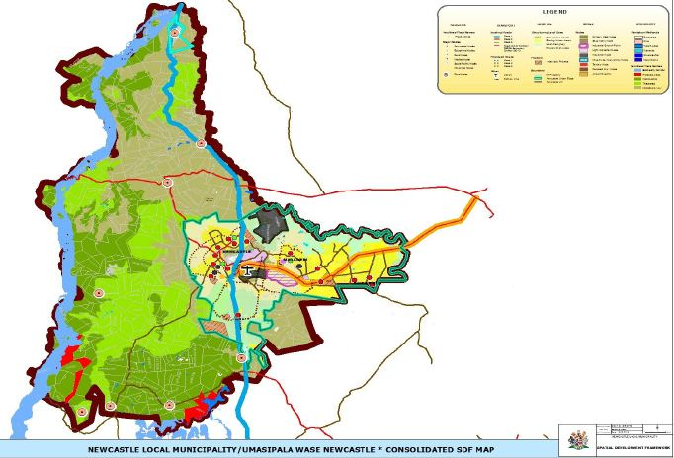
Source: Newcastle SDF 2016/17

EMadlangeni Local Municipality generally enjoys good linkages with Newcastle. The N11 links the two regions via the R34. The strongest linkage is however, via the P483 secondary activity corridor. It facilitates linkages in an east-west direction between Utrecht and Newcastle east. Nodal points of activity along this corridor provide opportunities for the provision of services as economic activities thereby providing strong linkages between the municipalities.
The area of Amantungwa in the west of eMadlangeni is located in close proximity to the Dicks cluster in Newcastle. The P483 corridor links this area to the Newcastle-Madadeni-Osizweni regional centre which provides higher order services and has greater regional influence in the district.
The linkages between these the two municipalities are virtually non-existent. Both municipalities are lower level nodes and would potentially utilise the services in Newcastle within the District as it offers more variety and higher order services.
The P332 provides the strongest linkages between eDumbe municipality and eMadlangeni. This is due to the farming in the northeast linking these two regions. The P332 is identified as a tertiary corridor in eMadlangeni SDF while it is identified as an agricultural corridor in the eDumbe SDF. Further, many residents in the north-eastern portion of eMadlangeni use the shopping centres in Paulpietersburg within eDumbe municipality.
The P43 links eMadlangeni to Wakkerstroom within Pixely KaSeme municipality in the Mpumalanga province. The linkages between Pixley Ka Seme and eMadlangeni also include the birding linkages between Wakkerstroom and the northern portions of the Utrecht Municipality, particularly around Groenvlei and the Zaaihoek Dam and The trout fishing linkages between Wakkerstroom.
The eMadlangeni SDF indicates that the settlements around Groenvlei and the Nzima settlement make use of the services in Wakkerstroom due to restrictive road access to Utrecht. This has also resulted in these settlements having stronger linkages with Wakkerstrom compared to Utrecht. The settlement of Esizameleni in Pixely KaSeme municipality face limited expansion opportunities into the municipal area as a result of wetlands and tributaries. The only opportunity for expansion for the town exists in a southeast direction towards Groenvlei.
These linkages thus have implications for service delivery for these communities and collaboration between the two municipal areas to curb potential conflict.
The commercial farming enterprises in the eastern portion of eMadlangeni generally have good linkages with Abaqulusi. The R33 corridor links the two municipal areas. According the eMadlangeni SDF, the municipality has strong linkages to the urban core of Vryheid. Additionally, the Abaqulusi municipality offers higher order services than those offered in the eMadlangeni urban area.

Map 20: Environmental Framework

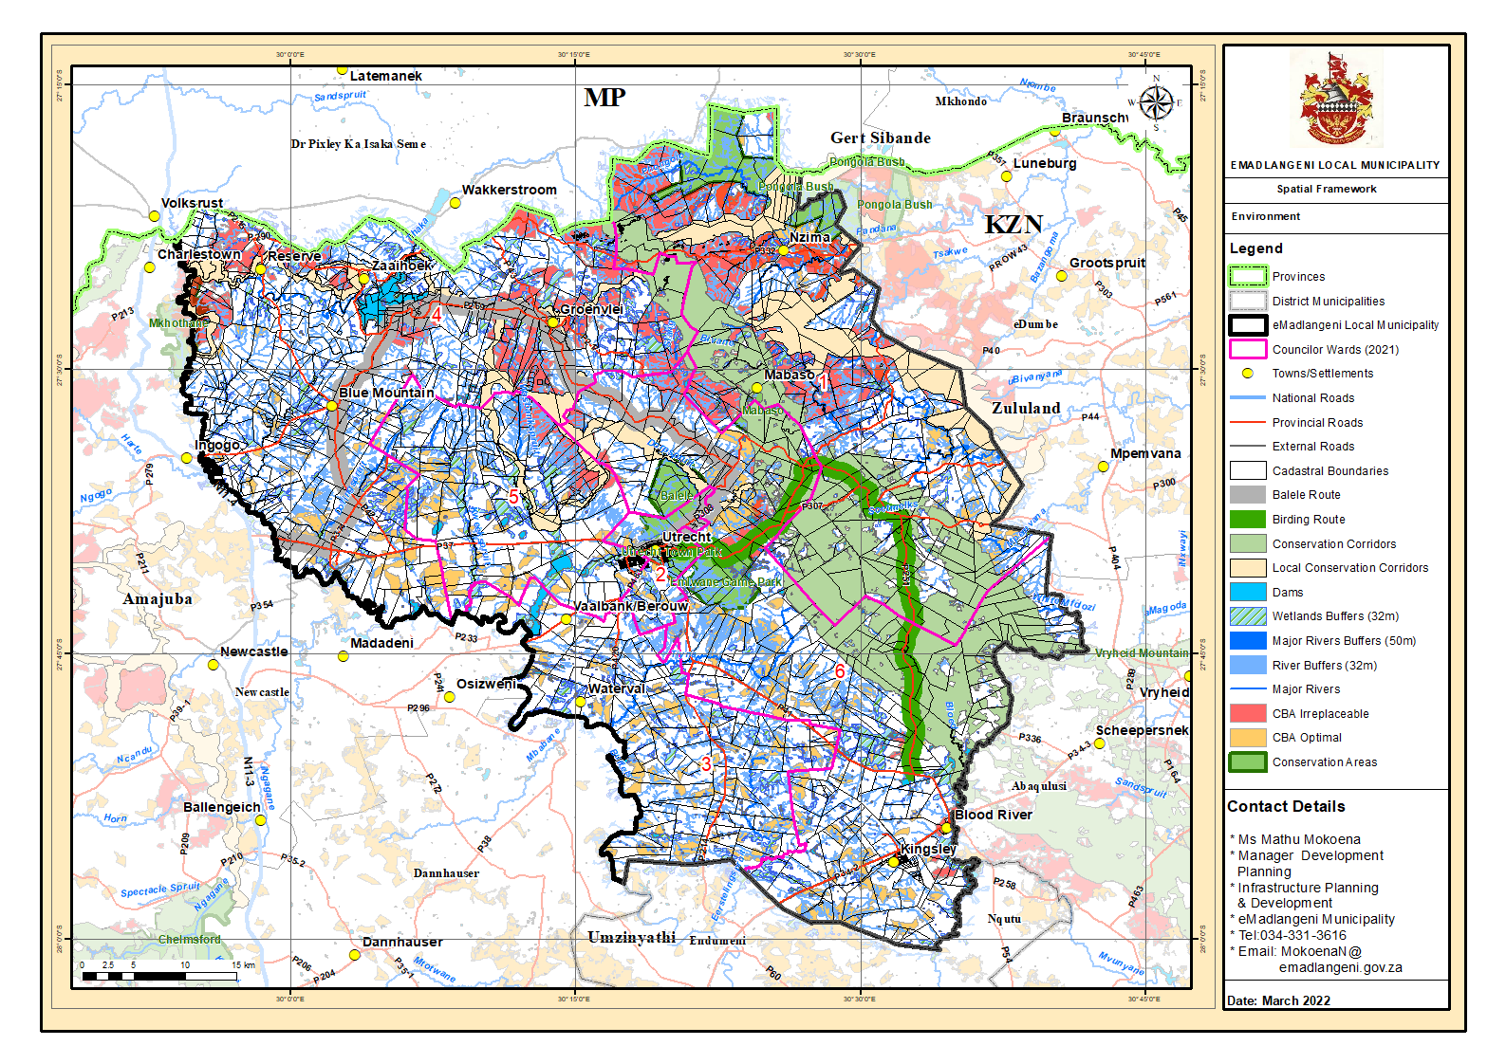

Map 21: Agricultural Framework
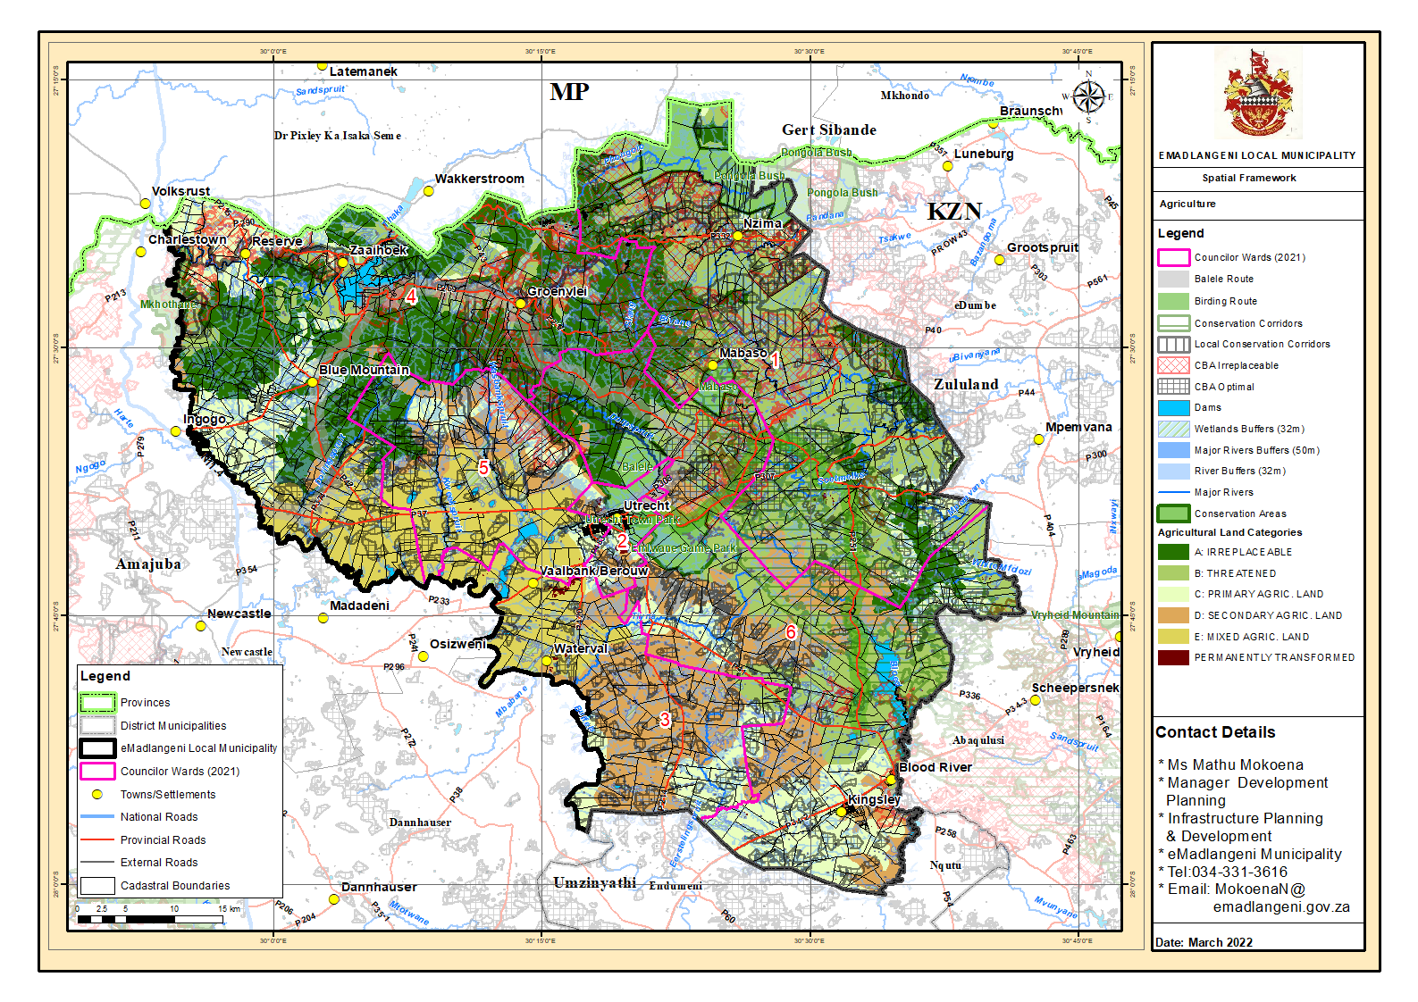
Map 23: Cross-Border Alignment

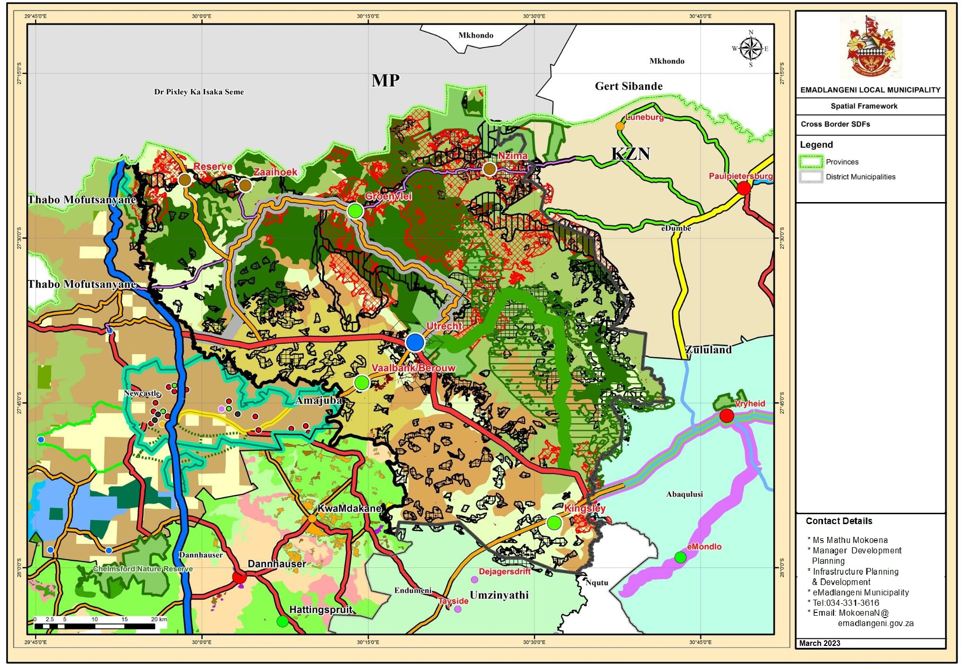
Map 24: Cross- Border Alignment
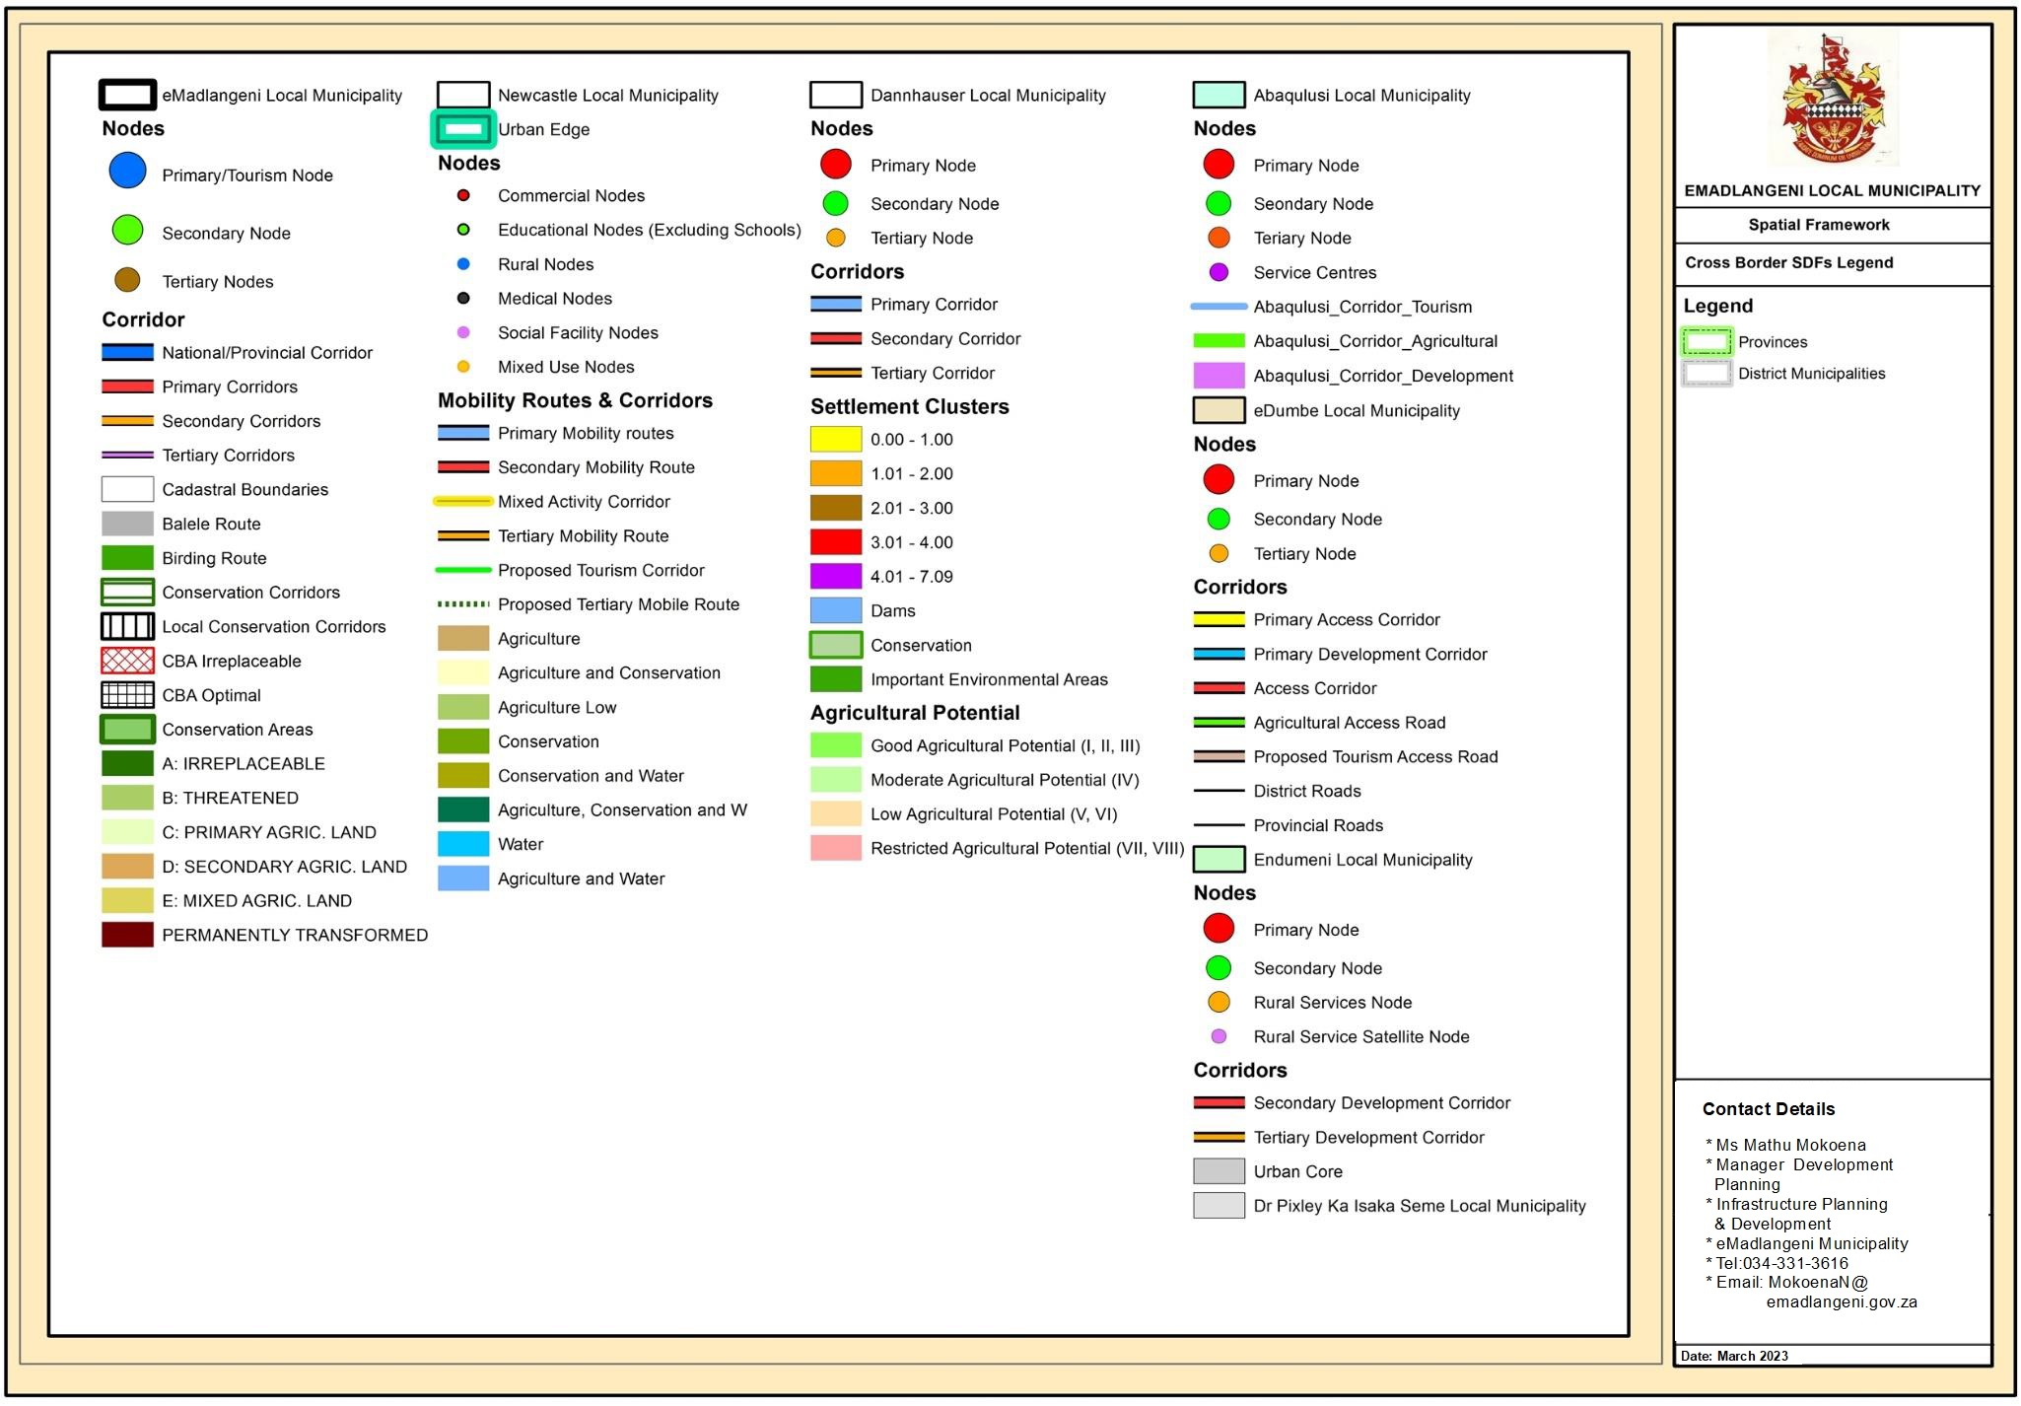

C.7 KPA: FINANCIAL VIABILITY & MANAGEMENT

C.7.1.1 Capital funding and expenditure to address service delivery
The tables below reflect the municipality capital programme in relation to capital expenditure by municipal vote (multi-year appropriations); capital expenditure by standard classifications; and the funding source is necessary to fund the capital budget, including information on capital transfers from national and provincial departments.
The MFMA provides that a municipality may approve multi-year or single-year capital budget appropriations. Budget appropriations for the two outer years are indicative allocations based on departmental plans as informed by the IDP and will be reviewed on an annual basis to assess the relevance of the expenditure in relation to the strategic objectives of the municipality.
The capital programme is funded mainly from grants and transfers, and internal generated funds. Capital grants and receipts equates to 95 per cent of the total funding source which represents R31.9 million for the 2024/25 financial year and R1.5 million from internal generated fund. The municipality through its constitutional mandate has been able to spend all its allocation for the past financial years to service delivery as indicated in both tables.

Capital Expenditure against Budgeted Amounts
Table A5 Consolidated Budgeted Capital Expenditure by vote, standard classification and funding

All grants amounts are gazetted on Division of Revenue Act (DORA) and procurement plans for capital projects has already been submitted to Treasury
Medium Term Expenditure Framework

2024/25 CAPITAL EXPENDITURE
R 33 383 272

- YEAR CAPITAL PLAN
2024/2025 | MIG | R10 160 000
 | Rural electrification | R 15 518 000 |  | .
 | Disaster | R 6 180 000
 | Other Capital Expenditure | R 1 525 272 |  | eMadlangeni Movable Assets
2025/2026 | MIG |  | R 10 430 000
 | Rural electrification |  | R 8 000 000
 | Disaster |  | R 6 181 000
 | Other Capital Expenditure |  | R 287 905 | eMadlangeni Movable Assets
2026/2027 | MIG |  | R 10 932 000
 | Rural electrification |  | R 5 000 000
 | Other Capital Expenditure |  | R 301 147 | eMadlangeni Movable Assets

C.7.1.2 MIG and ENEP FUNDING
NO. | FUNDING | AMOUNT | PROJECT
1 | MIG | R 10 160 000 | Council to draw up priority list for 2024/25
2 | INEP | R 15 518 000 | Council to draw up priority list for 2024/25

ITEM | ASSUMPTION
Property rates | 80%
Electricity rates | 85%
Refuse rates | 85%
Source: Emadlangeni municipality Medium-Term Budget (2024/25-2026/27)
The municipality’s debt impairment is expected to decrease as stringent debt and credit control by-laws have been finalised. These will help improve collection rates within the municipality.

C.7.1.3 Municipal Standard Chart of Accounts
The Minister of Finance promulgated Government Gazette No. 37577, Municipal Regulations on Standard Chart of Accounts (mSCOA), on 22 April 2014. In accordance with the Regulations, all municipalities and related municipal entities are required to be mSCOA compliant on 01 July 2017.

C.7.1.4 Budget Assumptions
EMadlangeni Local Municipality exists within a global financial environment where changes in the global market have an impact on the national to the local government sphere. The depreciation in the rand, increase in electricity bulk purchases and rising unemployment have affected the municipality’s residents and the 2024/25 budget. The assumptions and percentage increases in 2024/25 are indicated in the table below.
Table 29: Budget Increases and Assumptions
Item Description | 2024/2025 | 2025/26 | 2026//2027
Assessment Rates | 4.9% | 4.6 % | 4.6%
Electricity tariffs | 4.9% | 4.6 % | 4.6%
Refuse tariffs | 12.72% | 4.6 % | 4.6%
Salaries and allowances | 4.9 % | 4.6 % | 4.6%
Councillors Remuneration | 4.9 % | 4.6 % | 4.6%
Electricity Bulk Purchases | 4.9 % | 4.6 % | 4.6%
General Expenses | 4.9 % | 4.6 % | 4.6%

- Source: Emadlangeni municipality Medium-Term Budget (2024/25-2026/27)

Table 30: Collection Rates Assumptions
ITEM | ASSUMPTION
Property rates | 80%
Electricity rates | 85%
Refuse rates | 85%
Source: Emadlangeni municipality Medium-Term Budget (2024/25-2026/27)

The municipality’s debt impairment is expected to decrease as stringent debt and credit control by-laws have been finalised. These will help improve collection rates within the municipality.
Table 1: Tariff Increases
 | 2024/25
Rates | 4.9%
Electricity | 12.72%
Refuse removal services | 4.9%
Source: eMadlangeni Local Municipality Medium-Term Budget (2024/25-2026/27)

C.7.2 REPAIRS AND MAINTENANCE

Assets and Infrastructure MAINTENANCE
Asset Management
The table below provides an overview of municipal capital allocations to building new assets and renewal of existing assets, as well as spending on repairs and maintenance by asset class. National Treasury has recommended that municipalities should allocate at 40% per cent of their capital budget to the renewal of existing assets, and allocations to repairs and maintenance should be 8 per cent of PPE. The municipality is still experiencing challenges in complying with the set threshold due to limited resources

The asset register has been updated with all movable and immovable assets, including investment property, and is in compliance with all applicable standards of GRAP. The verification, conditional assessment, and revaluation of infrastructure assets have been done and updated in the asset register in compliance with Grap 17. No impairment reports have been made to date. Movable assets are verified on an annual basis. The asset register is updated, on a monthly basis, with asset acquisitions (movable and immovable), disposals, and movements.

Consolidated Asset as per Audited Financial Statement of Various Years
As per Audited Financial Statements at 30 June 2023, eMadlangeni Local Municipality had assets to the tune of R159 million, made up of Investment property, Property plant and equipment, Intangible assets, Heritage assets, Receivables from exchange transactions, Receivables from non-exchange transactions, VAT receivable, Consumer debtors, Financial asset and cash and equivalents. It should be noted the property plant and equipment amount to a meagre R102 million, an indication that there is still a huge backlog on road and electricity infrastructure.
Repairs and maintenance of assets
The repairs and maintenance as a percentage of carrying value of property plant and equipment is far from the benchmark of 8%. The average over the past 3 years is 2%. The forecast for the next three years is less than 2%. The ratio has deteriorated over the years as depicted in the table above. It is of paramount importance that the municipality channel resources to repairs and maintenance in order to preserve and enhance the useful lives of the assets. However, the municipality has been unable to budget the norm of 8% due to the small budget and limited revenue resources. It should also be noted that the municipality infrastructure is archaic. Therefore, spending huge resources on the aging infrastructure may not be wise. The municipality is exploring all avenues to source funding for replacing of the aging electricity and road infrastructure which is in dire straits.
In light of the above it should be acknowledged that it will take considerable time to meet the desirable 8% benchmark on repairs and maintenance of municipal assets due to the financial constraints facing the municipality. In order to improve the current ratio to the periphery and eventually within the expected norm, the municipality is looking at implementing the revenue enhancement strategy which will allow the municipality to budget adequately for repairs and maintenance as the cash flow improves accordingly.

Assets
 | Note(s) | 2023 | 2022 Restated*
Current Assets
Other financial assets | 8 | - | R 451 111
Receivables from exchange transactions | 11 & 14 | R 210 410 | R 3 036 793
Receivables from non-exchange transactions | 12 & 14 | R 10 180 935 | R 8 894 718
VAT receivable | 13 | R 1 825 | 5 476 471
Prepayments | 10 | R 148 654 | R406 866
Cash and cash equivalents | 15 | R 924 181 | R 2 956 639
 |  | R17 490 100 | R211 222 598
Non-Current Assets
Biological assets that form part of an agricultural activity | 3 | R4 349 646 | R4 268 701
Investment property | 4 | R34 581 830 | R34 832 328
Property, plant and equipment | 5 | R102 190 757 | R109 349 756
Intangible assets | 6 | R 53 978 | R 214 717
Heritage assets | 7 | R1 190 581 | R1 190 581
R142 366 792 R149 856 083
Total Assets R159 856 892 R171 078 681

C.7.3 SUPPLY CHAIN EVALUATION
The municipal council reviewed and adopted Supply Chain Management Policy on the 27th of MARCH 2024, refer to ANNEXURE J1, to adhere to PPPFA of 2022 and ensure that people living with disabilities are fully accommodated in tender biddings. Due to the size and the budget of the municipality, BTO appointed the SCM Manager and SCM Officer in 2021/22 and 2022/23 respectively. SCM has a procumbent plan in place for 2024/25 financial year. Poor planning by departments creates challenges for the SCM unit in complying with the legislation.
EMadlangeni Local Municipality has functioning Bid committees in place established in line with regulations 26-29 of the Municipal Finance Management Act No.56 of 2003’s Supply chain management regulations. The committee system for competitive bids is made up of the following:
- Bid specifications committee(BSC)
- Bid evaluation committee(BEC)
- Bid adjudication committee(BAC)
The municipal manager appoints members of the bid committees. The sitting of committees is determined by members as and when need comes, since the municipality does not have so many tenders.

C.7.4 INDIGENT MANAGEMENT

SOCIAL AND ECONOMIC REDRESS VIA INDIGENT SUPPORT
Cost of free basic services to eMadlangeni Local Municipality
The municipality reviewed and adopted Indigent Policy on the 27th of MARCH 2024, See attached ANNEXURE J2. The Municipal indigent register was approved by council with the total of 114 beneficiaries, however the indigent register is still under verification process by AG. The indigent register will be implemented on the 1st of July 2024.

The indigent policy articulates the criteria and steps to be followed in order to qualify for indigent subsidies. The Auditor General does help the municipality with due diligence. The Accounting Officer is responsible for the implementation and administration of the Indigent policy and is assisted by the Chief Financial Officer for the department of Budgetary and Treasury Office.

Indigent register over 3 years
Financial Year | Approved Indigents | % (Increase) / decrease
2022/23 | 181 | 100%
2023/24 | 154 | (14%)
2024/25 | 114 | (26%)
See attached ANNEXURE J3 Indigent Register

C.7.5 REVENUE MANAGEMENT

C.7.5.1 Revenue Enhancement and Protection Strategies
The municipality has identified a number of areas from which it can enhance its revenue, therefore the municipality reviewed and adopted Revenue Enhancement Strategy on the 27th of March 2024 to assist in improving, protecting and increasing revenue streams, see attached ANNEXURE J. The impact of these strategies are expected in 2024/25 and the outer years once the plan is fully implemented in earnest
The following are the areas identified for improvement;
- Property rates and penalties
- Service charges-electricity revenue
- Identification of new sources of revenue
- Rental of Hawkers sites and SMME units
- Fines for illegal trading
- Licences and permits
- Grant income-operating and capital
- Service Charges-Refuse revenue
- Game and Recreation park tariffs revenue
- Incentivising payment of long outstanding debt

C.7.5.2 Municipal Consumer Debt Position
EMadlangeni Local Municipality’s majority of debtors fall within the outstanding debt over 180 days is impaired in terms of GRAP accounting standard 104. The impairment account stood at R12 425 064, which is 17% of the debtor’s book. The collection rate is low due to lack of economic and employment opportunities in the municipality’s jurisdiction, hence the municipality is characterised by high indigents. The municipality has a challenge collecting property tax on agricultural properties who argue that they do not receive any services from the municipality. Concerted efforts are being enforced to ensure recovery thereof and implementation of the Municipality debt and credit control policy. Cogta municipal finance and Provincial treasury have also been romped in to assist in this regard. Debt is written off only for indigent households on the approved indigent register on implementation of the reviewed indigent register annually.

C.7.5.3 Grants & Subsidies
The municipality’s revenue is 48% government grants and 52% internally generated.
Revenue through grants and subsidies
The following table summarizes the unspent conditional grants for the municipality and the grants for the current and two out-lying financial years. Kindly note that some grants straddle multiple financial years, owing to the fact that municipal and provincial financial years differ. These figures also indicate ‘in kind’ allocations, where the grantor pays service providers directly.
List of Grants and Transfers Table

The municipality is highly dependent on government grants to fund expenditure. Currently government grants account for approximately 48% of total revenue. Detailed information is on the financial plan section.

C.7.5.4 Employee Related Costs
Employee related costs in 2024/2025 is budgeted at R56 million and that is 40% of the total operational expenditure. The increase is due to filling of vacant posts as well as annual increase. The municipality is still having a challenge of filling in the critical positions which could cause the employee cost to increase, which has already exceeded the benchmark of 31% to 40%.

EMPLOYEE- RELATED COSTS TO TOTAL EXPENDITURE (INCLUDING COUNCILLOR ALLOWANCES)

The following table summarises the employee-related costs for the Municipality in terms of actual and budgeted expenditure.
Employee (excluding Councillors allowances) per financial years

REVENUE
Revenue by Source

The total revenue for the budget year 2024/25 is R161 335 070.00 and is composed the following:
Grants: R 78 161 000 (48%)
Property rates: R 54 130 116 (34%)
Service charges: R 23 808 813 (15%)
Other revenue: R 05 235 141 (3%)

C.7.6.1 Government Grants
The largest source of operating revenue is Grants, followed by Property rates and Service charges.
The revenue from property rates is less than half of government grants.

Table 2: Government Grants
NO. | NAME OF GRANT | 2024/2025 ALLOCATION
1 | Equitable Share | R 39 936 000
2 | Municipal Infrastructure Grant(MIG) | R 10 160 000
3 | Finance Management Grant(FMG) | R 3 000 000
4 | Library Grant | R 2 036 000
5 | Integrated National Electrification Programme (INEP) | R 15 518 000
6 | EPWP | R 1 331 000
7 | Disaster Grant | R 6 180 000

C.7.6.2 Capital Funding by Source

The total capital funding for the financial year 2024/25 is R 33 383 272

The municipality’s capital funding is composed of the following:
Government Grants: R 31 858 000
Internally generated funds: R 1 525 272

C.7.6 DEBT CATEGORY

Age debtors per category

Collection rate
2020-21 59%
2021-22 74%
2022-23 73%
Write-off amount
2020-21 R 0
2021-22 R 296 722
2022-23 R 2 011 469
Bad debts provision
2020-21 R 11 690 816
2021-22 R 12 382 314
2022-23 R 11 690 816

Plan to improve debt collection
Municipality has revived the Debt Collection Steering Committee War Room that seat every week to discuss challenges and solution to improve collection rate as well as customer care. This is the implementation of Revenue Enhancement Strategy.
We also have debt inceptive that is assisting in improving debt collection.

Challenges in data cleansing write-off and impairment
Old debts that are before 2017 opening balances that cannot be traced.
Some deposits do not have correct reference and cannot be allocated.
Deposit that do not have correct reference and cannot be allocated

C.7.7 FINANCIAL RATIO’S

The 2022/2023 Auditor General report found eMadlangeni Local Municipality financial statements fairly presenting the financial position of the municipality except for the PPE and Accrued Leave as at 30 June 2023. In accordance with the SA Standards of GRAP and the requirements of the Municipal Financial Management Act, Act No.56 of 2003 (MFMA) and the Division of Revenue Act, Act No.1 of 2015 (DoRA). Moreover, the table below shows the outcomes of the Auditor General Report. Refer to ANNEXURE B.
Financial Ratios
Cost coverage ratio | 0 Months
Current Ratio (Current assets to current liabilities); | 2.25
Capital expenditure to total expenditure; | 16%
Debt to revenue; | 0%
Collection rate; | 65%
Remuneration (Employee and Councilors) to total expenditure; | 37%
Distribution losses: Electricity/ Water; | 39%
Creditors days; | 12 Days
Budget funding status; | Unfunded
Conditional grants cash backed; | Not cashed back
Grant dependency; | 51%
Loans. | 0%

Table 33: Summary of Audit Outcomes
SELECTED OBJECTIVES | USEFULNESS | RELIABILITY
Objective one: Infrastructure and services | unqualified | unqualified

C.7.7.1 loans/borrowings and grand dependency
EMadlangeni municipality is lowly geared, that is the percentage of debt relative to the capital structure is insignificant. The municipality has only one loan. The DBSA loan was obtained in 2004 to fund the construction of the new municipal buildings and it was expected to be repaid in 2024. The term loan was 20 years, however the Municipality has been able to settle the loan in October 2022. It was settled before it’s term as we were just serving the interest.

C.7.8 AUDITOR-GENERAL OPINION

The eMadlangeni Local Municipality has received an Unqualified Audit Opinion with Matters for the 2022- 2023 financial year. This is a positive and most welcomed improvement from the Qualification Opinions received in the prior three years.
The Municipality has resolved to work hard to maintain the current opinion while taking all necessary steps towards achieving clean Audit Outcome in the future.
A credible audit action plan has been developed to respond to all matters as raised by the Auditor General.
Outline of Municipal Audit Outcomes
2020/21 | 2021/22 | 2022/23
Qualification | Qualification | Unqualified with Matters

C.7.9 FINANCIAL VIABILITY SWOT ANALYSIS

STRENGTHS | WEAKNESSES
Indigent policy  Revenue enhancement strategy  Debt Collection and Credit Control Policy  Property Rates policy  Municipal By-laws | Heavy reliance on national and provincial government grants  Revenue generation  Debt Collection
OPPORTUNITIES | THREATS
Debt collection strategies  Austerity measures | Loss of revenue as a result of unpaid tariffs  Limited funding

C.7.10 PROJECTS PRIORITIZED AS PER BUDGET

The municipality has paid more attention to new infrastructure projects, to address backlogs than renewal of existing assets.
Municipal Projects (MIG)
Funded Projects 2024-25 Road Projects (MIG)
Funded project for 2024-25 road project (MIG)
PROJECT NAME | WARD NUMBER | ACTUAL BUDGET
Barouw Gravel Access Road | 05 | R6 003 806.16
Emathangeni Gravel Access Road | 03 | R6 027 513.50

New Projects for 2024.25 Financial year (unfunded Projects)

PROJECT NAME | STATUS | ESTIMATED COST | FUNDED/NOT FUNDED
Rehabilitation of the eMadlangeni Electrical Infrastructure | Sourcing funding | R 19 000 000 | NOT FUNDED

 | ITEMS | DESCRIPTION | QUANTITY | ESTIMATE COST
1 | POLES | Timber 9.0m x 175/200mm (H4CCA) Treated Poles for Streetlights and Low Voltage power transmission | 200 | 350 000
2 | POLES | Timber 12.0m x 175/200mm (H4CCA) Treated Poles for Medium Voltage power transmission | 100 | 150 000
3 | STREET LIGHTS | 1200 W Solar Street lights | 400 | 2 250 000
4 | MINI SUBSTATION | Complete 315kVA,11kV/400V with switch gear and plinth | 20 | 13 000 000
5 | CABLE | 16 mm X 4 Core armoured cable | 1000 meter | 208 000
6 | CABLE | 16 mm Airdec cable | 1000 meter | 127 000
7 | CABLE | 35 mm 4 core armoured | 1000 meter | 600 000
8 | CABLE | 70 mm 4 core armoured | 1000 meter | 1000 000
9 | CABLE | 95 mm 4 core armoured | 1000 meter | 1500 000

PROJECT NAME | STATUS | ESTIMATED COST | FUNDED/NOT FUNDED
Utrecht Mall Development Project | Sourcing funding | Request for proposal | NOT FUNDED

INEP PROJECT FOR 2024/25FY
No | Project Name | Ward | Connections | Budget
1 | Luthilunye Phase 2 | 4 | 44 | R7 493 000.00
2 | Blue Mountain Phase 3 | 5 | 50 | R8 025 000.00
TOTAL |  |  |  | R15 518 000.00

DISASTER ROADS PROJECTS 2023/24 FY POSSIBLE ROLLOVER TO 2024/25FY
No | Road Projects | Ward | Project estimate in Rands (R) | Reasons
1 | Re-gravelling of Dorothea access road | 1 | 3 521 250.00 | - Delays in appointment of Contractors for the implementation of the projects due to huge number of bidders received (245 bidders) would force the projects to roll over to 2024/25financial year.  - The construction works has not commence yet and we are one month away from the end of 2023/24 financial year.
2 | Re-gravelling of Vaalbank access road | 3 | 2 615 028.00
3 | Re-gravelling of Reserve access road | 4 | 3 912 500.00
4 | Re-gravelling of Lenz access road | 5 | 2 347 500.00
5 | Re-gravelling of Mlwane access road | 6 | 2 738 750.00
6 | Rehabilitation of Keerom Street | 2 | 3 387 972.00
TOTAL |  |  | 18 523 000.00

ESKOM ELECTRIFICATION PROJECTS 2024/2025
The Department of Mineral Resources and Energy (DMRE) and in support of the eMadlangeni Local Municipal Integrated Development Plan (IDP) will implement the below electrification projects, the projects were adopted by Council in line with the municipal resolution number A163/2003, dated 30 May 2023. The Confirmation Letter of Eskom Projects is attached as Annexure M.

Project Name | Project type | DoE TOTAL Planned CAPEX Incl VAT & Admin | DoE TOTAL Planned Connections
Utrecht NB 10-Newlook ward 5 | Households | R 6 315 003.83 | 300
EMadlangeni type 1 | Infills | R 1 800 000.00 | 200
Utrecht NB 10-Newlook ward 5 (link line) | Infrastructure-Line | R 2 400 000.00 | 0
EMadlangeni Microgrids | Pre- Engineering | R 3 000 000.00 | 0

C.8 AG ACTION PLAN

AUDIT ACTION PLAN
Name of Municipality | Emadlangeni Local Municipality
Document | Audit Action plan - Audit Report
Financial year | 2023- 2024
Audit Opinion | Unqualified with Emphasis of Matter
STATUS SNAPSHOT
Outstanding | 1
In progress | 8
Completed | 0

D. MUNICIPAL DEVELOPMENT STRATEGY

D.1.1 MUNICIPAL VISION, GOALS AND OBJECTIVES

VISION
THE MUNICIPALITY WILL INCULCATE, AMONG ITS EMPLOYEES, MANAGEMENT AND LEADERSHIP THE FOLLOWING CORE VALUES:

- Accountability
- Transparency and openness
- Responsiveness
- Ethical leadership
- Integrity
- Courtesy
- Honesty and pride
- Excellency
- Efficiency and effectiveness
- Professionalism
- Diligence

By 2036 Emadlangeni Municipality:
will be a self-sustaining exemplary local municipality with a diverse thriving economy where all citizens enjoy a high quality of life within a sustainable and resilient environment.

MISSION STATEMENT
IN PURSUIT OF ITS DEVELOPMENT VISION, EMADLANGENI MUNICIPALITY PLEDGES TO ITS COMMUNITIES AND STAKEHOLDERS TO:
- Be the embodiment of good governance;
- Deliver services in an efficient and effective manner;
- Promote and facilitate sustainable socio-economic development;
- To create mutual trust and understanding between the municipality and the community.
- Promote tourism, agriculture and mining, and facilitate development of urban hubs in support of these economic sectors and delivery of services.
- To apply good and transparent corporate governance in order to promote community prosperity.

D.1.2 STRATEGY MAP AND STRATEGIC FIT

SUSTAINABLE DEVELOPMENT GOALS
EMADLANGENI INTEGRATED DEVELOPMENT PLAN
LONG-TERM DEVELOPMENT VISION AND GOALS
SMART
OBJECTIVES
PRACTICAL & IMPLEMENTABLE ACTIVITIES
MEASURABLE TARGETS
PERFORMANCE INDICATORS
RESOURCES (PERSONNEL, FINANCES AND TOOLS OF TRADE)
PERFORMANCE MANAGEMENT SYSTEM
DEVIATION
YES
NO
KEEP UP GOOD WORK
CORRECTIVE MEASURES

D.1.3 PRIORITY ISSUES AND STRATEGIC DEVELOPMENT GOALS

PURSUIT OF THE DEVELOPMENT VISION WILL LEAD TO THE REALISATION OF THE FOLLOWING DESIRED FUTURE SITUATION:

- Sustainable economy based on agriculture, tourism and mining.
- Universal and equitable access to basic services
- Equitable access to social and public facilities
- Prime tourist destination
- Food and social security
- Resilient, compact and safe living environments
- Capable and financially viable municipality
- Informed and engaging community (education)

STRATEGIC DEVELOPMENT GOALS:
- Creating a conducive environment for inclusive and diverse economic development and growth.
- Developing a financially viable and sustainable institution.
- Ensuring universal access to reliable basic services and physical infrastructure.
- Promoting a peaceful, tolerant and inclusive society.
- Enhancing and protecting the quality of the natural environment, and preserving the biodiversity integrity.
- Ensuring good and sound governance.
- Facilitating spatial integration and development of sustainable human settlements.

THE MUNICIPALITY WILL FOCUS ON THE FOLLOWING KEY ISSUES OVER THE NEXT FIVE YEARS:
- Debt collection and revenue generation.
- Access roads.
- Electrification
- Non-grid for commercial farms.
- Grid for settlements and town.
- Water:
- Boreholes and windmills (priority areas are wards 1, 4 and parts of wards 3, 5 and 6.
- Dams for livestock
- Upgrading of ageing infrastructure in Utrecht.
- Fencing of camps.
- Provision of sports facilities.
- Development of sustainable human settlements.
- Fencing of cemeteries
- Finalisation of labour tenants applications and land restitution claims.
- Support to emerging farmers and recapitalisation of land under communal property institutions (CPI’s).
- Tourism, agriculture and mining development

VISION STATEMENT:
BY 2036 EMADLANGENI MUNICIPALITY:
will be a self-sustaining exemplary local municipality with a diverse thriving economy where all citizens enjoy a high quality of life within a sustainable and resilient environment.

D.1.4 STRATEGIC FRAMEWORK

D.1.4.1 BASIC SERVICE DELIVERY AND INFRASTRUCTURE DEVELOPMENT
STRATEGIC GOALS | STRATEGIC OBJECTIVES | 2024/25 STRATEGIES | MEASURABLE OBJECTIVES
- Facilitating universal access to reliable basic services and physical infrastructure. | 1.1 Improved access to all basic services – Ensuring provision of basic services in a sustainable manner | 1.1.1 Facilitate access to electricity for all targeted households | 1.1.1.1. Number of households connected to rural electricity
 |  |  | 1.1.1.2 Number or percentage of bulk electricity provided.
 |  | 1.1.2 Facilitate access to electricity for all targeted households | 1.1.2.1 Number of households provided with alternative energy  1.1.2.4 Number of indigent households provided with Free Basis Electricity
 |  | 1.1.3 Reduce the road infrastructure backlog and maintain the existing infrastructure | 1.1.3.1 Ensure the existence of a road infrastructure provision framework
 |  |  | 1.1.3.2 Percentage of kilometres of new roads constructed
 |  |  | 1.1.3.3 Percentage of kilometres of roads maintained
 |  |  | 1.1.3.4 Number of road designs drawn and approved
 |  | 1.1.4 Reduce the road infrastructure backlog and maintain the existing infrastructure  1.1.4 Facilitate the reduction of the housing backlog | 1.1.4.1 Number of approved updated Housing Sector Plan
 |  |  | 1.1.4.2 Number of adopted Spatial Development Framework
 |  |  | 1.1.4.3 Number of houses constructed
 |  | 1.1.5 Facilitate the reduction of the housing backlog | 1.1.5.1 Collect waste from all targeted households
 |  | 1.1.5 Facilitate the reduction of the housing backlog | 1.1.5.2 Manage waste efficiently
 |  | 1.1.6 Provide efficient waste collection and management service to all targeted household | 1.1.6.1 Number of households and businesses  1.1.6.2 Number of Integrated Waste Management Plan adopted
 |  |  | 1.1.6.3 Number of environmental impact assessment in Groenvlei
 |  |  | 1.1.6.4 Number of ERF 750 Cemetery Hydrological study conducted
1.(I) Creating job opportunities for all | 1.2 Create employment opportunities for all skilled and employable people of eMadlangeni | 1.2.1 Implement the EPWP programme | 1.2.1.1 Number of EPWP jobs created
1.(I) Creating job opportunities for all |  | 1.2.2 Strategically plan for the local economic development | 1.2.2.1 Number of reviewed LED strategy adopted
1.(I) Creating job opportunities for all |  | 1.2.3 facilitate the implementation of the CWP | 1.2.3.1 Number of quarterly CWP reports submitted to council.
1.(I) Creating job opportunities for all |  | 1.2.3 facilitate the implementation of the CWP | 1.2.3.2 Number of business license applications conducted
1.(I) Creating job opportunities for all |  |  | 1.2.3.3 Number of informal trading permit applications conducted
1.(I) Creating job opportunities for all |  | 1.2.4 Facilitate SMME development | 1.2.4.1 Number of the existing SMME development framework.
1.(I) Creating job opportunities for all |  | 1.2.5 Coordinate the fight against poverty | 1.2.5.1 Number of people assisted as per poverty alleviation plan
1.(I) Creating job opportunities for all |  | 1.2.5 Unlock the agricultural potential | 1.2.5.1 Number of small farmers assisted as per the plan
1.(I) Creating job opportunities for all |  | 1.2.5 Unlock the agricultural potential | 1.5.1.2 Number of lightning conductors installed
1.(I) Creating job opportunities for all |  | 1.2.5 Unlock the agricultural potential | 1.5.1.3 Number of times the summer season contingency plan reviewed and updated
1.(I) Creating job opportunities for all |  | 1.2.5 Unlock the agricultural potential | 1.5.1.4 Number of times the winter season contingency plan reviewed and updated
1.(I) Creating job opportunities for all |  | 1.2.5 Unlock the agricultural potential | 1.5.1.5 Number of Disaster Management trainings & awareness campaigns conducted
1.(I) Creating job opportunities for all |  | 1.2.5 Unlock the agricultural potential | 1.5.1.6 Number of incidents responded to and relief material issued
1.(I) Creating job opportunities for all |  | 1.2.5 Unlock the agricultural potential | 1.5.1.7 Number of fire Hose reels for municipal buildings
1.(I) Creating job opportunities for all |  | 1.2.6 Ensure Disaster Management Sector Plan is well implemented | 1.6.1.1 Review & Update Disaster Management Sector Plan
1.(I) Creating job opportunities for all |  |  | 1.6.1.2 Monitor construction of Disaster Management Centre
1.(I) Creating job opportunities for all |  | 1.2.7 Promote the mining activities | 1.2.7.1 Percentage/number of quarterly mining applications reports submitted to council.
1.(I) Creating job opportunities for all |  | 1.2.8 Promote eMadlangeni to be a tourist destination. | 1.2.8.1 Number of reviewed and adopted tourism sector plan
Promoting spatial and environmental management (Cross-cutting Measures) | 1.3 Realize a complete environmental protection | 1.3.1 Improve community awareness on environmental protection | 1.3.1.1 Design and implement the community awareness programme on environmental protection
 | 1.3 Realize a complete environmental protection | 1.3.2 Ensure the existence of a municipal spatial development framework | 1.3.2.1 Number of reviewed 2021/22 SDF
 | 1.4 Ensure an integrated and aligned planning system | 1.4.1 Ensure the existence of a municipal land use guideline | 1.4.1.1 Review and implement Town Planning Scheme
 | 1.4 Ensure an integrated and aligned planning system | 1.4.1 Ensure the existence of a municipal land use guideline | 1.4.1.2 Implementation of SPLUMA

D.1.4.2 MUNICIPAL INSTITUTIONAL DEVELOPMENT AND TRANSFORMATION

STRATEGIC GOALS | STRATEGIC OBJECTIVES | 2024/25 STRATEGIES | MEASURABLE OBJECTIVES
2. Provision of effective and efficient leadership | 2.1 Ensure a sustainable working environment | 2.1.1 Review and develop municipal policies | 2.1.1.1 Number of adopted reviewed and new policies developed
2. Provision of effective and efficient leadership | 2.1 Ensure a sustainable working environment | 2.1.2 Ensure effective and efficient human resource management | 2.1.2.1 Number of adopted reviewed Organogram
2. Provision of effective and efficient leadership | 2.1 Ensure a sustainable working environment |  | 2.1.2.2 Number of LLF meetings conducted
2. Provision of effective and efficient leadership | 2.1 Ensure a sustainable working environment |  | 2.1.2.3 Number of filled budgeted vacant posts
2. Provision of effective and efficient leadership | 2.1 Ensure a sustainable working environment |  | 2.1.2.4 Number of employment equity plan implemented
2. Provision of effective and efficient leadership | 2.1 Ensure a sustainable working environment |  | 2.1.2.5 Number of Labour relations matters reports submitted Corporate Services Standing Committee
2. Provision of effective and efficient leadership | 2.1 Ensure a sustainable working environment |  | 2.1.2.6 Number of reviewed Human Resources Plan
2. Provision of effective and efficient leadership | 2.1 Ensure a sustainable working environment | 2.1.3 Ensure effective and efficient human resource development and improve the community skills base | 2.1.3.1 Number of approved Workplace Skills Plan submitted to LG SETA
2. Provision of effective and efficient leadership | 2.1 Ensure a sustainable working environment |  | 2.1.3.2 Number of Officials &councillor’s trained
2. Provision of effective and efficient leadership | 2.1 Ensure a sustainable working environment |  | 2.1.3.3 Number of employment equity report compiled
2. Provision of effective and efficient leadership | 2.1 Ensure a sustainable working environment |  | 2.1.3.4 Number of community members trained as per Workplace Skills Plan
2. Provision of effective and efficient leadership | 2.1 Ensure a sustainable working environment |  | 2.1.3.5 Number of skills development plan linked to WSP developed
2. Provision of effective and efficient leadership | 2.1 Ensure a sustainable working environment |  | 2.1.3.6 Number of youth members assisted as per youth development plan
2. Provision of effective and efficient leadership | 2.1 Ensure a sustainable working environment | 2.1.4 Improve on customer care | 2.1.4.1 Percentage of records and attendance to customer complaints
 | 2.1 Ensure a sustainable working environment | 2.1.4 Improve on customer care | 2.1.4.2 Percentage on the upgrade of IT
 | 2.1 Ensure a sustainable working environment | 2.1.5 Improve information technology and document management systems | 2.1.5.1 Number of tools of trade procured for Councillor's
 | 2.1 Ensure a sustainable working environment |  | 2.1.5.2 Number of tools of trade procured for the administration staff
 | 2.1 Ensure a sustainable working environment |  | 2.1.5.3 Number of monthly reports on document management system maintained

D.1.4.3 MUNICIPAL FINANCIAL VIABILITY AND MANAGEMENT (SOUND FINANCIAL MANAGEMENT)

STRATEGIC GOALS | STRATEGIC OBJECTIVES | 2024/25 STRATEGIES | MEASURABLE OBJECTIVES
 | 3.1 Ensure a financially viable and sustainable municipality | 3.1.1 Improve the audit opinion | 3.1.1.1 Number of audit action plan developed and adopted on Good Governance
 | 3.1 Ensure a financially viable and sustainable municipality | 3.1.2 Ensure the IDP aligned financial planning | 3.1.2.1 Number of municipal annual budget adopted
 | 3.1 Ensure a financially viable and sustainable municipality | 3.1.2 Ensure the IDP aligned financial planning | 3.1.2.2 Number of municipal adjustment budget adopted
 | 3.1 Ensure a financially viable and sustainable municipality | 3.1.3 Effectively and efficiently manage the expenditure of the municipality | 3.1.3.1 Number of monthly investments reconciliation
 | 3.1 Ensure a financially viable and sustainable municipality |  | 3.1.3.2 Number of monthly grant reconciliation
 | 3.1 Ensure a financially viable and sustainable municipality |  | 3.1.3.3 Number of monthly creditors reconciliation
 | 3.1 Ensure a financially viable and sustainable municipality |  | 3.1.3.4 Number of monthly reports on expenditure variance
 | 3.1 Ensure a financially viable and sustainable municipality |  | 3.1.3.5 Percentage of supplies paid
 | 3.1 Ensure a financially viable and sustainable municipality | 3.1.4 Manage and increase the municipal revenue base | 3.1.4.1 Number of monthly valuation roll reconciliation
 | 3.1 Ensure a financially viable and sustainable municipality | 3.1.4 Manage and increase the municipal revenue base | 3.1.4.2 Number of monthly debtors reconciliation
 | 3.1 Ensure a financially viable and sustainable municipality | 3.1.4 Manage and increase the municipal revenue base | 3.1.4.3 Monthly percentage on rates collection
 | 3.1 Ensure a financially viable and sustainable municipality | 3.1.4 Manage and increase the municipal revenue base | 3.1.4.4 Number of monthly cash book reconciliation
 | 3.1 Ensure a financially viable and sustainable municipality | 3.1.5 Ensure that the municipality acquires goods and services in terms of supply chain regulations. | 3.1.5.1 Number of monthly and quarterly Supply Chain processes reports
 | 3.1 Ensure a financially viable and sustainable municipality |  | 3.1.5.2 Number of adopted and updated SCM framework
 | 3.1 Ensure a financially viable and sustainable municipality |  | 3.1.5.3 Number of contract register reviewed and updated
 | 3.1 Ensure a financially viable and sustainable municipality |  | 3.1.5.4.Number of approved procurement plan
 | 3.1 Ensure a financially viable and sustainable municipality |  | 3.1.5.5. Improve internal communication on budget matters  3.1.5.6 Maintenance of fixed assets register  3.1.5.7 Credit control and debt collection  3.1.5.8 Compliant internal controls  3.1.5.9 Compliant grand reporting  3.1.5.10 Obtain targeted cash-backed statutory reserves  3.1.5.11 Development and appropriate training and assistance to employees  3.1.5.12 Identify and redress electricity tempering  3.1.5.13 Demand and acquisition management  3.1.5.14 Warehouse management  3.1.5.15 Contract administration  3.1.2.16 Compliant statutory reporting
 | 3.1 Ensure a financially viable and sustainable municipality | 3.1.6 Ensure a constant and accurate financial reporting. | 3.1.6.1 Number of monthly Section71 reports compiled
 | 3.1 Ensure a financially viable and sustainable municipality | 3.1.6 Ensure a constant and accurate financial reporting. | 3.1.6.2 Number of quarterly financial reports adopted by Council
 | 3.1 Ensure a financially viable and sustainable municipality | 3.1.6 Ensure a constant and accurate financial reporting. | 3.1.6.3 Number of annual financial reports
 | 3.1 Ensure a financially viable and sustainable municipality | 3.1.6 Ensure a constant and accurate financial reporting. | 3.1.6.4 Number of VAT returns submitted to SARS
 | 3.1 Ensure a financially viable and sustainable municipality | 3.1.6 Ensure a constant and accurate financial reporting. | 3.1.6.5 Number of monthly assets reconciliation
 | 3.1 Ensure a financially viable and sustainable municipality | 3.1.6 Ensure a constant and accurate financial reporting. | 3.1.6.6 Number of monthly bank reconciliation
 | 3.1 Ensure a financially viable and sustainable municipality | 3.1.7 Ensure the existence of updated finance management strategies | 3.1.7.1 Number of adopted reviewed fraud prevention plan
 | 3.2 Sound Financial and Supply Chain Management | 3.2.1 Compliance with financial legislation and policies | 3.2.1.1 Ensure GRAP compliance  3.2.1.2 M-SCOA Compliant (new reform)  3.2.1.3 Review off all budget related policies  3.2.1.4 Adherence to all MFMA and budget and reporting  3.2.1.5 Compliance with Supply Chain Management regulation and PPPFA

C.1.4.4 GOOD GOVERNANCE AND PUBLIC PARTICIPATION (PUTTING PEOPLE FIRST)

STRATEGIC GOALS | STRATEGIC OBJECTIVES | 2024/25 STRATEGIES | MEASURABLE OBJECTIVES
 | 4.1 Ensure a participative, transparent and accountable governance | 4.1.1 Improve the public participation and communication processes | 4.1.1.1 Number of public consultation (per ward) meetings conducted
 |  |  | 4.1.1.2 Number of Izimbizo meeting conducted
 |  |  | 4.1.1.3 Number of quarterly meetings reports per ward
 |  |  | 4.1.1.4 Ensure the functionality of the youth council.
 |  |  | 4.1.1.5 Number of the IDP RF functionality.
 |  | 4.1.2 Ensure the existence and functionality of the public participation structures | 4.1.2.1 Number of radio slots conducted
 |  |  | 4.1.2.2 Number of newsletters published
 |  |  | 4.1.2.3 Number of marketing material procured (banners, calendars & diaries)
 |  |  | 4.1.2.4 Number of photography services conducted
 |  |  | 4.1.2.5 Number of communication material (camera, roving speaker, graphic designer& media jacket) allocated
 |  | 4.1.3 Improve workforce performance | 4.1.3.1 Number of prepared, adopted and submitted IDP
 |  | 4.1.3 Improve workforce performance | 4.1.3.2 Number of prepared, adopted and submitted IDP& Budget Process Plan
 |  | 4.1.3 Improve workforce performance | 4.1.3.3 Number of Annual Performance Reports prepared and submitted to AG and relative authorities
 |  | 4.1.3 Improve workforce performance | 4.1.3.4 Number of reviewed and adopted performance management system
 |  | 4.1.3 Improve workforce performance | 4.1.3.5 Number of oversight reports prepared and submitted to MPAC
 |  | 4.1.3 Improve workforce performance | 4.1.3.6 Number of adopted quarterly Performance Reports by the Council
 |  | 4.1.3 Improve workforce performance | 4.1.3.7 Number of municipal performance targets set
 |  | 4.1.3 Improve workforce performance | 4.1.3.8 Number of departmental performance targets set
 |  | 4.1.3 Improve workforce performance | 4.1.3.9 Number of quarterly reports reviewed
 |  | 4.1.3 Improve workforce performance | 4.1.3.10 Number of underperformance areas accessed and addressed
 |  | 4.1.4 Ensure functional municipal structures | 4.1.4.1 Number of legislated management council meetings seated
 |  | 4.1.4 Ensure functional municipal structures | 4.1.4.2 Number of legislated council meetings seated
 |  | 4.1.4 Ensure functional municipal structures | 4.1.4.3 Number of audit committee quarterly meetings
 |  | 4.1.4 Ensure functional municipal structures | 4.1.4.4 Number of risk management meetings conducted
 |  | 4.1.4 Ensure functional municipal structures | 4.1.4.5 Number of Annual Risk Assessment & Annual Fraud Risk Assessment conducted
 |  | 4.1.4 Ensure functional municipal structures | 4.1.4.6 Number of internal audit report generated.
 |  | 4.1.4 Ensure functional municipal structures | 4.1.4.7 Number of reviewed internal audit charter and be approved by audit committee
 |  | 4.1.4 Ensure functional municipal structures | 4.1.4.8 Number of audit committee charter reviewed and approved by council
 |  | 4.1.4 Ensure functional municipal structures | 4.1.4.9 Number of performance audit committee reports tabled to council
 |  | 4.1.4 Ensure functional municipal structures | 4.1.4.10 Number of internal audit annual plan developed
 |  | 4.1.4 Ensure functional municipal structures | 4.1.4.11 Number if action plan prepared on audit findings and submitted to municipal manager
 |  | 4.1.4 Ensure functional municipal structures | 4.1.4.12 Number of quarterly update for risk register conducted

D.1.4.5 LOCAL ECONOMIC AND SOCIAL DEVELOPMENT (SERVICE DELIVERY)

STRATEGIC GOALS | STRATEGIC OBJECTIVES | 2024/25 STRATEGIES | MEASURABLE OBJECTIVES
5. Promoting human development | 5.1 Achieve a holistic human development and capacitation for the realization of skilled and employable workforce | 5.1.1 Ensure the empowerment of youth, women and people living with disabilities | 5.1.1.1 Number of tasks/ functionalities of forums for vulnerable groups implemented
5. Promoting human development |  |  | 5.1.1.2 Number of special programmes coordinated to empower the vulnerable groups
 |  |  | 5.1.1.3 Number of functionality of gender and disability forums.
Facilitating access to health, safety and welfare facilities and services | 5.2 Ensure that all people of eMadlangeni have access to community facilities and services | 5.2.1 Provide the library services | 5.2.1.1 Number of book exchange programmes
 |  | 5.2.1 Provide the library services | 5.2.1.2 Number of library orientation and outreach programmes
 |  | 5.2.1 Provide the library services | 5.2.1.3 Number of patrons visiting library
 |  | 5.2.2 The maintenance of municipal facilities | 5.2.2.1 Number of community facilities (buildings) maintained
 |  | 5.2.2 The maintenance of municipal facilities | 5.2.2.2 Number of the sports and recreation facilities maintained
 | 5.3 Facilitate a creation of a viable arts, culture and heritage celebration, playing and recreation spaces. | 5.3.1 Design and implement sports, arts and heritage celebration programs | 5.3.1.1 Number of programmes on municipal sports, arts and heritage celebrated
 | 5.4 Aspire to a healthy, safe and crime free area | 5.4.1 Ensure the municipal contribution to HIV/AIDS | 5.4.1.1 Number of programmes/campaigns conducted as per HIV/AIDS plan
 | 5.4 Aspire to a healthy, safe and crime free area | 5.4.1 Ensure the municipal contribution to HIV/AIDS | 5.4.1.2 Number of quarterly reports on HIV/AIDS submitted to council
 | 5.4 Aspire to a healthy, safe and crime free area | 5.4.1 Ensure the municipal contribution to HIV/AIDS | 5.4.1.3 Number of reports and meetings conducted on Local AIDS council
 | 5.4 Aspire to a healthy, safe and crime free area | 5.4.2 Ensure the municipal contribution to community safety | 5.4.2.1 Number of awareness campaigns on crime prevention conducted
 | 5.4 Aspire to a healthy, safe and crime free area | 5.4.2 Ensure the municipal contribution to community safety | 5.4.2.2 Number of quarterly reports on community safety reported to council
 | 5.4 Aspire to a healthy, safe and crime free area | 5.4.3 Improve on road safety | 5.4.3.1 Number of road blocks conducted
 | 5.4 Aspire to a healthy, safe and crime free area | 5.4.3 Improve on road safety | 5.4.3.2 Number of traffic offences reported

E. IMPLEMENTATION PLAN

PROJECT DESCRIPTION | TYPE OF PROJECT | WARD | ESTIMATED BUDGET | PROPOSED SOURCE OF FUNDING | BUDGETING WITH ESTIMATED START AND END DATES |  |  | CURRENT STATUS OF PROJECT | Responsibility
 |  |  |  |  | 3 YEARS |  |  | CURRENT STATUS OF PROJECT | Responsibility
 |  |  |  |  | 2024/25 | 2025/26 | 2026/27 | CURRENT STATUS OF PROJECT | Responsibility
White City Sport field | Recreational | 2 | R7 106 846.72 | MIG | R7 106 846.72 | 0 | 0 | Roll over project from 2023/24 to 2024/25 financial year. The project is ongoing | Infrastructure and Planning Development (HOD)
Barouw Gravel Access Road | Road Infrastructure | 5 | R6 003 806.16 | MIG | R6 003 806.16 | 0 | 0 | New project | Infrastructure and Planning Development (HOD)
Emathangeni Gravel Access Road | Road Infrastructure | 3 | R6 027 513.50 | MIG | R6 027 513.50 | 0 | 0 | New project | Infrastructure and Planning Development (HOD)
Luthilunye Access Gravel Road | Road Infrastructure | 1 | R8 527 772.36 | MIG | 0 | R8 527 772.36 | 0 | New proposed project for 2025/26 financial year. | Infrastructure and Planning Development (HOD)
Lembe- Thuthuka | Road Infrastructure | 5 | R 5 000 000.00 | MIG | 0 | R 5 000 000.00 | 0 | New proposed project for 2025/26 | Infrastructure and Planning Development (HOD)
Utrecht Town- Naude | Road Infrastructure | 2 | R 6 000 000.00 | MIG | 0 | R 6 000 000.00 | 0 | New proposed project for 2025/26 | Infrastructure and Planning Development (HOD)
Utrecht Town - Maarschalk | Road Infrastructure | 2 | R 4 000 000.00 | MIG | 0 | 0 | R 4 000 000.00 | New proposed project for 2026/27 | Infrastructure and Planning Development (HOD)
Jerico | Road Infrastructure | 4 | R5 000 000.00 | MIG | 0 | 0 | R5 000 000.00 | New proposed project for 2026/27 | Infrastructure and Planning Development (HOD)
Dorothea | Electrification Project | 1 | R6 000 000.00 | INEP | R6 000 000.00 | 0 | 0 | Roll over project from 2023/24 to 2024/25 financial year. The project is ongoing | Infrastructure and Planning Development (HOD)
Blue Mountain Phase 2 | Electrification Project | 4 | R10 867 000.00 | INEP | R10 867 000.00 | 0 | 0 | Roll over project from 2023/24 to 2024/25 financial year. The project is ongoing | Infrastructure and Planning Development (HOD)
Luthilunye Phase 2 | Electrification Project | 4 | R7 493 000.00 | INEP | R7 493 000.00 | 0 | 0 | New Project | Infrastructure and Planning Development (HOD)
Blue Mountain Phase 3 | Electrification Project | 5 | R8 025 000.00 | INEP | R8 025 000.00 | 0 | 0 | New Project | Infrastructure and Planning Development (HOD)
Re-gravelling of Dorothea access road | Road Infrastructure | 1 | R3 521 250.00 | Disaster Grant | R3 521 250.00 | 0 | 0 | Roll over project from 2023/24 to 2024/25 financial year. The project is ongoing | Infrastructure and Planning Development (HOD)
Re-gravelling of Vaalbank access road | Road Infrastructure | 3 | R2 615 028.00 | Disaster Grant | R2 615 028.00 | 0 | 0 | Roll over project from 2023/24 to 2024/25 financial year. The project is ongoing | Infrastructure and Planning Development (HOD)
Re-gravelling of Reserve access road | Road Infrastructure | 4 | R3 912 500.00 | Disaster Grant | R3 912 500.00 | 0 | 0 | Roll over project from 2023/24 to 2024/25 financial year. The project is ongoing | Infrastructure and Planning Development (HOD)
Re-gravelling of Lenz access road | Road Infrastructure | 5 | R2 347 500.00 | Disaster Grant | R2 347 500.00 | 0 | 0 | Roll over project from 2023/24 to 2024/25 financial year. The project is ongoing | Infrastructure and Planning Development (HOD)
Re-gravelling of Mlwane access road | Road Infrastructure | 6 | R2 738 750.00 | Disaster Grant | R2 738 750.00 | 0 | 0 | Roll over project from 2023/24 to 2024/25 financial year. The project is ongoing | Infrastructure and Planning Development (HOD)
Rehabilitation of Keerom Street | Road Infrastructure | 2 | R3 387 972.00 | Disaster Grant | R3 387 972.00 | 0 | 0 | Roll over project from 2023/24 to 2024/25 financial year. The project is ongoing | Infrastructure and Planning Development (HOD)

G. AMENDED ANNUAL OPERATIONAL PLAN (SDBIP) 2024.2025
G.1 Amended SDBIP 2024.2025
MUNICIPAL PLANNING AND TECHNICAL SERVICES

Department | Key Performance Area 1 | Project | Baseline | Performance Indicator | Annual Budget | Annual Target | Quarter 1 (JUL-SEP 2024) |  | Quarter 2 (OCT-DEC 2024) |  | Quarter 3 (JAN-MAR 2025) |  | Quarter 4 (APR-JUN 2025) |  | Actual Achievement Per Quarter (Achieved/Not Achieved) | Challenges/Blockages in meeting targets | Corrective Measures to be taken
 |  |  |  |  |  |  | Target | PoE Required | Target | PoE Required | Target | PoE Required | Target | PoE Required
MUNICIPAL PLANNING AND TECHNICAL SERVICES | BASIC SERVICE DELIVERY AND INFRASTRUCTURE DEVELOPMENT | Connection of 56 households through rural electrification projects for year ending June 2025: Blue Mountain Phase 2, Ward 4. | Roll over | 1.1.1.2. Number of households connected through rural electrification at Blue Mountain Phase 2, Ward 4. | 2 716 750 | 58 connections | Construction | Quarterly Progress Report | Completion of 58 connections | Quarterly Progress Report or Close-out report | n/a |  | n/a
MUNICIPAL PLANNING AND TECHNICAL SERVICES | BASIC SERVICE DELIVERY AND INFRASTRUCTURE DEVELOPMENT | Connection of 151 households through rural electrification projects for year ending June 2025: Dorothea, Ward 1 | Roll over | 1.1.1.3. Number of households connected through rural electrification at Dorothea, Ward 1 | 11 093 682.84 | 155 connections | Construction | Quarterly Progress Report | Construction | Quarterly Progress Report | Construction | Quarterly Progress Report | Construction | Quarterly Progress Report or Close-out report
MUNICIPAL PLANNING AND TECHNICAL SERVICES | BASIC SERVICE DELIVERY AND INFRASTRUCTURE DEVELOPMENT | Connection of 25 households through rural electrification projects for year ended June 2025: KwaNtaba Phase 3, Ward 4 | Roll over | 1.1.1.4. Number of households connected through rural electrification at KwaNtaba Phase 3, ward 4 | 179 664.04 | 25 connections at KwaNtaba Phase 3 | Construction | Quarterly Progress Report or Close-out report | n/a |  | n/a |  | n/a
MUNICIPAL PLANNING AND TECHNICAL SERVICES | BASIC SERVICE DELIVERY AND INFRASTRUCTURE DEVELOPMENT | Connection of 19 households through rural electrification projects for year ended June 2025: Kaarpoort Phase 3, Ward 4 | Roll over | 1.1.1.5. Number of households connected through rural electrification at Kaarpoort Phase 3, Ward 4 | 494 144.13 | 19 connections | Construction | Quarterly Progress Report or Close-out report | n/a |  | n/a |  | n/a
MUNICIPAL PLANNING AND TECHNICAL SERVICES | BASIC SERVICE DELIVERY AND INFRASTRUCTURE DEVELOPMENT | Connection of 20 households through rural electrification project for year ending June 2025: Blue Mountain Phase 3, ward 4 | New Indicator | 1.1.1.6 Number of Households connected through rural electrification at Blue Mountain, Phase 3, ward 4 | 8 025 000 | 20 connections at Blue Mountain Phase 3, ward 4 | Site establishment, construction | Quarterly Progress Report | Construction | Quarterly Progress Report | Construction | Quarterly Progress Report | Construction and Completion | Quarterly Progress Report or Close-out report
MUNICIPAL PLANNING AND TECHNICAL SERVICES | BASIC SERVICE DELIVERY AND INFRASTRUCTURE DEVELOPMENT | Construction of 2.8 KMs Access gravel road at Emathangeni ward 3 for the year ending 30 June 2025 | New Indicator | 1.2.1.1. construction of 2.8 KMs Access gravel road at Emathangeni, ward 3 | 5 000 000 | Completion of 2.8 KMs | SCM Processes and site establishment | Letter of Appointment and Quarterly Progress Report | Construction | Quarterly Progress Report | Construction | Quarterly Progress Report | Construction | Certificate of Completion
MUNICIPAL PLANNING AND TECHNICAL SERVICES | BASIC SERVICE DELIVERY AND INFRASTRUCTURE DEVELOPMENT | Construction of 2.6 KMs Access gravel road at Berouw ward 5 the year ending in 30 June 2025 | New Indicator | 1.2.1.2. construction of 2.6 KMs Access gravel road at Berouw ward 5 | 5 000 000 | Completion of 2.6 KMs | SCM Processes and site establishment | Letter of Appointment and Quarterly Progress Report | Construction | Progress Report | Construction | Quarterly Progress Report | Construction | Certificate of Completion
MUNICIPAL PLANNING AND TECHNICAL SERVICES | BASIC SERVICE DELIVERY AND INFRASTRUCTURE DEVELOPMENT | Length of roads levelled through road maintenance program in the 2024/25 Financial Year | 60KM | 1.2.1.4 Maintenance of 60 km of gravel roads in all 6 Wards | 400 000 | Maintenance of 60 KM in 6 Ward | 15 KMs of Road Maintanance | Quarterly Report and Ward councilor’s letter | 15 KMs of Road Maintanance | Quarterly Report and Ward councilor’s letter | 15 KMs of Road Maintanance | Quarterly Report and Ward councilor’s letter | 15 KMs of Road Maintanance | Completion certificate signed by supervisor & HOD
MUNICIPAL PLANNING AND TECHNICAL SERVICES | BASIC SERVICE DELIVERY AND INFRASTRUCTURE DEVELOPMENT | Regravelling of 4.65 KM at Dorothea access road in ward 1 for year ending 30 June 2025 | Roll-over | 1.2.1.6 Regravelling of 4.65 KM at Dorothea access road in ward 1 | 3 360 289.97 | Regravelling of 4.65 KM, Dorothea Ward 1 | Appointment, Site establishment , Construction | Appointment letter, Progress report | Construction | Progress report | Construction | Progress report | Construction, completion | Close out report
MUNICIPAL PLANNING AND TECHNICAL SERVICES | BASIC SERVICE DELIVERY AND INFRASTRUCTURE DEVELOPMENT | Rehabilitation of Keerom Street 0.65 km in ward 2 for year ending 30 June 2025 | Roll-over | 1.2.1.8 Rehabilitation of Keerom Street 0.65 km in ward 2 | 3 185 387.06 | Rehabilitation of 0.65 km,Keerom Street, ward 2 | Appointment, Site establishment , Construction | Appointment letter, Progress report | Construction | Progress report | Construction | Progress report | Construction, completion | Close out report
MUNICIPAL PLANNING AND TECHNICAL SERVICES | BASIC SERVICE DELIVERY AND INFRASTRUCTURE DEVELOPMENT | Regravelling of 2.49 KM at Vaalbank access road in ward 3for year ending 30 June 2025 | Roll-over | 1.2.1.8 Regravelling of 2.49 KM at Vaalbank access road in ward 3 | 2 449 420.34 | Regravelling of 2.49 KM, Vaalbank, Ward 3 | Appointment, Site establishment , Construction | Appointment letter, Progress report | Construction | Progress report | Construction | Progress report | Construction, completion | Close out report
MUNICIPAL PLANNING AND TECHNICAL SERVICES | BASIC SERVICE DELIVERY AND INFRASTRUCTURE DEVELOPMENT | Regravelling of 4.6 KM at Reserve access road in ward 4 for year ending 30 June 2025 | Roll-over | 1.2.1.9 Regravelling of 4.6 KM at Reserve access road in ward 4 | 3 770 198.36 | Regravelling of 4.6 KM, Reserve, Ward 4 | Appointment, Site establishment , Construction | Appointment letter, Progress report | Construction | Progress report | Construction | Progress report | Construction, completion | Close out report
MUNICIPAL PLANNING AND TECHNICAL SERVICES | BASIC SERVICE DELIVERY AND INFRASTRUCTURE DEVELOPMENT | Regravelling of 2.99 KM at Lenz access road in ward 5 for year ending 30 June 2025 | Roll-over | 1.2.1.10 Regravelling of 2.99 KM at Lenz access road in ward 5 | 2 249 460.11 | Regravelling of 2.99 KM, Lenz, Ward 5 | Appointment, Site establishment , Construction | Appointment letter, Progress report | Construction | Progress report | Construction | Progress report | Construction, completion | Close out report
MUNICIPAL PLANNING AND TECHNICAL SERVICES | BASIC SERVICE DELIVERY AND INFRASTRUCTURE DEVELOPMENT | Regravelling of 4.7 KM at Mlwane access road in ward 6 for year ending 30 June 2025 | Roll-over | 1.2.1.11 Regravelling of 4.7 KM at Mlwane access road in ward 6 | 2 599 643.86 | Regravelling of 4.7 KM, Mlwane, Ward 6 | Appointment, Site establishment , Construction | Appointment letter, Progress report | Construction | Progress report | Construction | Progress report | Construction, completion | Close out report
MUNICIPAL PLANNING AND TECHNICAL SERVICES | BASIC SERVICE DELIVERY AND INFRASTRUCTURE DEVELOPMENT | Rehabilition of Naude Street,Ward 2 1.3 KMs for the year ending in June 2025 | New Indicator | 1.2.1.12 Rehabilitation of of Naude Street 1.3 KMs in ward 2 | 6 180 000 | Rehabilitation of 1.3 KMs in ward 2 | Appointment, site establishment | Appointment letter | Site establishment, progress report, construction | Progress report | Construction | Progress report | Construction, completion | Close out report/completion certificate
MUNICIPAL PLANNING AND TECHNICAL SERVICES | BASIC SERVICE DELIVERY AND INFRASTRUCTURE DEVELOPMENT | Reviewing and Adopting the Housing Sector Plan for the year ending June 2025 | 1 | 1.3.1.1 Number of Reviewed & Adopted Housing Sector Plan (HSP) within the 2024/25 financial year |  | 1 | n/a |  | n/a |  | Submission of the Draft Housing Sector Plan to Council for adoption | Council Resolution | Submission of the Housing Sector Plan to Council for adoption | Council Resolution & Copy of HSP
MUNICIPAL PLANNING AND TECHNICAL SERVICES | BASIC SERVICE DELIVERY AND INFRASTRUCTURE DEVELOPMENT | Reviewing and adopting the Spatial Development Plan (SDP) for the year ending June 2025 | 1 | 1.3.1.2 Number of Reviewed & Adopted& SDP within the 2024/25 financial year |  | 1 | n/a |  | n/a |  | Submission of the Draft SDP to Council for adoption | Council Resolution | Submission of the SDP to Council for adoption | Council Resolution and Copy of the SDP
MUNICIPAL PLANNING AND TECHNICAL SERVICES | BASIC SERVICE DELIVERY AND INFRASTRUCTURE DEVELOPMENT | Reviewing and adoption of the LED strategy for the year ending June 2025 | 1 | 1.4.1.1 Number of reviewed and adopted LED strategy within the 2024/25 Financial Year |  | 1 | n/a |  | n/a |  | n/a |  | Submission of the LED Strategy to Council for adoption | LED Strategy & Council Resolution
MUNICIPAL PLANNING AND TECHNICAL SERVICES | BASIC SERVICE DELIVERY AND INFRASTRUCTURE DEVELOPMENT | 120 Job opportunities created under Extended Public Works Programme (EPWP) in year ending June 2025 | 120 | 1.4.1.2 Number of Job opportunities created under EPWP within the 2024/25 financial year |  | 120 | 120 | Attendance Register & Signed EPWP Contracts | 120 | Attendance registers (Last month of the Quarter)
MUNICIPAL PLANNING AND TECHNICAL SERVICES | BASIC SERVICE DELIVERY AND INFRASTRUCTURE DEVELOPMENT | Provide 4 Capacity Building Interventions for Entrepreneurs and SMME’s for year ending June 2025 | 4 | 1.4.1.3 Number of Capacity Building Interventions for Local Entrepreneurs and SMME’s provided within the 2024/25 financial year |  | 4 | 1 | Training Report & Attendance Register | 1 | Training Report & Attendance Register | 1 | Training Report & Attendance Register | 1 | Training Report & Attendance Register
MUNICIPAL PLANNING AND TECHNICAL SERVICES | BASIC SERVICE DELIVERY AND INFRASTRUCTURE DEVELOPMENT | Effective implementation and spending on the Balele Game Park Refurbishment Grant for year ending June 2025 | New Indicator | 1.4.1.4 100% Spending on Balele Game Park Refurbishment Phase 2 as per the approved Balele Game Park Implementation Plan within 2024/25 financial year | 4 500 000 | Spending 100% of the Balele Refurbishment Grant - Phase 2 | n/a |  | n/a |  | 75% expenditure | Invoice | 100% expenditure | Invoice
MUNICIPAL PLANNING AND TECHNICAL SERVICES | BASIC SERVICE DELIVERY AND INFRASTRUCTURE DEVELOPMENT | Effective implementation and spending on the Balele Game Park Refurbishment Grant for year ending June 2025 | New Indicator | 1.4.1.5 Appointment of service provider for the Balele Game Park Refurbishment Phase 3 within the 2024/25 financial year | 3 000 000 | Appointment of service provider for the Balele Game Park Refurbishment | n/a |  | n/a |  | SCM Process (Specification; Evaluation & Adjudication) | Advert; minutes and attendance registers for all Bid Committees | Appointment of service provider | Appointment Letter
MUNICIPAL PLANNING AND TECHNICAL SERVICES | MUNICIPAL INSTITUTIONAL DEVVELOPMENT & TRANSFORMATION | Attending of the Municipal Planning & Technical Services Portfolio Committee Meetings for year ending June 2025 | 10 | 1.4.1.6 Number of Portfolio Committee Meetings held within the 2024/25 financial year |  | 10 | 3 | Notice of Meeting, Agenda, Minutes & Attendance Register | 2 | Notice of Meeting, Agenda, Minutes & Attendance Register | 2 | Notice of Meeting, Agenda, Minutes & Attendance Register | 3 | Notice of Meeting, Agenda, Minutes & Attendance Register

CORPORATE SERVICES
Department | Key Performance Area 2 | Project | Baseline | Performance Indicator | Annual Budget | Annual Target | Quarter 1 (JUL-SEP 2024) |  | Quarter 2 (OCT-DEC 2024) |  | Quarter 3 (JAN-MAR 2025) |  | Quarter 4 (APR-JUN 2025) |  | Actual Achievement Per Quarter (Achieved/Not Achieved) | Challenges/Blockages in meeting targets | Corrective Measures to be taken
 |  |  |  |  |  |  | Target | PoE Required | Target | PoE Required | Target | PoE Required | Target | PoE Required
CORPORATE SERVICES | MUNICIPAL INSTITUTIONAL DEVELOPMENT & TRANSFORMATION | Review & Adoption of Municipal Policies for the year ending June 2025 | 4 | 2.1.1.1 Number of Developed, Adopted & Reviewed Policies within the 2024/25 financial year |  | 4 | n/a |  | n/a |  | n/a |  | 4 Policies Reviewed & Submitted to Council for Adoption | Council Resolutions & Signed Municipal Policies
CORPORATE SERVICES | MUNICIPAL INSTITUTIONAL DEVELOPMENT & TRANSFORMATION | Building capable work force to deliver services for the year ending June 2025 | 1 | 2.1.1.2 Number of Employee Wellness Campaigns held within the 2024/25 financial year |  | 1 | n/a |  | 1 Employee Wellness Campaign conducted | Attendance Register | n/a |  | n/a
CORPORATE SERVICES | MUNICIPAL INSTITUTIONAL DEVELOPMENT & TRANSFORMATION | Reviewing and adoption of the organisational structure for the year ending June 2025 | 1 | 2.2.1.2 Number of Adopted & Reviewed Organogram for 2024/25 financial year |  | 1 | n/a |  | n/a |  | Submit Reviewed Draft Organogram to Council | Council Resolution | Submit Reviewed Organogram to Council | Council Resolution
CORPORATE SERVICES | MUNICIPAL INSTITUTIONAL DEVELOPMENT & TRANSFORMATION | Convening of the Local Labour Forum for year ending June 2025 | 4 | 2.3.1.1 Number of LLF meetings conducted within the 2024/25 financial year |  | 4 | 1 | Notice of Meeting, Minutes & Attendance Register | 1 | Notice of Meeting, Minutes & Attendance Register | 1 | Notice of Meeting, Minutes & Attendance Register | 1 | Notice of Meeting, Minutes & Attendance Register
CORPORATE SERVICES | MUNICIPAL INSTITUTIONAL DEVELOPMENT & TRANSFORMATION | Convening of the Corporate Services & Budget & Treasury Office Portfolio Committee Meetings for year ending June 2025 | 10 | 2.3.1.2 Number of Portfolio Committee Meetings conducted within the 2024/25 financial year |  | 10 | 3 | Notice of Meeting, Agenda, Minutes & Attendance Register | 2 | Notice of Meeting, Agenda, Minutes & Attendance Register | 2 | Notice of Meeting, Agenda, Minutes & Attendance Register | 3 | Notice of Meeting, Agenda, Minutes & Attendance Register
CORPORATE SERVICES | MUNICIPAL INSTITUTIONAL DEVELOPMENT & TRANSFORMATION | Convening of the Executive Committee (EXCO) Meetings for year ending June 2025 | 4 | 2.3.1.3 Number of EXCO Meetings held within the 2024/25 financial year |  | 4 | 1 | Notice of Meeting, Agenda, Minutes & Attendance Register | 1 | Notice of Meeting, Agenda, Minutes & Attendance Register | 1 | Notice of Meeting, Agenda, Minutes & Attendance Register | 1 | Notice of Meeting, Agenda, Minutes & Attendance Register
CORPORATE SERVICES | MUNICIPAL INSTITUTIONAL DEVELOPMENT & TRANSFORMATION | Convening of the Legislated Council Meetings for year ending June 2025 | 4 | 2.3.1.4 Number of Council Meetings held within the 2024/25 financial year |  | 5 | 1 | Notice of Meeting, Agenda, Minutes & Attendance Register | 1 | Notice of Meeting, Agenda, Minutes & Attendance Register | 2 | Notice of Meeting, Agenda, Minutes & Attendance Register | 1 | Notice of Meeting, Agenda, Minutes & Attendance Register
CORPORATE SERVICES | MUNICIPAL INSTITUTIONAL DEVELOPMENT & TRANSFORMATION | Convening of the Municipal Public Account Committee (MPAC) Meetings for year ending June 2025 | 4 | 2.3.1.5 Number of MPAC Meetings held within the 2024/25 financial year |  | 4 | 1 | Notice of Meeting, Agenda, Minutes & Attendance Register | 1 | Notice of Meeting, Agenda, Minutes & Attendance Register | 1 | Notice of Meeting, Agenda, Minutes & Attendance Register | 1 | Notice of Meeting, Agenda, Minutes & Attendance Register
CORPORATE SERVICES | MUNICIPAL INSTITUTIONAL DEVELOPMENT & TRANSFORMATION | Reviewing of the Workplace Skills Plan (WSP) for ending June 2025 | 1 | 2.4.1.1 Number of approved Workplace Skills Plans submitted to LG SETA within the 2024/25 financial year |  | 1 | n/a |  | n/a |  | n/a |  | 1 | Acknowledgement letter from LGSETA
CORPORATE SERVICES | MUNICIPAL INSTITUTIONAL DEVELOPMENT & TRANSFORMATION | Conducting of Induction Programmes for Municipal Employees for year ending in June 2025 | 1 | 2.4.1.2 Number of Induction Programmes conducted within the 2024/25 financial year |  | 1 | n/a |  | Conduct Induction Programme | Induction/Training Manual & Attendance Register | n/a |  | n/a
CORPORATE SERVICES | MUNICIPAL INSTITUTIONAL DEVELOPMENT & TRANSFORMATION | Compile the Employment Equity Report for the year ending June 2025 | 1 | 2.4.1.3 Number of Employment Equity Report compiled within the 2024/25 financial year |  | 1 | n/a |  | n/a |  | 1 Report submitted | Acknowledgement letter from Labour and Employment | n/a
CORPORATE SERVICES | MUNICIPAL INSTITUTIONAL DEVELOPMENT & TRANSFORMATION | Convening of the Municipal Facilities Committee Meetings for year ending June 2025 | 4 | 2.5.1.1 Number of Faciities Committee Meetings conducted within the 2024/25 financial year |  | 4 | 1 | Notice of Meeting, Agenda, Minutes & Attendance Register | 1 | Notice of Meeting, Agenda, Minutes & Attendance Register | 1 | Notice of Meeting, Agenda, Minutes & Attendance Register | 1 | Notice of Meeting, Agenda, Minutes & Attendance Register
CORPORATE SERVICES | MUNICIPAL INSTITUTIONAL DEVELOPMENT & TRANSFORMATION | Convening of Information & Communications Technology (ICT) Steering Committee Meeting for year ending in June 2024 | 1 | 2.5.1.2 Number of ICT Steering Committee Meetings for 2024/25 financial year |  | 4 | 1 ICT Steering Committee Meeting | Agenda, Minutes & Attendance Register | 1 ICT Steering Committee Meeting | Agenda, Minutes & Attendance Register | 1 ICT Steering Committee Meeting | Agenda, Minutes & Attendance Register | 1 ICT Steering Committee Meeting | Agenda, Minutes & Attendance Register
CORPORATE SERVICES | GOOD GOVERNANCE & PUBLIC PARTICIPATION (PUTTING PEOPLE FIRST) | 24 Public meetings conducted in year ending in June 2025 | 24 | 4.1.1.1 Number of public meetings (per ward) conducted in 2024/25 financial year |  | 24 | 6 | Minutes & Attendance register | 6 | Minutes & Attendance register | 6 | Minutes & Attendance register | 6 | Minutes & Attendance register
CORPORATE SERVICES |  | Conducting one consolidated imbizo meeting amongst including all 6 municipal wards during the year ending in June 2025 | 6 | 4.1.1.2 Number of Izimbizo meetings conducted in 2024/25 financial year |  | 1 imbizo meeting | n/a |  | n/a |  | n/a |  | 1 imbizo meeting | Attendance Registers
CORPORATE SERVICES |  | 72 ward committee meetings held during the year ending in June 2025 | 72 | 4.1.1.3 Number of quarterly meetings per ward (ward committee) during the 2024/25 financial year |  | 72 | 18 | Minutes & Register | 18 | Minutes & Register | 18 | Minutes & Register | 18 | Minutes & Register
CORPORATE SERVICES |  | Publishing of Municipal Newsletters in the year ending June 2025 | 4 | 4.3.1.1 Number of Municipal Newsletters Published within the 2024/25 financial year | 100 000 | 1 | 1 | Copy of the newsletter | n/a |  | n/a |  | n/a
CORPORATE SERVICES |  | Conduct Radio Interviews by the Executive Mayor of the Municipality in the year ending June 2025 | 4 | 4.3.1.2 Number of Media Engagements conducted in the 2024/25 financial year |  | 4 | 1 Media Engagements | Infographic | 1 Media Engagements | Infographic | 1 Media Engagements | Infographic | 1 Media Engagements | Infographic
CORPORATE SERVICES |  | Procurement of Banners in the year ending June 2025 | 2 | 4.3.1.3 (a) Number of Banners Procured within the 2024/25 financial year |  | 2 Banners Procured | n/a |  | n/a |  | n/a |  | 2 Banners Procured | Invoice
CORPORATE SERVICES |  | Procurement of Municipal Calendars & Diaries in the year ending June 2025 | 10 000 calendars & 200 diaries | 4.3.1.3 (b) Number of marketing material procured (calendars & diaries) |  | 300 calendars & 20 diaries | n/a |  | n/a |  | 300 calendars & 20 diaries | Invoice | n/a
CORPORATE SERVICES |  | 40 Political/Official bearers pictures in a collage or uploaded in social media platform in the year ended 30 June 2025 | 40 | 4.3.1.4 Number of photography services conducted within 2024/25 financial year |  | 40 | 40 Pictures | Invoice | n/a |  | n/a |  | n/a
CORPORATE SERVICES |  | 8 Outreach and Activation artwork | 8 | 4.3.1.5 Number of artwork services produced 2024/25 |  | 8 | 2 | Artwork | 2 | Artwork | 2 | Artwork | 2 | Artwork
CORPORATE SERVICES |  | 4 District Communicators Forum Meetings | 4 | 4.3.1.6 Number of DCF Meetings conducted 2024/25 |  | 4 | 1 | Attendance Register | 1 | Attendance Register | 1 | Attendance Register | 1 | Attendance Register
CORPORATE SERVICES |  | 2 Local Government Communicators Forum meeting | 2 | 4.3.1.7 Number of LGCF meetings attended in 2024/25 |  | 2 | n/a |  | 1 | Attendance Register | 1 | Attendance Register | n/a
CORPORATE SERVICES | LOCAL ECONOMIC & SOCIAL DEVELOPMENT (SERVICE DELIVERY) | Conduct Vulnerable Groups Forum Meetings/ Workshops for year ending in June 2025 | 4 | 5.1.1.1 Number of meetings/ workshop for forums of vulnerable groups implemented in 2024/25 financial year |  | 4 | 1 | Agenda, Minutes & Attendance Registers | 1 | Agenda, Minutes & Attendance Registers | 1 | Agenda, Minutes & Attendance Registers | 1 | Agenda, Minutes & Attendance Registers
CORPORATE SERVICES | LOCAL ECONOMIC & SOCIAL DEVELOPMENT (SERVICE DELIVERY) | Conduct Special Programmes for the year ending June 2025 | 8 | 5.1.1.2 Number of special programmes coordinated to empower the vulnerable groups for 2024/25 financial year |  | 8 | 2 | Report & Register | 2 | Report & Register | 2 | Report & Register | 2 | Report & Register

 |  |  |  |  |  |  |  | BUDGET AND TREASURY OFFICE
Department | Key Performance Area 3 | Project | Baseline | Performance Indicator | Annual Budget | Annual Target | Quarter 1 (JUL-SEP 2024) |  | Quarter 2 (OCT-DEC 2024) |  | Quarter 3 (JAN-MAR 2025) |  | Quarter 4 (APR-JUN 2025) |  | Actual Achievement Per Quarter (Achieved/Not Achieved) | Challenges/Blockages in meeting targets | Corrective Measures to be taken
 |  |  |  |  |  |  | Target | PoE Required | Target | PoE Required | Target | PoE Required | Target | PoE Required
BUDGET AND TREASURY OFFICE | MUNICIPAL FINANCIAL VIABILITY AND MANAGEMENT (SOUND FINANCIAL MANAGEMENT) | Annual Financial Statements prepared and submitted to Auditor General for the year ending June 2025 | 1 | 3.1.1.1 Number of Annual Financial Statement submitted to Auditor General within the 2024/25 financial year |  | 1 | 1 | Proof of Submission & Copy of Annual Financial Statement | n/a |  | n/a |  | n/a
BUDGET AND TREASURY OFFICE |  | Preparing and submitting the Draft & Final Budget to Council & Treasury for the year ending June 2025 | 1 | 3.1.1.2 Number of Municipal Draft & Final Annual Budget adopted within the 2024/25 financial year |  | 1 | n/a |  | n/a |  | Compile the Draft Annual Budget, & Table the Budget to Council. | Council Resolution | Final Budgets prepared and adopted by Council and submitted to Treasury | Council Resolution & Proof of Submission to Treasury
BUDGET AND TREASURY OFFICE |  | Reviewing & adopting the Adjustment Budgetfor adoption by Council & submission to Treasury for the year ending in June 2025 | 1 | 3.1.1.3 Number of Municipal Adjustment Budget adopted within the 2024/25 financial year |  | 1 | n/a |  | n/a |  | Compile and adopt the Adjusted Budget &Submit to Provincial Treasury | Council Resolution & Proof of Submission to Treasury | n/a
BUDGET AND TREASURY OFFICE |  | 12 Investment Reconciliations prepared for the year ending in June 2025 | 12 | 3.2.1.1 Number of Monthly Investments Reconciliation within the 2024/25 financial year |  | 12 | 3 | Signed Investment Registers | 3 | Signed Investment Registers | 3 | Signed Investment Registers | 3 | Signed Investment Registers
BUDGET AND TREASURY OFFICE |  | 12 Grant Reconciliations prepared for the year in June 2025 | 12 | 3.2.1.2 Number of Monthly Grant Reconciliation prepared within the 2024/25 financial year |  | 12 | 3 | Signed copies of Grant Reconciliations | 3 | Signed copies of Grant Reconciliations | 3 | Signed copies of Grant Reconciliations | 3 | Signed copies of Grant Reconciliations
BUDGET AND TREASURY OFFICE |  | 12 Creditors Reconciliations prepared for the year ending in June 2025 | 12 | 3.2.1.3 Number of Monthly Creditors Reconciliations prepared within the 2024/25 financial year |  | 12 | 3 | Signed copies of the Creditors Reconciliations | 3 | Signed copies of the Creditors Reconciliations | 3 | Signed copies of the Creditors Reconciliations | 3 | Signed copies of the Creditors Reconciliations
BUDGET AND TREASURY OFFICE |  | Preparing 12 Valuation Roll Reconciliations for the year ending June 2025 | 12 | 3.2.1.4 Number of Monthly Valuation Roll Reconciliations prepared within the 2024/25 financial year |  | 12 | 3 | Signed copies of Valuation Roll Reconciliations | 3 | Signed copies of Valuation Roll Reconciliations | 3 | Signed copies of Valuation Roll Reconciliations | 3 | Signed copies of Valuation Roll Reconciliations
BUDGET AND TREASURY OFFICE |  | Preparing 12 Debtors Reconciliations for the year ending June 2025 | 12 | 3.2.1.5 Number of Monthly Debtors Reconciliations prepared within the 2024/25 financial year |  | 12 | 3 | Signed copies Debtors Reconciliations | 3 | Signed copies Debtors Reconciliations | 3 | Signed copies Debtors Reconciliations | 3 | Signed copies Debtors Reconciliations
BUDGET AND TREASURY OFFICE |  | Prepare 12 Assets Reconciliations for the year ending in June 2025 | 12 | 3.2.1.6 Number of Monthly Assets Reconciliation compiled within the 2024/25 financial year |  | 12 | 3 | Signed Copies of Asset Reconciliations | 3 | Signed Copies of Asset Reconciliations | 3 | Signed Copies of Asset Reconciliations | 3 | Signed Copies of Asset Reconciliations
BUDGET AND TREASURY OFFICE |  | Prepare 12 Bank Reconciliation for the year ending in June 2025 | 12 | 3.2.1.7 Number of Monthly Bank Reconciliations prepared within the 2024/25 financial year |  | 12 | 3 | Signed Copies of Bank Reconciliations | 3 | Signed Copies of Bank Reconciliations | 3 | Signed Copies of Bank Reconciliations | 3 | Signed Copies of Bank Reconciliations
BUDGET AND TREASURY OFFICE |  | Preparing 12 Supply Chain Management Reports for submission to the Mayor; CoGTA and Provincial Treasury for the year ending June 2025 | 12 | 3.3.1.1 Number of Monthly and Quarterly Supply Chain Processes reports prepared within the 2024/25 financial year |  | 12 | 3 | Monthly & Quarterly Reports | 3 | Compile monthly & quarterly reports | 3 | Compile monthly & quarterly reports | 3 | Compile monthly & quarterly reports
BUDGET AND TREASURY OFFICE |  | Preparing & Submitting Procurement Plans for the year ending June 2025 | 1 | 3.3.1.2 Number of Adopted and Updated SCM Framework within the 2024/25 financial year |  | 1 | 1 | Proof of Submission and Signed Procurement Plan | n/a |  | n/a |  | n/a
BUDGET AND TREASURY OFFICE |  | Reviewing and Updating the Contract Register 4 times annually for the year ending in June 2025 | 4 | 3.4.1.1 Number of Contract Registers Reviewed and Updated within the 2024/25 financial year |  | 4 | 1 | Signed copies of Updated Contract Registers | 1 | Signed copies of Updated Contract Registers | 1 | Signed copies of Updated Contract Registers | 1 | Signed copies of Updated Contract Registers
BUDGET AND TREASURY OFFICE |  | Prepare 12C schedule (S71) Reports & Submit to Mayor and Provincial Treasury for the year ending in June 2025 | 12 | 3.4.1.2 Number of Compiled Monthly Section71 Reports within the 2024/25 financial year |  | 12 | Compile 3 Reports for S71 reports | Proof of Submission & Copy of Report | Compile 3 Reports for S71 reports | Proof of Submission & Copy of Report | Compile 3 Reports for S71 reports | Proof of Submission & Copy of Report | Compile 3 Reports for S71 reports | Proof of Submission & Copy of Report
BUDGET AND TREASURY OFFICE |  | Prepare 1 Section 72 Report & submit to Council for adoption for year ending in June 2025 | 1 | 3.4.1.3 Number of Section 72 reports Completed & Submitted to Council within the 2024/25 financial year |  | 1 | n/a |  | n/a |  | Submit Section 72 Report to Council for adoption | Extract of the Report & Council Resolution | n/a
BUDGET AND TREASURY OFFICE |  | Prepare 4 Section 52 Reports & Submit to Council for the year ending in June 2025 | 4 | 3.4.1.4 Number of Annual Financial Reports compiled & submitted within the 2024/25 financial year |  | 4 | 1 Submission | Proof of Submission & Report | 1 Submission | Proof of Submission & Report | 1 Submission | Proof of Submission & Report | 1 Submission | Proof of Submission & Report
BUDGET AND TREASURY OFFICE |  | 12 VAT Returns Submitted to SARS for the year ending June 2025 | 12 | 3.4.1.5 Number of VAT returns submitted to SARS within the 2024/25 financial year |  | 12 | 3 | VAT 201 Statements | 3 | VAT 201 Statements | 3 | VAT 201 Statements | 3 | VAT 201 Statements

 |  |  |  |  |  |  |  | OFFICE OF THE MUNICIPAL MANAGER
Department | Key Performance Area 4 | Project | Baseline | Performance Indicator | Annual Budget | Annual Target | Quarter 1 (JUL-SEP 2024) |  | Quarter 2 (OCT-DEC 2024) |  | Quarter 3 (JAN-MAR 2025) |  | Quarter 4 (APR-JUN 2025) |  | Actual Achievement Per Quarter (Achieved/Not Achieved) | Challenges/Blockages in meeting targets | Corrective Measures to be taken
 |  |  |  |  |  |  | Target | PoE Required | Target | PoE Required | Target | PoE Required | Target | PoE Required
OFFICE OF THE MUNICIPAL MANAGER | MUNICIPAL INSTITUTIONAL DEVVELOPMENT & TRANSFORMATION | Ensure sustainable working environment | 16 | 2.2.1.1 Number of lease agreements signed for Municipal Properties (Rental Houses) within the 2024/25 financial year |  | 16 | 16 | Individual Signed Lease Agreements | n/a |  | n/a |  | n/a
OFFICE OF THE MUNICIPAL MANAGER | GOOD GOVERNANCE & PUBLIC PARTICIPATION (PUTTING PEOPLE FIRST) | Conducting of IDP Representative Forum meetings in the year ending June 2025 | 2 | 4.2.1.1 Number of the IDP RF functionality.in the 2024/25 financial year |  | 2 | n/a |  | 1 IDP Representative Forum | Meeting invitation; Minutes & Attendance Register | 1 IDP Representative Forum | Meeting invitation; Minutes & Attendance Register | n/a
OFFICE OF THE MUNICIPAL MANAGER |  | Prepare, Adopt & Submit the IDP for the year ending in June 2025 | 2024/2025 IDP | 4.2.1.2 Adoption & Submission of a credible reviewed Integrated Development Plan (IDP) in terms of Municipal Systems Act (MSA) within the 2024/25 Financial year |  | Review and adopt 2025/26 IDP | Development & adoption of the 2025/26 IDP, PMS & Budget Process Plan in terms of MSA | Council Resolution | n/a |  | Submission of 2025/26 Draft IDP to Council & KZN CoGTA by March 2025 | Council Resolution & Proof of submission to CoGTA | Submit 2025/26 Final IDP to Council | Council Resolution & Proof of submission to CoGTA
OFFICE OF THE MUNICIPAL MANAGER |  | Preparation, Adoption and Submission of the Service Delivery & Budget Implementation Plan (SDBIP) for the 2024/25 Financial Year | 2024/25 SDBIP | 4.2.1.3 2025/2026 Service Delivery and Budget Implementation Plan |  | 1 Adoption of SDBIP | n/a |  | n/a |  | Submit the 2025/26 Draft SDBIP to the Mayor | Acknowlegdement letter signed by the Mayor | Submission of the 2025/26 Final SDBIP to the Mayor | Acknowledgement Letter signed by the Mayor
OFFICE OF THE MUNICIPAL MANAGER |  | Prepare the Annual Performance Report & Submit to Auditor General (AG) & Relative Authorities | 1 | 4.2.1.4 Number of Annual Performance Reports prepared & submitted to AG and relative authorities |  | 1 | Submission of the 2023/24 Annual Performance Report | Extract for Annual Performance Report & Proof of Submission | n/a |  | n/a |  | n/a
OFFICE OF THE MUNICIPAL MANAGER |  | Review & Adopt the Performance Management System (PMS) for the year ending June 2025 | 1 | 4.2.1.5 Number of Reviewed & Adopted (PMS) Policy |  | 1 | n/a |  | n/a |  | n/a |  | Submit the PMS Policy to Council for adoption | Council Resolution & Extract of the Policy
OFFICE OF THE MUNICIPAL MANAGER |  | Manage the adopted Performance Management System (PMS) in terms of Chapter 6 of the Municipal Systems Act (MSA) | Signed Section 54&56 Performance Agreements | 4.2.1.6 Number of managed Performance Management Systems in terms of Chapter 6 MSA within the 2024/25 financial |  | Section 54&56 Managers to sign 2024/25 Performance Agreements & Conduct Performance Assessments | Sign Performance Agreements; Submit to CoGTA & Publish the Performance Agreements | Copy of signed Performance Agreements; Proof of Submission & Advert | Conduct Performance Assessments for Quarter 1 | Copy of Completed Assessment Sheet | Conduct 2024/25 Mid-year Performance Assessments & Annual Assessment for 2023/24 financial year | Copy of Completed Assessment Sheet | Conduct Performance Assessments for Quarter 3 | Copy of Completed Assessment Sheet
OFFICE OF THE MUNICIPAL MANAGER |  | Prepare 4 Quarterly Performance Reports & submit to Internal Auditor & Council for adoption for year ending June 2025 | 4 | 4.2.1.7 Number of Quarterly Performance Reports generated & submitted to Internal Auditors within the 2024/25 financial year |  | 4 | 1 Quarterly Report Submission | Extract of the report & Proof of Submission from Internal Auditor | 1 Quarterly Report Submission | Extract of the report & Proof of Submission from Internal Auditor | 1 Quarterly Report Submission | Extract of the report & Proof of Submission from Internal Auditor | 1 Quarterly Report Submission | Extract of the report & Proof of Submission from Internal Auditor
OFFICE OF THE MUNICIPAL MANAGER |  | Prepare the 2023/24 Annual Report to be submitted to Council for Adoption |  | 4.2.1.8 Number of Annual Reports prepared & submitted within the 2024/25 financial year |  | 2023/24 Annual Report | n/a |  | n/a |  | Submit the 2023/24 Annual Report to Council | Council Resolution | n/a
OFFICE OF THE MUNICIPAL MANAGER |  | Prepare Oversight Report 2023/24 & Submit to MPAC for the year ended in June 2025 | 1 | 4.2.1.9 Number of Oversight Reports prepared & submitted to MPAC |  | 1 | n/a |  | n/a |  | 1 | Extract of the Oversight Report, MPAC minutes, & /Council Resolution | n/a
OFFICE OF THE MUNICIPAL MANAGER |  | Convening of the Municipal Council Meetings for the year ending in June 2025 | 4 | 4.4.1.1 Number of Legislated Council Meetings within the 2024/25 financial year |  | 4 | 1 | Notice of Meeting, Agenda, Extract of Minutes & Attendance Register | 1 | Notice of Meeting, Agenda, Extract of Minutes & Attendance Register | 1 | Notice of Meeting, Agenda, Extract of Minutes & Attendance Register | 1 | Notice of Meeting, Agenda, Extract of Minutes & Attendance Register
OFFICE OF THE MUNICIPAL MANAGER |  | 4 Audit Committee Meetings to convene in the year ending in June 2025 | 4 | 4.5.1.1 Number of Quarterly Audit Committee Meetings within the 2024/25 financial year |  | 4 | 1 | Notice of Meeting, Agenda, Minutes & Attendance Register | 1 | Notice of Meeting, Agenda, Extract of Minutes & Attendance Register | 1 | Notice of Meeting, Agenda, Extract of Minutes & Attendance Register | 1 | Notice of Meeting, Agenda, Extract of Minutes & Attendance Register
OFFICE OF THE MUNICIPAL MANAGER |  | Prepare & Generate 12 Internal Audit Reports in the year ending June 2025 | 12 | 4.5.1.2 Number of internal audit report generated within the 2024/25 financial year |  | 12 | 3 | Extracts of Reports | 3 | Extracts of Reports | 3 | Extracts of Reports | 3 | Extracts of Reports
OFFICE OF THE MUNICIPAL MANAGER |  | Approval of the Internal Audit Charter by the Audit Committee for the year ending in June 2025 | 1 | 4.5.1.3 Number of Internal Audit Charter approved by Audit Committee within the 2024/25 financial year |  | 1 | 1 | Audit Committee Resolution on Approved Charter | n/a |  | n/a |  | n/a
OFFICE OF THE MUNICIPAL MANAGER |  | Tabling of Audit Committee Reports to Council for the year ending in June 2025 | 4 | 4.5.1.4 Number of Audit Committee Reports tabled to Council within the 2024/25 financial year |  | 4 | 1 | Council Resolution | 1 | Council Resolution | 1 | Council Resolution | 1 | Council Resolution
OFFICE OF THE MUNICIPAL MANAGER |  | Developing 1 Internal Audit Annual Plan in the year ending June 2025 | 1 | 4.5.1.6 Number of Internal Audit Annual Plan developed within the 2024/25 financial year |  | 1 | Develop an Internal Audit Annual Plan | Audit Committee Resolution & Copy of Internal Audit Annual Plan | n/a |  | n/a |  | n/a
OFFICE OF THE MUNICIPAL MANAGER |  | Preparation of Action Plan on Audit Findings & Submit to the Municipal Manager for the year ending June 2025 | 1 | 4.5.1.7 Number of Action Plan prepared on audit findings and submitted to Municipal Manager within the 2024/25 financial year |  | 1 | n/a |  | n/a |  | 2023/24 Action Plan | Copy Action Plan & Proof of Submission | n/a
OFFICE OF THE MUNICIPAL MANAGER |  | Convene Risk Management Meetings for year ending in June 2025 | 4 | 4.6.1.1 Number of Risk Management meetings held within the 2024/25 financial year |  | 4 | 1 | Agenda, Minutes & Attendance Register | 1 | Agenda, Minutes & Attendance Register | 1 | Agenda, Minutes & Attendance Register | 1 | Agenda, Minutes & Attendance Register
OFFICE OF THE MUNICIPAL MANAGER |  | Conduct an Annual Risk Assessment & Annual Fraud Risk Assessment for 2024/25 | 1 | 4.6.1.2 Number of Annual Risk Assessment & Annual Fraud Risk Assessment conducted |  | 1 | n/a |  | n/a |  | n/a |  | 1 | Copy of Reviewed Risk Register & Attendance Register
OFFICE OF THE MUNICIPAL MANAGER |  | Update the Risk Register generated Quarterly for the year ending in June 2025 | 4 | 4.6.1.3 Number of Risk Registers updated quarterly within the 2024/25 financial year |  | 4 | 1 | Updated Risk Register | 1 | Updated Risk Register | 1 | Updated Risk Register | 1 | Updated Risk Register
OFFICE OF THE MUNICIPAL MANAGER |  | Reviewal & Approval of the Risk Committee Charter, Risk Management Policy & Risk Management Strategy by Council for year ending June 2025 | New Indicator | 4.6.1.4 Number of Reviewed & Approved Risk Committee Charter; Risk Management Policy & Risk Management Strategy within the 2024/25 financial year |  | Council Resolutions | Submission of the Risk Committee Charter, Risk Management Policy & Risk Management Strategy to the Risk Management Committee | Minutes | Submission of the Risk Committee Charter, Risk Management Policy & Risk Management Strategy to Coucil for adoption | Council Resolution | n/a |  | n/a
OFFICE OF THE MUNICIPAL MANAGER |  | Convening of Management Committee (MANCO) Meetings for year ending in June 2025 |  | 4.7.1.1 Number of MANCO meetings seating within the 2024/25 financial year |  | 12 | 3 | Agenda, Minutes & Attendance Register | 3 | Agenda, Minutes & Attendance Register | 3 | Agenda, Minutes & Attendance Register | 3 | Agenda, Minutes & Attendance Register

 |  |  |  |  |  |  |  | COMMUNITY SERVICES AND PUBLIC SAFETY
Department | Key Performance Area 5 | Project | Baseline | Performance Indicator | Annual Budget | Annual Target | Quarter 1 (JUL-SEP 2024) |  | Quarter 2 (OCT-DEC 2024) |  | Quarter 3 (JAN-MAR 2025) |  | Quarter 4 (APR-JUN 2025) |  | Actual Achievement Per Quarter (Achieved/Not Achieved) | Challenges/Blockages in meeting targets | Corrective Measures to be taken
 |  |  |  |  |  |  | Target | PoE Required | Target | PoE Required | Target | PoE Required | Target | PoE Required
COMMUNITY SERVICES AND PUBLIC SAFETY | BASIC SERVICE DELIVERY & INFRASTRUCTURE DEVELOPMENT | 4 Disaster Management Advisory Forum Meetings to be conducted in the year ending June 2025 | 4 | 1.5.1.1 Number of Disaster Management Advisory Forum Meetings conducted within the 2024/25 financial year |  | 4 | 1 | Notice, Agenda & attendance register | 1 | Notice, Agenda & attendance register | 1 | Notice, Agenda & attendance register | 1 | Notice, Agenda & attendance register
COMMUNITY SERVICES AND PUBLIC SAFETY | BASIC SERVICE DELIVERY & INFRASTRUCTURE DEVELOPMENT | 20 lightning conductors to be installed within the year ending June 2025 | 20 | 1.5.1.2 Number of lightning conductors installed within the 2024/25 Financial Year | 120 000 | 30 | n/a |  | n/a |  | 30 | Progress Report | n/a
COMMUNITY SERVICES AND PUBLIC SAFETY | BASIC SERVICE DELIVERY & INFRASTRUCTURE DEVELOPMENT | 2 Reviewed and Updated Contingency Plans for the year ending June 2025 | 2 | 1.5.1.3 Number of Reviewed and updated contingency plan (Summer & Winter) for 2024/25 year |  | 2 | 1 Summer Season Plan | Plan and Council resolution | n/a |  | 1 Winter Season Plan | Plan and Council resolution | n/a
COMMUNITY SERVICES AND PUBLIC SAFETY | BASIC SERVICE DELIVERY & INFRASTRUCTURE DEVELOPMENT | Disaster Management trainings & awareness campaigns conducted in the year ending June 2025 | 8 | 1.5.1.4 Number of Disaster Management trainings & awareness campaigns conducted within 2024/25 Financial Year | 30 000 | 20 | 6 | Report & Attendance register | 4 | Report & Attendance register | 4 | Report & Attendance register | 6 | Report & Attendance register
COMMUNITY SERVICES AND PUBLIC SAFETY | BASIC SERVICE DELIVERY & INFRASTRUCTURE DEVELOPMENT | 1 Review & Update Disaster Management Sector Plan in the year ending in June 2025 | 1 | 1.5.1.5 Review & Update Disaster Management Sector Plan within 2024/25 financial year |  | 1 | n/a |  | n/a |  | n/a |  | Submission of Disaster Management Sector Plan to Council | Disaster Management Sector Plan & Council resolution
COMMUNITY SERVICES AND PUBLIC SAFETY | BASIC SERVICE DELIVERY & INFRASTRUCTURE DEVELOPMENT | 1 Review & Adopt Disaster Management Sector Plan in the year ending in June 2025 | 1 | 1.5.1.6 Review & Adopt Disaster Management Plan within 2024/25 financial year |  | 1 | n/a |  | n/a |  | n/a |  | Submission of Disaster Management Plan to Council | Disaster Management Plan & Council resolution
COMMUNITY SERVICES AND PUBLIC SAFETY | BASIC SERVICE DELIVERY & INFRASTRUCTURE DEVELOPMENT | Monitoring of Construction of Disaster Management Centre for year ending 2025 | 1 | 1.5.1.7 Monitor construction of Disaster Management Centre within the 2024/25 financial year |  | 1 | n/a |  | 1 | Progress Report | n/a |  | n/a
COMMUNITY SERVICES AND PUBLIC SAFETY | BASIC SERVICE DELIVERY & INFRASTRUCTURE DEVELOPMENT | Reviewing and Adopting the Integrated Waste Management Plan (IWMP) for the year ending June 2025 | New Indicator | 1.7.1.1 Number of Reviewed & Adopted IWMP within the 2024/25 financial year |  | 1 | Submission of the IWMP to Council for adoption | Council Resolution & Copy of the IWMP | n/a |  | n/a |  | n/a
COMMUNITY SERVICES AND PUBLIC SAFETY | BASIC SERVICE DELIVERY & INFRASTRUCTURE DEVELOPMENT | Total number of formal households, business and governement areas with access to refuse removal once per week | New Indicator | 1.7.1.2 Number of formal households, businesses and government areas with access to refuse removal within the 2024/25 financial year |  | 1320 | 1320 | Quarterly Report; Billing System & Collecting Schedule | 1320 | Quarterly Report; Billing System & Collecting Schedule | 1320 | Quarterly Report; Billing System & Collecting Schedule | 1320 | Quarterly Report; Billing System & Collecting Schedule
COMMUNITY SERVICES AND PUBLIC SAFETY | MUNICIPAL INSTITUTIONAL DEVELOPMENT & TRANSFORMATION | Convening of the Community Services and Public Safety Portfolio Committee Meetings for year ending June 2025 | New Indicator | 1.7.1.3 Number of Portfolio Committee Meetings conducted within the 2024/25 financial year |  | 5 | n/a |  | n/a |  | 2 | Notice of Meeting, Agenda, Minutes & Attendance Register | 3 | Notice of Meeting, Agenda, Minutes & Attendance Register
COMMUNITY SERVICES AND PUBLIC SAFETY | LOCAL ECONOMIC AND SOCIAL DEVELOPMENT (SERVICE DELIVERY) | Conducting Book Exchange Programmes for the year ending June 2025 | 4 | 5.2.1.1 Number of book exchange programmes within the 2024/25 financial year |  | 4 | 1 | Quarterly Report | 1 | Quarterly Report | 1 | Quarterly Report | 1 | Quarterly Report
COMMUNITY SERVICES AND PUBLIC SAFETY | LOCAL ECONOMIC AND SOCIAL DEVELOPMENT (SERVICE DELIVERY) | Conduct Library Orientation & Outreach Programmes for the year ending June 2025 | 4 | 5.2.1.2 Number of Library Orientation & Outreach Programmes within the 2024/25 financial year |  | 4 | 1 | Agenda, Minutes & Attendance Registers | 1 | Agenda, Minutes & Attendance Registers | 1 | Agenda, Minutes & Attendance Registers | 1 | Agenda, Minutes & Attendance Registers
COMMUNITY SERVICES AND PUBLIC SAFETY | LOCAL ECONOMIC AND SOCIAL DEVELOPMENT (SERVICE DELIVERY) | Conduct Road Blocks for the year ending June 2025 | 8 | 5.4.3.1 Number of road blocks conducted within the 2024/25 financial year |  | 12 | 3 | Quarterly Report | 3 | Quarterly Report | 3 | Quarterly Report | 3 | Quarterly Report

H. ORGANISATIONAL & INDIVIDUAL PERFOMANCE MANAGEMENT SYSTEMS

H.1 PERFORMANCE MANAGEMENT POLICY STATEMENT
The Performance Management System Policy outlined the objectives and principles of eMadlangeni Local Municipality PMS. The PMS Policy was reviewed and adopted by Council on 23 May 2024. This document serves as a guideline document for the implementation of the Performance Management System (PMS) within the Municipality, attached as ANNEXURE F.
The OPMS Framework is inclusive of the following interrelated processes:
• Planning
• Implementation
• Monitoring
• Evaluation.
The Municipality’s PMS is the primary mechanism to monitor, review, and improves the implementation of its IDP and to gauge the progress made in achieving the objectives set out in the IDP. In addition, the Municipality’s PMS facilitates increased accountability, learning, improvement, as well as providing early warning signals to facilitate decision-making. The PMS monitors actual performance against set targets and contractual obligations. Effective service delivery relies upon the IDP, efficient utilization of all resources and the PMS being closely integrated across all functions at an organizational and individual level. The most valuable reason for measuring performance is that what gets measured gets done. Once performance planning and the IDP have been completed and departmental SDBIP’s are in place, they need to be implemented by executing the work in accordance with these plans. As the work is executed, it needs to be continuously monitored and periodically measured and reported on. Reporting requires that the Municipality takes the priorities of the organization, its performance objectives, indicators, targets, measurements, and analysis, and present this information in a simple and accessible format, relevant and useful to the specific target group, whilst meeting the legal prescripts for reporting. EMadlangeni Local Municipality is preparing its Performance reports on a quarterly, Mid-term and annual basis. These reports are submitted to Internal Audit Unit for audit purposes and subsequently submitted to Performance Audit Committee and Council.

The PMS Cycle

SCHEDULE OF PERFORMANCE EVALUATIONS (Reviews)
- Individual performance reviews shall, similarly as the SDBIP evaluations be conducted quarterly within 10 days after each quarter.
- The Quarterly evaluations shall be conducted using the provided Performance plans with Quarter 2 and Quarter 4 providing the midterm and annual Performance monitoring and reporting.

THE EVALUATION PANEL: MUNICIPAL MANAGER AND SENIOR MANAGERS
- The following table outlines the structure of the evaluation panel for the Municipal manager and Employees reporting directly to the Municipal Manager.
- The evaluation panel shall only sit, based on the structure below, for the annual evaluations.

Evaluation of the Municipal Manager | Evaluation of Employees reporting directly to the Municipal Manager
- Mayor  - Chairperson of the Audit committee (for mid-term and final year reviews)  - Elected performance management member from the Council  - Mayor (and/or Municipal Manager) from another municipality. (for mid-term and final year reviews)  - Member of a ward committee as nominated by the Mayor or Speaker.  (for mid-term and final year reviews) | - Municipal Manager  - Member for Audit committee (for mid-term and final year reviews)  - Elected performance management members from council  - Mayor (and/or Municipal Manager) from another municipality (for mid-term and final year reviews)
Evaluation for sectional Managers  TASK Grade 14-18 | Evaluations for permanent employees  TASK Grade 13 and below
- Immediate Senior Manager of the assessed Manager Corporate Services  - Audit Committee member (mid-term and final year reviews) | - Immediate Superior of the assessee,  - Corporate Services Representative
The performance assessment results of the municipal manager must be submitted to the MEC responsible for local government as well as the national minister responsible for local government, within fourteen (14) days after the conclusion of the assessment.

The objectives of the eMadlangeni PMS are as follows:
Facilitate increased accountability among the citizens, political and administrative components of the municipality,
Facilitate learning and improvement through enabling the municipality to employ the best approaches for desired impact and improve service delivery.
Provide early warning signals in case of a risk against implementation of the IDP and ensuring that the system itself makes provision for Council to be timeously informed of risks for facilitation and intervention.
Facilitate decision-making though an appropriate information management mechanism enhancing efficient, effective and informed decision making, especially in allocation of resources.

The Performance Management System for the eMadlangeni Local Municipality is guided by the following principles:
Simplicity
The system will need to be kept as simple as possible to ensure that the municipality can develop, implement, manage and review the system without placing an unnecessary great burden on the existing capacity of the municipality.
Politically acceptable and administratively managed
The system must be acceptable to political role players on all levels. It must also be flexible enough to be accepted by the municipal council and to enjoy buy-in across political differences. The process will involve both Councillors and officials but the day-to-day management of the process will be managed administratively with regular report back on progress to the political level.
Implementable
Considering the resource framework of the municipality, the PMS should be implementable with these resources, which will include time, institutional, financial, and technical resources.
Transparency and accountability
The development and implementation of a PMS should be inclusive, transparent and open. The general public should, through the system, be made aware of how the operations of the municipality are being administered, how the public resources are being spent and who certain responsibilities belong to.
Efficient and Sustainable
The PMS should, like other services within the municipality, be cost effective and should be professionally administered, and needs to happen in a sustainable manner
Public participation
The constituency of the municipality should be granted their legal rights, in terms of the Constitution and the MSA, through encouragement of public participation by the municipality during the development and implementation of a PMS.
Integration
The PMS should be developed and implemented in such a manner that it will be integrated with the integrated development process of the municipality and its employee performance management.
Objectivity
The PMS to be developed and implemented must be developed on a sound value system with the management of the system and the information it is based upon being objective and credible.
Reliability
The PMS should provide reliable information on the progress made by the municipality in achieving the objectives as set out in its IDP.

ORGANISATIONAL PERFORMANCE AND MANAGEMENT SYSTEM
Performance Management involves the setting of targets, and measuring the desired outcomes and activities undertaken to attain the targets of an organization. It also involves measuring the performance of the individuals who contribute towards the achievement of the strategic vision of the organization.
For a Performance Management System to be successful it is imperative that:
- Top management and the Council take ownership of the development and implementation of the OPMS.
- All stakeholders understand and are actively involved in performance management processes.
- All officials are trained and take responsibility for performance management.
- The IDP is linked to the PMS and as well as the five national KPAs being:
- Infrastructure and Basic Service Delivery
- Socio-Economic Development and Local Economic Development (LED)
- Institutional Transformation
- Good Governance and Public Participation
- Financial Viability and Management
Each organizational KPA is cascaded down to a level at which it could be allocated to the department and this the specific individual Section 57 Manager who need to fulfill that functions. For each KPA, a KPI is derived in respect of each of the development priorities and objectives contained in the IDP and a performance target with a timeline for that particular function is assigned.

OPERATIONAL AND CAPITAL BUDGET OF PROGRAMMES AND PROJECTS – PER DEPARTMENTS
The departmental capital programmes and projects have been broken down per quarter in terms of the activities to be undertaken as from the 1 July 2023 to 30 June 2024. and also the expenditure patterns thereof for each programme and project. Through this format, it becomes easier for the municipality to monitor performance of the departments in relation to the quarterly, mid-year and annual targets to be achieved. This format provides a basis for performance appraisal for the municipality as a whole for departments, senior managers and staff with a clear sense of purpose of the corporate goals. The 2023/2024 amended scorecard (28 February 2024-30 June 2024) see attached ANNEXURE F1. The new scorecard for 2024/25 financial year is due 28 days after the adoption of the budget as set out by Section 53 of the MFMA.

ROLES AND RESPONSIBILITIES IN OPMS
ROLES AND RESPONSIBILITIES IN ORGANISATIONAL PERFORMANCE MANAGEMENT SYSTEMS
Municipal Council | Approving the PMS, monitoring and reviewing the IDP in terms of the PMS.
Councillors | Encouraging the community to involve themselves in the development, implementation and review of the municipality’s performance management system and, in the setting of appropriate key performance indicators and performance targets for the municipality.  Providing input into the development and implementation of the PMS and the annual performance report.
Executive Committee and Portfolio Committees | Decide on the PMS process. Nominate persons to ‘drive’ the PMS process, monitor the development, implementation and management process.
Municipal Manager | Overall management and coordination responsibility to ensure that all relevant role-players are involved and that the process is proceeding as planned.
IDP/PMS Manager | Day to day management of the IDP and PMS; fulfil the role of the “Performance Champion”.
IDP/PMS Technical Committee /Task Team | Development and implementation of the PMS.  Summarising and processing inputs from the consultative process.
Facilitators (Either from internal resources or contracted) | Methodological guidance, facilitation of planning workshops, documentation and special studies.
Municipal Officials  (Heads of Departments and Senior Officials) | Providing technical and sector expertise and information relating to performance measures and targets.  Implement and manage the PMS in their departments.
Internal Auditor | Auditing performance measures.

MEASUREMENT AND ANALYSIS
Measurement and analysis will be the responsibility of respective line managers. Certain baseline data is not available on an annual basis (e.g. access to basic services), and surveys will therefore need to be conducted. It was suggested that the following annual surveys should be required:
- A customer satisfaction survey (involving households and businesses in eMadlangeni) and an employee satisfaction survey (conducted internally).
- A basic socio-economic survey to measure access to services and other indicators. Co-ordination of measurement and analysis of the surveys should be the responsibility of the Municipal Manager’s office.

PERFORMANCE REPORTING AND REVIEWS
Council will need to set up reporting and review processes, which will involve the following:
- Exco Review (quarterly).
- Council Reviews (bi-annually).
- Community (Biannually)
- Public Review should be provided through an annual public report.

ANNUAL PERFORMANCE REPORT
A municipality is required to prepare an Annual report in terms of Section 121 0f the Municipal Finance Management Act (MFMA) No 56 of 2003. The purpose of an annual report is to provide a record of activities, report on performance against the budget and promote accountability to the local community for the decisions made thorough the year.

ORGANISATION KEY PERFORMANCE INDICATORS LINKED TO DEPARTMENTAL INDICATORS
Progress will be measured through organizational key performance indicators linked to departmental indicators. In the SDBIP organizational key performance indicators are presented at an annual and quarterly level. Departmental indicators are broken down into monthly indicators, which are monitored and reported on a monthly basis at the meetings of the operational management committee.
The key performance indicators of the municipality, authorized by the Minister in terms of Section 43 of MSA, should include the salient Key Performance Indicators. It also shows the relationship between the municipality’s strategic development objectives as espoused in Chapter Three and the Key Performance Indicators for eMadlangeni Local Municipality.
Key Performance Area Salient Key Performance Indicators | Key Performance Area Salient Key Performance Indicators
Good governance | Job creation - The number of local jobs created through the Municipality’s local, economic development initiatives, including capital projects.
Institutional Development and Transformation | Employment Equity – the number of people from employment equity target groups employed in the three highest levels of management in compliance with a Municipality’s approved employment equity plan. Skills Development – the percentage of a Municipality’s budget actually spent on implementing its workplace skills plan.
Financial viability and sustainability | Budget – the percentage of the Municipality’s capital budget actually spent on capital projects in terms of the IDP. Financial viability with respect to debt coverage; outstanding debtors in relation to revenue and cost coverage
Infrastructure Planning and Development | Access to basic services – the percentage of households with access to basic levels of water, sanitation, electricity and solid waste removal.
Local economic development | Income and access to free basic services – the percentage of households earning less than R3 500-00 per month with access to free basic services.

H.2 2022/23 Auditor General Report on Performance Management
The Auditor General did not identify any material findings on the reported performance information for the selected indicators. The annual performance report includes information on reported achievements against planned targets and provides the measures taken to improve performance.

H.3 BACK TO BASICS
The Local Government Back to Basics programme (B2B) was initiated by the National Department of Cooperative Governance and Traditional Affairs (COGTA), the EMadlangeni Local Municipality is adhering to B2B by responding to all B2B pillars on the quarterly basis. This programme is founded on the following pillars:
- Put people and their concerns first and ensure constant contact with communities through effective public participation platforms. This is the essence of our ‘back to basics’ approach.
- Create conditions for decent living by consistently delivering municipal services to the right quality and standard. This includes planning for and delivery of infrastructure and amenities, maintenance and upkeep, including the budgeting to do this. Ensure no failures in services and where there are, restore services with urgency.
- Be well governed and demonstrate good governance and administration - cut wastage, spend public funds prudently, hire competent staff, ensure transparency and accountability.
- Ensure sound financial management and accounting, and prudently manage resources to sustainably deliver services and bring development to communities.
- Build and maintain sound institutional and administrative capabilities, administered and managed by dedicated and skilled personnel at all levels.

SECTOR INVOLMENTS

Government is still faced with a challenge with regards to the participation by sector departments in the IDP planning processes. The level of participation is too low resulting in some sector departments not submitting their projects. The following are the only sector departments who have submitted their planned programmes and projects in the IDP Representative Forum meetings held on 30 November 2023 and 08 March 2024.
2024/25 EMADLANGENI LOCAL MUNICIPALITY DEPARTMENT OF EDUCATION PROJECT LIST
SCHOOL NAME | PROJECT STATUS | SUB PROGRAMME | BUDGET PROGRAMME NAME | CONSTRUCTION COSTS
Emalahleni Combined School | Design | Water & Sanitation | Upgrade and Additions | R8 960 115
Emalahleni Combined School | Project Initiation | Repairs and Renovations | Renovations, Rehabilitation or refurbishments | R4 000 000
Emxhakeni Intermediate School | Project Initiation | Upgrades and additions | Upgrades and additions | R5 000 000
Isibonelesihle Combined School | On hold – Low enrolment | Water and Sanitation | Upgrades and additions | R6 821 812
Izimbuthu Intermediate School | Design | Early Childhood Development (Grade R) | Upgrades and additions | R 5 559 607
Kwamagidela Secondary School | On hold – Low enrolment | Storm Damage Programme | Maintenance and Repairs | R6 185 142
Lembe Combined School | On hold – Low enrolment | Water and Sanitation | Upgrades and Additions | R8 521 626
Lembe Primary School | On hold – Low enrolment | Storm Damage Programme | Maintenance and Repairs | R 6185 142
Emadlangeni Primary School | On hold – Low enrolment | Storm Damage Programme | Maintenance and Repairs | R 6 185 142
Ngcaka Combined School | Design | Floods Damaged | Renovations, Rehabilitation or refurbishments | R5 991 234
Ngcaka Combined School | Design | Water and Sanitation | Upgrades and Additions | R6 259 627
Nhlazadolo Combined School | On hold – Low enrolment | Storm Damage Programme | Maintenance and Repairs | R6 135 142
Utrecht Primary School | Design | Storm Damage Programme | Renovations, Rehabilitation or refurbishments | R 12 941 910
Utrecht Primary School | Design | Early Childhood Development (Grade R) | Upgrades and Additions | R 269 379
Utrecht Primary School | Project Initiation | Upgrades and Additions | Upgrades and Additions | R1 599 900
Waaihoek Primary School | Design | Storm Damage Programme | Maintenance and Repairs | R6 164 241

DEPARTMENT OF ECONOMIC DEVELOPMENT, TOURISM & ENVIRONMENTAL AFFAIRS 2024/25
PROJECT | DESCRIPTION | BUDGET
Balele Game Park | Refurbishment – Phase 2 | R4 500 000
EMadlangeni 1000 Jobs on Waste Management | 20 People | R188 053.14
Mgundeni Invasive Plants Clearing | Invasive Plants Clearing | R520 000.00
Bio-gas feasibility (Through UNEP) |  | Budget not confirmed

DEPARTMENT of HEALTH 2024/25
Institution | Project Description | Estimated Costs | Estimated Completion
Niemeyer Hospital | Replace old corroded iron in Block A, medical and Dental Flat and paving of parking bays. | R480 000 | March 2025

NIEMEYER GATEWAY HOSPITAL
1. 16th June 2024 – Youth day
2. 21 to 27 June 2024– SANCA Drug Awareness Week
3. 18th July 2024– Nelson Mandel International Day
4. 09th August 2024 – National Women’s day
5. 25th November 2024 to 10th of December 2024 – 16 days of Activism for No Violence Against Women and Children

DEPARTMENT OF HOME AFFIARS
EMadlangeni Local Municipality does not have a stationed Service Office for Home Affairs however the mobile is visiting the municipality every Wednesday for the community to access Home Affiars Services.
DEPARTMENT OF HUMAN SETTLEMENTS 2024/25

PROJECT | TYPE | STATUS | UNITS | BUDGET
Goedehoop Extension | Housing | Phase 1 (completed) | 596 units
Goedehoop Extension | Housing | Phase 2  Internal reticulation Complete  Sewer treatment plant upgrade  Registration of sites | 596 units
Khayalethu Formalisation | Township Establishment | Completed | 60 units | R150 000
Khayalethu Extension | Housing | Service provider appointed | 150 units | R150 000
Khayalethu | Title deed | Conveyancer appointed | 60  Units | R103 620
Groenvlei (Agri-village) | Housing | EIA | 150 units | R 410 100
Erf 739 | Social housing | Service provider appointed | 300 units | R1 900 000
Portion 2 of 7 of the farm Weltervreden 53  (Balgrey) | HDA Land acquisition | Completed |  | R5 500 000
Portion 2 of 7 of the farm Weltervreden 53  (Balgrey) | Hous ing | Service provider appointed | 300 units | R1.737 720.00
Portion 2 of 7 of the farm Weltervreden 53  (Balgrey) | Renovations |  | 18 units | TBC

Preferred Location | Totals
Utrecht Town | 1007 Households
Kingsley | 269 Households
Groenvlei | 202 Households
Vaalbank/Berouw | 1295 Households
Reserve | 175 Households
Zaaihoek | 95 Households
Nzima | 661 Households
Preferred Location Grand Total | 3705 Households

eMadlangeni Pipeline List of Projects
 | Project | Type | Units | Date | Budget | Status
 | Groenvlei Housing Project | Rural (Agri-village) | 150 | 2014 |  | Await EIA appointment by DHS
 | Kingsley Housing Project | Rural (Agri-village) | TBC | TBC | TBC | - Project identified as potential site for development
 | Waaihoek Housing Project | Rural (Agri-village) | TBC | TBC | TBC | - Project Identification in the IDP not yet finalized
 | Amantungwa Housing Project | Rural (Agri-village) | TBC | TBC | TBC | - Project Identification in the IDP not yet finalized
 | KwaNdlamlenze Housing Project | Rural (Agri-village) | TBC | TBC | TBC | - Project Identified in the IDP & SDF
 | Kingsley | Housing | 200 units | TBC | TBC | - Project Identified in the IDP & SDF
 | Remainder of erf 740 | Land Acquisition | 100 units | TBC | TBC | Project Identification in the IDP& SDF not yet finalized
 | Bensdorp extension | Vacant sites | 50 units | TBC | TBC | Project Identification in the IDP& SDF not yet finalized
 | Erf 10 000 | Balele estate | 30 units | TBC | TBC | Project Identification in the IDP& SDF not yet finalized
 | Erf 10000 | Middle income housing | 200 units | TBC | TBC | Project Identification in the IDP& SDF not yet finalized
 | Erf 1001  Remainder of erf 1000 | Land acquisition | 300 units | TBC | TBC | Project Identification in the IDP& SDF not yet finalized

DEPARTMENT OF AGRICULTTURE PROGRAMMES AND PROJECTS FOT 2023/2024 FINANCIAL YEAR
- Food Security: R1- R49 999.00
- Awaiting Budget Allocation
- Mushrooms (provision of substrate to two projects).
- 1household:1 garden
- 1household:1 ha
- Water tanks
- Seeds & Seedlings
- Garden tools
- Comprehensive Agricultural Support Programme: National DARDLR finalizing list of approved projects
- Smallholder production (R50 000.00- R5 000 000.00)
- Infrastructure, livestock, irrigation, tunnels
- Commercial production (R5000 000.00 and above)
- Agri hubs, jobs funds
- Farmer Support
- Placement of Agricultural Graduates in Farms
- Currently 11 graduates placed at Geelhoutboom, Ekuphileni (Waaihoek), Mkhonza, CSPS Poultry Farm and Amahlubi Farming
- 5 Land Reform and Rural Development AAP (Agricultural Assistant Practioners) placed at the Emadlangeni Local Office
- CASP direct funded projects 1. Cebolakhe - R 15 000 000
2. Amahlubi – R 6 800 000

Ilima Letsema
- Mechanization( ploughing/ ripping, discing, planting, fertilizer spreading/spraying)
- Budget 2023/2024: R6 500 000.00 (District)
- 1900 planned ha 2023/2024 (Service Providers & Communal Estates)
- 1653ha (service providers)

Agri-Village (Farm Dweller Support)
- Infrastructure : fencing -15 households
- Budget: R450 000.00
- Subsistence food security -Seeds & Seedlings: R175 000.00

ECONOMIC DEVELOPMENT, TOURISM AND ENVIRONMENTAL AFFAIRS.
2024/25 BUDGET ALLOCATION FOR IASP EPWP ALIEN PLANT CLEARING PROJECTS
Project name | District municipality | Local municipality | Wards target | Budget allocated | Allocated EPWP contractors | Job to be created | comments
Mgundeni IAS Project | Amajuba | Newcastle | 1 | R813 000,00 | 2 | 102 | Additional 51 participants were recruited as part of contingency plan in 2023/24 and will be retained going forward.

QUARTER 4 PROJECTS PROGRESS REVIEW 2023/2024
DDM ONE PLAN PROJECTS | Balele Game Park
Description | Activities | District/Spatial location | Budget/Expenditure | Implementing Agent | Stakeholders/Partnerships | Milestones/Operationalisation
Tourism project | The refurbishment of tourism infrastructure,  repair and upgrading of swimming pools,  installation of signage,  refurbishment of the entrance gate block, and;  Provision of furniture and décor and other amenities within the park | Amajuba Emadlangeni Local Municipality | R4.5Mil | Emadlangeni municipality | COGTA EDTEA  Amajuba DM  Emadlangeni LM | The project has commenced implementation for phase 2 and planning for phase 2B is underway

Department of Transport Projects 2023/24 projects

Betterment & Regravelling Projects 2023-2024
No. | Project | Total length | Ward | Inkosi & Tribal Authority
43 | D699 | 5 | 1 | Mabaso – Mgundeni TC
44 | P332 | 6 | 4 | Shabalala – Thekwane TC
45 | P42 | 6 | 4 | Shabalala – Thekwane TC
46 | P217 | 5.6 | 4 | Shabalala – Thekwane TC
47 | L1429 | 6.6 | 5 | Khumalo – Amantungwa TC
48 | L1562 | 1.9 | 1 | Mabaso – Mgundeni TC
49 | L1431 | 5.4 | 1 | Mabaso – Mgundeni TC
50 | D673 | 6 | 4 | Shabalala – Thekwane TC
51 | P269 | 6 | 4 | Shabalala – Thekwane TC
52 | P43 | 7 | 4 | Shabalala – Thekwane TC
53 | D318 | 3.5 | 3 | Mbatha – Amashandu TC
54 | P307 | 7.4 | 1 | Mabaso – Mgundeni TC
55 | D2454 | 3.8 | 3 | Mbatha – Amashandu TC
56 | L2413 | 1.8 | 1 | Mabaso – Mgundeni TC
57 | L2137 | 3.4 | 1 | Mabaso – Mgundeni TC

Blacktop Patching & Rut Repair Projects 2023-2024
No. | Project | Total length | Ward | Inkosi & Tribal Authority
01 | P37 | 0-35.4 Km | 5 | Khumalo – Amantungwa TC
02 | P41 | 0-40.2 Km | 3,6 | Mbatha – Amashandu TC
03 | P34-2 | 32-47.4 | 6 | Mbatha – Amashandu TC
04 | P308, P565, P420 | (0-5.8),(0-7.3), (0-9) | 2, 3 | Khumalo – Amantungwa TC

OPERATION SIYAZENZELA:
- MEC Progamme – aiming at reducing the backlog in the maintenance of roads.
- Grouping of departmental staff (driver/operators, Field Support Officers and Mechanical artisans) from the region to form teams that will work in different areas per district under different municipalities at once doing road maintenance in different wards.
- The programme will be rotating in all three district municipalities with Ladysmith Region (Uthukela, Umzinyathi, Amajuba)

OPERATION VALA AMAPOTHOLES:
- MEC Programme – launched on 9 May 2022 aiming at reducing the backlog in the maintenance of roads.
- Using EPWP Youth programme for skills development to close potholes on our blacktopped roads.
- The programme is aimed at making safe our blacktopped roads for the public.

OPERATIONAL CHALLENGES:
- Drought / Heavy rains causing flood damages road infrastructure
- Road furniture theft, e.g. guardrails, road signs, poles and posts which is due to criminal activities.
- Shortage of suitable quarry materials.
- Unavailability of quarry due to refusal by land owners leading to movement / relocation of projects to other areas with available material.
- Delays in projects due to inexperienced emerging contractors – non visibility of contractors due to subcontracting of projects.
- Delays in the implementation of projects and construction material purchases due to lengthy SCM processes.

CURRENT AND COMMITTED SLP PROJECTS 2024/25 FINANCIAL YEAR

KARIBOO COLLIERY MINE
Kariboo Colliery SLP Budget | 2023/2024 | 2024/2025 | 2025/2026 | 2026/2027 | 2027/2028 | Totals
HRD: AET (mine) | R12 439 | R12 439 | R12 439 | R12 439 | R12 439 | R62 195
HRD: AET (community) | R12 439 | R12 439 | R12 439 | R12 439 | R12 439 | R62 195
Internal Bursaries: refer to SLP Budget summary Table 29C | R24 878 | R24 878 | R24 878 | R24 878 | R24 878 | R124 389
HRD: Mentorship | Internal Operational Costs
HRD: Secondary Education - Learners | R24 878 | R24 878 | R24 878 | R24 878 | R24 878 | R124 389
HRD: Tertiary Education – Artisans | R110 421 | R141 292 | R124 389 | R124 389 | R124 389 | R624 881
HRD: Tertiary Education – Graduates | R0 | R155 487 | R155 487 | R155 487 | R155 487 | R621 946
External Bursaries: refer to SLP Budget summary Table 29C | R135 299 | R321 657 | R304 754 | R304 754 | R304 754 | R1 371 217
HRD: Portable Skills | R53 643 | R53 643 | R53 643 | R53 643 | R53 643 | R268 214
Mining SETA 29C | R0 | R53 643 | R53 643 | R53 643 | R53 643 | R268 214
Table10: Human Resources Development | R213 820 | R453 820 | R436 917 | R436 917 | R436 917 | R2 032 034
SLP Account / Year | 2023/2024 | 2024/2025 | 2025/2026 | 2026/2027 | 2027/2028 | Totals
LED: Poverty Alleviation: Socio-economic development through  ecotourism - Balele Game park | R44 203 | R794 203 | R544 203 | R674 203 | R674 203 | R2 731 015
LED: Infrastructural Project: First phase Biomass Electrification (  gasification) exercise | R44 203 | R544 203 | R811 106 | R681 105 | R681 105 | R2 761 722
LED Projects | R88 406 | R1 338 406 | R1 355 309 | R1 355 308 | R1 355 308 | R5 492 736
Management of downscaling (per annum) | R7 774 | R7 774 | R7 774 | R7 774 | R7 774 | R38 872
Total SLP Budget per annum for the five-year period | R310 000 | R1 800 000 | R1 800 000 | R1 800 000 | R1 800 000 | R7 510 000

UITKOMST COLLIERY MINE PROJECT | VALUE
Emergency Service Centre | R3 700 000

IDWALA COAL MINE (PTY) LTD
Project | Financial Year and estimated Budget |  |  |  |  | Total Budget
Project | 2023 | 2024 |  | 2025 | 2026 | Total Budget
Rehabilitation of Electricity Infrastructure | R500 000 | R500 000 | R500 000 |  | R500 000 | R2 000 000
Installation of LED street lights in Utrecht Town | R125 000  X 13 Units | R125 000  X13 Units | R125 000  X13 Units |  | R125 000  X13 Units | R500 000
Drilling of Boreholes in Ward 1, 3,4 & 6 | R150 000 | R150 000 | R150 000 |  | R150 000 | R600 000
Scholar Transport and Uniform to communities neighbouring the mine | R250 000 | R250 000 | R250 000 |  | R250 000 | R1 000 000

ZENZELE AMAJUBA HORSE CARNIVAL
PROJECT NAME | PROJECT TYPE | ESTIMATED BUDGET | WARD
Zenzele Amajuba Horse Carnival | Amajua Rural Horse Racing Empowerment Programme | R 825 000 | 02 & 05

SOUTH AFRICAN SOCIAL SECURITY AGENCY (SASSA) PROJECT
- SASSA will host the Integrated Community Registration Outreach Programme

H.10.4 Municipal Projects (MIG & INEP)

AMAJUBA DISTRICT MUNICIPALITY - CAPITAL PROJECT PROGRESS REPORT:2023/24 FINANCIAL YEAR 31 JAN 2024
No. | Project Name | Original Budget | Expenditure (Vat Inclusive) | Outstanding (Vat Inclusive) | % | Contract Amount | Project Wards | Engineering Consultants | Contractor | Project Start | Project End | Actual completion Date | Progress | Challenges | Proposed Solution
MIG
1 | PMU Administration | R2 325 818 | R1 607 588 | R718 230 | 69% | N/A | N/A | N/A | N/A | 2023/07/01 | 2024/06/30 | 2024/06/30 | Implementation. On-going | Nil
2 | Emadlangeni Sanitation | R15 000 000 | R10 924 376 | R4 075 624 | 73% | R38 000 212 | eMadlangeni Ward 1,3,4,5,6 | Internal | Mybuko Trading & Godide Engineering | 21-Jun-23 | 30-Aug-24 | 30-Aug-24 | The project was separated into 3 contracts. Contract 1 has an allocation of 719 VIP units. Contract 1 is at practical completion, with the contractor finalising the signing of the happy letters. Contract 2 has an allocation of 792 VIP units. Contract 2 has established on site. Contract 3 has an allocation of 927 VIP units. Contract 3 has established on site. Overall construction progress is at 30%. | Procurement of VIP structures by the contractors | ADM has entered into cessions with the supplier of the VIP structure to assist the contractors with the procurement of the units
3 | Bulk Water Supply Goedehoop Housing Project (Phase 2) - Utrecht WWTW | R17 323 270 | R9 692 871 | R7 630 399 | 56% | R59 276 694 | Ward 2 eMadlangeni | Sivest Engineers | Udah Contruction | 21-Jun-23 | 28-Feb-25 | 28-Feb-25 | Internal road excavations are in progress. Water and sewer pipe excavation and laying is in progress. Works on the staff facilities, activated sludge reactor, clarifiers, sludge drying bed have commenced. The project is now at 14% complete. | Not much work was done in the month of January due to the rains that flooded the excavations. The major activity was clearing of the water from excavations | A meeting will be held mid month to check on progress.
4 | Hilltop Settlement Reservoir Water Reticulation | R664 000 | R568 100 | R95 900 | 86% | R70 315 065 | Ward 3, 7 and 12 | Royal Haskoning DHV | Khabeni Project enterprise | 15-Jun-20 | 30-Jun-22 | 28-Feb-24 | The major outstanding activities include: Pipe pressure testing & disinfecting, directional drilling and pipe route markers. The project is 90% complete | The contractor has failed to achieve practical completion by 15 Dec 2023 as he committed to. | The works have been ceeded to a subcontractor. Engineer awaits the program and commencement of works by the subcontractor
5 | Upgrading of Paving Area at Amajuba Disaster Management Centre | R2 000 000 | R4 639 474 | -R2 639 474 | 232% | R9 263 909 | Amajuba DM, Ward 22 | Vumesa | Vumesa | 23-Aug-23 | 03-Mar-24 | 01-Jul-24 | Establishment is 100% complete, Earthworks is 100% complete, Selected layer is 100% complete, Subbase layer is 100% complete, Base layer is 60% complete, Paving is 0% complete, Kerbing is 0% complete. The overall completion of the project is 65% complete. | Quality of workmanship | Contractor is required to do QA testing
6 | Construction of Groenvlei WTW & Bulk Water | R0 | R0 | R0 | #DIV/0! | N/A | NA | Mthabeleni Consulting | NA | NA | NA | NA | PSP appointment has been finalised. | The PSP has had a delay in finilising his business plan due to information required from DHS regarding the number of future households the business has to cater for | The engagement with DHS is on going. The matter has been raised on meetings held with DHS and will be descussed on the upcoming meeting
7 | Zaaihook WTW & Bulk Water Supply | R2 972 082 | R0 | R0 | 0% | N/A | eMadlangeni ward | Inguni Consulting | NA | NA | NA | NA | The business plan was submitted to DWS for funding | MISA and DWS comments was that the municipality is overcommitted with the current projects | Amajuba DM has submiited business plan to DWS with the intention that the project be financed by CoGTA. SAC meeting has been scheduled by DWS on 12 Feb 2024
8 | Sewer AC Pipeline Replacement in Dannhauser & Durnacol | R1 409 030 | R0 | R1 409 030 | 0% | N/A | Dannhauser Ward 2 | JTN Consulting Engineers | NA | NA | NA | NA | DWS requested some editions and thereafter submit the final business plan | Submission of a sound business plan for funding | The business plan has been submitted to DWS. SAC meeting has been scheduled by DWS on 12 Feb 2024
9 | Water AC Pipeline Replacement in Utrecht | R3 628 800 | R0 | R3 628 800 | 0% | N/A | eMadlangeni Ward 2 | uMvulo Consulting Engineers | NA | NA | NA | NA | The business plan was submitted to DWS for funding | MISA and DWS comments was that the municipality is overcommitted with the current projects | Amajuba DM has submiited business plan to DWS with the intention that the project be financed by CoGTA. SAC meeting has been scheduled by DWS on 12 Feb 2024
 | Total MIG | R45 323 000 | R27 432 409 | R17 890 591 | 61% | MIG
 | MIG Drawdowns | R37 800 000 | R27 432 409 | R10 367 591 | 73% | MIG
WSIG
1 | Re-furbishment of Water and Waste Water Treatment Plant - Utrecht WTW | R15 000 000 | R12 491 419 | R2 508 581 | 83% | R40 159 806 | Ward 2 Utrecht | Bigen Consulting Engineers | Delacom Sakha Sakhile JV | 01-Mar-22 | 30-Oct-23 | 30-Apr-24 | Inlet works is at 75%, Chemical dosing building is at 89%, Filter block is at 55%, Chlorine building is at 95%, Operator facilities is at 80%, SCADA system is at 30%, Machine room is at 10%, General equipment is at 15%. The project overall progress is 59% complete. | Contractor progress is behind program. The contractor has stated he has cashflow challenges. There was a buglary on site on 08 January 2024. | ADM has entered into cessions with the main contractors' suppliers to assist the contractor with the procurement of the required materials on site. A case was opened by the contractor at the police station. An incident report was submitted by the contractor. ADM requested a more detailed incident report from the contractor
2 | Construction of Braakfontein Reservoir | R0 | R0 | R0 | #DIV/0! | R59 913 612 | Dannhauser, all wards | Royal Haskoning DHV | Umzulu Projects JV Makhukhu | 15-Jun-20 | 30-Aug-22 | 28-Feb-24 | The project is at 98% complete. Major outstanding activities include: telemetry & testing of the reservoir. | Testing of the reservoir | The reservoir is currently being filled.
3 | Emergency Water Supply to Ramaphosa, Hilltop & Skombaren | R13 000 000 | R9 334 215 | R3 665 785 | 72% | R178 135 535 | Dannhauser ward 1,2,3,7 | Mariswe Engineers | Dawaila Group | 20-Oct-23 | 20-Oct-25 | 20-Oct-26 | Contractor is establishing on site and delivering pipes to site. The project is 5% complete | Rate of progress on the works on site | The contractor was informed of the expected rate of progress. Contractor has submitted a cashflow that is aligned to the required progress
4 | Reduction of Non Revenue Water via reduction of real losses | R12 000 000 | R188 831 | R11 811 169 | 2% | R39 442 052 | Dannhauser all wards, Emadlangeni ward 2 | BVI Consulting | Notha Africa | 30-Jun-22 | 01-Jul-25 | 01-Aug-25 | The project is at 36% complete. The contractor continues to install meters in Utrecht | Identifying the correct areas to install meters | The CLO and the contractor to establish all areas that require meters and advise ADM
5 | COVID-19 Intervention MIG/WSIG Reprioritisation | R10 000 000 | R2 751 386 | R7 248 614 | 28% | R23 364 429 | Dannhauser all wards | BVI Consulting | Mizane Engineering, Sinethemba Construction | 2022/02/01 | 2023/06/30 | 2024/07/30 | The project overall progress is 34% complete. Mizana Contract - Electricals at 51%, Outlet Upgrade at 1%, Flow Control Valve at 24%. Sinethemba Contract - Leake Testing & Repairs at 1%, Fairbreeze pumpstation inlet at 8%. | Tie-in at the valve kiosk and Braakfontein outlet upgrading. Commencement with the booster pumpstation | The contractor is to establish on site for commencing with the booster pump construction. The contractor awaits pipe fittings for upgrading at the Braakfontein outlet upgrade
6 | Augmentation of Sewer System in Utrecht and Surrounding Areas | R0 | R0 | R0 | #DIV/0! | N/A | Emadlangeni Ward 2 | Ingerop | TBA | TBA | TBA | TBA | The technical report has been reviewed by MISA. PSP addressing the comments of MISA | Submission of a sound business plan for funding | Rectify the comments made by MISA and submit a business plan to funders for funding
7 | Re-furbishment of Water and Waste Water Treatment Plant - Utrecht WTW - Phase 2 | R0 | R0 | R0 | #DIV/0! | N/A | Ward 2 Emadlangeni | Bigen Consulting Engineers | TBA | TBA | TBA | TBA | The business plan was submitted to DWS for funding | Submission of a sound business plan for funding | The business plan has been submitted to DWS, SAC meeting has been scheduled by DWS on 12 Feb 2024
 | Total WSIG | R50 000 000 | R24 765 851 | R25 234 149 | 50% | WSIG
 | WSIG Drawdowns | R46 600 000 | R24 765 851 | R21 834 149 | 53% | WSIG

EMADLANGENI MUNICIPALITY – MUNICIPAL INFRASTRUCTURE GRANT (MIG) PROJECTS 2024/25 FINANCIAL YEAR
PROJECT NAME | WARD NUMBER | ACTUAL BUDGET
Funded project for 2024-25 road project (MIG)
PROJECT NAME | WARD NUMBER | ACTUAL BUDGET
Barouw Gravel Access Road | 05 | R6 003 806.16
Emathangeni Gravel Access Road | 03 | R6 027 513.50

Unfunded projects for 2025-26 road project (MIG)
PROJECT NAME | WARD NUMBER | ACTUAL BUDGET
Luthilunye Access Gravel Road | 01 | R8 527 772.36 (Construction and Consultant)

2024.25 unfunded projects
PROJECT NAME | STATUS | ESTIMATED COST | FUNDED/NOT FUNDED
Rehabilitation of the eMadlangeni Electrical Infrastructure | Sourcing funding | R 19 000 000 | NOT FUNDED

 | ITEMS | DESCRIPTION | QUANTITY | ESTIMATE COST
1 | POLES | Timber 9.0m x 175/200mm (H4CCA) Treated Poles for Streetlights and Low Voltage power transmission | 200 | 350 000
2 | POLES | Timber 12.0m x 175/200mm (H4CCA) Treated Poles for Medium Voltage power transmission | 100 | 150 000
3 | STREET LIGHTS | 1200 W Solar Street lights | 400 | 2 250 000
4 | MINI SUBSTATION | Complete 315kVA,11kV/400V with switch gear and plinth | 20 | 13 000 000
5 | CABLE | 16 mm X 4 Core armoured cable | 1000 meter | 208 000
6 | CABLE | 16 mm Airdec cable | 1000 meter | 127 000
7 | CABLE | 35 mm 4 core armoured | 1000 meter | 600 000
8 | CABLE | 70 mm 4 core armoured | 1000 meter | 1000 000
9 | CABLE | 95 mm 4 core armoured | 1000 meter | 1500 000

PROJECT NAME | STATUS | ESTIMATED COST | FUNDED/NOT FUNDED
Utrecht Shopping Complex | Sourcing funding | Request for proposal | NOT FUNDED

Unfunded Project(s) as per the council resolution SP.COUN.2023.06.02 #A167/2023

Project Name | Ward
- Kwamgadlela Road | Ward 4
- Slagveld Road | Ward 6
- Mpongoza Pedestrian Bridge | Ward 2
- Dororhea Road | Ward 1
- Ngodini Road | Ward 5
- Nkululekweni Road | Ward 3

ROADS PRIORITY LIST
(MIG = 3 YEAR PLAN)
FINANCIAL YEARS :2024/25 - 2025/26
Ward | 2024/25 FY | VD | Village/Isigodi | Length (km)
1 | Year 1 | Emathengeni Gravel access road |  | 4
1 | Year 1 | Gelykwater | Esintabeni | 5
1 | Year 1 | Ndlamlenze | Hlathikhulu | 7
1 | Year 1 | Berouw | Dlamini mthandazi | 1.5
 |  | White City Sport Field | White City
2 |  | Utrecht Town | Loop Phase 2 | 0.7
2 |  | Utrecht Town | Scheepers | 0.7
2 |  | Utrecht Town | Keerom | 0.7
3 |  | Nkululekweni | Mavaneyisini | 3
3 |  | Vaalbank | Mathangini | 4
4 |  | Barroveldt | Barroveldt | 15
4 |  | Mange | Mange | 3
4 |  | Newlook | Eyingodweni to eyihlahleni to tar road | 15
6 |  | Wit Umfolozi | Shikila ngaphesheya | 2
6 |  | Waaihoek | Andries emasimini | 2
 | 2025/26 FY
1 | Year 2 | Lembe | Thuthuka | 5
2 |  | Utrecht Town | Naude | 1.3
2 |  | Utrecht Town | Hugo | 0.9
3 |  | Emxhakeni | Jiyane | 3
3 |  | Ndwakazane | Kamelboom | 3
4 |  | Reserve | Reserve | 16
4 |  | Mgadlela | Mgadlela | 5
5 |  | Berouw | Crèche | 2
5 |  | Emadlangeni 2 | Eyimpambanweni kwaKhoza | 1.5
6 |  | Wit Umfolozi | Jagpat/Khanda | 2.5
6 |  | Mancamane | Stol’ esimhlophe | 3
 | 2026/27 FY
1 | Year 3 | Luthilunye | Majalimaneni | 5
1 | Year 3 | Nzimane | Malinga/Sikoleni | 3
2 |  | Utrecht Town | Rissik | 1.2
2 |  | Utrecht Town | Maarschalk | 0.9
3 |  | Mazambane | Alex | 4
4 |  | Mzinyashane | Mzinyashane | 3
4 |  | Jerico | Jerico | 10
5 |  | Emadlangeni 2 | Eziphambanyweni to Mbokomane | 6
5 |  | Ngodini | Eyipolweni to Ngodini | 5.5
6 |  | Waaihoek | Nquth’ encane | 1
6 |  | Mbathani | Nzima | 5.5

INEP Projects

INEP PROJECT FOR 2023/24FY POSSIBLE ROLLOVER TO FOR 2024/25FY
No | Project Name | Ward | Connections | Budget | Reasons for Rollover
1 | Dorothea | 1 | 155 | R6 000 000.00 | - The total project cost is R16 863 682.84, while the funding received was R6 000 000.00.  - There is a shortfall of R10 863 682.84 and the application to request additional funding has been send to DMRE.
2 | Blue Mountain Phase 2 | 4 | 56 | R10 867 000.00

INEP PROJECT FOR 2024/25FY
No | Project Name | Ward | Connections | Budget
1 | Luthilunye Phase 2 | 4 | 44 | R7 493 000.00
2 | Blue Mountain Phase 3 | 5 | 50 | R8 025 000.00
TOTAL |  |  |  | R15 518 000.00

DISASTER ROADS PROJECTS 2023/24 FY
No | Road Projects | Ward | Project estimate in Rands (R)
1 | Re-gravelling of Dorothea access road | 1 | 3 521 250.00
2 | Re-gravelling of Vaalbank access road | 3 | 2 615 028.00
3 | Re-gravelling of Reserve access road | 4 | 3 912 500.00
4 | Re-gravelling of Lenz access road | 5 | 2 347 500.00
5 | Re-gravelling of Mlwane access road | 6 | 2 738 750.00
6 | Rehabilitation of Keerom Street | 2 | 3 387 972.00
TOTAL |  |  | 18 523 000.00

DISASTER ROADS PROJECTS 2023/24 FY ROLLOVER TO 2024/25FY
No | Road Projects | Ward | Project estimate in Rands (R) | Reasons
1 | Re-gravelling of Dorothea access road | 1 | 3 521 250.00 | - Delays in appointment of Contractors for the implementation of the projects due to huge number of bidders received (245 bidders) would force the projects to roll over to 2024/25financial year.  - The construction works has not commence yet and we are one month away from the end of 2023/24 financial year.
2 | Re-gravelling of Vaalbank access road | 3 | 2 615 028.00
3 | Re-gravelling of Reserve access road | 4 | 3 912 500.00
4 | Re-gravelling of Lenz access road | 5 | 2 347 500.00
5 | Re-gravelling of Mlwane access road | 6 | 2 738 750.00
6 | Rehabilitation of Keerom Street | 2 | 3 387 972.00
TOTAL |  |  | 18 523 000.00

DISASTER ROADS PROJECTS 2024/25 FY
No | Road Projects | Ward | Project estimate in Rands (R)
1 | No projects funding has been approved for 2024/25 financial year
TOTAL |  |  | R0.00

UNFUNDED ELECTRIFICATION PRIORITY PROJECTS
No | Ward | Village/Area Name | Estimated Connections
1 | 1 | Enzimane | 70
2 | 1 | Gelykwater | 50
3 | 1 | Kempslust | 30
4 | 1 | Jakobhisi | 25
5 | 1 | Ndlamlenze | 70
6 | 1 | Luthilunye | 60
7 | 2 | Mpongoza | 20
8 | 2 | Balgray / Vertevrede 53 | 85
9 | 2 | Politiki | 35
10 | 3 | Mispa | 120
11 | 3 | Sandspruit | 25
12 | 3 | Mxhakeni | 65
13 | 3 | Qedidlelo | 350
14 | 3 | Nkululekweni | 30
15 | 3 | Ndwakazana | 40
16 | 3 | Four Plaas | 20
17 | 4 | Rooiwal | 60
18 | 4 | Jerico | 45
19 | 4 | Mombisi | 25
20 | 4 | Reserve | 65
21 | 4 | Sibiza | 15
22 | 4 | Mgadlela | 15
23 | 4 | Mange/Ntuku | 50
24 | 4 | Zaaihoek | 55
25 | 4 | Phokweni | 80
26 | 4 | Slang River | 20
27 | 5 | Ngodini | 45
28 | 5 | Kwa- Let | 20
29 | 5 | Midway | 36
30 | 5 | Esigqumeni | 16
31 | 5 | Newlook | 550
32 | 5 | Ngodini | 45
33 | 5 | Chanceni | 50
34 | 5 | Uitkomst | 30
35 | 5 | Emadlangeni | 30
36 | 6 | Ezinhlonga | 20
37 | 6 | Mbathani/Hatting | 75
38 | 6 | Mlwane | 50
39 | 6 | Esidakeni | 70
40 | 6 | Slagveld | 40
41 | 6 | Esikhaleni | 25
42 | 6 | Jiyane | 45

ELECTRIFICATION PRIORITY LIST
(INEP = 3 YEAR PLAN)
FINANCIAL YEARS :2023/24 - 2025/26
Ward | 2023/24FY | Village/Isigodi | Number of connections | Funded/not funded
1 | Year 1 | Luthilunye Phase 1 | 44 | Will be implemented on 2024/25
1 | Year 1 | Dorothea | 66 | In progress
2 |  | Nzimane | 25 | No funding received yet
2 |  | Mpongosa | 12 | No funding received yet
3 |  | Vaalbank | 525 | Implemented by ESKOM
3 |  | Emxhakeni | 60 | No funding received yet
4 |  | Isibiza | 13 | No funding received yet
4 |  | Mgadlela | 12 | No funding received yet
5 |  | Berouw Farm | 74 | Implemented by ESKOM
5 |  | Newlook | 350 | No funding received yet
6 |  | Mlwane | 51 | No funding received yet
6 |  | Esidakeni | 72 | No funding received yet
 | 2024/25FY
1 | Year 2 | Luthilunye Phase 2 | 73 | No funding received yet
1 | Year 2 | Enzimane | 83 | No funding received yet
2 |  | Balgrey | 40 | No funding received yet
3 |  | Sandspruit | 20 | No funding received yet
3 |  | Nkululekweni | 16 | No funding received yet
4 |  | Mombisi | 13 | No funding received yet
4 |  | Reserve | 62 | No funding received yet
5 |  | Chanceni | 50 | No funding received yet
5 |  | Emadlangeni 1 | 70 | No funding received yet
6 |  | Mbathani | 46 | No funding received yet
6 |  | Slagveld | 49 | No funding received yet
 | 2025/26FY
1 | Year 3 | Gelykwater | 76 | No funding received yet
1 | Year 3 | Kempslust | 22 | No funding received yet
2
3 |  | Ndwakazane | 30 | No funding received yet
4 |  | Mange/Ntuku | 49 | No funding received yet
4 |  | Zaaihoek | 53 | No funding received yet
5 |  | Emadlangeni 3 | 29 | No funding received yet
5 |  | Uitkomst | 17 | No funding received yet
5 |  | Engodini | 20 | No funding received yet
6 |  | Esikhaleni | 61 | No funding received yet
6 |  | Mkhamba | 1 | No funding received yet

60 KM of roads to be maintained under Road Maintenance Programme in the entire municipal jurisdiction IN 2023-24 financial year

Unfunded Projects Priority List for 2022/23 to 2026/27
Type of Project | Name of road | Ward | Place
Road rehabilitation | Mbulungwane | 1 | Kwa-Mahleka
Road rehabilitation | KwaMahleka | 1
Road rehabilitation | Mandlakazi | 1
Road rehabilitation | ILembe Access road | 1
Road rehabilitation | Thuthuka Bridge | 1
Road rehabilitation | Plein Street | 2 | Utrecht
Road rehabilitation | Scheepers Street | 2 | Utrecht
Road rehabilitation | Hugo Street | 2 | Utrecht
Road rehabilitation | Road to kwa-Sithole | 3 | eMlwane
Road rehabilitation | Road to kwa-Ndlovu Phase 2 | 3 | eMlwane
Road rehabilitation | Keerom | 2 | Utrecht
Road rehabilitation | School- kwa-Zungu | 3 | eMlwane
Road rehabilitation | Mahukwini-Khumalo/Moloi  Causeway | 3 | Ndwakazana
Road rehabilitation | Cunjana | 3 | Ndwakazana
Road rehabilitation | Kwa-Magadlela | 4 | Kwa-Magadlela
Road rehabilitation | Slang | 4 | Slang/eMbokodweni
Road rehabilitation | EMbokodweni | 4
Road rehabilitation | Mumbisi | 4
Road rehabilitation | Berrouw | 5 | Berrouw
Road rehabilitation | Engodini farm road | 5 | Engodini
Sports field | Ndwakazane | 3
Sports field | Groenvlei | 4
Hall | Nkululekweni | 3

UNFUNDED ELECTRIFICATION PRIORITY LIST OF PROJECTS 2022-23 to 2026-27
Name of the project | Wards
Engodini | 5
Ntuku | 5
KwaThuthuka | 1
Speedkop | 1
Esikhaleni | 3
Jiyane phase | 3
Mpongoza | 2
Phokweni | 4
Reserve Phase 2 | 4
Esilang (Slang Rever) | 4
Mpongoza | 2
Luthulunye | 1
Chanceni | 5
Enzimane | 5

Local Economic Development
Development of Integrated Waste Management Plan (Unfunded)
Situation Analysis | Desired end state (Goals) | Targets | Y1 | Y2 | Y3 | Y4 | Y5 | Selected alternatives | (Implementation mechanisms) Resources
 |  |  |  |  |  |  |  |  | Human Resource (HR) | Equipment (EQP) | Finance  (HR+EQP)
Lack of waste management structure | Adopt an effective waste management structure | - Council adoption of the proposed functional structure | Planning | Adoption | Implementation |  |  | - For implementation there is alternatives to achieve the objectives of the structure. E.g. hiring of interns and secondments | - Waste Management Officer x 1  - Landfill operator x 1  - General workers x 10 |  | R5 000 000
No transfer station | Transfer station | - Identify land for the transfer station  - Construction of one transfer station | - Consult with PMU  - Proposal and submit to local and internationalsdonors |  |  |  |  | - Apply for extension for the current landfill site | - Existing staff |  | R2 000 000
Lack of recycling facility / waste minimization | - New buyback centre | - Get DFFE to speed up the process of constructing the buy- back facility | Agreements with neighbouring municipalities | Construction of buy back centre | Operation of buy back centre |  |  | - Private Recyclers | - Existing Staff |  | R10 000 000
Lack of waste disposal facility | - New landfill site | - Identify the land  - Do the assessment studies | Ongoing |  |  |  |  |  | Existing Staff in collaboration with Government Departments |  | To be determined by identification
Current landfill site is licensed for closure | - Complete the closure and rehabilitation |  |  |  | License Expires | Rehab | Rehab
Lack of collection services to un-serviced areas | - Extend waste collection services to un-serviced areas | - Apply for specialised vehicles  - On site supervised disposal | Compactor Truck and tipper truck |  |  |  |  | - EPWP,CWP and 60 municipal cleaning and greening participants  - 22 participants from GGD | Existing staff | Compactor truck  Tipper truck | R 3 000 000
Illegal Dumping hotspots | - Clear and removal of illegal dumps | - Clearing and removal of illegal hotspots in all wards  - Continuous education campaigns  - Conduct clean up campaigns | Ongoing |  |  |  |  | - EPWP,CWP and 60 municipal cleaning and greening participants  - 22 participants from GGD  - Converting hotspots to sustainable projects | Existing staff | Tools of trade
Waste Diversion | - Establish a waste composting facility | - One composting facility | Feasibility study |  | Operation of composting facility |  |  |  | Existing staff | Chipping/mulching machines | R50 000

Upgrade /Refurbishment of Balele Game Park

Unfunded Balele Game Park Projects
The following projects and objectives are an adaptation from the official park concept document and they look at short to medium term which runs with the duration of the IDP.

Item | Estimated cost
Structural Refurbishment of accommodation | R 2 000 000, 00
Repair of park roads (Short and medium term) | R 250 000, 00
Repair and upgrading of pools (kiepersol and Caravan Park) | R 200 000, 00
Signage | R 100 000, 00
Abattoir refurbishment | R 200 000, 00
Thatch Roofing repair | R 300 000,00
Accommodation Furniture | R 1 000 000, 00
Alien Invasive Plant Control | R 250 000, 00
Mangosuthu Cultural Centre refurbishment | R 1 000 000, 00
Picnic Area/Boat Launching and Jetty repair | R 150 000,00
Game Fence | R 2 000 000, 00
Grand Total | R 7 450 000. 00

H.10.6 MUNICIPAL UNFUNDED PROJECT | VALUE
Upgrade of electrification infrastructure | Unfunded

